Human Anatomy & Physiology I
Lab 8 The skeletal muscles of the head and trunk

Lab exercises 8.1
- Give the reasons the following muscles were given their names. For muscles with multi-word names, identify the meaning of or reason for each component of the muscle’s name.

  - Deltoid muscle

  - External oblique muscle

  - Platysma muscle

  - Rectus abdominis muscle

  - Frontal epicranius muscle

  - Zygomaticus major muscle

Lab exercises 8.2
- The following are muscles of facial expression. For each, give its location and describe its action when it contracts.

Muscle | Location | Action when contracted
Epicranius frontalis
Epicranius occipitalis
Orbicularis oculi
Zygomaticus major
Zygomaticus minor
Buccinator
Orbicularis oris
Nasalis

- The following are muscles of mastication. For each, give its location and describe its action when it contracts.

Muscle | Location | Action when contracted
Masseter
Temporalis
Platysma

Lab exercises 8.3
- The following are muscles that move the pectoral girdle. For each, give its location and describe its action when it contracts.

Muscle | Location | Action when contracted
Trapezius
Pectoralis minor
Serratus anterior

- The following are muscles that move the arm. For each, give its location and describe its action when it contracts.

Muscle | Location | Action when contracted
Pectoralis major
Latissimus dorsi
Deltoid

- The following are muscles of the abdominal wall. For each, give its location and describe its action when it contracts.

Muscle | Location | Action when contracted
Rectus abdominis
External oblique
Internal oblique
Transversus abdominis

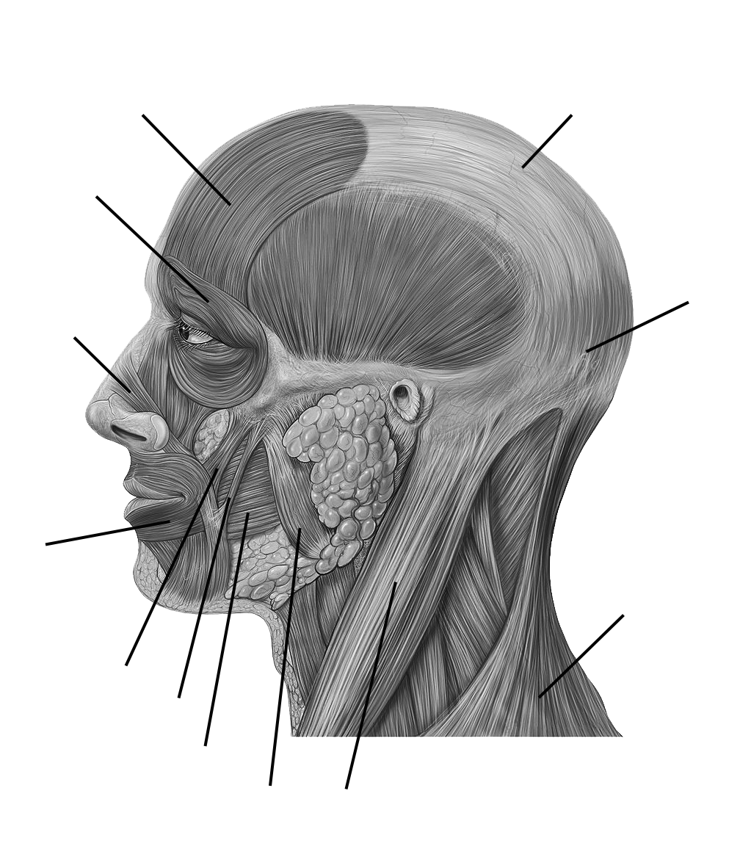
- Label the indicated facial muscles in Figure 8-9.
Figure 8-9. Facial muscles.

