St Kilda



Melbourne’s bayside

playground

# Melbourne Property Market National Context

* Melbourne is Australia’s largest city (~5.6M people) with fastest population growth (142,600 in 2023–24)
* More affordable than Sydney and Brisbane – Price-to- income ratio ~7.5 vs Sydney ~9.3
* Strong infrastructure, job growth (~880,000 jobs added in a decade), and investor yields up to 6.9%
* Dwelling values rising in 2025 +0.4% in May, strongest of any capital city

Perth

2.2m

Bris

2.6m

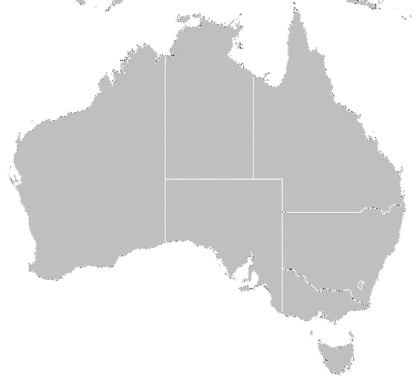

Sydney

5.4m

Melbourne

5.6m

*Source: ABS (2024), CoreLogic (2025), Zagga, Simply Wealth Group* 2

# Melbourne is Massively Underpriced

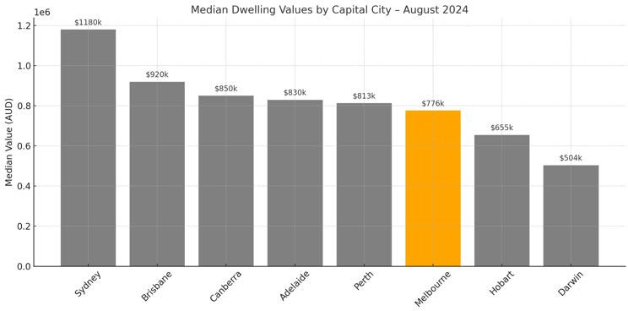

3

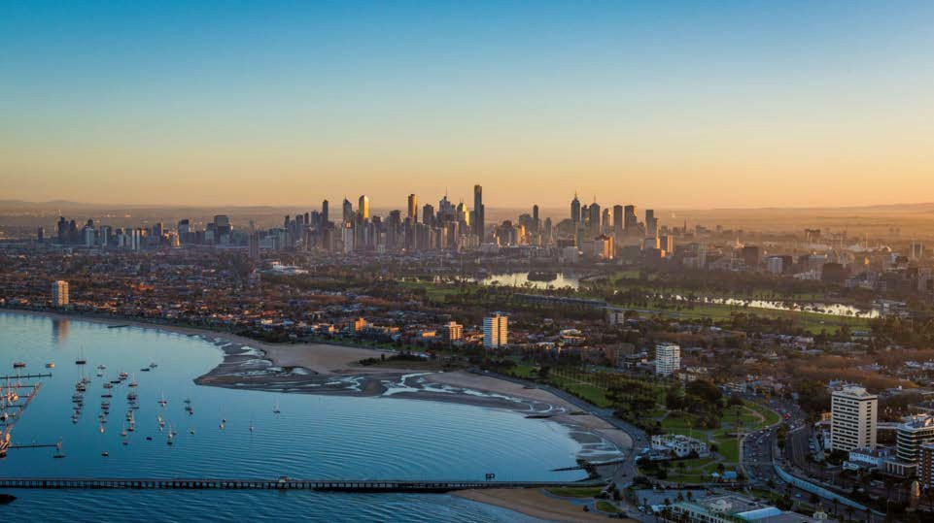Premier Location

St Kilda is Melbourne’s most famous suburb with its beachfront lifestyle and café and restaurant culture. With 20,000 permanent residents and over 2 million visitors annually St Kilda is the place to be.

4

# St Kilda poised for incredible growth

**Middle Park**

**83%**

**Houses: $2,550,000 Apartments: $1,047,500**

St Kilda is the cheapest inner bayside suburb. Direct neighbour’s to St Kilda are 35%- 83% more expensive. St Kilda is set to boom due to this relative affordability combined with:

* Ongoing rapid gentrification
* Strong rental demand
* Lifestyle appeal
* Superior transport links

**St Kilda**

**Houses: $1,600,000**

**Apartments: $505,000**

**Elwood**

**35%**

**Houses: $2,295000**

**Apartments: $635,000**

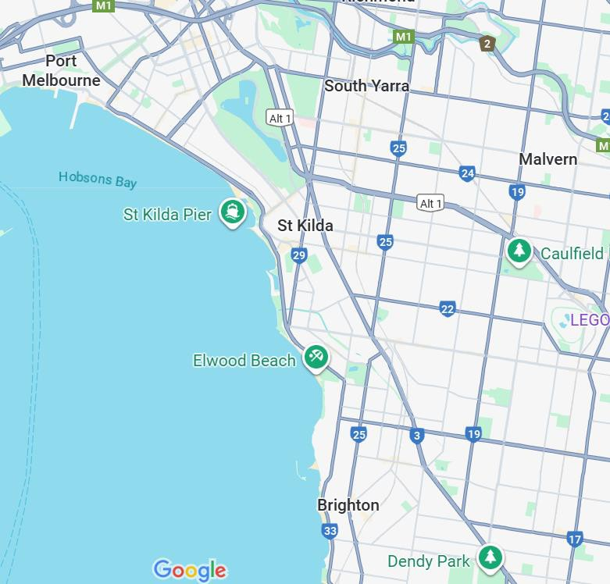

**Brighton**

**128%**

**Houses: $3,155,000**

**Apartments: $1,300,000**

*Realestate.com.au*

5

# Multiple market potential

Strong demand from local tenants combined with the option of short stay makes St Kilda a diversified, robust investment choice.

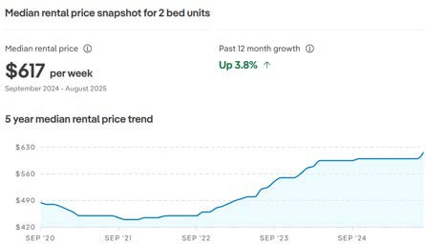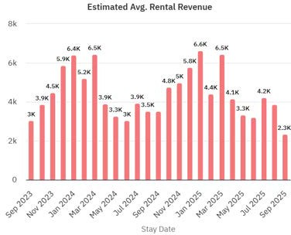

# BTR transforming rentals

Quality Build To Rent operators are transforming the rental market, increasing rental price expectations in the market:

1. Bedrooms: $690 – $995 per week
2. Bedrooms: $875 – $1,183 per week
3. Bedrooms: $1,575 – $1,888 per week



# 2,000,000 visitors

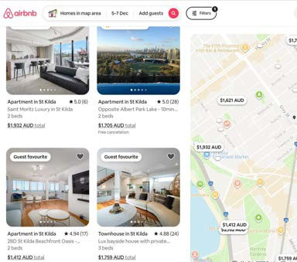

Premium 2 bedroom units in St Kilda average $66k per annum in net revenue after cleaning costs.

The top 10% of the market achieves $119k per annum or $2,288 per week!

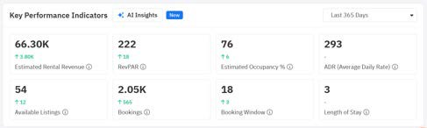



**Full stamp duty savings**

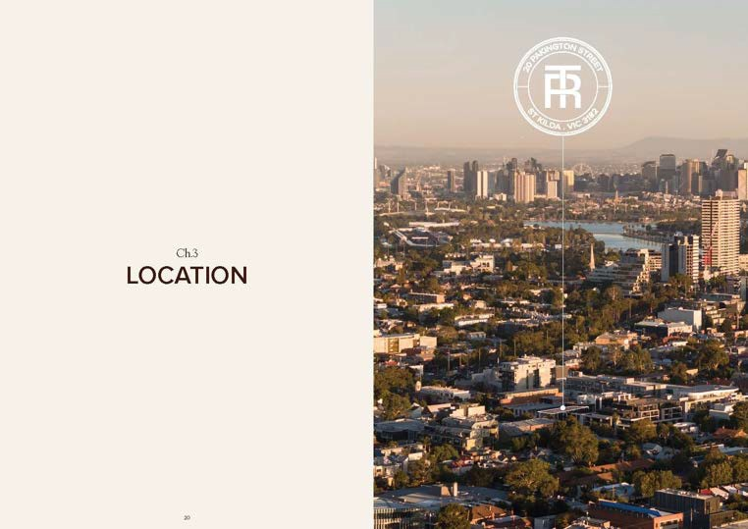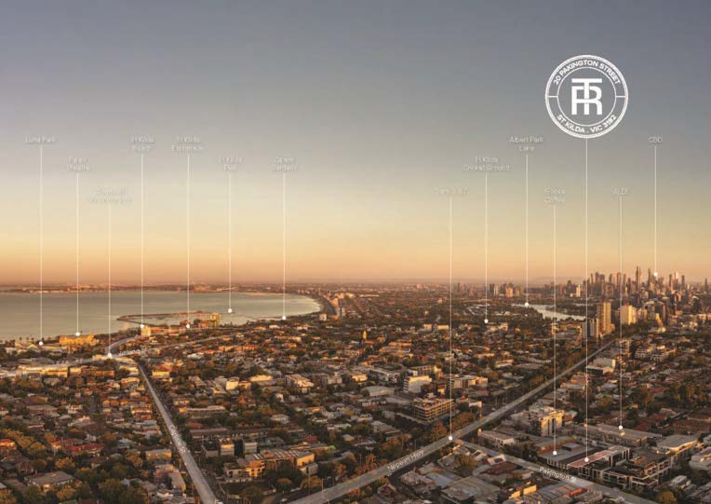

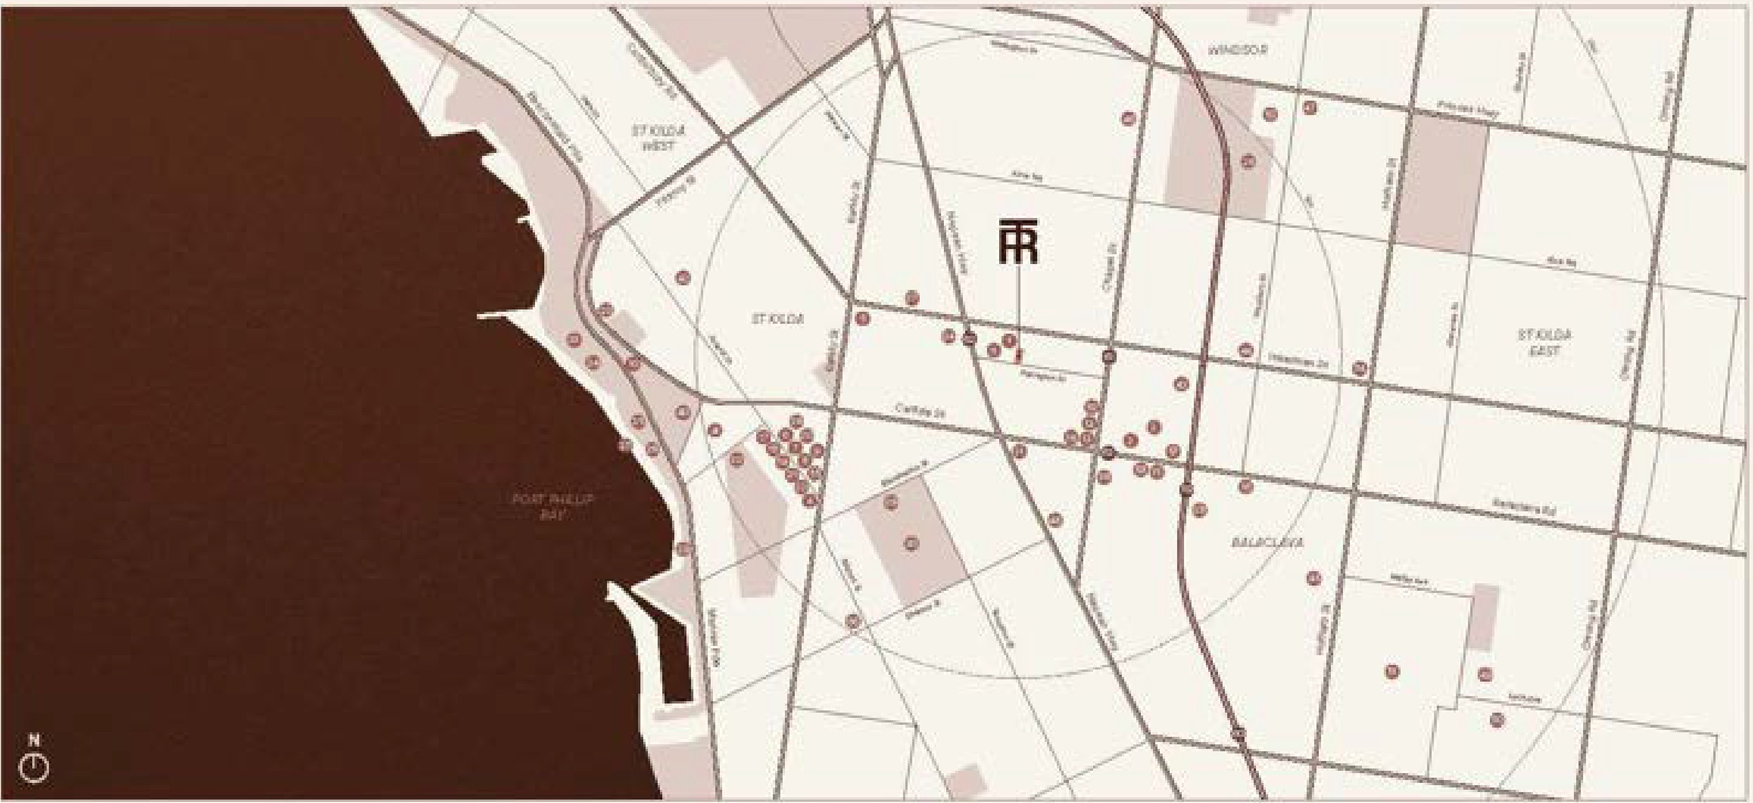

Retiil H lt1.hry ��fW **MM** � "

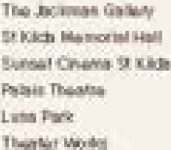1 **•11)1** t1

**t** � I] **]I**

1 11 ::,;

Ill �

� **11.D**

ll' �

II lmisponr

-



'

•II

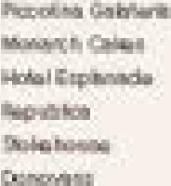� ]�



**;r.**

**:tll**

***1�***

**11,**





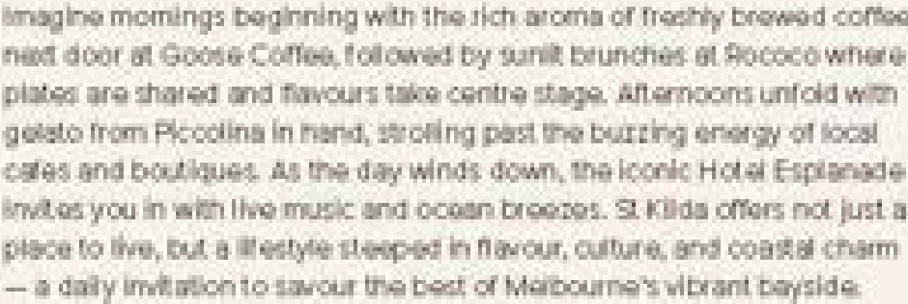Loe 1Ll

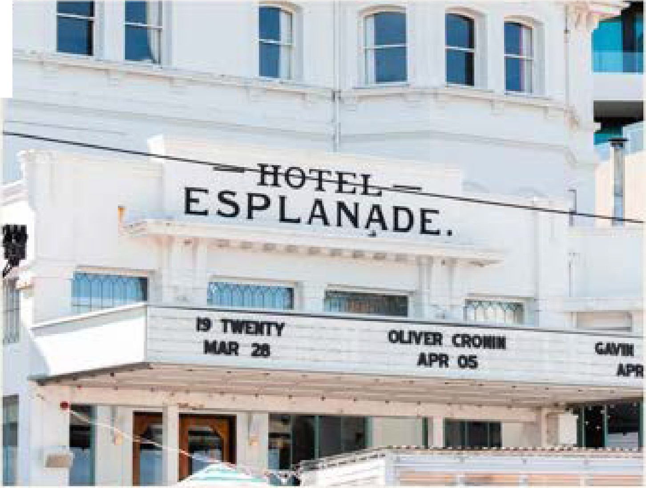

-

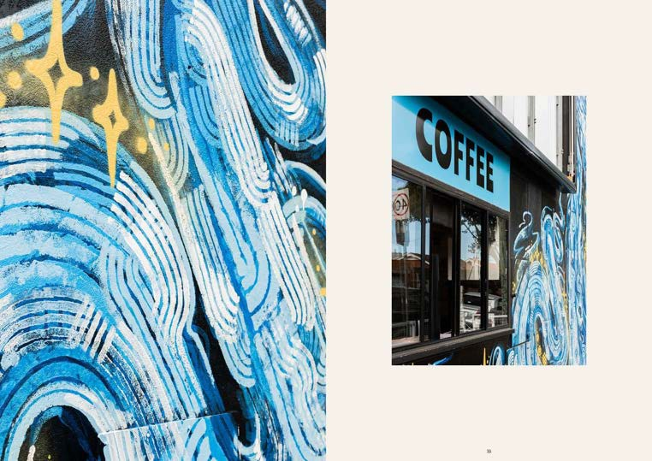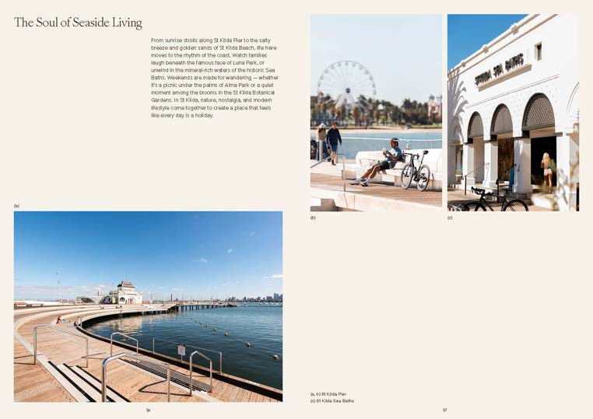

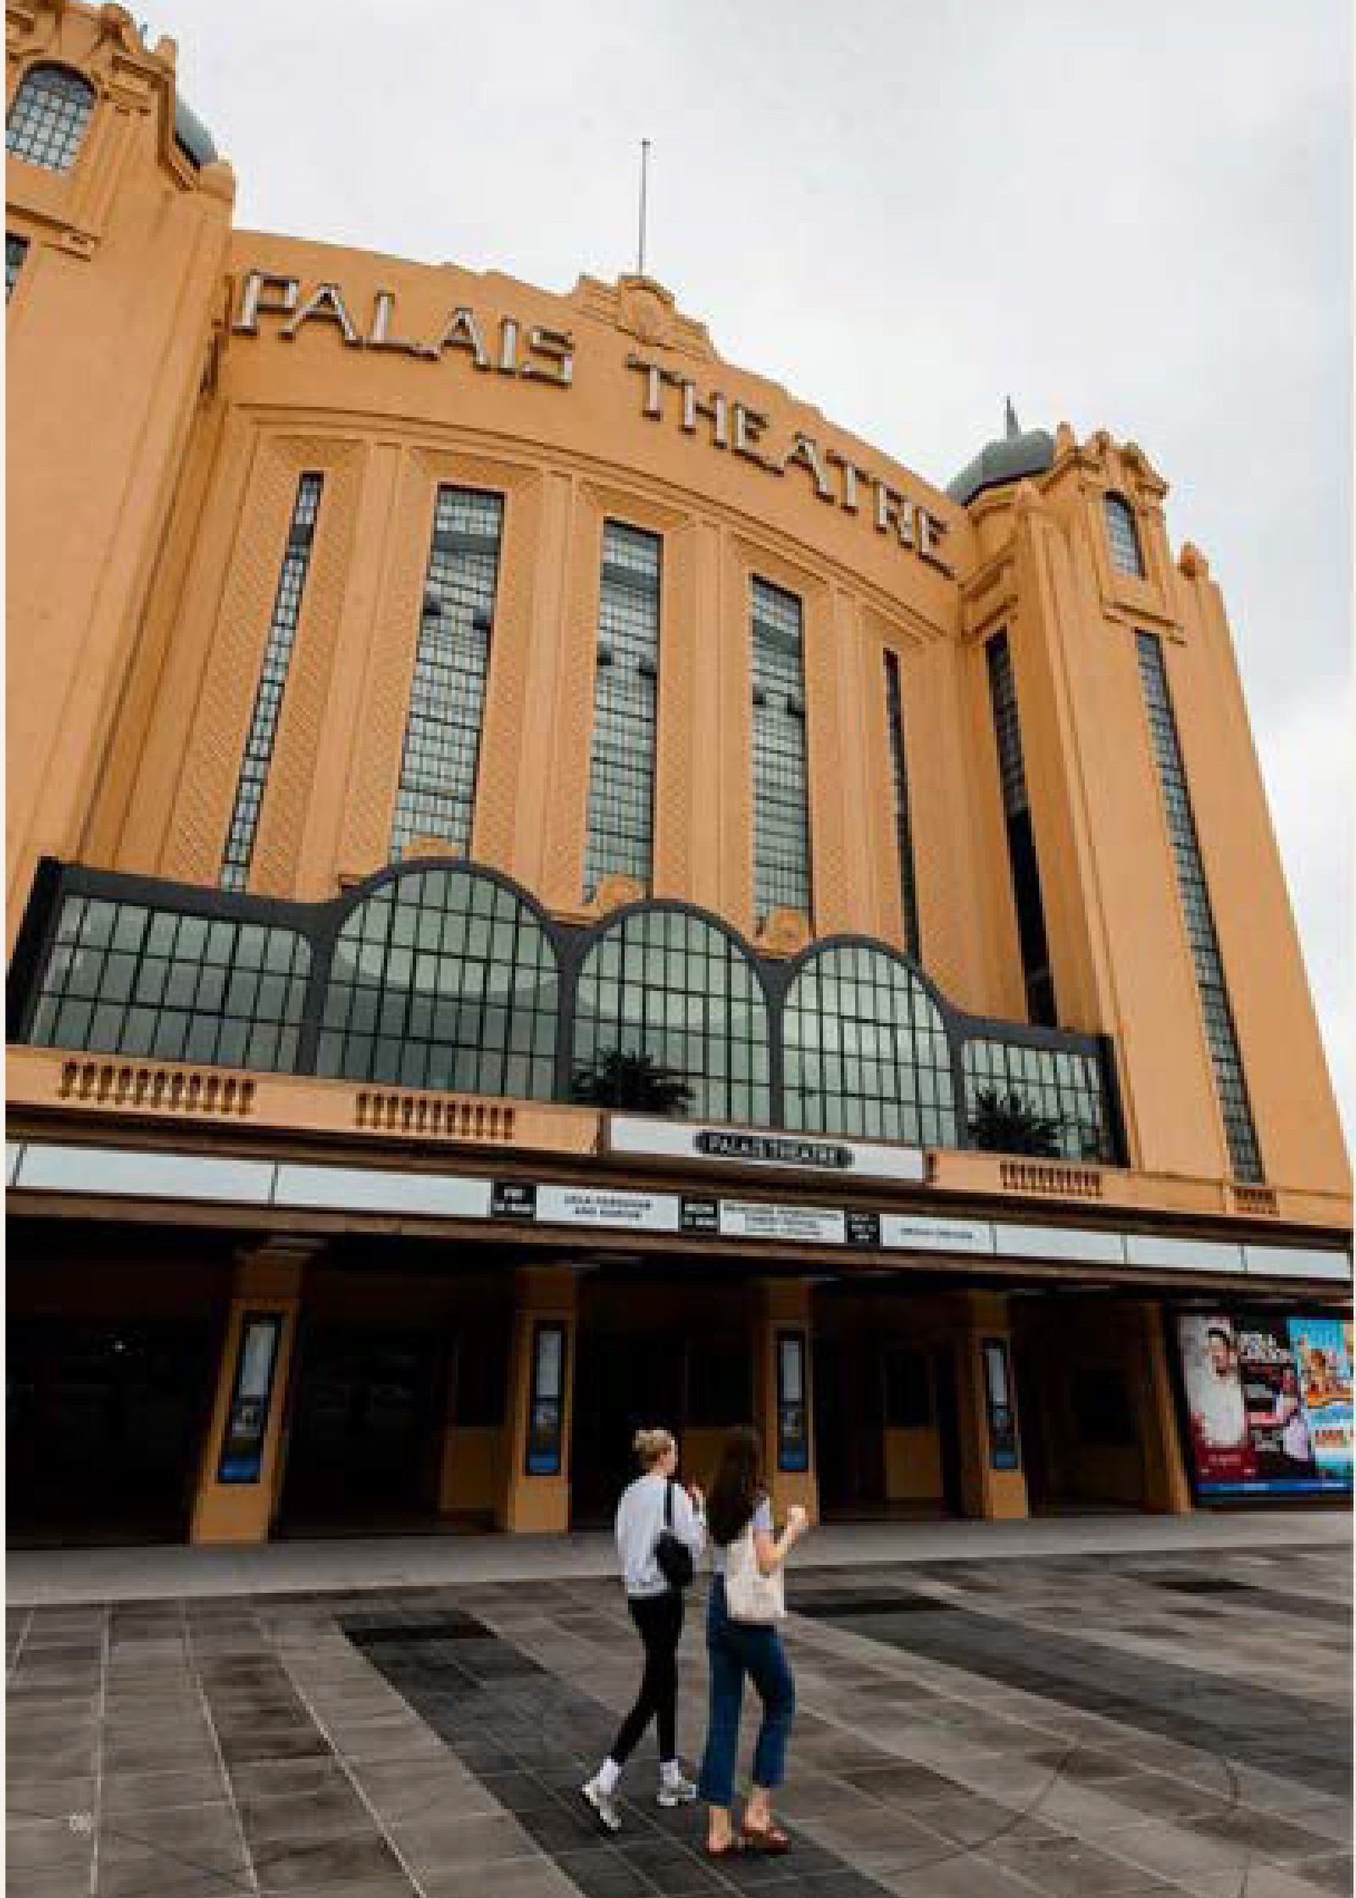la . P. rform�

and · • tive:



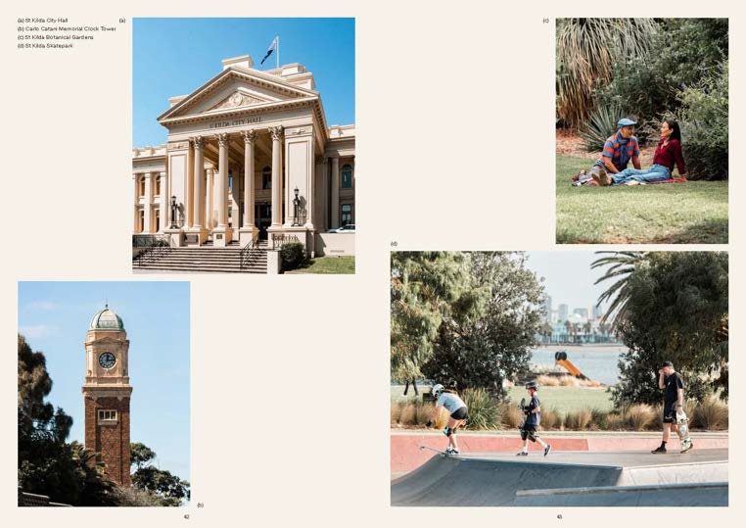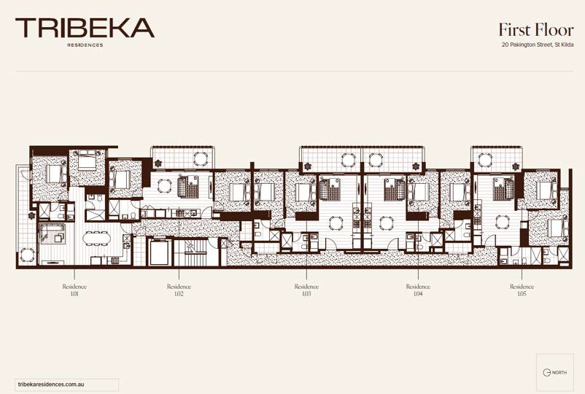

22

# $759,000

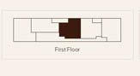

* 2 bed 2 bath
* 1 Car

- Rental $750 - $800pw

Over $30,000 in stamp duty savings!

