After visiting your home and talking with you about what you would like for your outdoor area, I am pleased to present you with the following quote.
The price below is to custom design, measure, manufacture and install a Shade/sun sail.
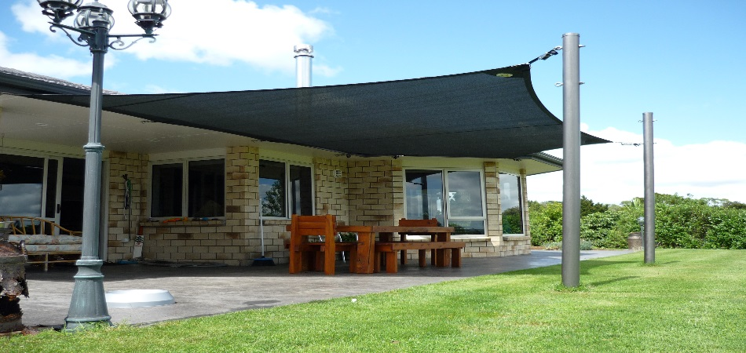
This will have 2 steel poles, each 100mm in diameter.
Shade Sail tensioned with 25mm stainless steel mini ratchet
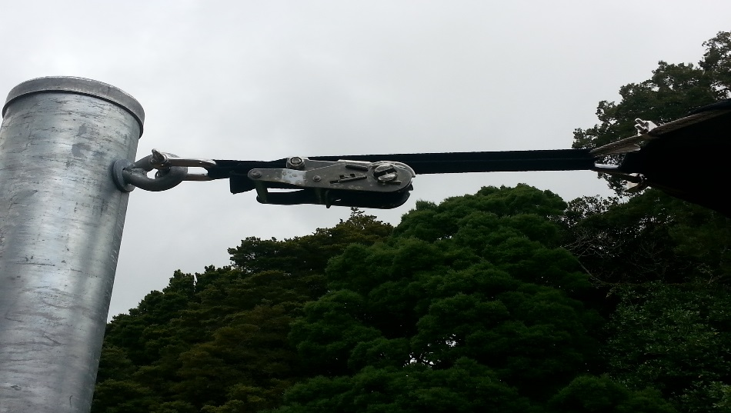
Attachment under soffit Attachment for Iron Roofs
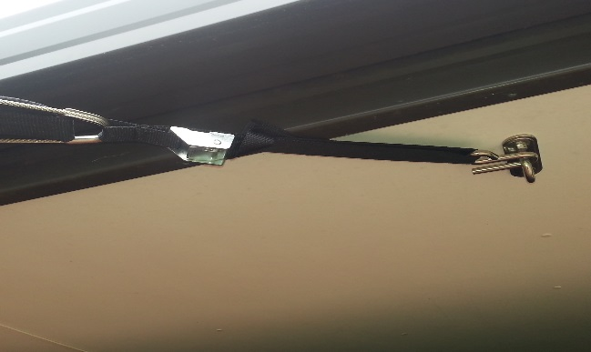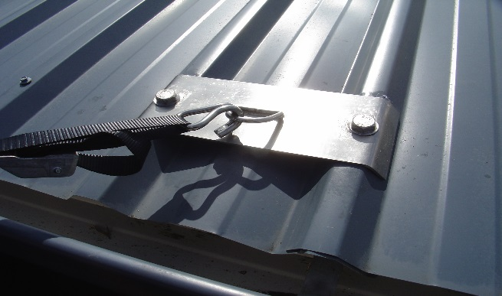

Wire edge Shade/Sun Sail

The Shade/sun sail will be manufactured with stainless steel wire around the outside for tensioning. All fittings used on the sail and on your home will be stainless steel. The material used will be very high quality, UV treated which means it will not shrink or fade. The amount of UV rays that are blocked out depend on the colour you chose, but most fabrics block 90-97% of UV.
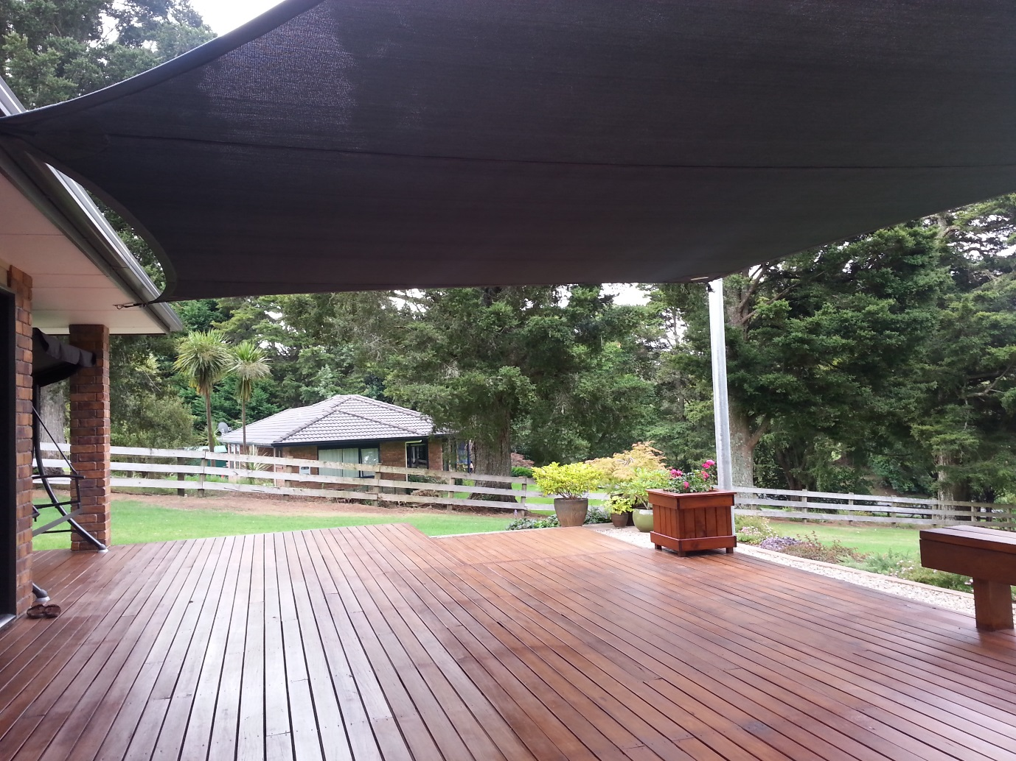

Once you accept the quote, we will arrange for the poles to be installed and then will come back for a more accurate measure in relation to the position of the poles. If you have not already done so, a colour can be chosen at this point.

The Shade/sun sail will then be manufactured and installed.

Webbing edge Shade/Sun Sail

The Shade/sun sail will be manufactured with 38mm polyester webbing around the outside for tensioning. All fittings used on the sail and on your home will be stainless steel. The material used will be very high quality, UV treated which means it will not shrink or fade. The amount of UV rays that are blocked out depend on the colour you chose, but most fabrics block 90-97% of UV.
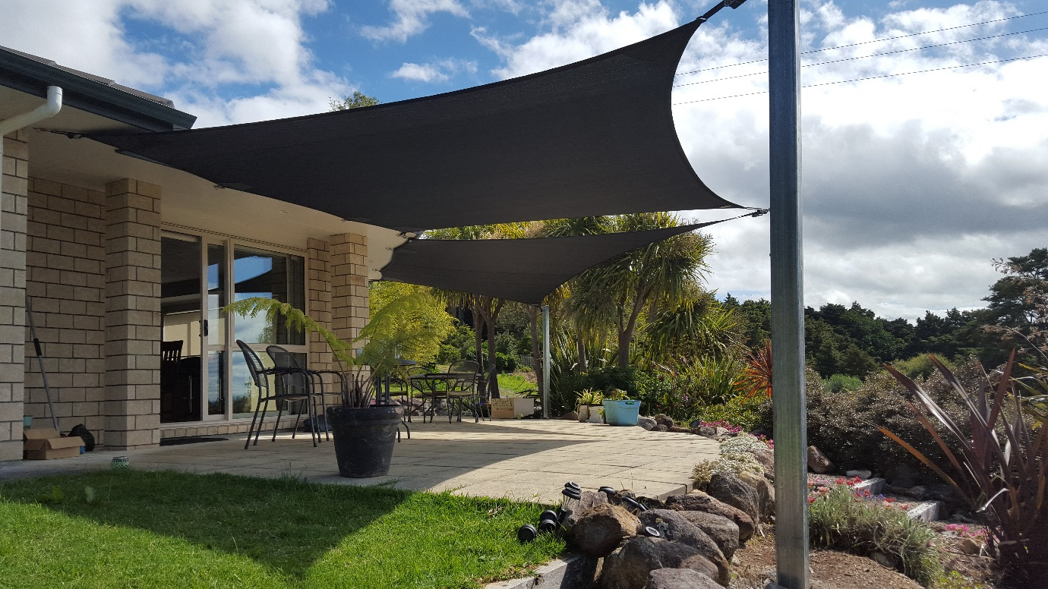
The attached scale drawing shows the location of the sail, and the area it will cover.

Once you accept the quote, we will arrange for the poles to be installed and then will come back for a more accurate measure in relation to the position of the poles. If you have not already done so, a colour can be chosen at this point.

The Shade/sun sail will then be manufactured and installed.

