International Youth Forum
„Challenges of member and non-member countries of European union“
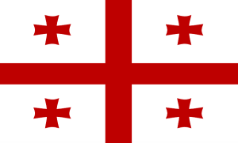

9-16 MAY 2014
Tbilisi,Georgia

First name

Last name
University or Institution or collage
Faculty / course
Country, City, Address
E-MAIL:
Phone number:

Title of the Paper
Abstract / Résumé

Max 300/500 words

Please use the registration form template and send it to IYF@Europe.com until March 15 2014.

