REVISED 2/22/2018
SCHEDULE FOR 2017 – 2018
GRADES 1 – 8
6:30 – 7:45p

September 17th: FF Family Opening Mass and Potluck
September 27th: Chapter 1

October 4th: Chapter 2 Fr. Tony will visit Grades 1-3 & Parent Meeting for Sacramental Prep
October 6th: Family Night at Minnetonka Orchards 6:30 – 8:30 pm
October 11th: Chapter 3
October 18th: No Class – MEA Break
October 25th: Chapter 4 & All Saints

November 1st: All Saints Day Mass
November 8th: Chapter 6 Fr. Tony will visit Grades 4-6
November 15th: Mandatory Safety Session
November 22nd: No Class – Thanksgiving Break
November 29th: Chapter 7

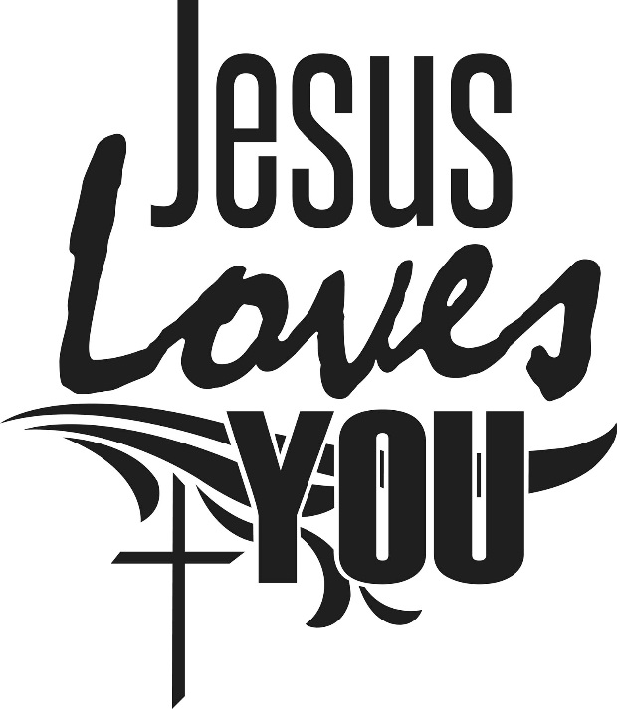
December 6th: Chapter 8
December 13th: Class/Reconciliation
December 20th: Chapter 9
December 27th: No Class - Merry Christmas!

January 10th: Chapter 11
January 17th: Chapter 12
January 24th: Chapter 13
January 31st: Chapter 14

February 7th: Chapter 16 & Lent
February 14th: Ash Wednesday Mass
February 21st: Chapter 17
February 28th: Chapter 18

March 7th: Chapter 19
March 14th: Chapter 21
March 21st: Chapter 22 & Holy Week
March 28th: No Class – Spring Break

April 4th: Chapter 23 & Easter
April 11th: Chapter 24 & Pentecost
April 18th: Closing Mass

June 11 – 15th: Vacation Bible School

Please call the Faith Formation Office or email Kathy at khejna@ourladyofthelake.com to let us know if your child is unable to be here. If classes need to be cancelled due to weather conditions, etc., a general email will be sent out immediately and we will also indicate this on our greeting at 952-472-8202.
2/2018

