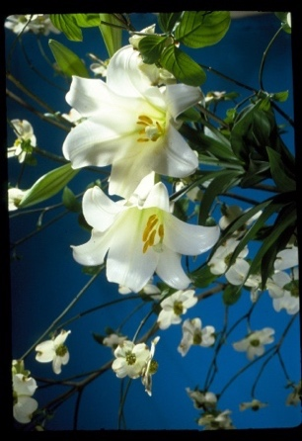
Easter Sunday is April 17, and we would love to beautify the Chancel area with flowering plants.
This year, we are offering a few different options. Please fill out the order form below, and give to Deaconess Kris in the church office along with your check made out to Redeemer Lutheran Church.
Deadline to order is Sunday, March 27.

Flower Cost How Many Total $
[ ] Easter Lilies (5 + flowers) $ 9.00 _______ _______
[ ] Tulips [ ]Red [ ]Purple [ ]Yellow $ 8.50 _______ _______
[ ] Mums [ ]Purple [ ]Yellow [ ]White $ 9.00 _______ _______
[ ] Hydrangeas (pink) $16.25 _______ _______
[ ] Pansy Bowl 12” bowl (assorted colors) $16.00 _______ _______

[ ] I will take my plant after the last Easter service
[ ] I wish to donate my plant(s)

PLEASE PRINT:
Name___________________________________________________________________
Phone __________________________________________________________________
In honor of_______________________________________________________________
________________________________________________________________________
In memory of_____________________________________________________________
________________________________________________________________________

For office use only
Date:______________________________
Paid [ ] Cash [ ] Check #__________

