September 22, 2024
Eighteenth Sunday After Pentecost

Opening Hymn: Only-Begotten, Word of God Eternal LSB 916
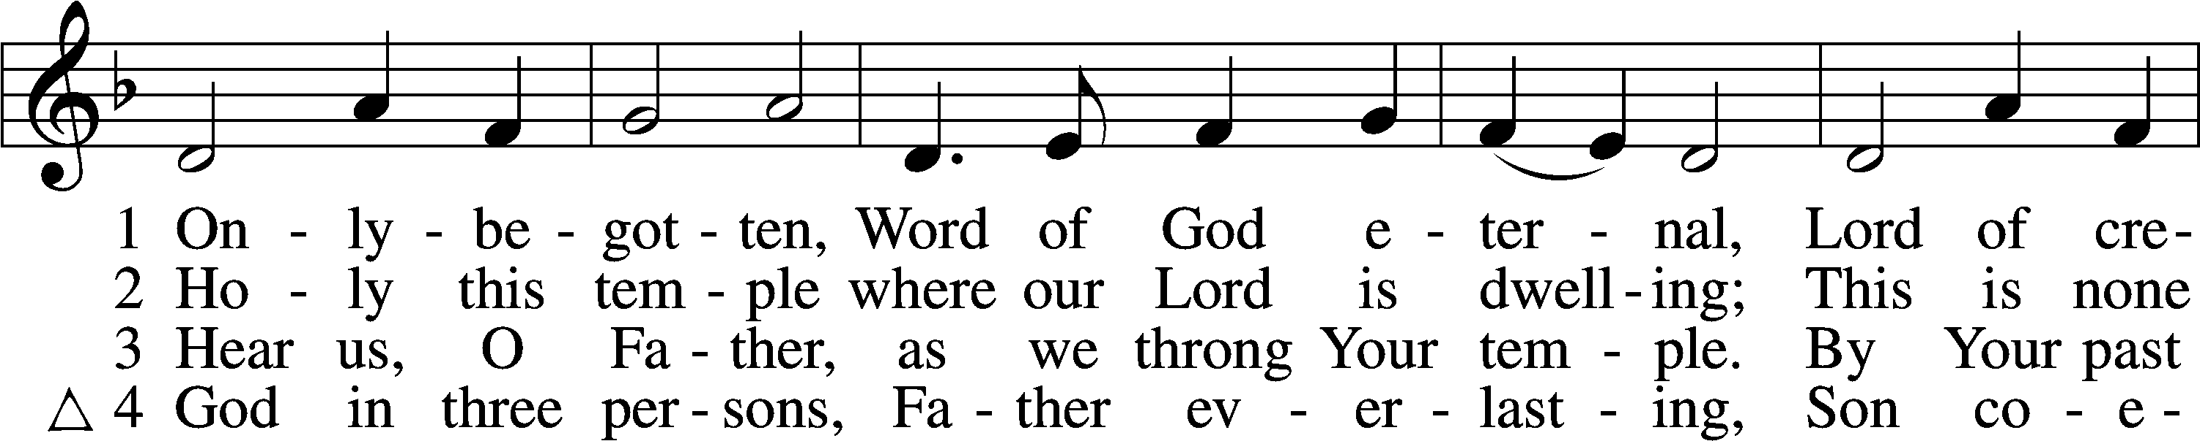
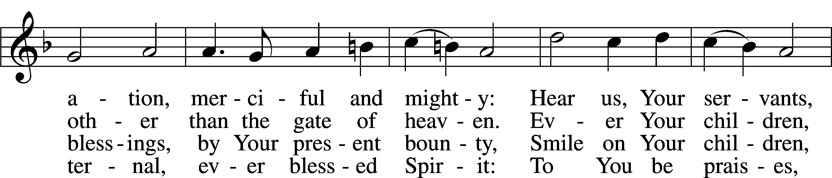
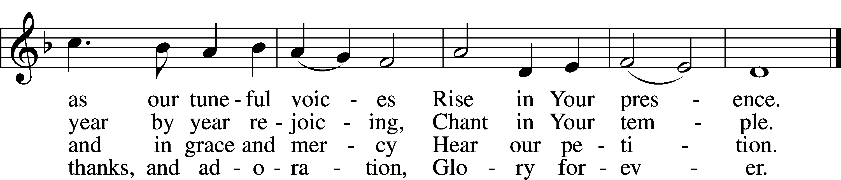
Text: Latin, c. 9th cent.; tr. Maxwell J. Blacker, 1822–88, alt.
Tune: Antiphoner, 1746, Poitiers
Text and tune: Public domain

The sign of the cross may be made by all in remembrance of their Baptism.
Invocation Matthew 28:19b; 18:20
P In the name of the Father and of the T Son and of the Holy Spirit.
C Amen.

Exhortation Hebrews 10:22; Psalm 124:8; Psalm 32:5 LSB 184
P Beloved in the Lord! Let us draw near with a true heart and confess our sins unto God our Father, beseeching Him in the name of our Lord Jesus Christ to grant us forgiveness.

P Our help is in the name of the Lord,
C who made heaven and earth.
P I said, I will confess my transgressions unto the Lord,
C and You forgave the iniquity of my sin.
Confession of Sins LSB 184
P O almighty God, merciful Father,
C I, a poor, miserable sinner, confess unto You all my sins and iniquities with which I have ever offended You and justly deserved Your temporal and eternal punishment. But I am heartily sorry for them and sincerely repent of them, and I pray You of Your boundless mercy and for the sake of the holy, innocent, bitter sufferings and death of Your beloved Son, Jesus Christ, to be gracious and merciful to me, a poor, sinful being.

Absolution [John 20:19–23] LSB 185
P Upon this your confession, I, by virtue of my office, as a called and ordained servant of the Word, announce the grace of God unto all of you, and in the stead and by the command of my Lord Jesus Christ I forgive you all your sins in the name of the Father and of the T Son and of the Holy Spirit.
C Amen.

Service of the Word

Kyrie Mark 10:47 186
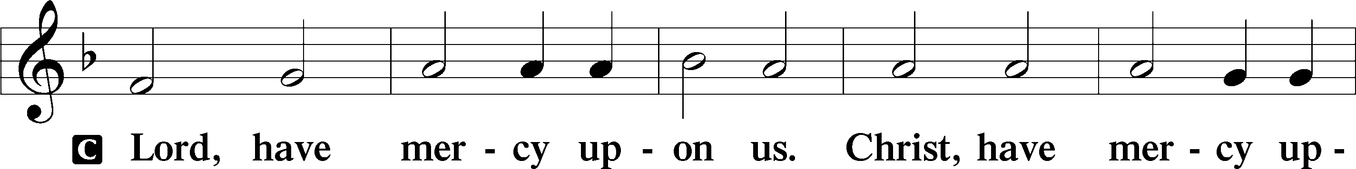
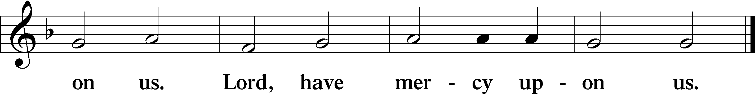

Gloria in Excelsis Luke 2:14; John 1:29 LSB 187
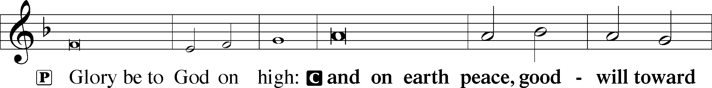
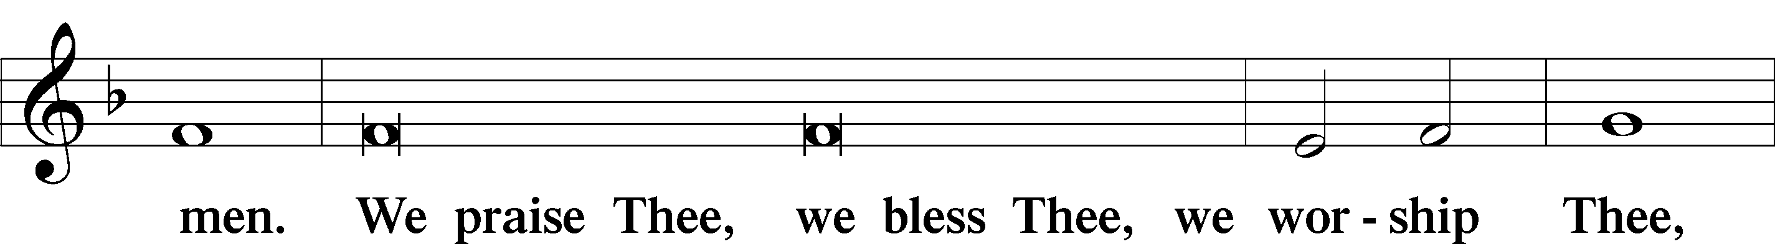
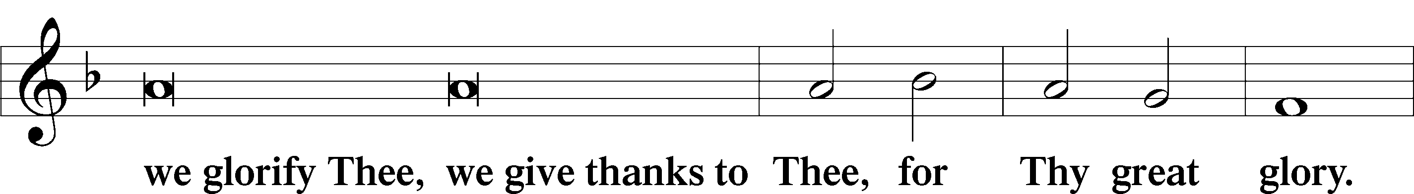
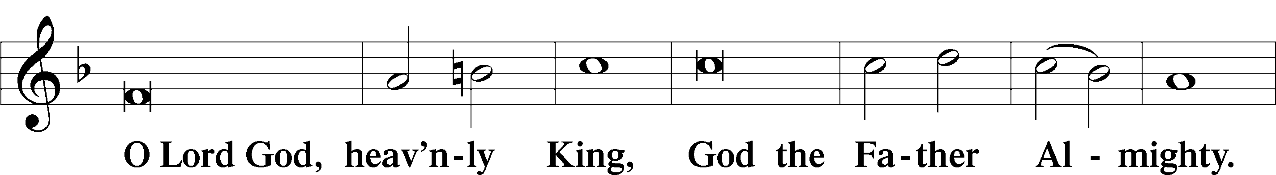
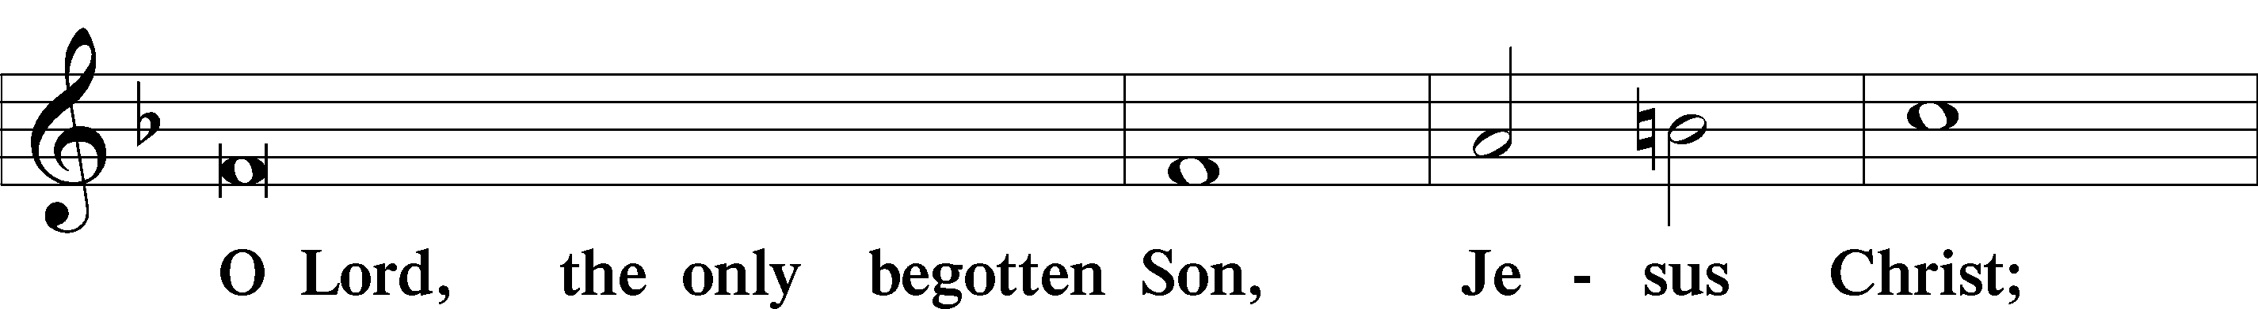
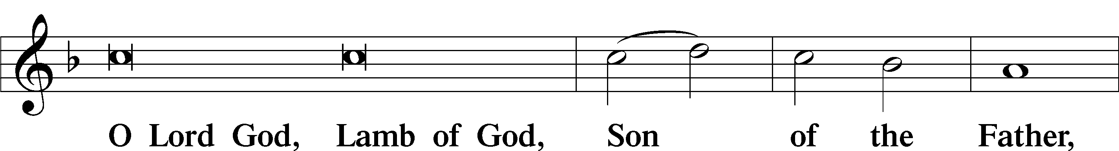
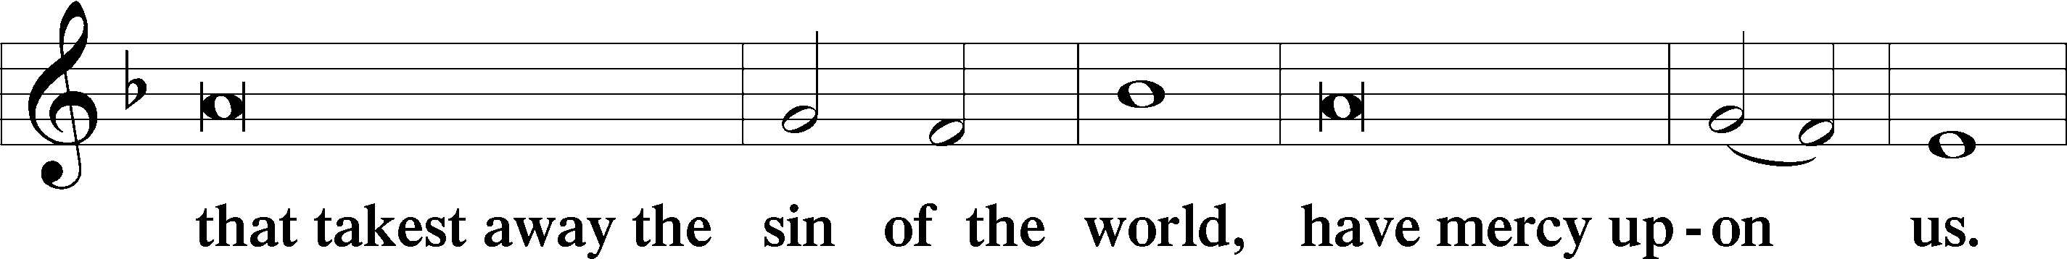
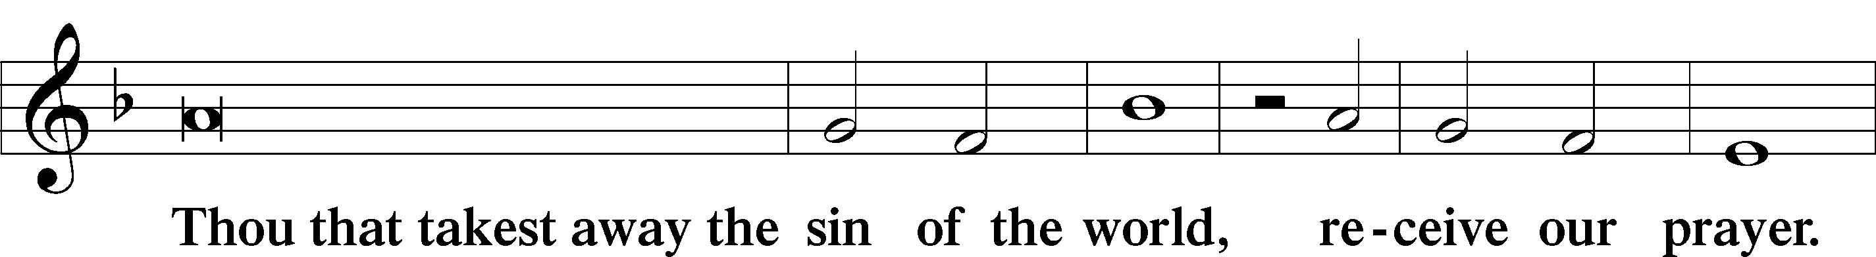
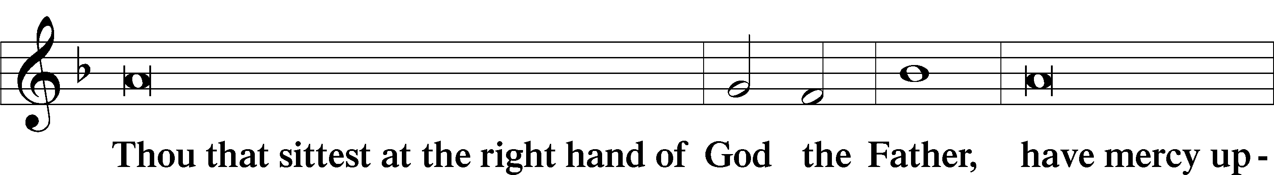
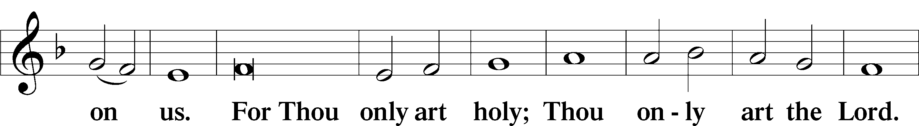
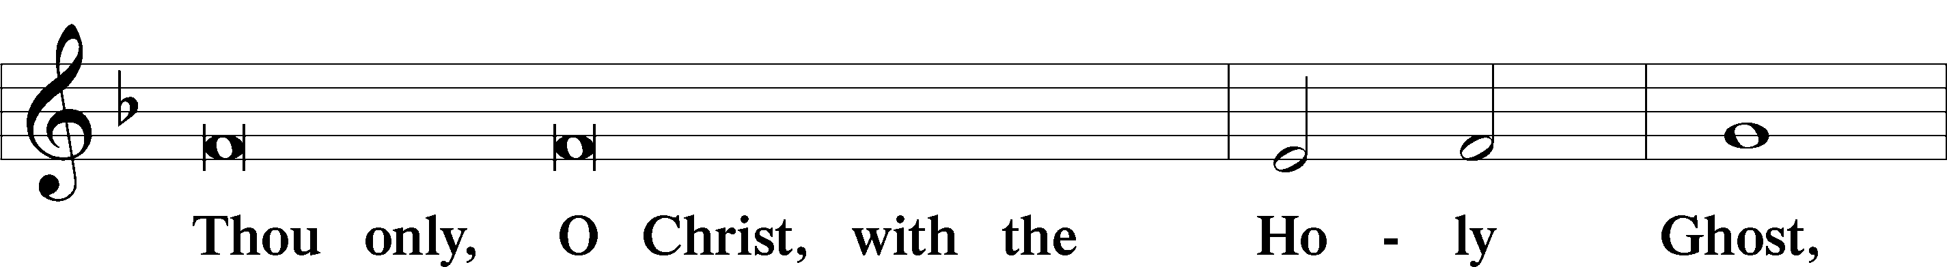
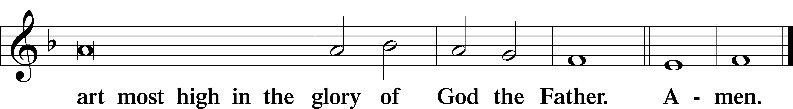

Salutation and Collect of the Day
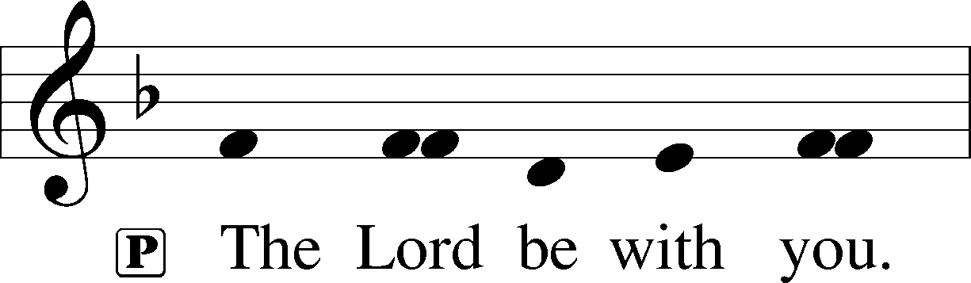
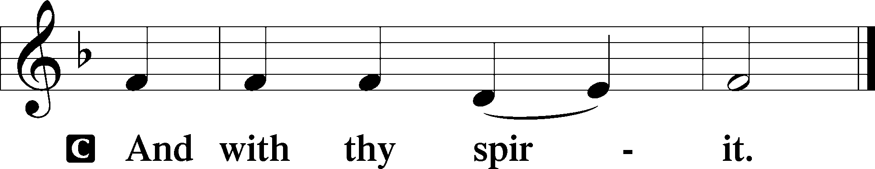

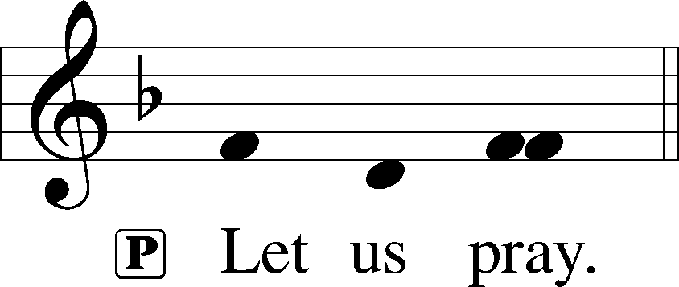

P O God, whose strength is made perfect in weakness, grant us humility and childlike faith that we may please You in both will and deed; through Jesus Christ, Your Son, our Lord, who lives and reigns with You and the Holy Spirit, one God, now and forever.

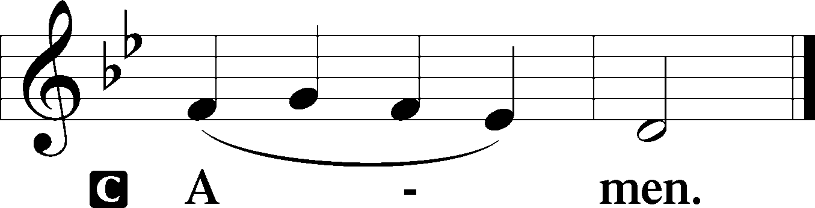

Sit
Old Testament Reading Jeremiah 11:18–20
A The Old Testament Reading is from Jeremiah, chapter 11.

¹⁸The Lord made it known to me and I knew;
then you showed me their deeds.
¹⁹But I was like a gentle lamb
led to the slaughter.
I did not know it was against me
they devised schemes, saying,
“Let us destroy the tree with its fruit,
let us cut him off from the land of the living,
that his name be remembered no more.”
²⁰But, O Lord of hosts, who judges righteously,
who tests the heart and the mind,
let me see your vengeance upon them,
for to you have I committed my cause.

A This is the Word of the Lord.
C Thanks be to God.

Gradual Psalm 34:9, 19, alt.
Fear the Lord, you his saints,
for those who fear him lack nothing!
Many are the afflictions of the righteous,
but the Lord delivers him out of them all.

Epistle James 3:13—4:10
A The Epistle is from James, chapter 3.

¹³Who is wise and understanding among you? By his good conduct let him show his works in the meekness of wisdom. ¹⁴But if you have bitter jealousy and selfish ambition in your hearts, do not boast and be false to the truth. ¹⁵This is not the wisdom that comes down from above, but is earthly, unspiritual, demonic. ¹⁶For where jealousy and selfish ambition exist, there will be disorder and every vile practice. ¹⁷But the wisdom from above is first pure, then peaceable, gentle, open to reason, full of mercy and good fruits, impartial and sincere. ¹⁸And a harvest of righteousness is sown in peace by those who make peace.
¹What causes quarrels and what causes fights among you? Is it not this, that your passions are at war within you? ²You desire and do not have, so you murder. You covet and cannot obtain, so you fight and quarrel. You do not have, because you do not ask. ³You ask and do not receive, because you ask wrongly, to spend it on your passions. ⁴You adulterous people! Do you not know that friendship with the world is enmity with God? Therefore whoever wishes to be a friend of the world makes himself an enemy of God. ⁵Or do you suppose it is to no purpose that the Scripture says, “He yearns jealously over the spirit that he has made to dwell in us”? ⁶But he gives more grace. Therefore it says, “God opposes the proud, but gives grace to the humble.” ⁷Submit yourselves therefore to God. Resist the devil, and he will flee from you. ⁸Draw near to God, and he will draw near to you. Cleanse your hands, you sinners, and purify your hearts, you double-minded. ⁹Be wretched and mourn and weep. Let your laughter be turned to mourning and your joy to gloom. ¹⁰Humble yourselves before the Lord, and he will exalt you.

A This is the Word of the Lord.
C Thanks be to God.

Stand
Alleluia LSB 190
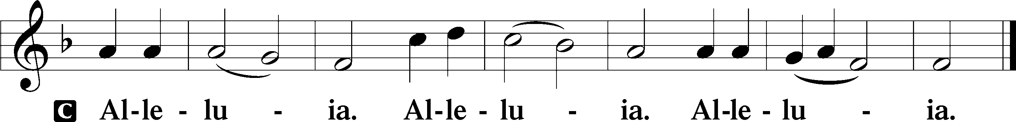

Holy Gospel Mark 9:30–37
P The Holy Gospel according to St. Mark, the ninth chapter.

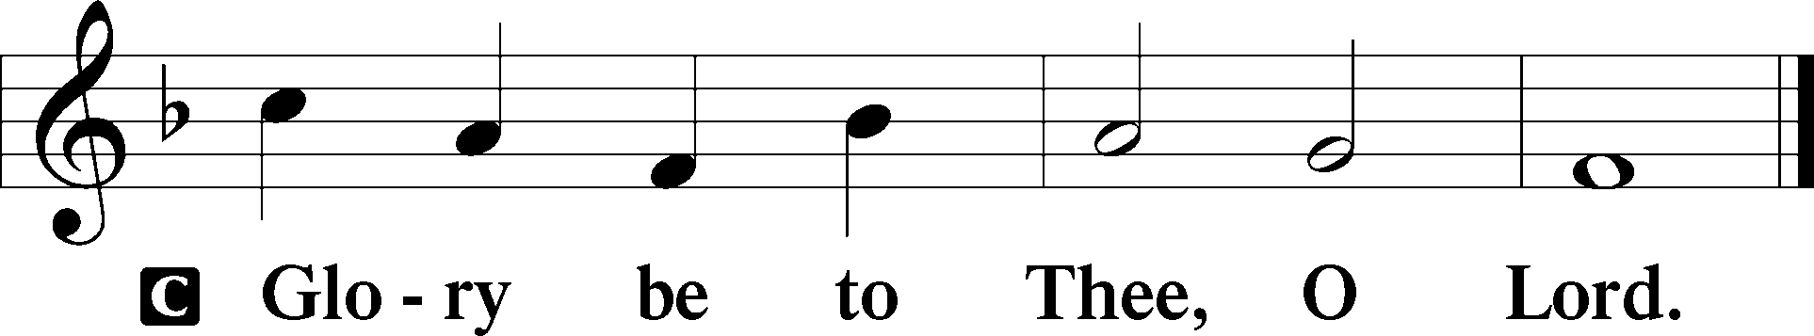

³⁰[The disciples] went on from there and passed through Galilee. And [Jesus] did not want anyone to know, ³¹for he was teaching his disciples, saying to them, “The Son of Man is going to be delivered into the hands of men, and they will kill him. And when he is killed, after three days he will rise.” ³²But they did not understand the saying, and were afraid to ask him.
³³And they came to Capernaum. And when he was in the house he asked them, “What were you discussing on the way?” ³⁴But they kept silent, for on the way they had argued with one another about who was the greatest. ³⁵And he sat down and called the twelve. And he said to them, “If anyone would be first, he must be last of all and servant of all.” ³⁶And he took a child and put him in the midst of them, and taking him in his arms, he said to them, ³⁷“Whoever receives one such child in my name receives me, and whoever receives me, receives not me but him who sent me.”

P This is the Gospel of the Lord.

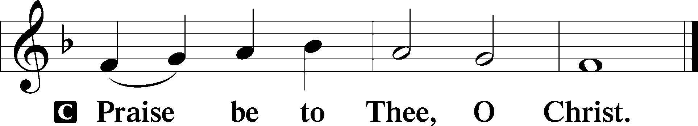

Nicene Creed
C I believe in one God,
the Father Almighty,
maker of heaven and earth
and of all things visible and invisible.

And in one Lord Jesus Christ,
the only-begotten Son of God,
begotten of His Father before all worlds,
God of God, Light of Light,
very God of very God,
begotten, not made,
being of one substance with the Father,
by whom all things were made;
who for us men and for our salvation came down from heaven
and was incarnate by the Holy Spirit of the virgin Mary
and was made man;
and was crucified also for us under Pontius Pilate.
He suffered and was buried.
And the third day He rose again according to the Scriptures
and ascended into heaven
and sits at the right hand of the Father.
And He will come again with glory to judge both the living and the dead,
whose kingdom will have no end.

And I believe in the Holy Spirit,
the Lord and giver of life,
who proceeds from the Father and the Son,
who with the Father and the Son together is worshiped and glorified,
who spoke by the prophets.
And I believe in one holy Christian and apostolic Church,
I acknowledge one Baptism for the remission of sins,
and I look for the resurrection of the dead
and the life T of the world to come. Amen.

Sit

Announcements

Hymn of the Day: What Is the World to Me LSB 730
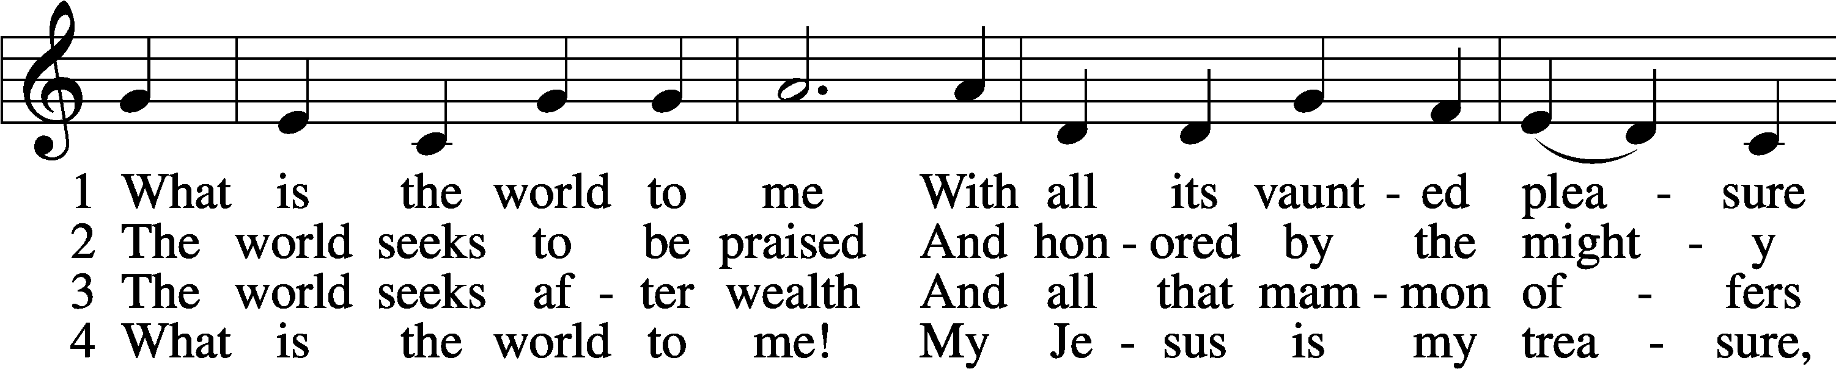
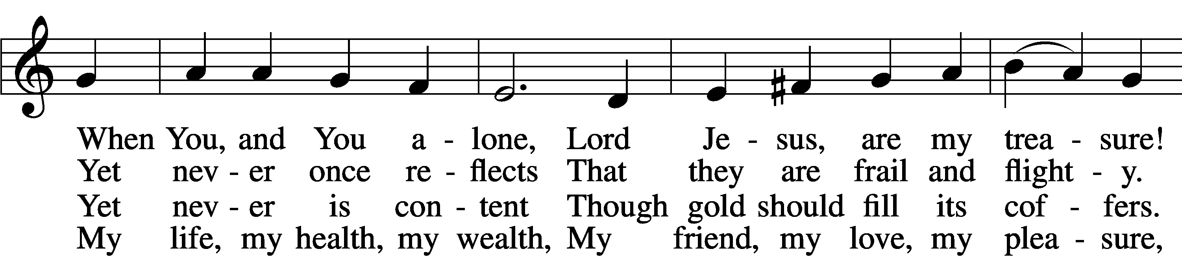
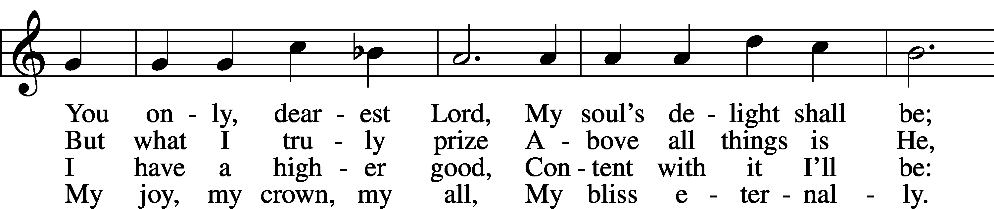
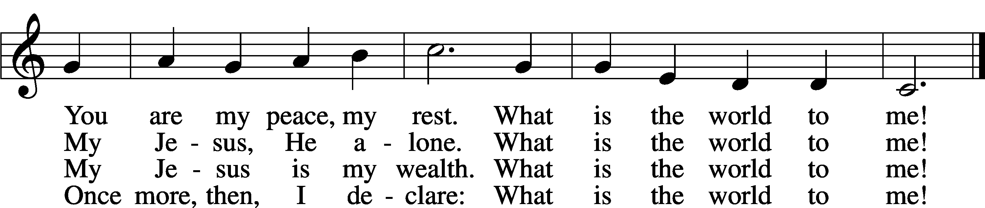
Text: Georg Michael Pfefferkorn, 1645–1732; tr. August Crull, 1845–1923, alt.
Tune: Ahasverus Fritsch, 1629–1701
Text and tune: Public domain

Sermon Rev. Philip Zielinski

Stand
Offertory Psalm 51:10–12 LSB 192
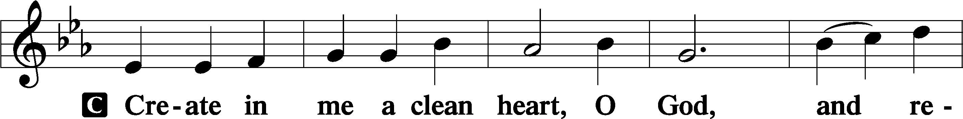
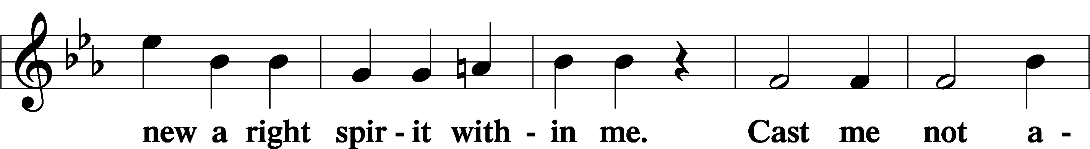
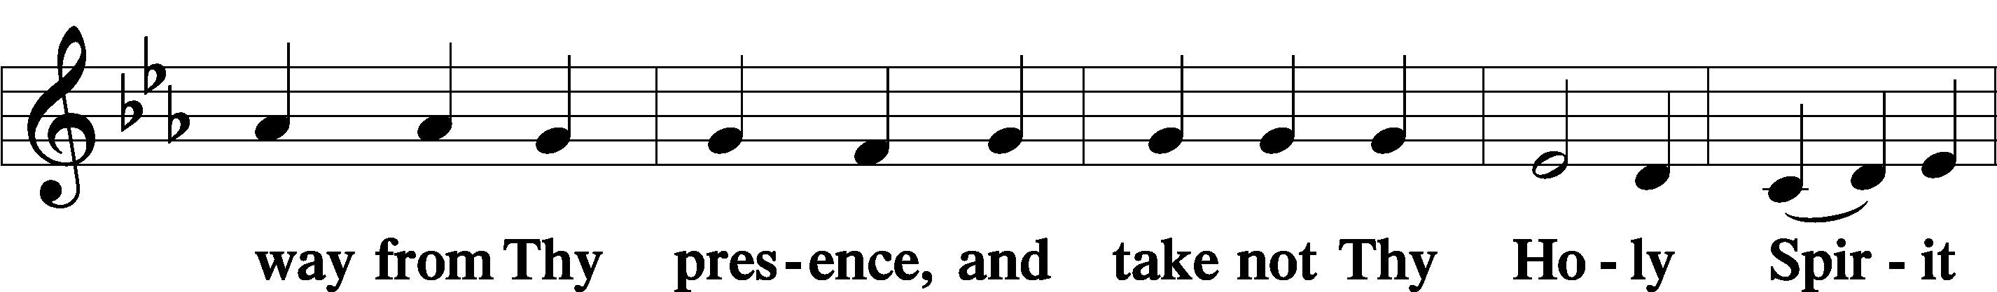
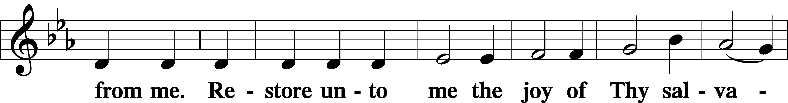
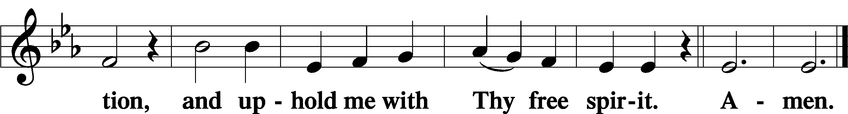

Sit
Offering
Note: Please continue to place your offerings into the plates as you enter or leave church as we will not be passing the plates through the congregation. The offering plates will be brought forward at this time to remind us that our offerings are given in thankfulness to Him for His blessings to each of us.

Stand
Prayer of the Church
P Let us pray for the whole Church of God in Christ Jesus and for all people according to their needs.

Heavenly Father, You have taken us from all nations and united us in the Body of Your Son. Send Your Holy Spirit to rid Your children of all bitter jealousy, boasting and selfish ambition. Fill the baptized with Your wisdom, that we may lead peaceable lives with sincerity and love. Lord, in Your mercy,
C hear our prayer.

P O Lord of hosts, give our Synod’s leaders and all pastors the wisdom that comes down from above, that they may be peaceable, gentle, open to reason, full of mercy and good fruits, impartial, and sincere. Let them sow among us in peace, and grant a harvest of righteousness. Lord, in Your mercy,
C hear our prayer.

P Uphold this world in Your order. Preserve the Church and the preaching of Your Word against all enemies. Bless our homes, that parents and children may serve one another faithfully and grow in instruction and faith until life’s end. Give health and wisdom to all who serve in public office, that their authority may be exercised for the benefit of our people. Lord, in Your mercy,
C hear our prayer.

P Lord, in Your lovingkindness You do not abandon Your children to suffer alone but promise to care for all who call upon Your name. Bless the homebound, the lonely, the depressed and anxious, those preparing for surgery, the ill and the dying [and especially those who desire our prayers: _____________]. Comfort them in their distress, heal all their ills of body and soul, and grant them Your peace. Lord, in Your mercy,
C hear our prayer.

P O Lord of hosts, Your Son was cut off from the land of the living on the tree of the cross, that we might eat and drink the fruit of His body and blood and live forever. Grant that we may worthily receive His Supper in remembrance of Him. Lord, in Your mercy,
C hear our prayer.

P Father, grant that what we ask from You may not be squandered after our passions but sought rightly in faith, that we may receive them and put them into service for You and our neighbors. Lord, in Your mercy,
C hear our prayer.

P Into Your hands, we commend all for whom we pray, trusting in Your mercy; through Jesus Christ, Your Son, our Lord, who lives and reigns with You and the Holy Spirit, one God, now and forever.
C Amen.
Service of the Sacrament

Preface 2 Timothy 4:22; [Colossians 3:1]; [Psalm 136] LSB 194

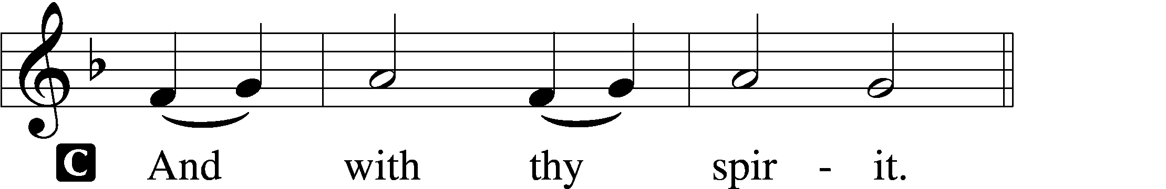

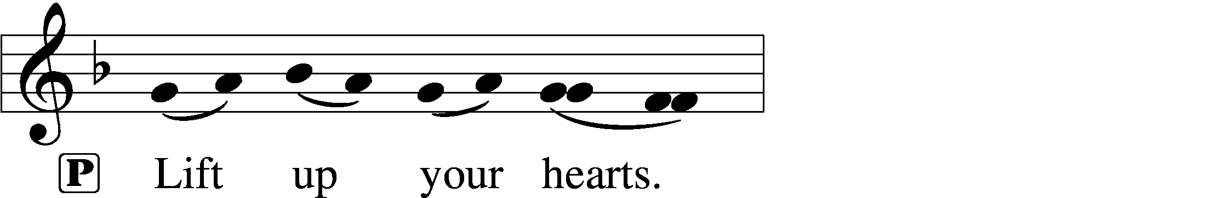
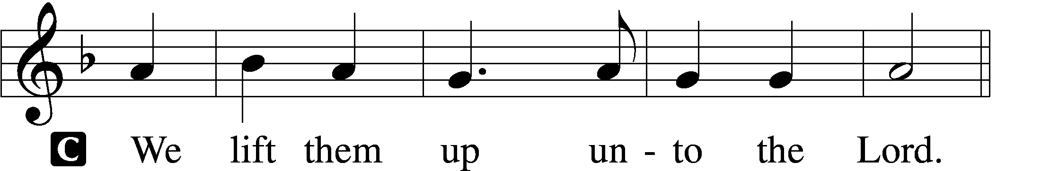

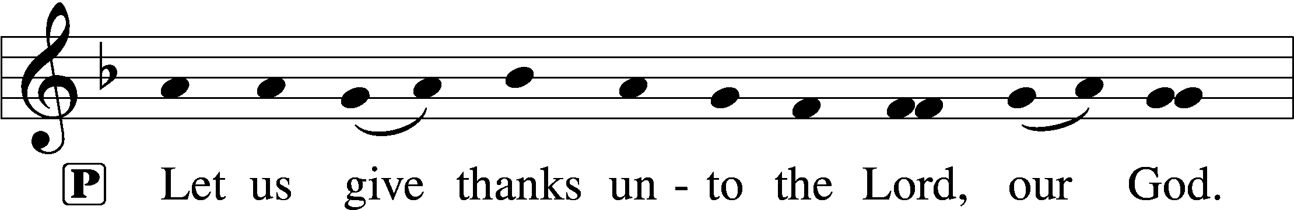
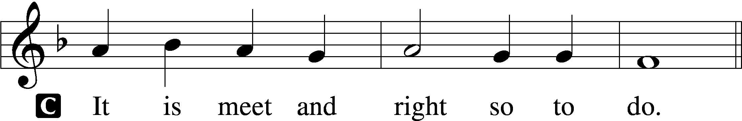

Proper Preface (Full)
P It is truly meet, right, and salutary that we should at all times and in all places give thanks to You, holy Lord, almighty Father, everlasting God, through Jesus Christ, our Lord, who, out of love for His fallen creation, humbled Himself by taking on the form of a servant, becoming obedient unto death, even death upon a cross. Risen from the dead, He has freed us from eternal death and given us life everlasting. Therefore with angels and archangels and with all the company of heaven we laud and magnify Your glorious name, evermore praising You and saying:

Sanctus Isaiah 6:3; Matthew 21:9 LSB 195
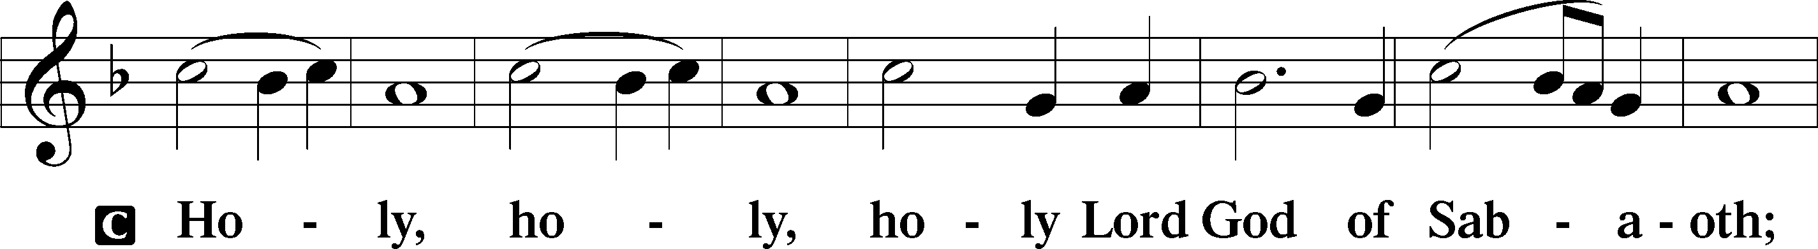
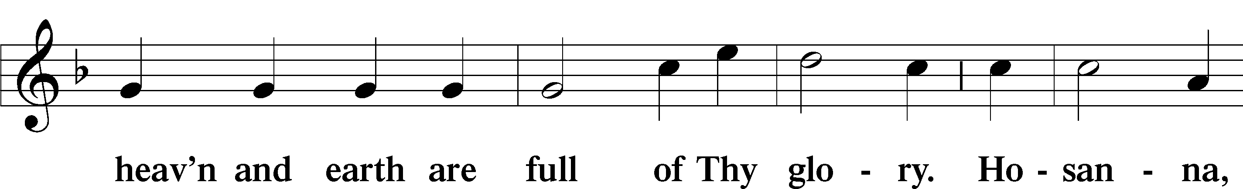
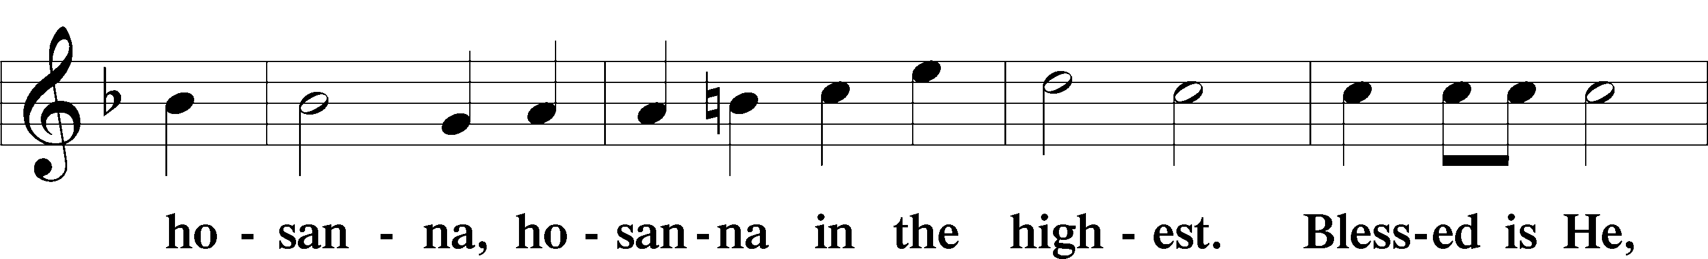
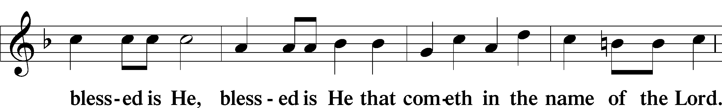
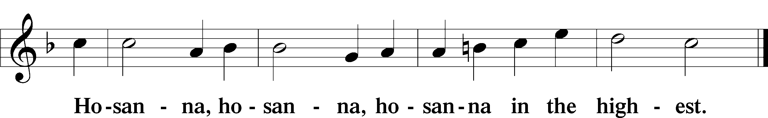

Lord’s Prayer Matthew 6:9–13 162
P Lord, remember us in Your kingdom and teach us to pray:
C Our Father who art in heaven,
hallowed be Thy name,
Thy kingdom come,
Thy will be done on earth
as it is in heaven;
give us this day our daily bread;
and forgive us our trespasses
as we forgive those
who trespass against us;
and lead us not into temptation,
but deliver us from evil.
For Thine is the kingdom
and the power and the glory
forever and ever. Amen.

The Words of Our Lord
P Our Lord Jesus Christ, on the night when He was betrayed, took bread, and when He had given thanks, He broke it and gave it to the disciples and said: “Take, eat; this is My T body, which is given for you. This do in remembrance of Me.”

In the same way also He took the cup after supper, and when He had given thanks, He gave it to them, saying: “Drink of it, all of you; this cup is the new testament in My T blood, which is shed for you for the forgiveness of sins. This do, as often as you drink it, in remembrance of Me.”

Pax Domini John 20:19 197
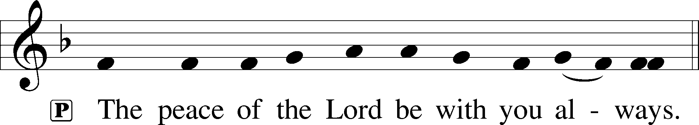

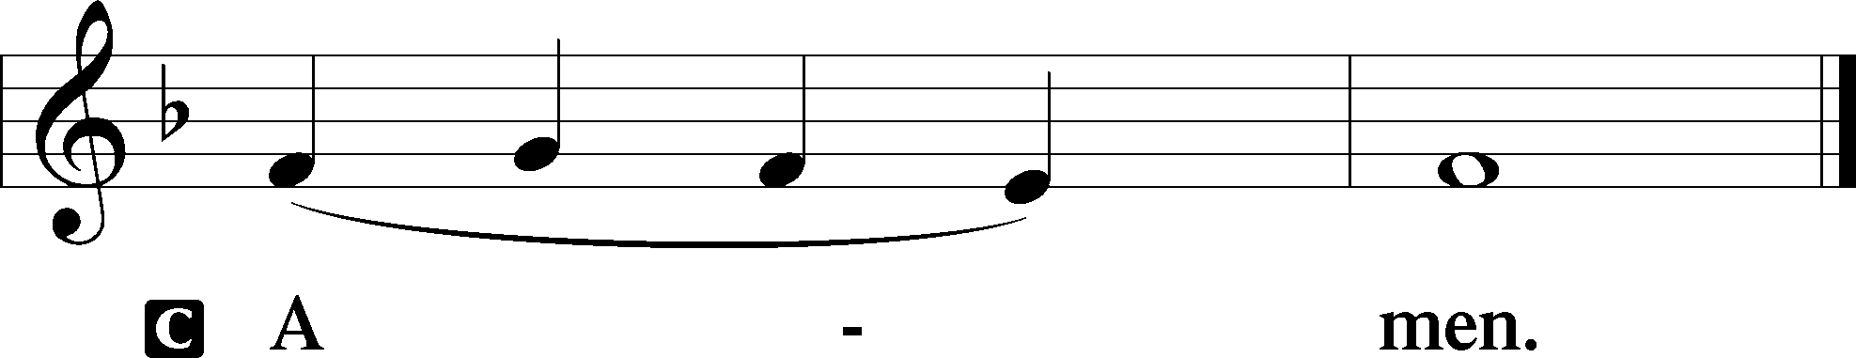

Agnus Dei John 1:29 LSB 198
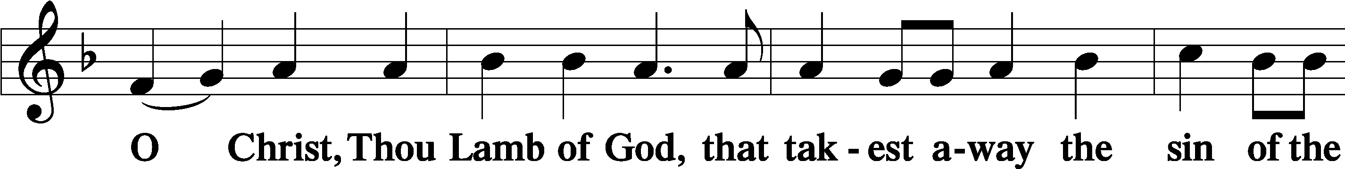
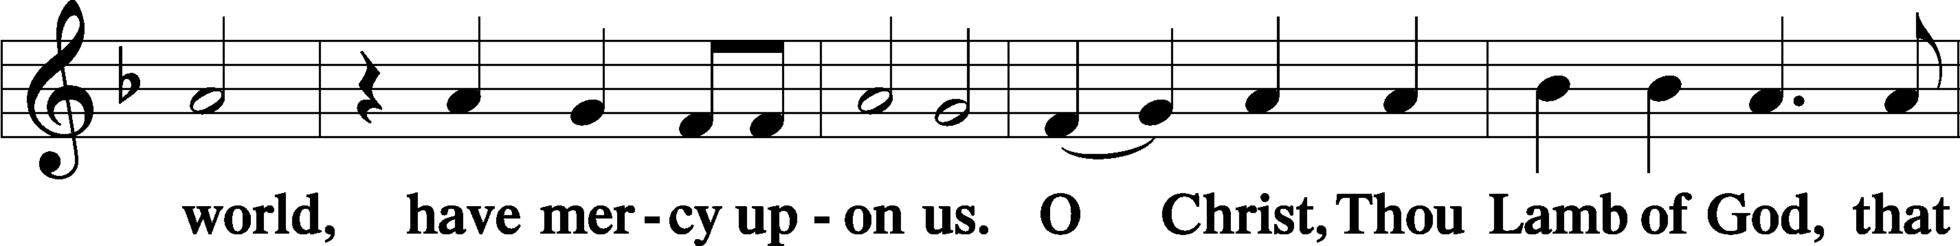
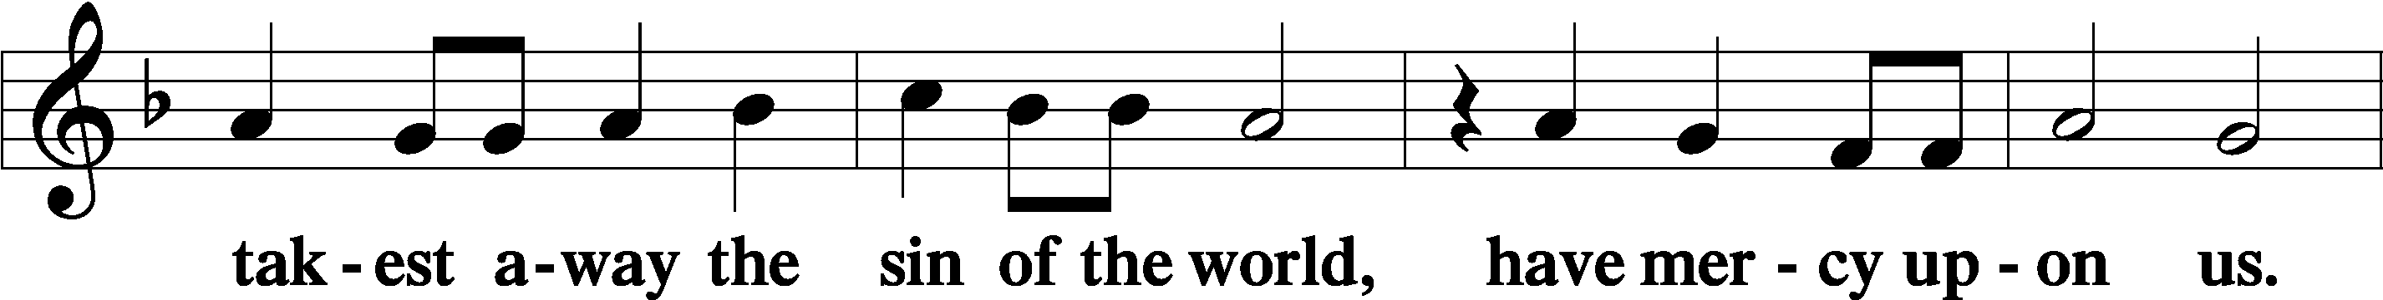
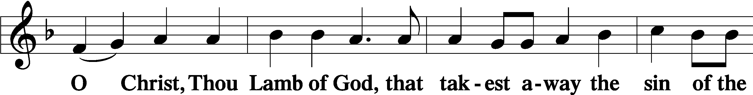
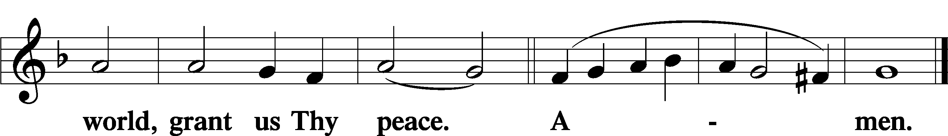
Sit
Distribution

Distribution Hymn:
Draw Near and Take the Body of the Lord LSB 637
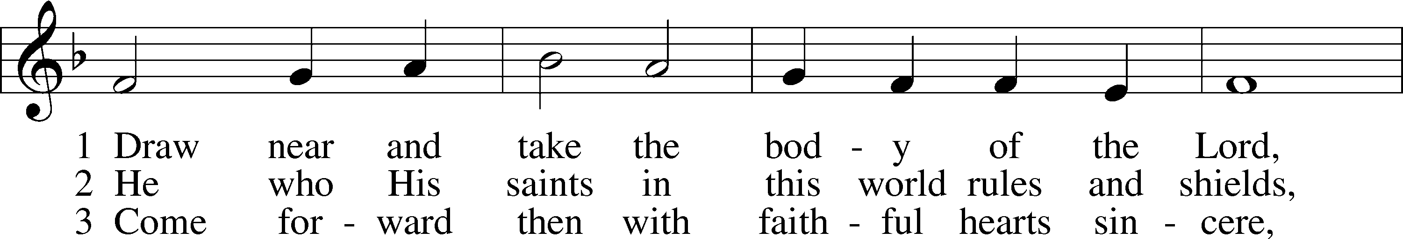
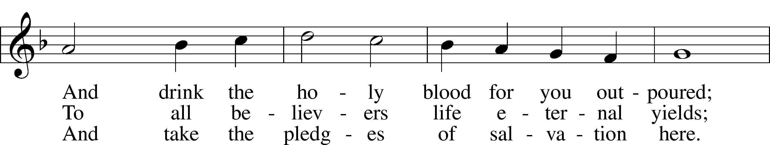
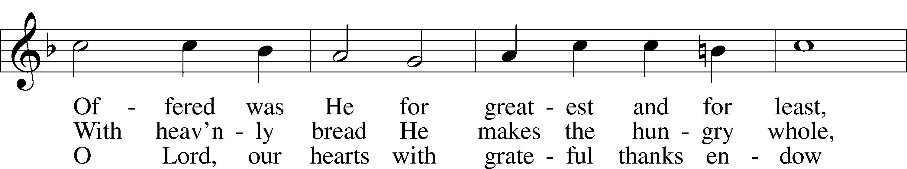
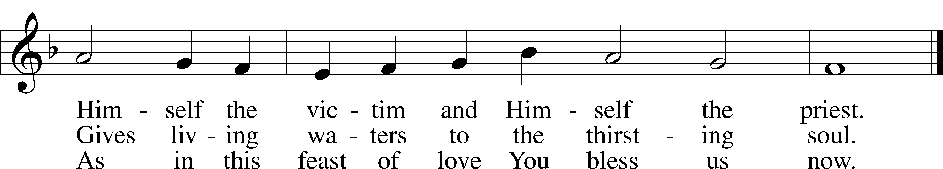
Text: Latin, 7th cent.; tr. John Mason Neale, 1818–66, alt.
Tune: Trente quatre Pseaumes de David, 1551, Geneva, ed. Louis Bourgeois
Text and tune: Public domain

Distribution Hymn: Children of the Heavenly Father LSB 725
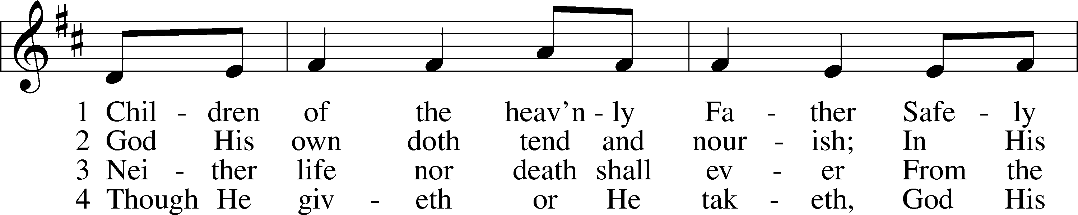
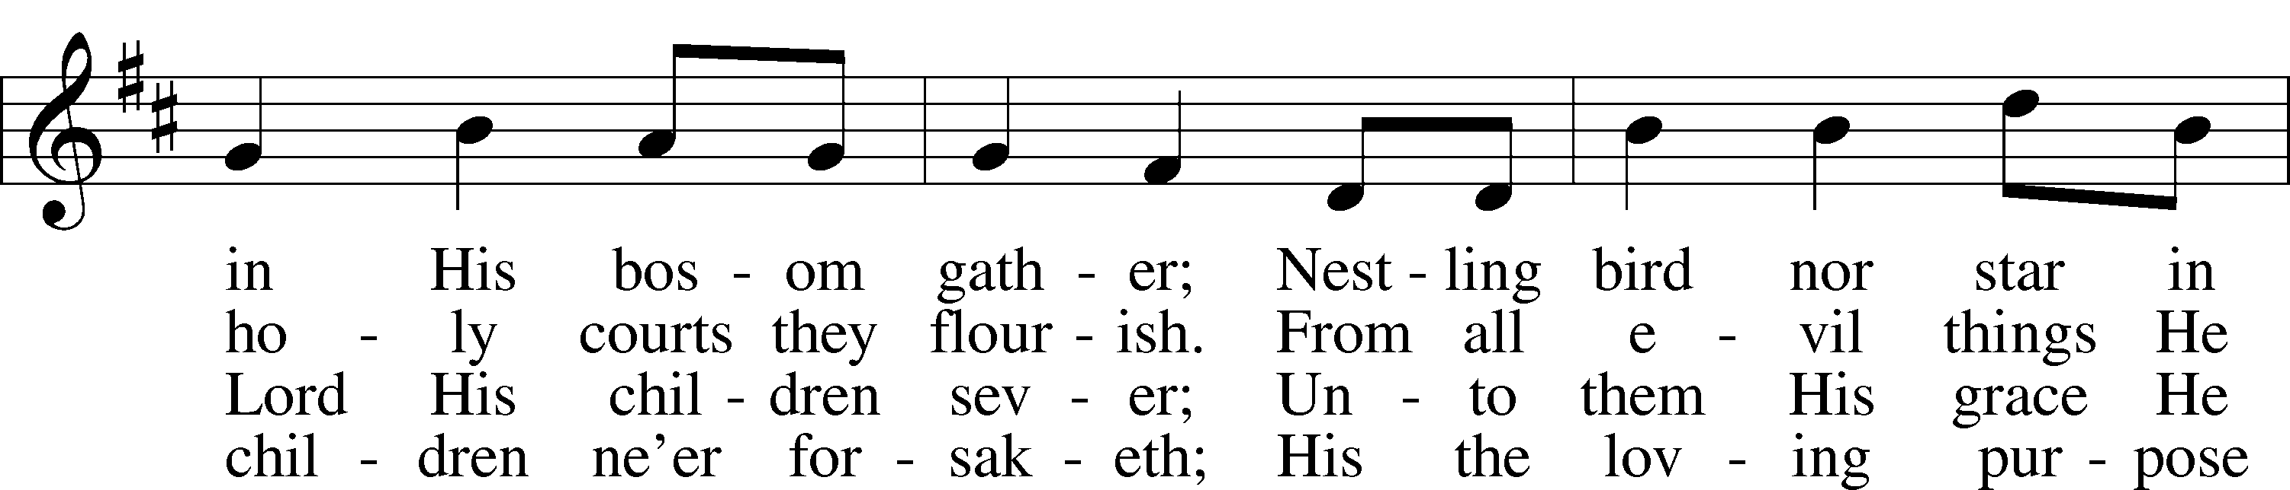
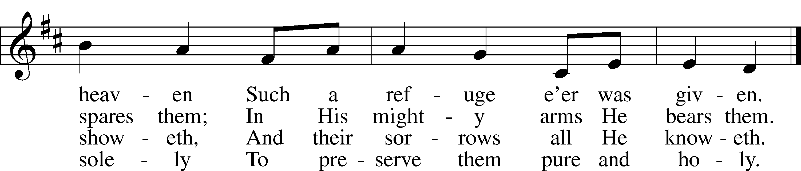
Text: Carolina Sandell Berg, 1832–1903; tr. Ernst W. Olson, 1870–1958
Tune: Lofsånger och andeliga wisor, 1873, Sweden
Text: Public domain
Tune: Public domain

Distribution Hymn: Where Charity and Love Prevail LSB 845
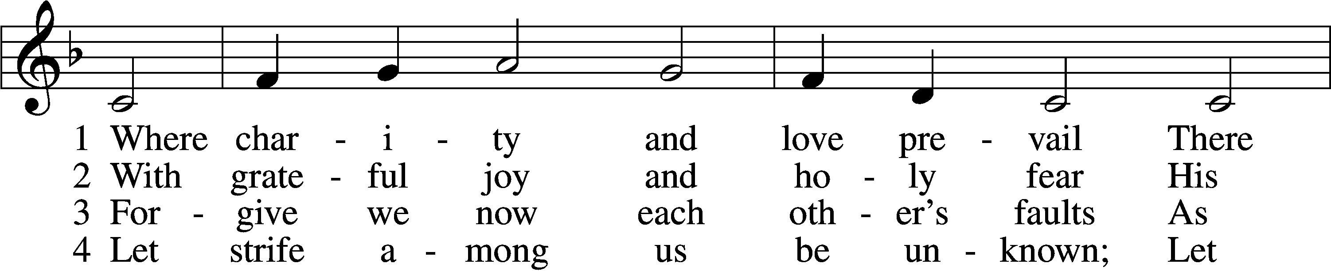
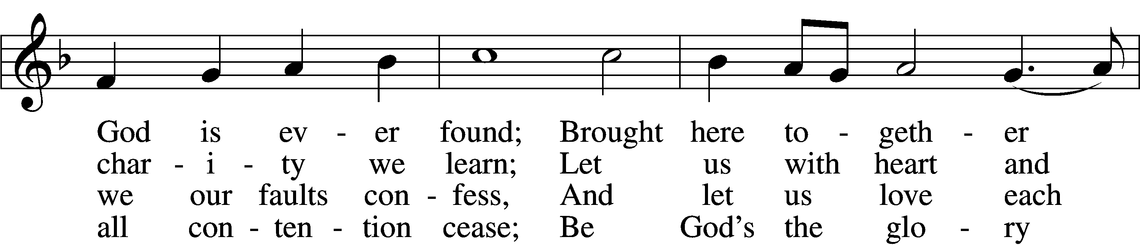
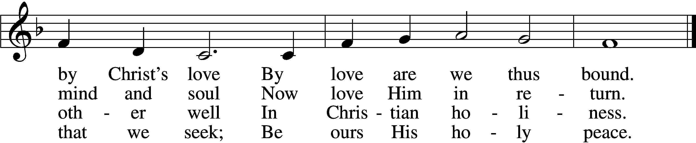

5 Let us recall that in our midst
Dwells Christ, His only Son;
As members of His body joined
We are in Him made one.
6 For love excludes no race or clan
That names the Savior’s name;
His family embraces all
Whose Father is the same
Text: Latin, c. 9th cent.; tr. Omer E. Westendorf, 1916–97, alt.
Tune: Lucius Chapin, 1760–1842
Text: © 1960 World Library Publications. Used by permission: LSB Hymn License no. 110004522
Tune: Public domain

Stand
The Dismissal 199
P The body and blood of our Lord Jesus Christ strengthen and preserve you in body and soul to life everlasting. Depart T in peace.
C Amen.

Nunc Dimittis Luke 2:29–32 LSB 199
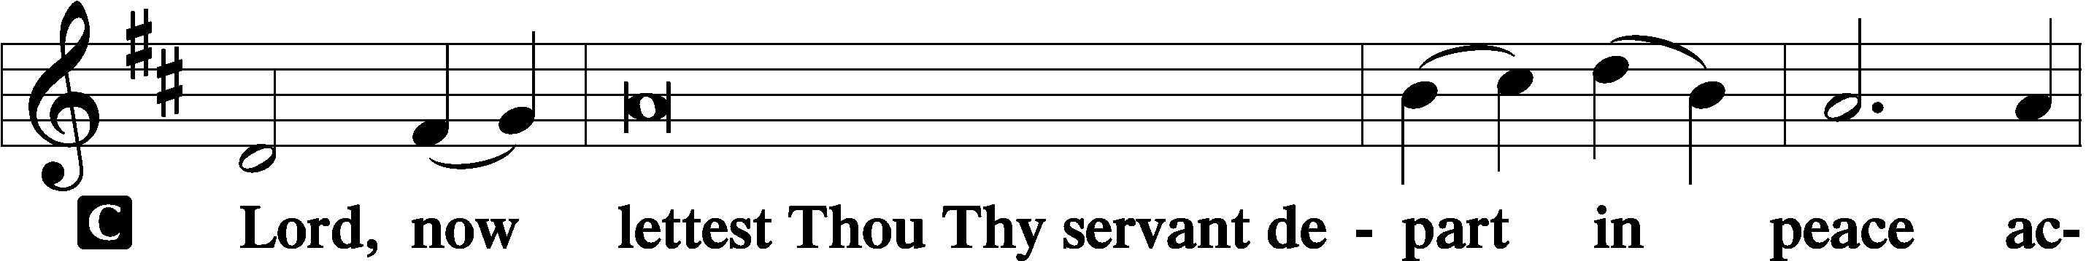

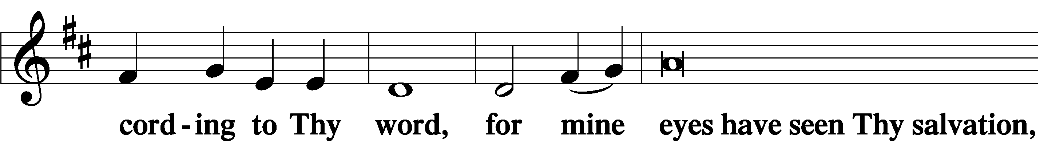

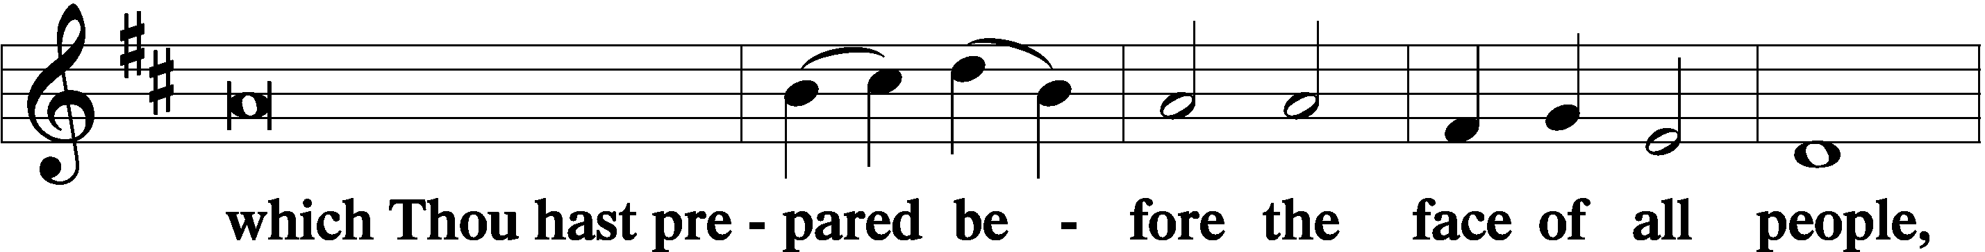

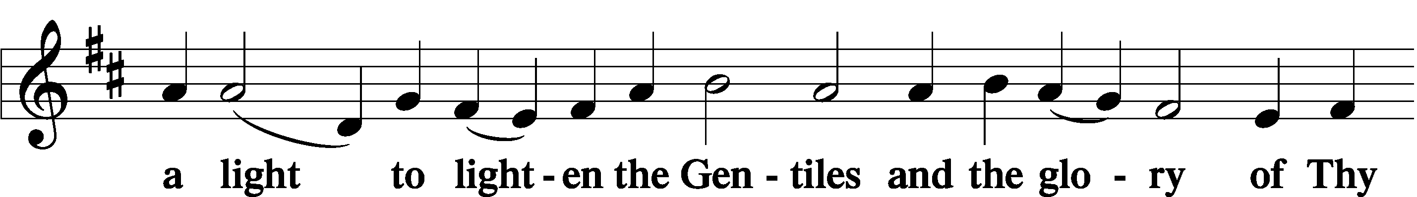

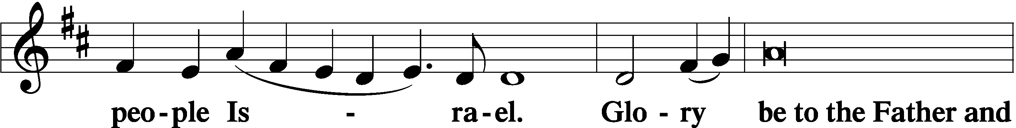

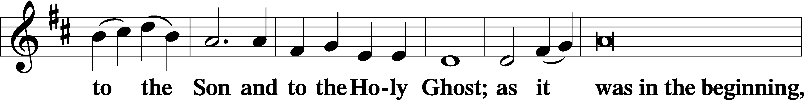

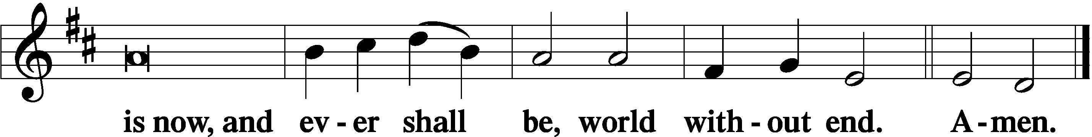

Thanksgiving Psalm 107:1 LSB 200
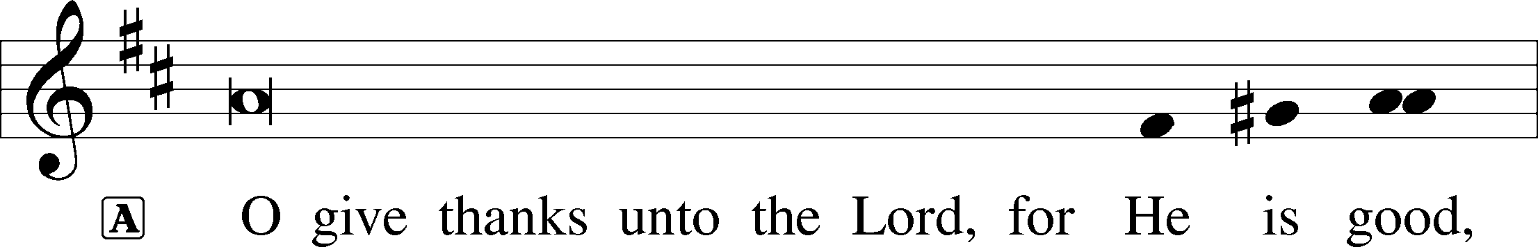

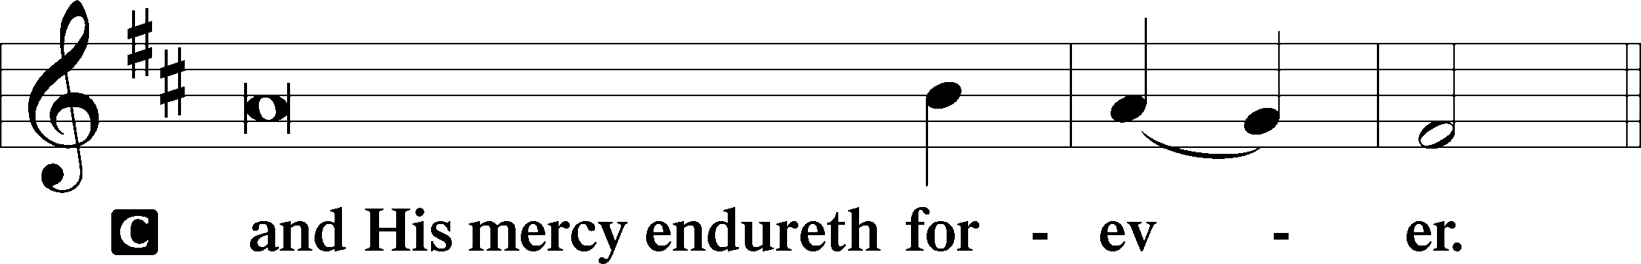

Post-Communion Collect
A Let us pray.
We give thanks to You, almighty God, that You have refreshed us through this salutary gift, and we implore You that of Your mercy You would strengthen us through the same in faith toward You and in fervent love toward one another; through Jesus Christ, Your Son, our Lord, who lives and reigns with You and the Holy Spirit, one God, now and forever.

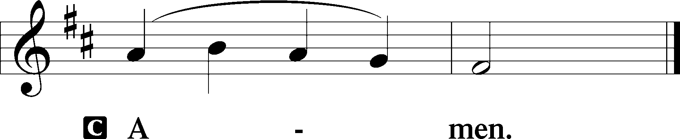

Salutation 2 Timothy 4:22 LSB 201
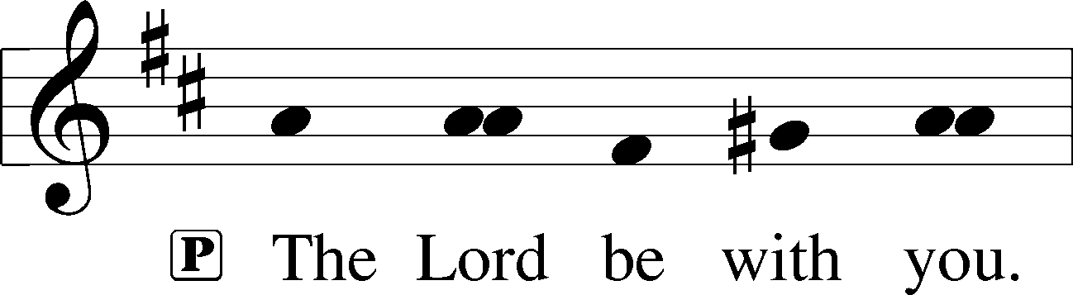

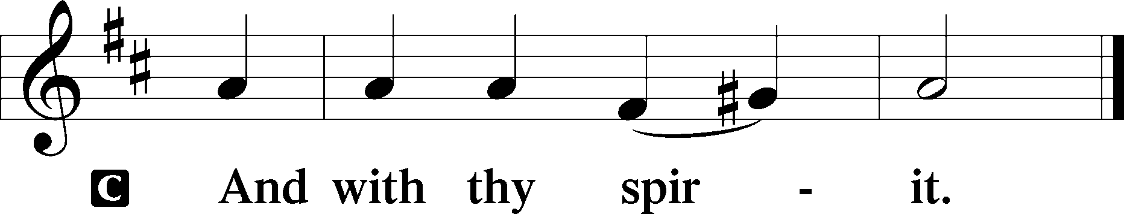

Benedicamus Psalm 103:1 LSB 202
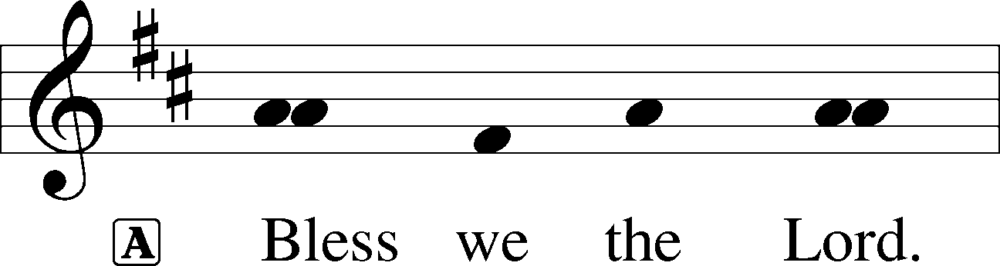

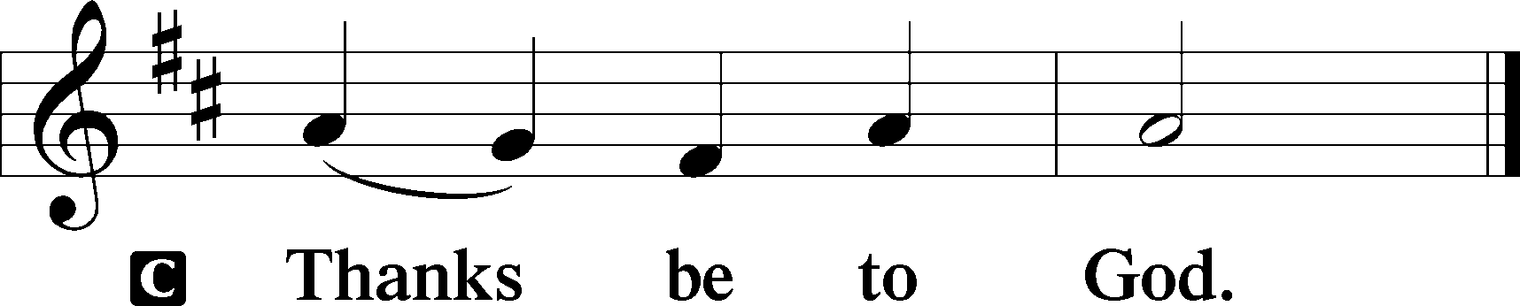

Benediction Numbers 6:24–26 LSB 202
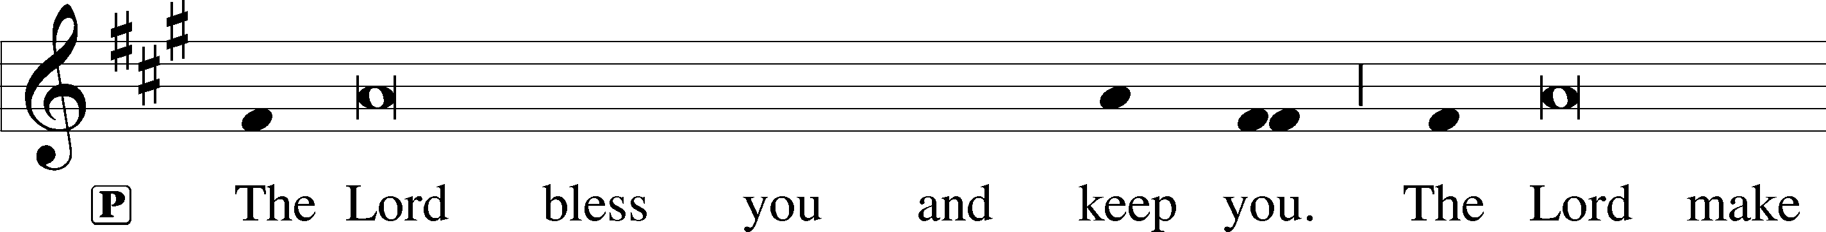
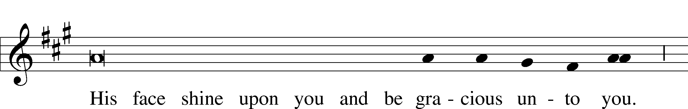
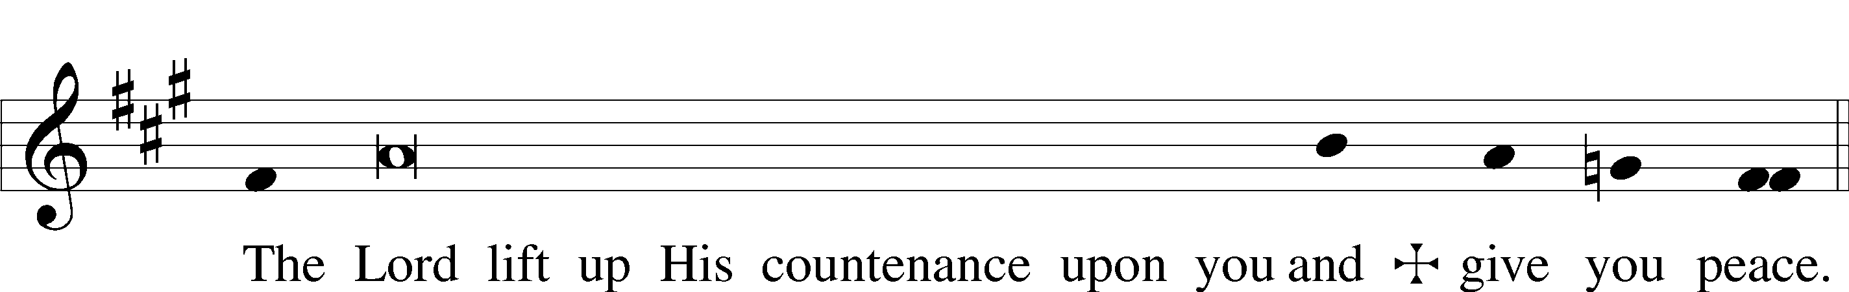

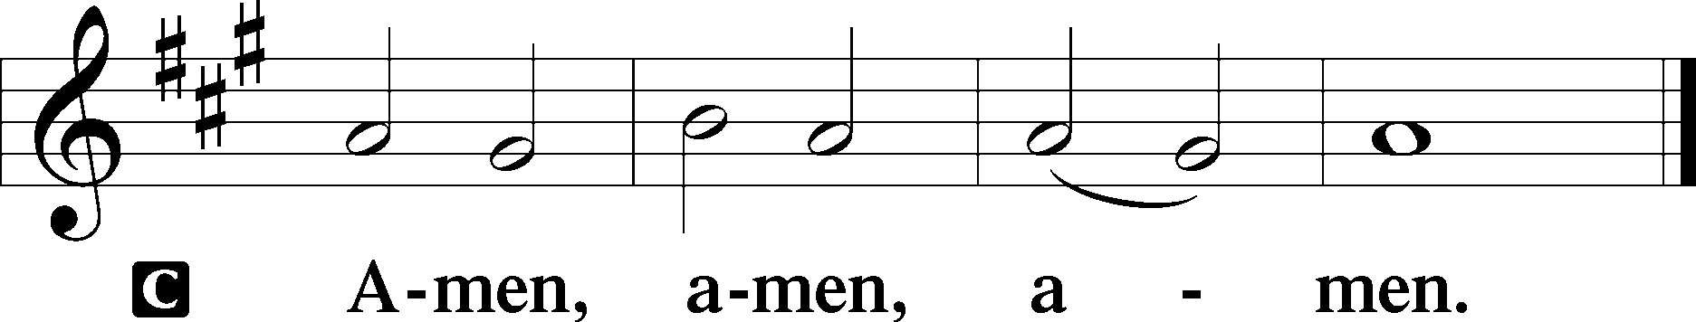

Closing Hymn: Lord of Glory, You Have Bought Us LSB 851
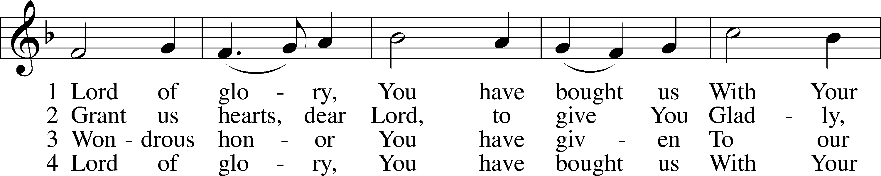
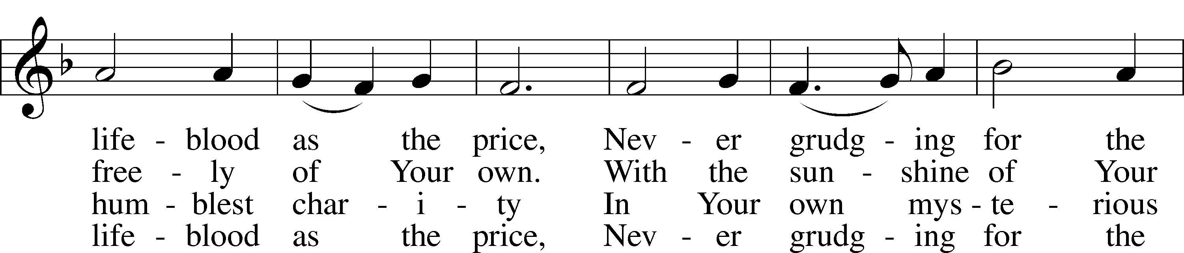
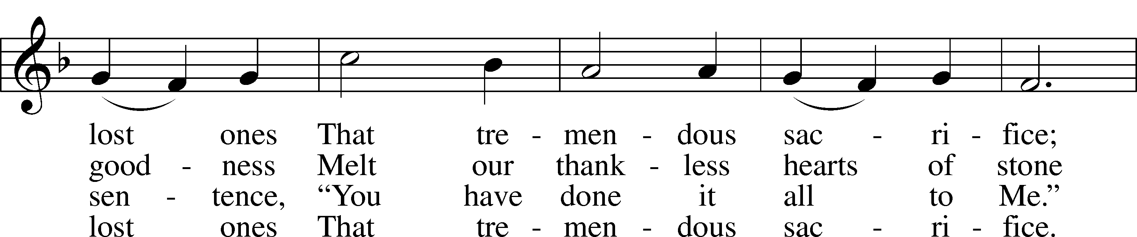
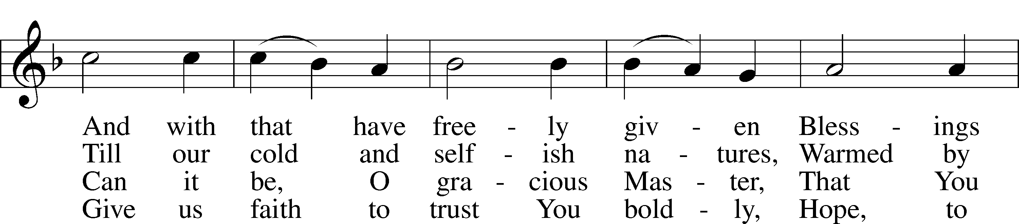
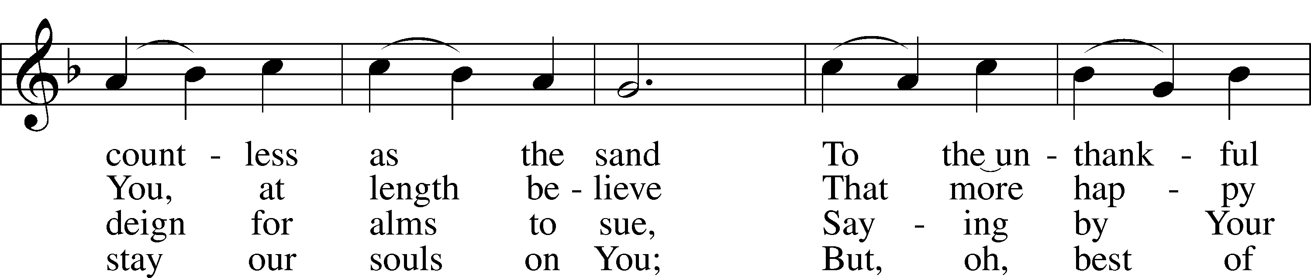
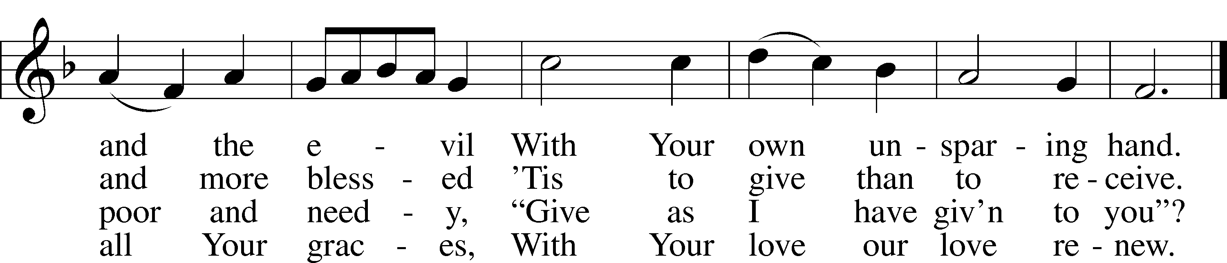
Text: Eliza S. Alderson, 1818–89, alt.
Tune: Rowland H. Prichard, 1811–87
Text and tune: Public domain

Acknowledgments
Unless otherwise indicated, Scripture quotations are from the ESV® Bible (The Holy Bible, English Standard Version®), copyright © 2001 by Crossway, a publishing ministry of Good News Publishers. Used by permission. All rights reserved.
Created by Lutheran Service Builder © 2024 Concordia Publishing House.
THIS WEEK AT ST. PAUL

ONE WORSHIP SERVICE
Today 8:00 AM Worship Service
Today 9:00 AM Coffee Fellowship
Today 9:15 AM Sunday School
Today 9:30 AM Bible Study
Today 10:30 AM Worship Service
Today 11:30 AM Adult Confirmation Instruction
Today 12:00 – 2:00 PM Walk-in Communion
Monday 6:30 – 8:00 PM Youth Night: Scouts
Tuesday NO Walk-in Communion
Wednesday NO Bible Study

+JOYCE MINICH + A funeral service will be held for Joyce Minich, wife of Gary, at Prince of Peace Lutheran, 335 Medina Road, Medina on Saturday, October 5th at 11:00am with luncheon to follow. Friends from St. Paul are invited to attend.

- - - - - - - - - - - - - - - - - - - - - - - - - - - - - - - - - - - - - - - - - - - - - - - - - - - - - - - - - - - - - - -

HYGIENE KITS LWML is collecting items for 100 hygiene kits. The collection box and information can be found at the welcome center.

LUTHERAN CYCLING FRIENDS On Saturday, September 28 at 9:15am, we will ride on the Holmes County Trail to help support the Fredericksburg Community Library in the 20th Annual Library Roll. The cost is $35. Download the registration form which must be mailed in from their website, fredlib.org. Ask Walter Dill for more details about these rides or any of the other rides which may be found on the calendar in the hallway.

OAKS FAMILY CARE CENTER 3rd Annual Soup Cook Off Fundraiser – An evening of helping families! Saturday, October 12, 2024 5:30 - 8:00pm, Comfort Suites, Brunswick. Live dessert auction after the dinner. Space is limited, tickets are $15.

LWML LADIES LUNCH LWML is providing a Salad Lunch for all Ladies at noon on October 13, 2024 here at St. Paul. Please sign up at the Welcome Center so we know how many will be expected.

- - - - - - - - - - - - - - - - - - - - - - - - - - - - - - - - - - - - - - - - - - - - - - - - - - - - - - - - - - - - - - -

PASTORAL CARE Should you desire pastoral care, please contact the church office 330.483.3883, or 330.483.4119 and leave a message for Pastor.

COMMUNION OPPORTUNITIES Pastor is providing individual communion opportunity for the foreseeable future. Check the posted times for “walk-in” communion below.
“Walk-In” times at Church: Sundays, 12:00 – 2:00pm & Tuesdays, 5pm - 7pm
Scheduling an appointment for communion at church or in your home:
To schedule a time other than the walk-in times you may call Pastor Zielinski at 440-458-0189 or, visit www.spvc.org and click “Book with Pastor” to see available times for appointments.

TITHES & OFFERINGS are needed; our Lord still provides for us and we return to Him a portion of His generosity. You have several ways to continue contributing:
1. In-person Worship on Sundays at 9:30 AM
2. Mail your contributions to the church.
3. Talk to your bank about "bill-pay” options. They can likely send a check directly
to the church on a scheduled basis.
4. Visit www.spvc.org and click on “Give Online” - you’ll be taken to our secure
online giving site where you can make a one-time or on-going contribution.

PRAYER REQUESTS – To submit a prayer request or join the Prayer Chain, visit our website, spvc.org under Prayer. You can also do both by filling out the back side of the attendance slip or sending an email to prayer@spvc.org.

WATCH WORSHIP LIVE OR ON-DEMAND 9:30 AM on Sundays, or on-demand at YouTube, Facebook, or www.spvc.org – on the homepage is a viewer for the livestream (when active) and for the most recent service. Bulletins are available via the link. Select the bulletin for the date of the service you are watching.

IN-PERSON SUNDAY BIBLE CLASS watch LIVE or On-Demand just like our worship services (YouTube, Facebook, or www.spvc.org) on Sunday mornings at 8:00 AM.

- - - - - - - - - - - - - - - - - - - - - - - - - - - - - - - - - - - - - - - - - - - - - - - - - - - - - - - - - - - - - - -

ONLINE DIRECTORY UPDATE If your mobile app needs updated and it’s asking for an “online code” please use “SPVC” and that should reconnect the app.

SUPPORT FOR UKRAINE, ISRAEL & FOREIGN MISSIONS We continue to take offerings to provide relief to Lutheran church partners who suffer calamity in these areas. Thank you to everyone who has shown their generosity.

PORTALS OF PRAYER The 2024 July-Sept devotion booklets are available on the Welcome Table and in the Narthex hallway, please take a copy home today.

LUTHERAN HOUR MINISTRIES offers a wonderful daily devotion with Scriptures & Reflection Questions. Go to www.lhm.org and click on Today’s Devotion.

HEARING AIDS? Do you wear hearing aids? If they’re able to connect to your phone we have an app to help you hear the spoken-word parts of the worship service (readings, prayers, sermon, etc.). Download the “Audiofetch” app then connect to the “Audiofetch” wifi here at church. See Rev. Streeper if you need help getting set up.

HEALTH & SAFETY There is a black First Aid bag hung in the vestibule containing emergency supplies. Some of the contents include bandages, instant glucose, breathing barriers, and blood pressure equipment. Please see Beth Bremke if you would like training in the use of these supplies.

WIGGLE BAGS Please help yourself to these goody bags that hold activities kids may engage and participate in the worship service. Hopefully this will help alleviate stress for parents who are worried about their child making it through the whole service, but more importantly, they help teach kids that “big church” is for them too. Please take a moment to collect all the contents of the Wiggle Bags and return it to the “Used Wiggle Bag” plastic bin after the Worship Service. We continue to be thankful for Sandy Turner, Jean Wadle and the others who are keeping up with providing clean Wiggle Bags each week. Donated supplies may be given to Sandy or Jean. Thank you.

RECYCLING BULLETINS You are encouraged to take your worship bulletins home with you to use the scriptures, hymns and prayers for your own devotions and to be able to refer to the updated schedule and announcements. If you would like, you may drop regular and large print bulletins in the blue recycle bin in the Narthex hallway upon exiting the service. Please remember, the recycle bin is only for bulletin materials. Thank you, we do recycle the black combs for the Large Print bulletins!

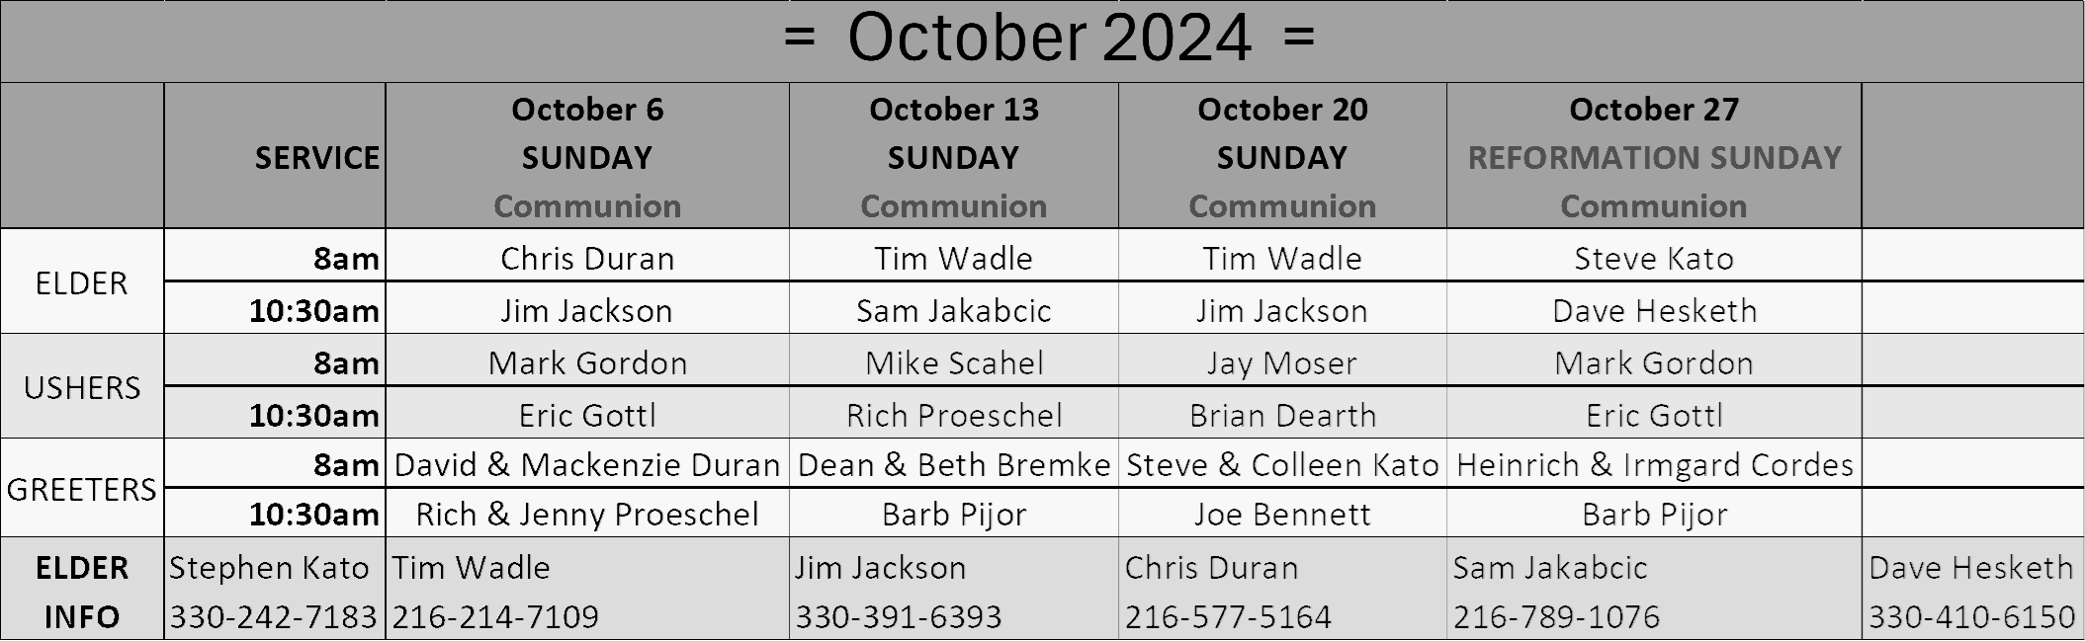
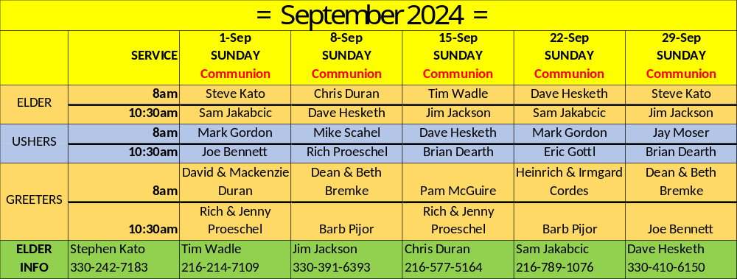

Prayers for Worship
On entering a church
Lord, I love the habitation of Your house and the place where Your glory dwells. In the multitude of Your tender mercies prepare my heart that I may enter Your house to worship and confess Your holy name; through Jesus Christ, my God and Lord. Amen.

Before worship
O Lord, my creator, redeemer, and comforter, as I come to worship You in spirit and in truth, I humbly pray that You would open my heart to the preaching of Your Word so that I may repent of my sins, believe in Jesus Christ as my only Savior, and grow in grace and holiness. Hear me for His sake. Amen.

After worship
Almighty and merciful God, I have again worshiped in Your presence and received both forgiveness for my many sins and the assurance of Your love in Jesus Christ. I thank You for this undeserved grace and ask You to keep me in faith until I inherit eternal salvation; through Jesus Christ, my Lord. Amen.

Before confession and absolution
Almighty, everlasting God, for our many sins we justly deserve eternal condemnation. In Your mercy You sent Your dear Son, our Lord Jesus Christ, who won for us forgiveness of sins and everlasting salvation. Grant us a true confession that, dead to sin, we may be raised up by Your life-giving absolution. Grant us Your Holy Spirit that we may be ever watchful and live true and godly lives in Your service; through Jesus Christ, our Lord.

Before communing
Dear Savior, at Your gracious invitation I come to Your table to eat and drink Your holy body and blood. Let me find favor in Your eyes to receive this holy Sacrament in faith for the salvation of my soul and to the glory of Your holy name; for You live and reign with the Father and the Holy Spirit, one God, now and forever. Amen.

Thanksgiving after receiving the Sacrament
Almighty and everlasting God, I thank and praise You for feeding me the life-giving body and blood of Your beloved Son, Jesus Christ. Send me Your Holy Spirit that, having with my mouth received the holy Sacrament, I may by faith obtain and eternally enjoy Your divine grace, the forgiveness of sins, unity with Christ, and life eternal; through Jesus Christ, my Lord. Amen.

For blessing on the Word
Lord God, bless Your Word wherever it is proclaimed. Make it a word of power and peace to convert those not yet Your own and to confirm those who have come to saving faith. May Your Word pass from the ear to the heart, from the heart to the lip, and from the lip to the life that, as You have promised, Your Word may achieve the purpose for which You send it; through Jesus Christ, my Lord. Amen.

