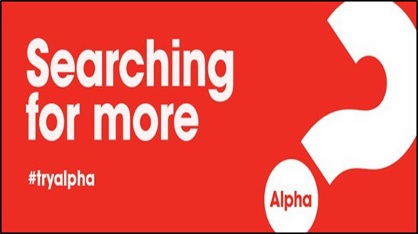

Alpha Guest Sign-up Sheet
Sunday  6:30-8:30 PM | Wednesday  7:00-9:00 PM | Topic
Welcome Luncheon 12:15 PM | Sept. 15 Both sessions | Is There More to Life Than This?
Session 2  Sept. 22 | Session 2  Sept. 18 | Who is Jesus?
Session 3  Sept. 29 | Session 3  Sept. 25 | Why did Jesus die?
Session 4  Oct. 6 | Session 4  Oct. 2 | How can we have faith?  Why & how do I pray?
Session 5  Oct. 13 | Session 5  Oct. 9 | Why & how should I read the Bible?
Session 6  Oct. 20 | Session 6  Oct. 16 | How does God guide us?
Day Away  Oct. 19 | Day Away  Oct. 19 | Alpha Day Away  8:30 AM-4 PM
Session 7  Oct. 27 | Session 7  Oct. 23 | How can I resist evil?
Session 8  Nov. 3 | Session 8  Oct. 30 | Why & how should we tell others?
Session 9  Nov. 10 | Session 9  Nov. 6 | Does God heal today?
Session 10  Nov. 17 | Session 10  Nov. 13 | What about the Church?
Sun. Nov. 24 | Sun. Nov. 24 | Celebration Dinner  6:30 PM

Alpha is a nine-week course where we are each invited to gather to search for answers and encounter Jesus together.
ALPHA—WHO IS IT FOR?
- for those seeking direction/purpose in life
- for those seeking a relationship with Jesus
- for those seeking a deeper faith life
- for those seeking a way to encourage others on their faith journey
- for YOU

Guests are encouraged to participate in all nine weekly sessions and the Day Away.
Our parish will support the majority of the costs of Alpha, but we need your help. A one-time offering of $40 per participant will help defray the costs of meals and supplies.

“Teaching the faith without having had the encounter with Jesus is like planting seeds in concrete. Alpha is about helping someone encounter Jesus.”
-Father John Riccardo

NAME:
ADDRESS:
CITY/ZIP CODE: | PHONE:
EMAIL:
CHURCH AFFILIATION:
*IS CHILD CARE NEEDED?: | NUMBER OF CHILDREN: AGES:
CHECK SESSION PREFERENCE & ALTERNATE. 1st and 2nd  : | ____ Sunday 6:30 - 8:30PM _____ Wednesday 7:00 - 9:00PM  *Childcare may or may not be offered for all sessions, TBD based on resources and need

Save time and sign up online! http://www.stfrancisparish.net/alpha

