OLSC BBQ’s
Upcoming events:
Event | Day | Minimum volunteers | Notes
Broncos V Dragons | Sunday 31 May | 5 | 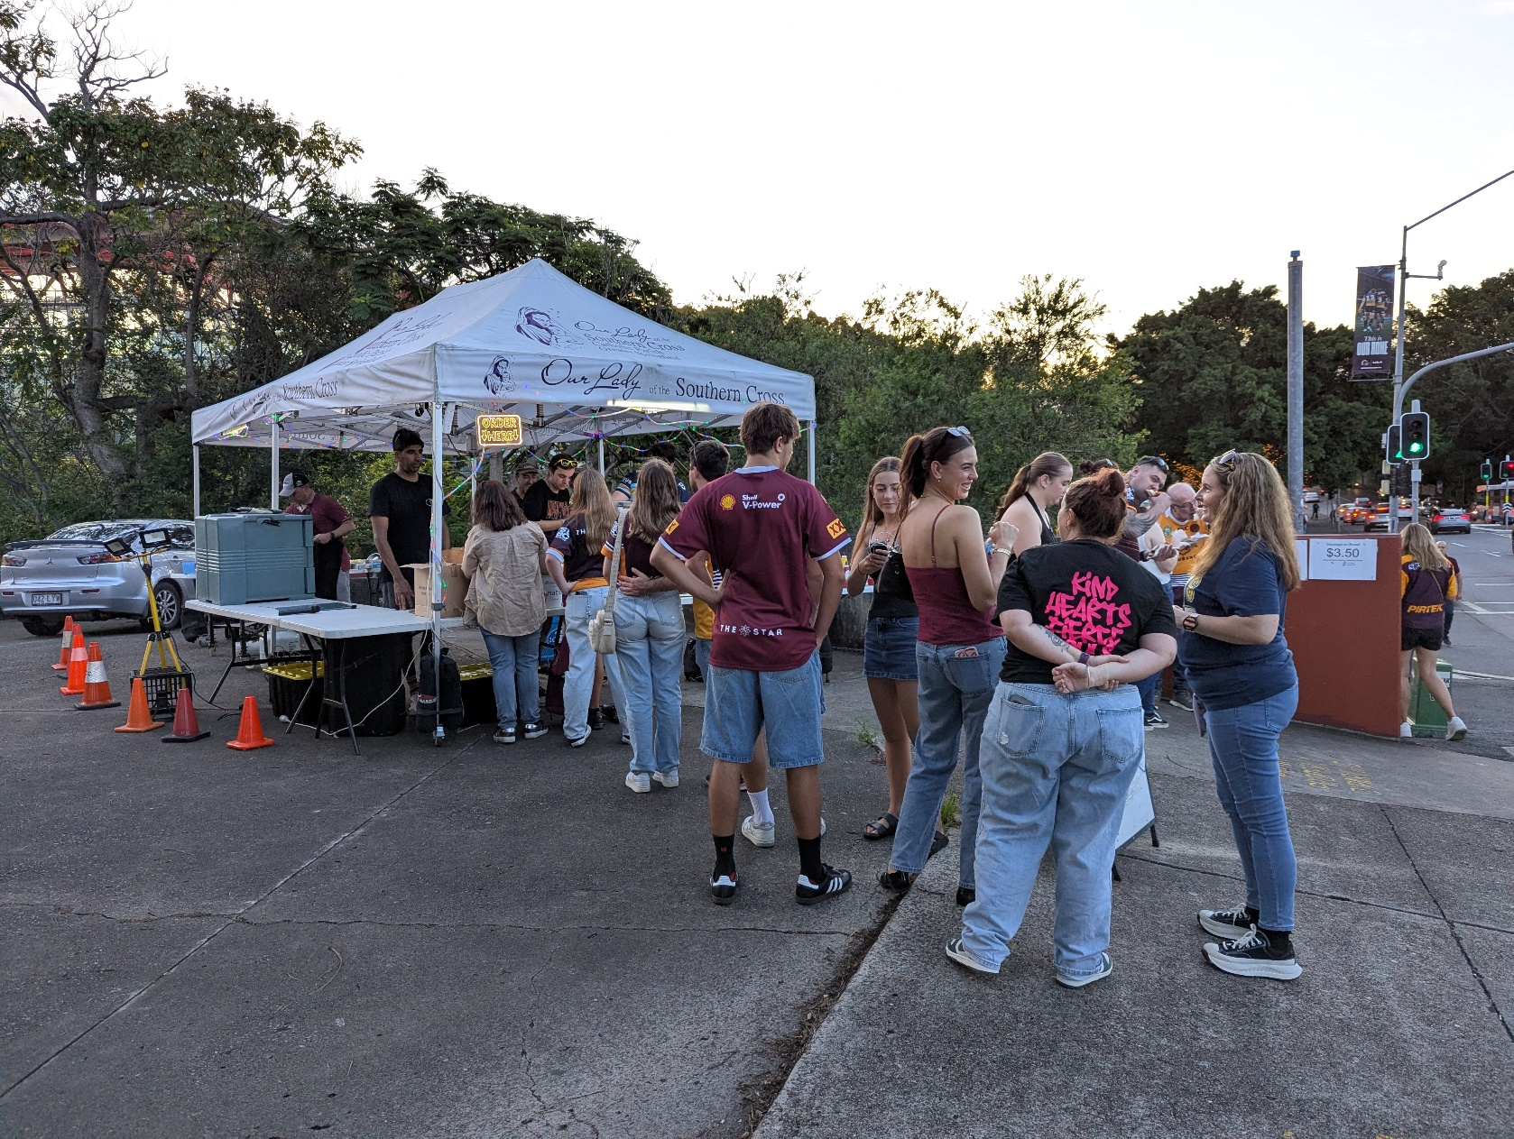  Hopefully busy, many hands make light work
Broncos V Titans | Saturday 6 Jun | 5 | Hopefully busy
Dolphins V Roosters | Friday 12 Jun | 4 | Probably a small sales night, good for new recruits
Broncos V Roosters | Friday 26 Jun | 5 | Hopefully busy
Dolphins V Warriors | Sat 27 Jun | 4
Broncos V Cowboys (Womens)  &  Broncos V Sharks | Sat 4 Jul | 6 | Should be able to have chips for all three of these events,
STATE of ORIGIN | Wednesday 8 July | 12 | Weekdays are difficult, but it is the school holidays
Union: Australia V France | Sat 11 July | 6
- Helps US raise funds outside of the parish
- Helps our FANS get a cheap meal
- Lots of FUN!!

Think you could help?
Contact us: olscbbqs@gmail.com,

