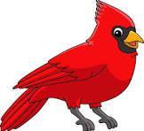 ST. MAXIMILIAN KOLBE SCHOOL
AFTER-SCHOOL ENRICHMENT PROGRAM
Open to All Grades | Fall 2025 Session

📚 ENRICH. EXPLORE. EXCEL
We’re thrilled to offer exciting after-school enrichment opportunities for St. Maximilian Kolbe students in all grades! Each session runs for 5 weeks, held from 3:15–4:15 PM, and is packed with fun, hands-on learning experiences tailored to every age and interest. Programs run based on enrollment. Do not delay…we anticipate max capacity in each program!
There will be three sessions during the school year:
🍁 Fall | ❄️ Winter | 🌸 Spring

🍂 FALL 2025 PROGRAMS
The dates for the Fall Session are: 10/9, 10/16, 10/23, 10/30, 11/6.
Choose from FOUR exciting programs this session:

🎶 MOVING & GROOVING
Instructor: Mrs. Mazurek
Grades: PreK3, PreK4, Kindergarten
A playful movement and music class using rhythm sticks, egg shakers, yoga, and mindfulness exercises. Great for developing coordination and calm!

🌍 WORLD CULTURE CLUB
Instructor: Mrs. Yoder
Grades: 4th–8th
Travel the globe each week! Explore world cultures through food, music, games, crafts, and language. Make your own country flag and learn a phrase in a new language!

📖 THE CARDINALS READING NEST
Instructor: Mrs. Sees
Grades: 1st–3rd
A cozy reading club where young readers grow their love for books! Enjoy independent and group reading, partner activities, games, and fun strategies to boost reading confidence and comprehension.

📣 CHEERLEADING CLUB
Instructor: Mrs. Marker
Grades: Kindergarten–4th
Bring the school spirit! Learn basic cheer skills, chants, teamwork, and a short dance routine in a fun, energetic environment.

💵 COST & REGISTRATION
Program Fee: $75 per child, per program
To register, please complete the Google Form linked below.
🔗 CLICK HERE TO REGISTER
📬 Send Payment To:
St. Maximilian Kolbe School
Envelope labeled: Enrichment Program c/o Stephanie Sees
Child’s First & Last Name/Grade
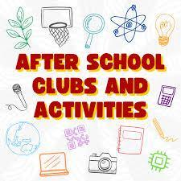
Venmo: @stmaxcardinals memo: afterschool enrichment program
✅ Checks Payable To: St. Maximilian Kolbe School
📅 Deadline: Friday, October 3rd

