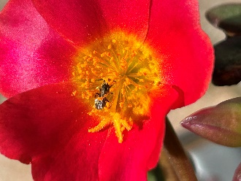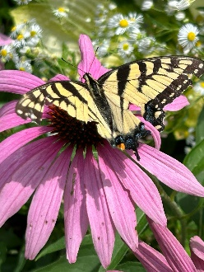
2024 Annual EcoPhilly Conference

Concerned about pollution, endangered species, climate change, environmental justice?
Interested in Creation Care and steps you can take to help?
EcoPhilly is a group of volunteers working with the Catholic Archdiocese of Philadelphia to help parishes, schools and universities follow biodiversity-boosting, sustainable practices as outlined in Pope Francis’ encyclical Laudato Si’. EcoPhilly has the blessing and support of the Archbishop, the Most Reverend Nelson J. Pérez.
On Saturday February 24th, EcoPhilly will be holding its annual meeting. All are encouraged to attend. Come and listen to groups from the greater Philadelphia area share their challenges and successes… lobby for state and city level initiatives … learn more about conserving energy and enhancing biodiversity …and more!
The event will take place in Harten Hall, below the St. Thomas of Villanova Chapel in Rosemont. The address is 1229 E. Lancaster Ave., Rosemont PA 19010 – please note that GPS will sometimes re-address this as Bryn Mawr. It is opposite a Sunoco gas station.
Register now – it’s free! Let us know how many people will be attending, and whether you will be stopping for lunch. Register via Mail EcoPhilly now! Call John Humphreys on 610-766-1125 if you have questions.

