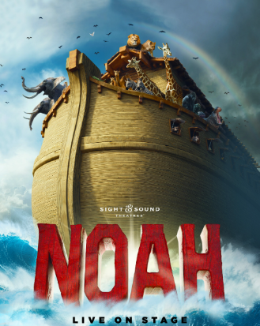
St. Maximilian Kolbe Church
and Touriffic Travel present
“NOAH” - Sight & Sound Theatre - Lancaster, Pa
Friday, December 12, 2025

All aboard the ark. With a catastrophic storm on its way, Noah
is given a monumental task: build a boat big enough to save his family from a flood that will cover the entire earth. As Noah endeavors to live faithfully in the midst of an increasingly chaotic world, can he trust that God’s promises run deeper than the rising waters around him? Returning for one season only, this landmark production takes you on board one of the world’s best-known voyages as live animals fill the stage and aisles. Set sail inside the enormous ark as this extraordinary story comes to life in this special 30th anniversary season!

Daytrip Itinerary:
8:45am Depart St. Maximilian Kolbe Church back parking lot via deluxe Motor coach
(Arrive by 8:15 am please.).
10:15am Arrive at Sight & Sound Theatre.
Take your Preferred reserved seat to NOAH
11:00am Show begins.
1:45pm Approximate Departure from theatre
2:30-4pm Enjoy a delicious and Family-style Lunch at the Fulton Steamboat Restaurant.
5:30pm (Approx.) Return to St. Maximilian Church
$220.00 per person

For Reservations, please contact contact Denise Pizzino 610-331-9896 * deepizzino@icloud.com
Please make check payable to: St. Maximilian Kolbe Church and remit with coupon
TO: Kolbe Club @ St. Maximilian Kolbe Parish, 15 East Pleasant Grove Road, West Chester, PA 19382
Do not miss out. . . Book early!.
Booking Information: Payment is due as soon as possible to confirm your seat. Reservation and payment is due by
October 27, 2025." No refunds for cancellations unless a replacement is made. Times are approximate and subject to slight change. The price is based on a minimum of 40 persons. Touriffic Travel, their employees, representatives and suppliers act solely as agents in arranging for transportation and other services and do not assume any liability whatsoever for injury, illness, damage, loss, accident or delay due to any act, negligence or default of any company or person engaged in rendering any services for any tour.
--------------------------------------------------------------------------------------------------------------------------------------------------------------------------------St. Maximilian Church/Touriffic Travel/NOAH Sight & Sound/12-12-25

Name(s): _______________________________________________________ Today’s Date______________
Address: _________________________________________________________________________________
City, State & Zip: ________________________/_____/___________
Phone ( ) ______/_______________ email: _________________________________________________
Emergency Contact: _____________________________Phone ( ) _______/_______________
Traveling With: _________________________________________ Cell #__________________________
Address: __________________________________City, State & Zip ________________/_____/_______
Phone ( ) _______/_______________ email: ________________________________________________
Payment Enclosed $_______________for # ______ (Number of people)

