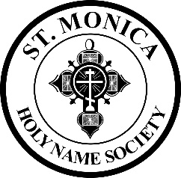

**HOLY NAME SOCIETY AND MEN’S CLUB**

**ST. MONICA CHURCH**

**AGENDA**

**Monday, August 2, 2021 7:30 PM Hagenbach Room**

1. Welcome and Call the Meeting to Order:

New Opening Prayer: “Lord, you have entrusted us as stewards of your creation. As we begin this gathering, we come to you asking for your guidance, wisdom and support. Help us engage in meaningful discussion. Fill us with your grace as we make the decisions that affect us, our family and friends, the people in our neighborhoods, our brothers and sisters in the wider world. Remind us that all that we do here today – all that we accomplish – is for your greater glory, and for the people to whom you send us to serve, Amen”

1. Introduction of New Officers
2. Special Thanks for Previous Officers
3. Approval of the Minutes of the June 7, 2021 Meeting
4. All Back to Mass beginning August 15th (Feast of the Assumption) per Archdiocese
5. Tonight’s Topics:

* 20th Anniversary of St. Monica Feast Day Parish and Community Picnic- Sunday, August 29th
  + Food Preparation/Barbecue
* HNS Brochure-Update with Current Information and Pictures
* Legacy of Life- Security and Lighting
* Membership- Current List of Members, Dues Envelope in September and October Mailing
* Old Business- BINGO Night Report from June 11th
* New Business- Social for Young Married Couples on September 18th
* Nocturnal Adoration-Friday, August 6th and Saturday, August 7th

Member Updates: This is our brief time set aside for members to update or inform our Society on a particularly nice or significant event that has occurred in his life or in the life of someone he knows and wants to share with the group.

Intentions and Closing Prayers

**NEXT MEETING: TUESDAY, SEPTEMBER 2021**