
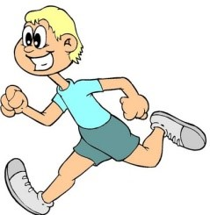 IHM TRACK FALL 2023
CHILDS NAME _____________________________ Parent Email:_______________
ADDRESS: ______________________________Cell Phone: ___________________
SCHOOL: __________________________________ GRADE: __________________
DATE OF BIRTH: ____________________ Size of Shirt: ___ *IHM track athlete can wear IHM gym shorts or any blue shorts with IHM track shirt. Track shirt is given only to new members.
PARENT NAME(S): _____________________________________________________
Can Parent Assist as a Coach: Y/N Manager: Y/N
My family is a registered member of Immaculate Heart of Mary Parish.
I authorize my child to participate in the Immaculate Heart of Mary Parish Cross Country &track program and agree that participation will be in accordance with all CYO and Parish policies, rules and regulations.
DATE: __________________ ________________________________
Signature of Parent or Guardian.
Fee Payable to Immaculate Heart of Mary Track $80 (fall season)
Send to the office, attn. Mrs. G, or bring to practice and hand to our coaches or manager. Last day for submitting registration form and waiver and fee is on September 22.*We are limiting fall season to 30 participants, first come first served.
Practices are on Friday afternoons at Hyatt Field, from 4-5 PM, starting on September 15.
Mail to: IHM Track
201 Boulevard, Scarsdale, NY 10583
Questions? E-mail us at IHMtrack@gmail.com

