Knights of Columbus

Free Throw Competition

Boys and Girls, Ages 9-14

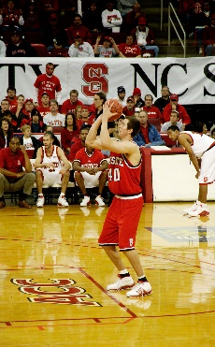

[This Photo](http://en.wikipedia.org/wiki/file:andrew_brackman_basketball_nc_state.jpg) by Unknown Author is licensed under [CC BY-SA](https://creativecommons.org/licenses/by-sa/3.0/)

Sunday, March 2, 2025

3pm – 5pm

Bowie City Gym, Quad 4

4100 Northview Drive, Bowie, MD 20715

(Gym shoes / sneakers required to participate)

Contact Information:

Bill Dziwura, 301-262-7278

Sacred Heart Council 2577