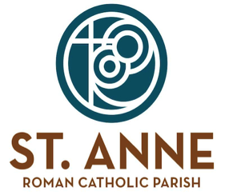
November Confession Changes:

Thursday, Nov. 6, 2025- 10:45 am – CANCELED

Thursday, Nov 27, 2025- 6:00 am- CANCELED
10:45 am- CANCELED
5:00 pm- CANCELED

Friday, Nov. 28, 2025- 6:00 am- CANCELED
10:45 am - CANCELED

