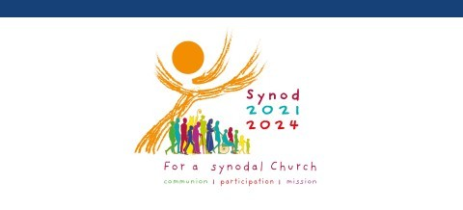

**Participate in the**

**Synod on Synodality!**

Pope Francis invites the whole Church to participate in the next phase of the Synod on Synodality through engagement sessions that will inform the upcoming Synod of Bishops on Synodality in October 2024.

**Engagement Sessions are taking place in each county this Lent:**

**San Mateo:**

**When:** Friday, March 8, 7:00 p.m. - 9:00 p.m.

**Where:** St. Matthew Catholic Church

1 Notre Dame Avenue

San Mateo, CA 94402

**Contact:** Teresita Contreras at tcontreras@stmatthewcath.org

**Marin:**

**When:** Saturday, March 9, 10:00 a.m. - 12:00 noon

**Where:** St. Raphael Church

1104 Fifth Avenue (at A St.)

San Rafael, CA 94901

**Contact:** Deacon David Bernstein at dcnbernstein@saintraphael.com

**San Francisco**:

**When:** Saturday, March 9, 2:00 p.m. - 4:00 p.m.

**Where:** St. Mary of the Assumption Cathedral

1111 Gough Street, San Francisco, CA 94109

**Contact:** Diane Luporini at dluporini@smcsf.org

More details are available through the Archdiocesan website at [www.sfarch.org/synod](https://nam12.safelinks.protection.outlook.com/?url=http%3A%2F%2Fwww.sfarch.org%2Fsynod&data=04%7C01%7Cksell%40catholicleaders.org%7C45f5b5225832429ba13308d9bc31e0e9%7C51c682377cdd4567b6349dec76cd4193%7C0%7C0%7C637747745591704106%7CUnknown%7CTWFpbGZsb3d8eyJWIjoiMC4wLjAwMDAiLCJQIjoiV2luMzIiLCJBTiI6Ik1haWwiLCJXVCI6Mn0%3D%7C2000&sdata=zLRo6H8VHDAtwkOCmJwmlIu5P7rdHaNg5Ku%2BQRNvWJg%3D&reserved=0)