Training sub-network
Tlp@dosp.org is super administrator of training sub-network.
Super Administrator creates groups and assigns an administrator to the group.
How to create a group? Scroll down left hand column to “Manage Groups.”
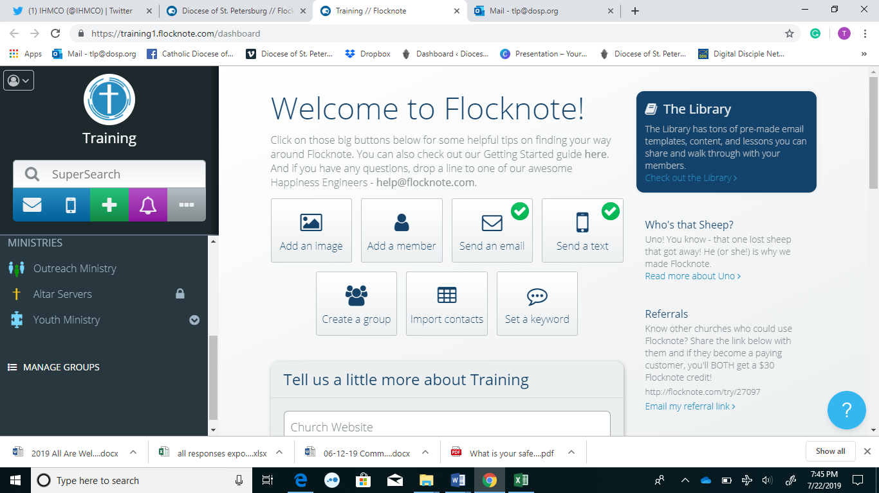

Select “New Group”
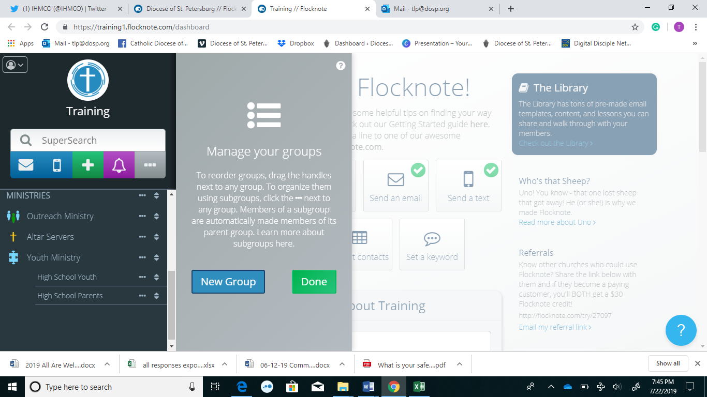
Type in “Name”
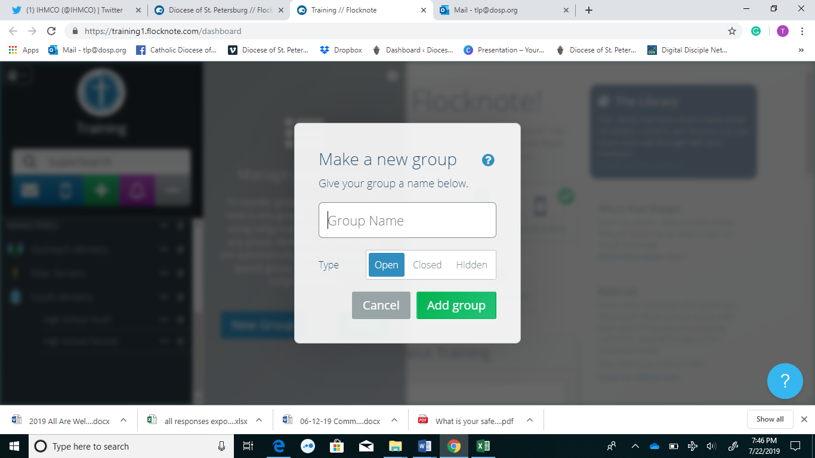
Decide if it’s Open, Closed, Hidden
Open = Any one can see group and join group.
Close = Any one can see group and ask to join group.
Hidden = No one can see group.
You will receive a verification code as the administrator.
Click on group on left hand corner
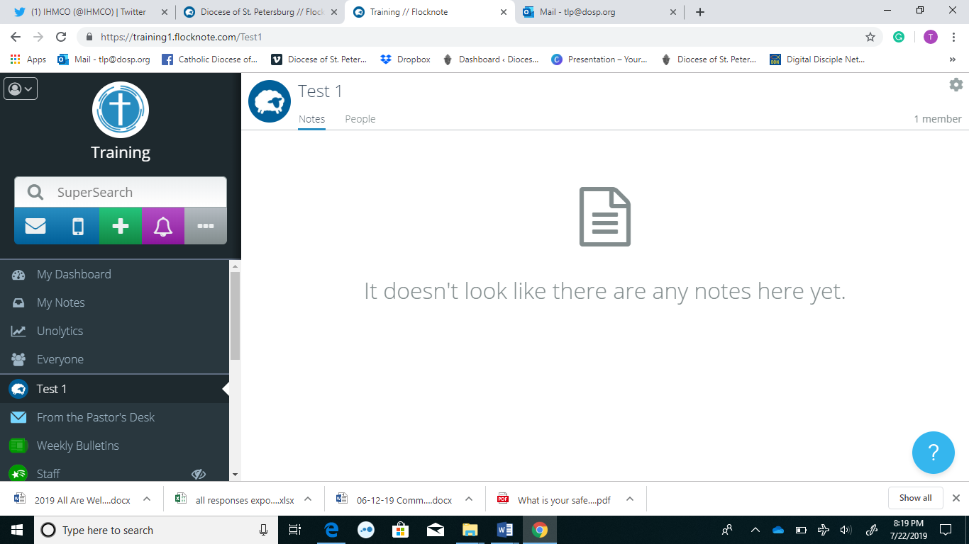
Click on People Tab
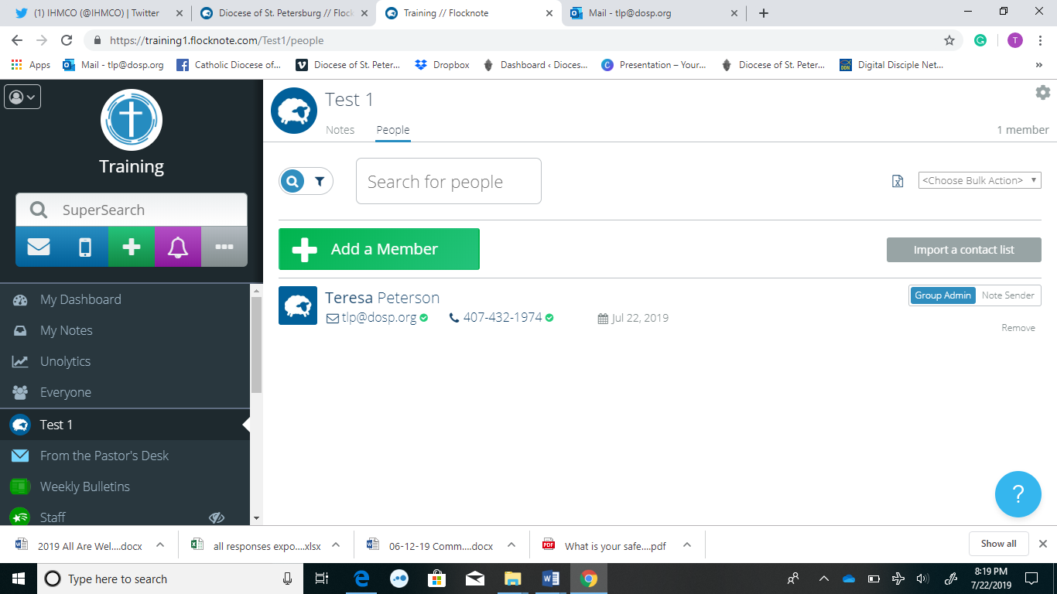
Add a member
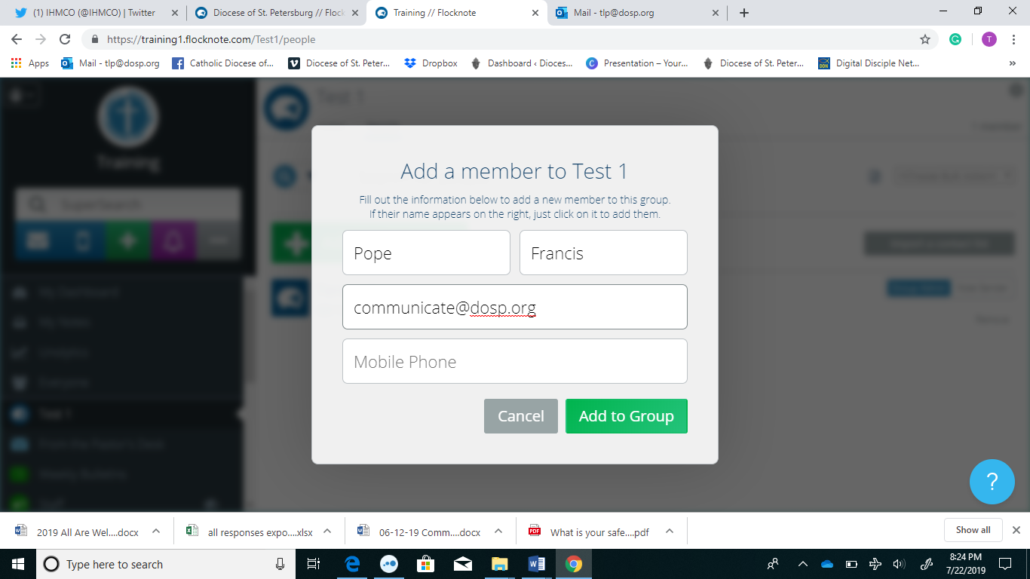
Select this person to be an administrator
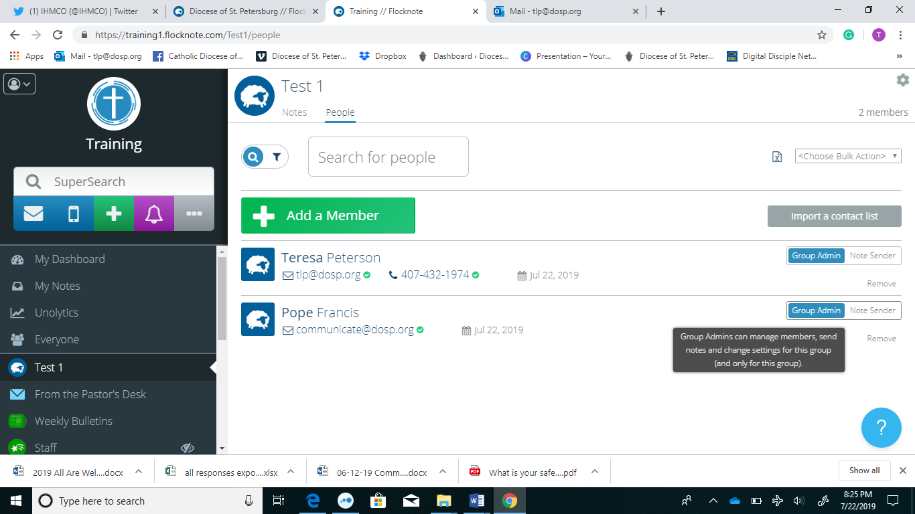
ADMINISTRATOR ROLES
Adjust Setting
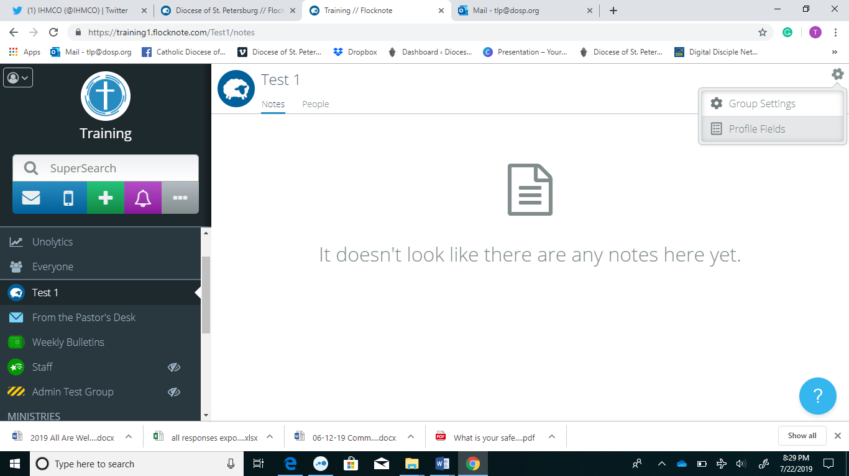Click on gear in upper right hand corner
You can edit group name – this is what appears in the “from line” in emails
You can edit short name – this is what appears in the “from line” in text message.
Add Text to Join Keyword
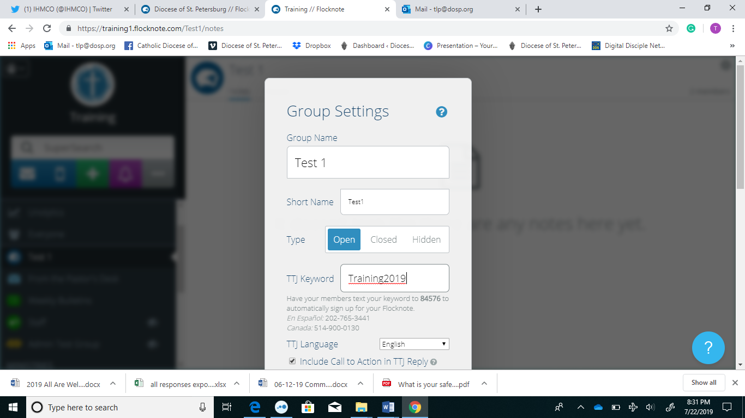
Training2019
(let’s test – everyone text Training 2019 to 84576 to automatically sign up for this group.
En Español: 202-765-3441 (instructions will be in Spanish)
https://www.youtube.com/watch?v=5Fq6GK-_yc4
Text to Join Call to Action
Include Call to Action in TTJ Reply
Including a call to action in your text-to-join response will help you collect additional contact information from your members as well as invite them to join other groups in your network. When this setting is on and someone texts in your keyword from their phone, they will receive a reply that states "Thx for connecting with GROUP NAME! Click to complete signup: [link] Or reply with your email. Powered by Flocknote." When this setting is turned off and someone texts in your keyword from their phone, they'll just receive "Thx for connecting with GROUP NAME! Powered by Flocknote." By default, this setting is turned on.
Welcome Email Message Replies
Designate which Group Admin will receive the replies your members send in response to the automatic Welcome Message.
Connect on Twitter
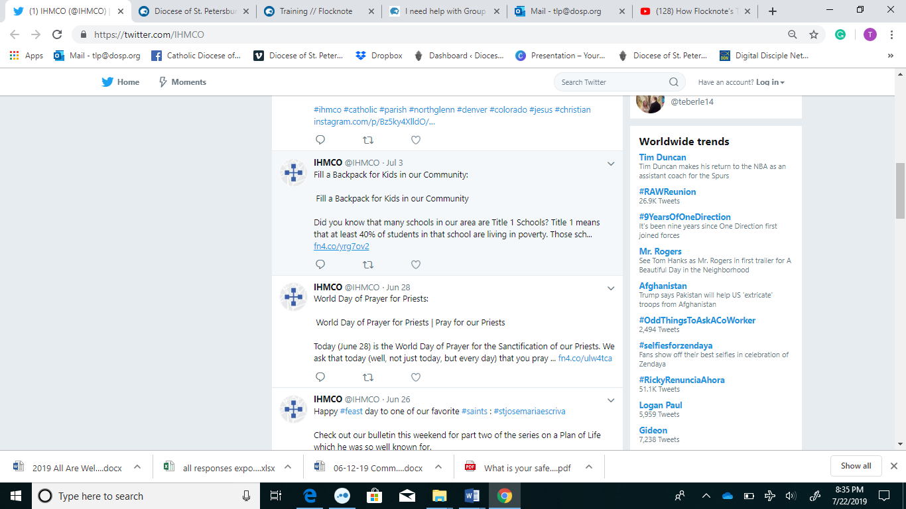
https://help.flocknote.com/article/45-group-settings
Import a Contact list
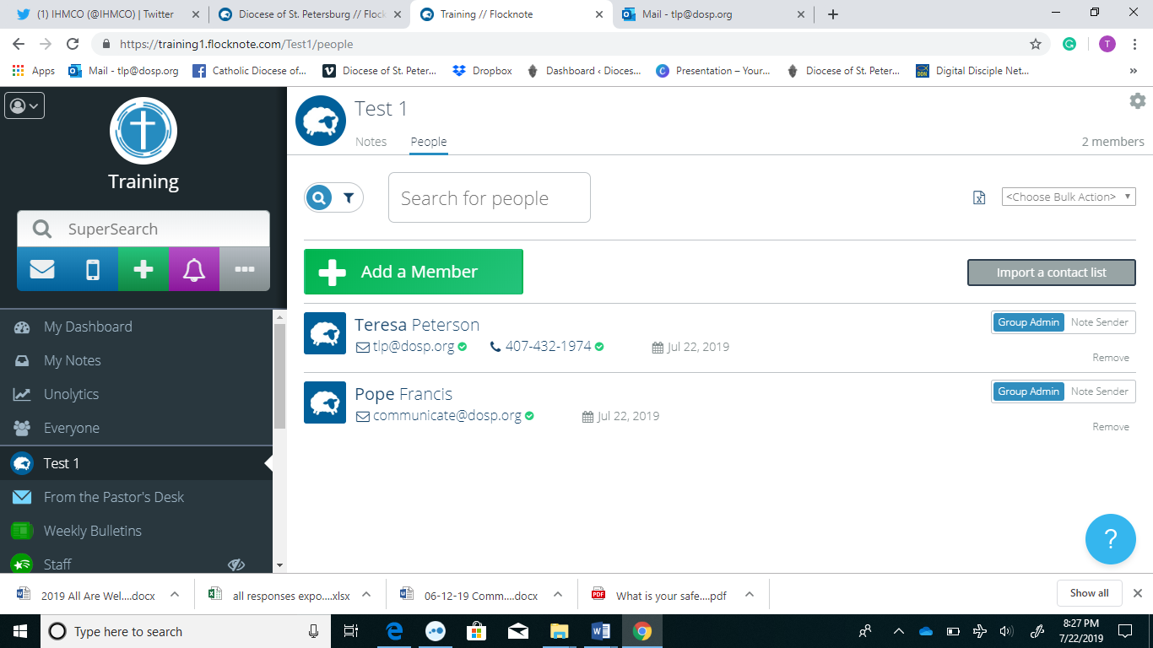
Send a Note
Click on Note Tab
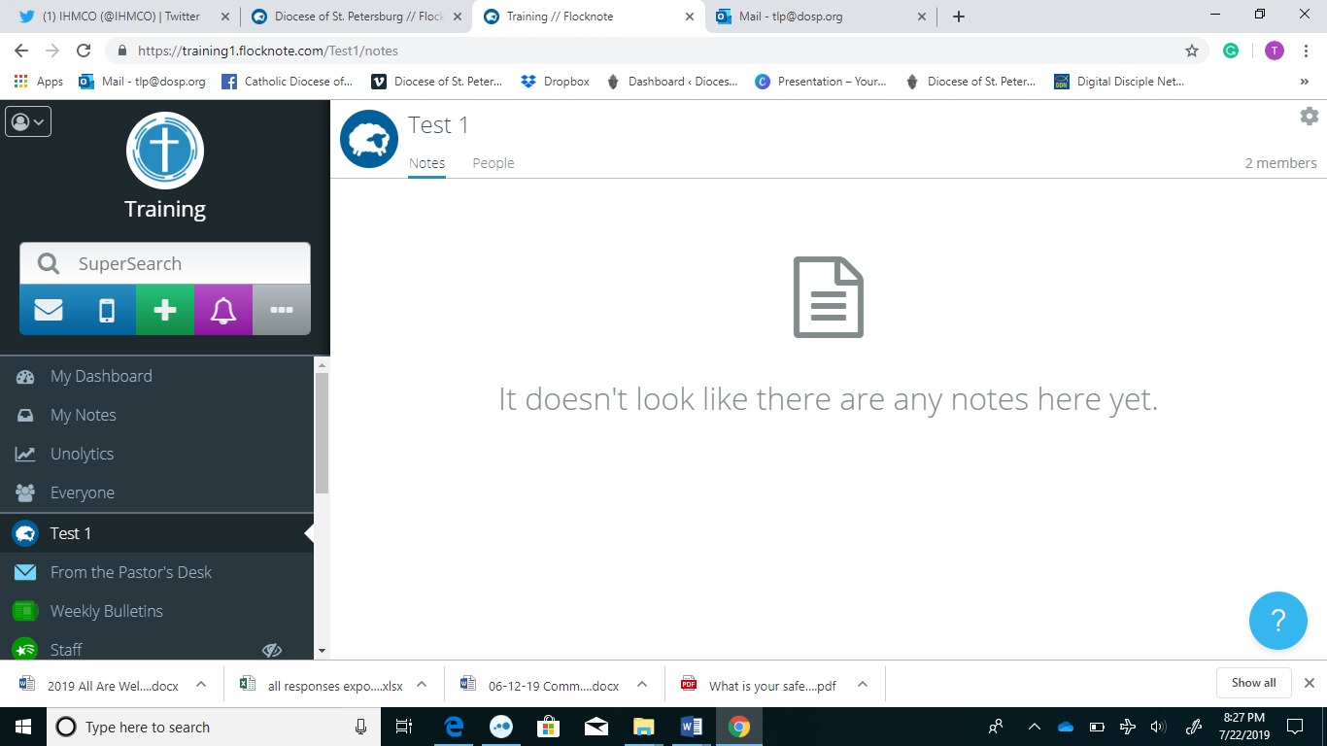
Click on envelope on left hand column
