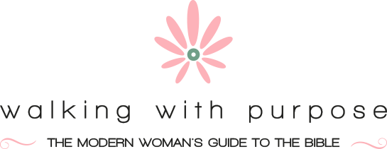

Dear Sacred Heart ladies,

We thank God for the wonderful groups of women that have met together throughout this past year to study His word! Though this year was a little different because of no large group gatherings, we had great attendance in many groups. We even had some new people discover WWP at our parish! In the coming 2021-2022 year we are believing that God will continue to grow our Bible study groups with both new women and women who have participated in past years.

We are excited to kick off our year with an Informational Gathering on Thursday, August 26th from 7-8pm in Whitemarsh Hall. All women interested in participating in a WWP group this year are encouraged to attend…and bring a friend! We will describe with a bit more detail each study that we are offering this year and take any questions that you have about the studies or the program. Come enjoy some light refreshments as you fellowship with women from the parish and hear how studying the Bible with other women will greatly bless your life and relationship with the Lord!

Below we have listed the study groups offered this year.

2020-2021 WWP Study Groups:
(Click study links for descriptions and to purchase.)

Discovering Our Dignity // TUESDAYS, 7:15PM, SUE CURRAN, WHITEMARSH HALL

Touching the Divine // TUESDAYS, 1PM, LINDA QUINN, WHITEMARSH HALL

Keeping in Balance (In-person & virtual) // MONDAYS, 7PM, MICHELLE BALLENGER, MICHELLE’S HOME

Discovering Our Dignity // MONDAYS, 7PM, JESSICA PTOMEY & SARAH SHELFER, JESSICA’S HOME

(Virtual Group) Keeping in Balance // THURSDAYS, 7:30PM, ELLEN EWING & MARY LEE WALLS, ZOOM

Please prayerfully consider participating in a group this fall. We do cap some of them at around 12 people, and they may fill up quickly. If you already know what group you would like to join, then you can click here to register for a study, and then go to the corresponding link above and order your book directly from WWP.

May God bless the rest of your summer, and we hope you are able to join one of our groups this fall!

Your sisters in Christ,

Jessica Ptomey & Mary Lee Walls
WWP Coordinators, Sacred Heart Church

