**Biomimicry**

**Drinking Water Out of Thin Air?**

**The Problem:**

People in many parts of the world suffer health consequences from the lack of access to clean water. Collecting water can often be dangerous, strenuous, or technologically challenging. Why not mimic the Desert denizen, the Darkling Beetle, who gets water from thin air!

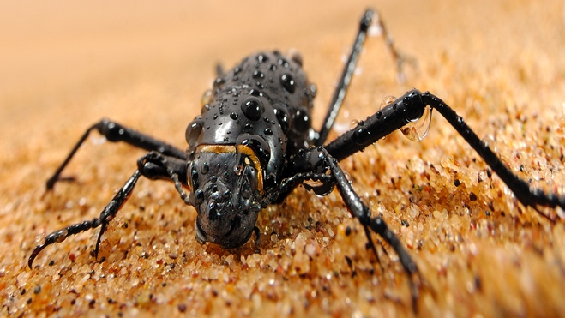

**Inspiration from Nature:**

Darkling Beetles get the water they need from dew and ocean fog in the air. Special tips and bumps on its wing scales help collect the water from the air, which condenses into droplets and flows off the bumps into the beetle’s mouth.

**Benefits:**

The Warka Tower is a bamboo frame that supports a polyester mesh material. The mesh is cold and causes the dew, fog or water vapor to condense on its surface in small droplets. They trickle by gravity into a reservoir at the bottom of the structure. Parts of the tower are shaded to prevent evaporation. This is the water cycle at work!

Here’s a video that illustrates this innovation: <https://youtu.be/xv44VPqf1QU>

Information was provided by AskNature.org (https://asknature.org/innovation/lightweight-water-collection-system-inspired-by-darkling-beetles/#biomimicry-story)