**Biomimicry**

**High Speed Train Takes a Nose Dive?**

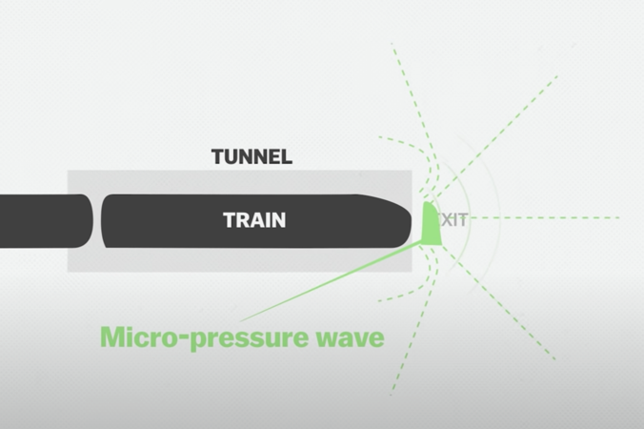**The Problem:**

The Shinkansen , or Japanese Bullet train, travels at fast speeds of nearly 200 miles per hour. This is great for getting people from place to place quickly and efficiently, but when these fast trains exit tunnels, the air pressure “boom” sound created is too loud and disturbing for people who live nearby. When a bird-loving engineer thought about how one sleek-beaked bird dives in water without a splash, he had an idea.

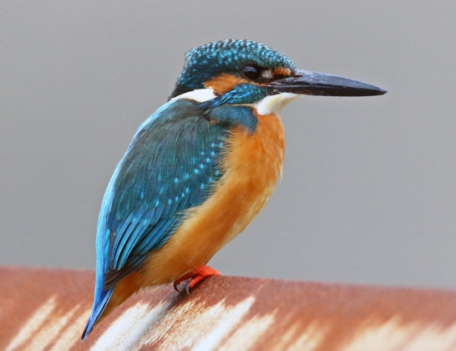**Inspiration from Nature:**

The Kingfisher, a species of bird found in tropical regions of Africa, Asia and Oceania, is well-known for hunting fish and other aquatic prey with its uniquely large and pointed beak. This beak allows it to dive into water at high speeds without making any splash or waves, which allows it to see its prey more clearly.

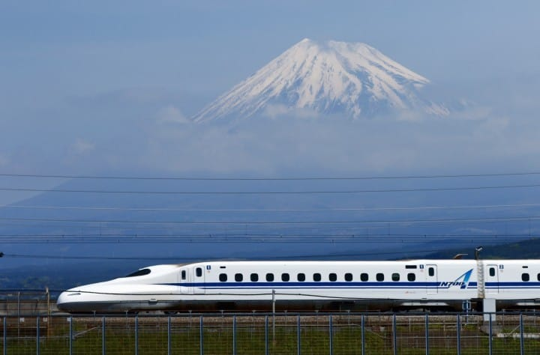

**Benefits:**

When engineers redesigned the front cars of high-speed trains to resemble Kingfisher’s beak, the train made considerably less noise exiting tunnels. Additionally, now this sleek-nosed design created less air friction, which resulted in greater energy efficiency. This means the trains needs less energy to travel the same distance.

Here’s a video that illustrates this innovation: <https://youtu.be/iMtXqTmfta0>

Information was provided by AskNature.org (https://asknature.org/innovation/high-speed-train-inspired-by-the-kingfisher/)