**Biomimicry**

**Sticking with Oysters**

**The Problem:**

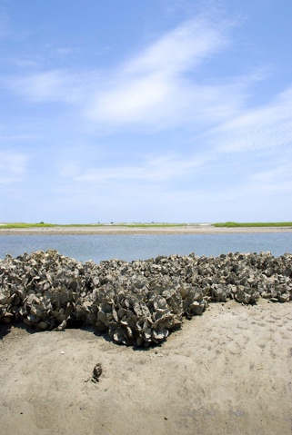How to make something strong and flexible at the same time, especially in a wet environment. The Eastern Oyster has the answer!

I**nspiration from Nature:** Many oysters are enjoyed by many people for their taste, but they also provide a strong and stable structural benefit in coastal ecosystems. They grow together, at first forming clumps, and eventually entire underwater cities. In these reefs, they provide habitat to many aquatic species, continuously filter, and improve water quality, and protect coastal erosion. One thing for sure, oysters stick together, and one scientist studied their strong bonds to create a new kind of cement.

**Benefits:**

The oyster cement is unique! It is both strong and flexible because it is made up of calcium carbonate (otherwise known as limestone) and proteins, which are softer and more flexible. The best of both worlds—especially in a tidal situation. This Oyster cement can considered in bone repair or dental cement or even in shoreline construction, which helps recover some of the oyster reefs that have been lost in the past.

Information was provided by AskNature.org (https://asknature.org/strategy/adhesive-is-both-strong-and-flexible/)