**Biomimicry**

**Velcro—A Fasten- ating Solution**

**The Problem:**

Often we need to attach objects together, but before the invention of VELCRO, rope was one of the “go-to” methods used. Tying or lashing could be awkward, bulky and time-consuming, especially when objects needed to be tied and untied frequently. In 1941, a Swiss engineer set out to develop an innovation that could attach two objects together quickly and easily without the use of a rope. The inspiration for this invention came while walking his dog through some weeds.

**Innovation from Nature:**

Plants have a wide variety of ways they spread their seeds. Some require wind, others rely on pollinators, and some hitch a ride on larger animals. One plant called the BURDOCK has hooks that grow from its seed pod. As animals brush up against these hooks, it catches on and is carried away. The animal ‘s journey becomes the seed pods’ too, and so, the seeds spread far and wide. This hooking and latching of the seed pod became the inspiration for VELCRO.

**The Benefit:**

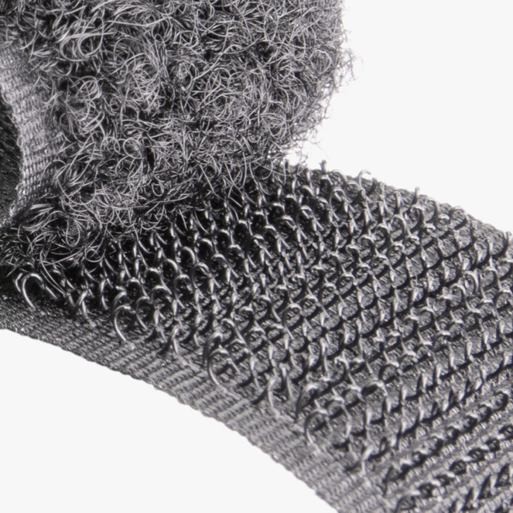 Velcro is used in some many ways these days that there are too many to name here, but all you have to do is look around your classroom to see Velcro sticking around. When you take it apart, take a minute to examine both sides closely and you will see our friend the seed pod at work. From shoes to backpacks on Earth to equipment on the International Space Station, we’re hooked on Velcro.

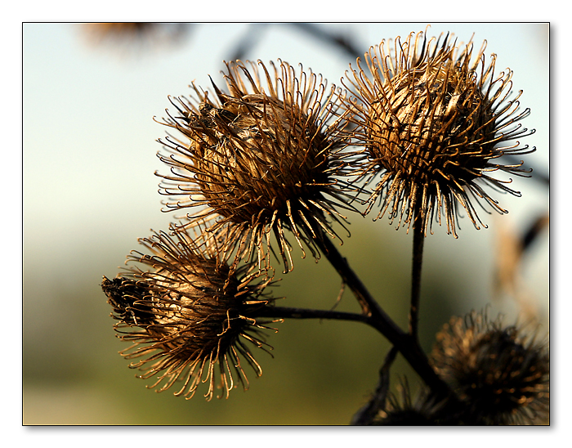Left: Dry seed pods from the Burdock plant. Notice the dozens of hooks on each pod. Right: Close-up of modern Velcro.

Information was provided by AskNature.org (https://asknature.org/strategy/hooked-spines-grab-onto-fibers/#the-potential)