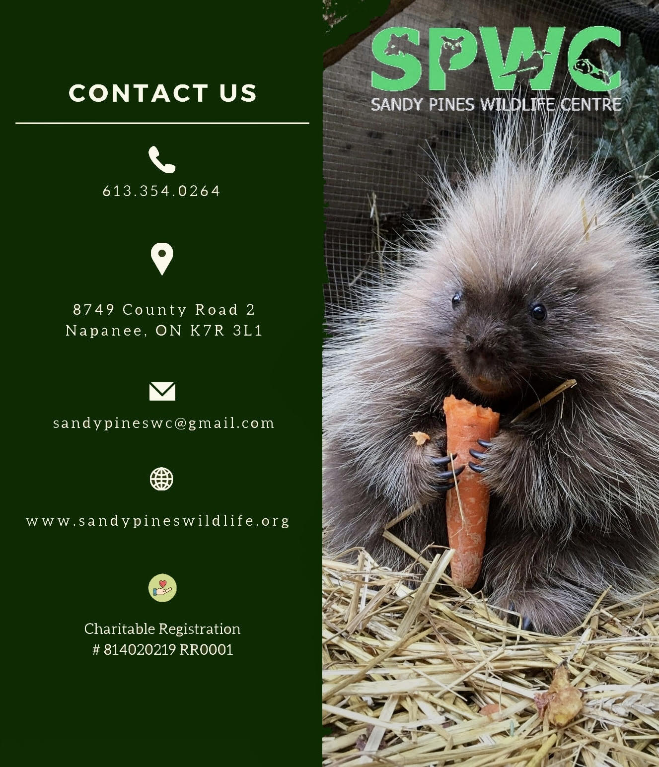
DIVE BROCKVILLE ADVENTURE CENTRE 20TH ANNUAL POLAR BEAR DIP 2025

Participants Information:
Name:___________________________________________________ Phone#:_________________________________________
Email:____________________________________________________
Total Money Raised:_______________________________________

Name | Address | Phone number | Amount pledged | Receipt Y or N
1
2
3
4
5
6
7
8
9
10
11
12
13
14
15
16

