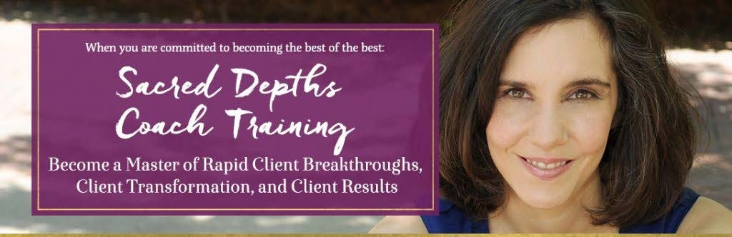
Sacred Depths Process for Befriending Your Fears
Overview of the 6-Step Process:
Step 1: Help Clients Become Aware of their Fears
The more you can help clients become clear on what their fears are and how they play out in their life, then the more you bring those fears out of the blindspot – where they are most likely to sabotage– and bring them into the light.

Step 2: Support Client to Understand their Fears
The next step is Understanding Fears. Understanding fears means seeing how your fears work in your life, and how you react to them.

Step 3: Lead Clients to Dialogue with their Fear
Step 3 is Dialoguing with Your Fears. learn a lot more about how your fears work within you, as well as moving them even further out of your blindspot. Even more important, by dialoguing with your fears, you’re going to learn how your fears have been serving you. Yup, it’s true – your fears have actually been serving you, doing something for you. You’re a smart person, you wouldn’t be holding onto something like fear so tightly if it wasn’t serving you. So if you find yourself holding on to a persistent fear, chances are it’s serving you in some way. This is also the part of the process where the deeper level of Befriending happens. When you’re willing to dialogue and engage with…and maybe even HONOR and LOVE your fears…instead of hate on, reject, fight against your fears…that’s when the fears can actually start to diminish. Because they don’t need to be like the man fighting against the wind to keep his hat on. They can relax a little because they know they’re not being ignored or hated. They know they’ll get the loving attention they deserve so they no longer need to be so in your face.

Step 4: Connect to Spirit, Trust and Love
So, in order to fully move through fear, it’s important to partner that fear with trust and love. And the trust can be trust in yourself, spirit, the universe, whatever works for you. In order to really be able to believe in your heart that you can walk a different path, that you can have what you want, it’s important that there’s trust, and even more important than trust it’s important that there’s love of self.
Step 5: CHOOSING to walk a different path
Once you’ve become aware of your fear, and once you’ve become aware of your full awareness and understanding how this fear works and why it’s there, how it’s served you,..then you’re at the 5th part of the process which is that you’re free to choose d walk a different path. Until getting to this 4th step, you haven’t really had an opportunity to choose to let the fear go, because you hadn’t embraced it. Why? Because when you’re not aware of your Fear, you literally ARE your fear; you’re not separate from it. It’s in your blindspot because you aren’t aware of it, you don’t see yourself as separate from it.

Step 6: Committing, and Re-committing and Re-committing to the new path
Remember the difference between a breakthrough and a transformation. Steps 1-5 are really about the breakthroughs and new awareness, and a little bit of the transformation. But the transformation comes when you can consistently and persistently apply the awarenesses. Here is a quote from John Assaraf: “When you’re interested in something, you’ll do what’s convenient. When you’re committed to something, you’ll do whatever it takes.”

Top 11 Underlying Fears
Here are the top 11 fears that often come up individuals upleveling their lives. I developed this content after….pretty much seeing it all!!!!! This isn’t a totally exhaustive list, but you’ll see that pretty much any surface or symptom fear can fall into one of these categories. It’s really helpful to just have these on hand for yourself as you work with clients because you can help them make connections and see how their actions are related to fears (because sometimes a client won’t get at first that a sabotaging action is related to a fear).
Fear #1: Fear of failure – It can sound like “I am simply not going to be able to make “this” happen. I’m going to fail. And failure in one task is somehow equated with failure as a human being. Like their value and worth is predicated on NOT failing.
Fear #2: Fear of not being good enough – It can say “You’re not smart enough, savvy enough. That design isn’t good enough. That coaching session wasn’t good enough. This fear can come up around ANYTHING not being good “enough”. We each have this fear inside ourselves, of not being ”enough”.
Fear #3: Fear of not knowing how to do something or not knowing how something will work out – For example, the fear of not knowing how to market yourself, or the fear of not knowing how to talk to a prospect. And of course you want to know how to do something ,but this fear is running the show if you’re letting the fear of not knowing how to do something stop you in your tracks. This can also be called the Fear of the Mystery….which is actually very related to the Fear of Death itself.
Fear #4: Fear of success – This, at first, might sound funny, but I want you to check this out for yourself: Do you have any preconceived negative notions of what it means to be successful? Any judgment around what kind of people successful people are, and what they have to do to get there?
Fear #5: Fear of being seen and being visible – As you step into bigger places and leadership places for yourself, naturally you are going to become more seen and more visible. And, perhaps while there’s a part of you that really longs to be seen, that really needs to be seen, there’s also a part of you that’s terrified of visibility. You’re terrified that then you’ll be much more open to criticism, that you’ll have to stand up for your values and your work and your sacred message. Or, perhaps you’re scared that if you’re seen, you’ll look TOO big, and others might think “who do she think she is?”
Fear #6: Fear of not deserving what you want –This fear can sound something like this: I just don’t deserve to have a great relationship or to have a thriving business or to get my book published.
Fear #7: Fear of losing connection with self or loved ones – This one may not be obvious right away: Do you have any fear that if you go after or achieve what you want you’ll become so busy, that you’ll get carried away by the work or the fame or get lost in the work, and therefore you won’t have the time or you won’t be connected with self or people you love any more. Or somehow you’ll “lose” your true self….or outgrow a loved one?
Fear #8: Fear of surpassing loved ones – this fear revolves around a parent or parental figure, a sibling, a mentor, a friend or an employer who you feel so incredibly loyal to, that there’s a part of you that fears if you go after what you want you’ll achieve more than they have and thereby defy or break an unspoken code or rule between the two of you. So instead, you hold yourself back so that you don’t get more successful than them.
Fear #9: Fear of having money or Fear of not having money
Fear #10 and Fear #11 often times go together: They are the fear of getting hurt and the fear of not being liked and the fear of having others get angry at you. These two can sound like – “If I put myself out there and really ask for the rates I want to, people will laugh at me and that will really hurt my feelings.” And “If I do this people won’t like me, or they’re going to reject me -- they won’t like my services, etc.”

Assignment: Tracking Your Fears Chart (Support for Steps 1 & 2)
Tracking your fears for a week will help you get even more aware and connected to what fears are holding you back from achieving what you want (which in turn will lead to more ease in moving past your fears!). Make time this week to track your fears closely.

TYPE OF FEAR: | DATE FEAR CAME UP: | TIME FEAR CAME UP: | HOW FEAR WAS MANIFESTED: | OTHER RELEVANT INFO:

