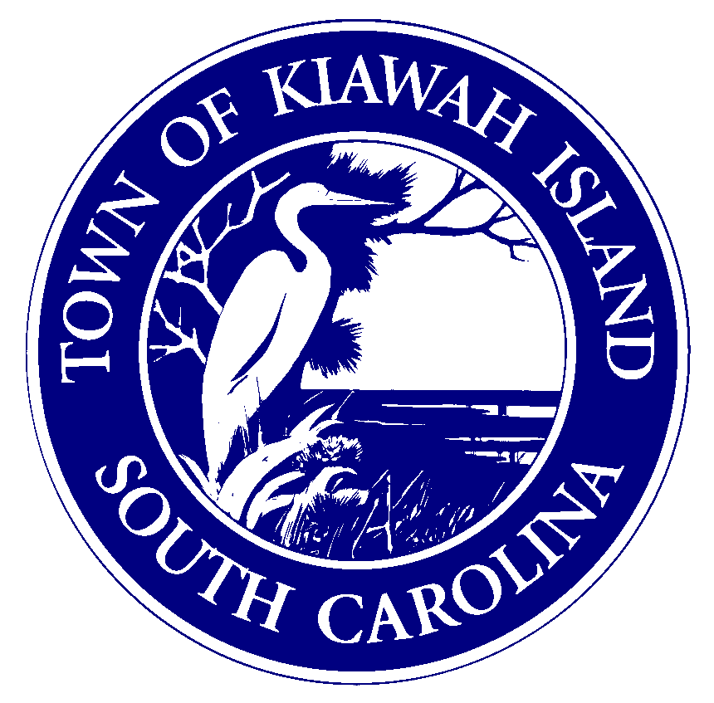

Planning
Kiawah Island BZA
Special Exception Application
Package (1 of 2)

Forms to be returned to the Planning Department with Items 1-6
- Special Exception Application
- Restrictive Covenants Affidavit

Application for Special Exception
Public Services Building
Zoning/Planning Department
4045 Bridge View Drive
North Charleston, SC 29405
Phone 843-202-7200
Fax 843-202-7222
www.charlestoncounty.org

Town of Kiawah Island

Board of Zoning Appeals

This application must be complete and submitted in person to the Charleston County Planning Department in order to apply for a Special Exception. Please read the entire form prior to completing the application. The applicant shall receive a copy of this completed form at the time the application is filed. This application will be returned to the applicant within fifteen (15) working days if these items are not submitted with the application or if any are found to be inaccurate:
- Copy of Current Recorded Deed to the property (Owner’s signature must match documentation). If the applicant is not the owner of the property, the Current Property Owner(s) must sign and print the Designation of Agent found below.
- Restrictive Covenants Affidavit(s) signed by the applicant or current property owner(s).
- A letter of intent signed by the applicant or property owner(s) stating the reason for the request that explains why this request should be granted and how it meets the Approval Criteria. All proposed Special Exceptions shall satisfy the Site Plan Review process and attend at least one Site Plan Review meeting prior to submitting this application.
An accurate, legible Site Plan drawn to Engineer’s Scale must be attached. The site plan must show property dimensions, dimensions and locations of all existing and proposed structures and improvements, parking areas, Grand trees (24” DBH or greater), wetlands (properties containing DHEC-OCRM Critical Line areas must contain an up to date DHEC-OCRM signature on the site plan or plat), holding basins and buffers when applicable. One (1) 24 x 36 copy and twenty (20) 11 x 17 copies.
- Twenty (20) copies of a legible Approved and Recorded Plat showing present boundaries of property.
- ARB stamp and signature or approval letter.
- Fee $250 check made out to “Charleston County” or cash.
_________________________________________________________________________________________________

Applicant Name:
Mailing Address:
City, State, Zip Code: Daytime Phone #:
Subject Property Address:
Present Use of Property:
Special Exception Description:

[Applicant Signature ] [Date]
[Applicant Email Address]

Designation of Agent (Complete only if owner is not applicant).
I hereby appoint the person named as Applicant as my(our) agent to represent me(us) in this application.
[Owner Print Name] [Date] [Owner Mailing Address]
[Owner Signature] [City, State, ZIP Code]
FOR OFFICE USE ONLY

Application #: Flood Zone:
Zoning District: Fee Paid ($250):
Date Filed: Zoning Officer:
TMS #:
[Owner Email Address]

Permit Application: Restrictive Covenants Affidavit
Public Services Building
Zoning/Planning Department
4045 Bridge View Drive
North Charleston, SC 29405
Phone 843-202-7200
Fax 843-202-7222

www.charlestoncounty.org

Fa
Fax 843-202-7222
Town of Kiawah Island

I, , have reviewed the restrictive covenants applicable to Parcel Identification Number(s) , located
[Print Name]
at (address) , and the proposed permit application is not contrary to, does not conflict with, and is not prohibited by any of the restrictive covenants, as specified in South Carolina Code of Laws, Section 6-29-1145.
[Print Name]

[Signature] [Date]

Explanation:
Effective July 1, 2007, South Carolina Code of Laws Section 6-29-1145 requires local governments to inquire in the permit application, or in written instructions provided to the applicant, if a tract or parcel of land is restricted by a recorded covenant that is contrary to, conflicts with or prohibits an activity for which a permit is being sought.
[Section 6-29-1145 is copied on the back of this page].

FOR STAFF USE ONLY

[Received By] [Date] [Application #]

Permit Application: Restrictive Covenants Affidavit – Charleston County
Section 6-29-1145

- “In an application for a permit, the local planning agency must inquire in the application or by written instructions to an applicant whether the tract or parcel of land is restricted by any recorded covenant that is contrary to, conflicts with, or prohibits the permitted activity.

- If a local planning agency has actual notice of a restrictive covenant or a tract or parcel of land that is contrary to, conflicts with, or prohibits the permitted activity:

  - in the application for the permit;

  - from materials or information submitted by the person or persons requesting the permit; or

  - from any other source including, but not limited to, other property holders, the local planning agency must not issue the permit unless the local planning agency receives confirmation from the applicant that the restrictive covenant has been released for the tract or parcel of land by action of the appropriate authority or property holders or by court order.

- As used in this section:

  - ‘actual notice’ is not constructive notice of documents filed in local offices concerning the property, and does not require the local planning agency to conduct searches in any records offices for filed restrictive covenants;

  - ‘permit’ does not mean an authorization to build or place a structure on a tract or parcel of land; and

  - ‘restrictive covenant’ does not mean a restriction concerning a type of structure that may be built or placed on a tract or parcel of land.”

Permit Application: Restrictive Covenants Affidavit – Charleston County

