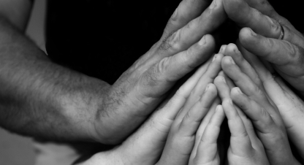

We welcome
children and
families here!

You may notice that there are many different people in church today: different shapes, sizes, genders, colors, ages and abilities. We have made the intentional and hopeful decision all people (children included!) to be active participants in this community!

When God came to dwell among us, the Word was born as a wordless child. When Jesus was doing his work on earth, he came close to people that his culture considered outcasts, including children. He didn’t stop there. Eight times in the gospels, Jesus commanded adults to include children in the community. This was counter-cultural.

Our congregation chooses to be counter-cultural in how we welcome others too, including children. Then Jesus took a little child and put it among them and taking it in his arms he said to them, “Whoever welcomes one such child in my name welcomes me, and whoever welcomes me welcomes not me but the one who sent me.” -Mark 9:36-37

You may have heard the phrase “it takes a village to raise a child,” but the reality may be something very different. Could it really be “it takes a child to make a village”? When we welcome children, we welcome Jesus, and when we welcome Jesus, we welcome God. We see all God’s children as bearers of God’s creative and redeeming Word to all the world, and we get to walk beside each other in that journey: children introduce us to God.

Making Space for Children

We encourage you to bring children to worship. Please sit close to the front or to the center aisle so children can see. Children can stand on the pew if that will help them see. If they need to step out, don’t feel like you are interrupting anyone. Relax! God put the wiggle in children, don’t feel like you have to suppress it in God’s house. We want children to know they are safe in this house of worship.

Children are welcome to eat at our great, big family table: Holy Communion. If your child expresses interest in taking Communion (by asking or by reaching out), they are ready to learn more. Please allow your children to participate. This meal is God’s gift and no one is denied. We offer classes for children of different ages to begin a journey of understanding the mystery of Holy Communion, and these classes can come even after they begin participating. Remember, the gift of Jesus’ forgiveness is free for all. There is really nothing you have do to “be ready”.

We encourage children to participate in worship by coming to the front to hear the Children’s Sermon. We also invite children to carry the wine or bread during the offertory. As they grow, we invite them to become acolytes, lectors and musicians.

Activity folders to use during the sermon time are available for children. These can be found in baskets in the narthex (lobby). Encourage them to participate: when we stand, when we sit, when we sing and when we pray.

Should your child need a short break from worship, feel free to continue worshipping with your child from in the narthex (lobby) in the back. Should your child need a longer break from worship, we have a nursery available for infants through 3-year-olds. Also, there are comfortable chairs in the “cry room”, where you can see and hear the service, should you need to further comfort your child. An usher can help you find these rooms.

Smile. Be friendly. Offer the peace to children. Learn their names. Let the children bless you!

