Activity 1 Let’s Observe some video clips, think and share!

- Sentence starters for video clip 1

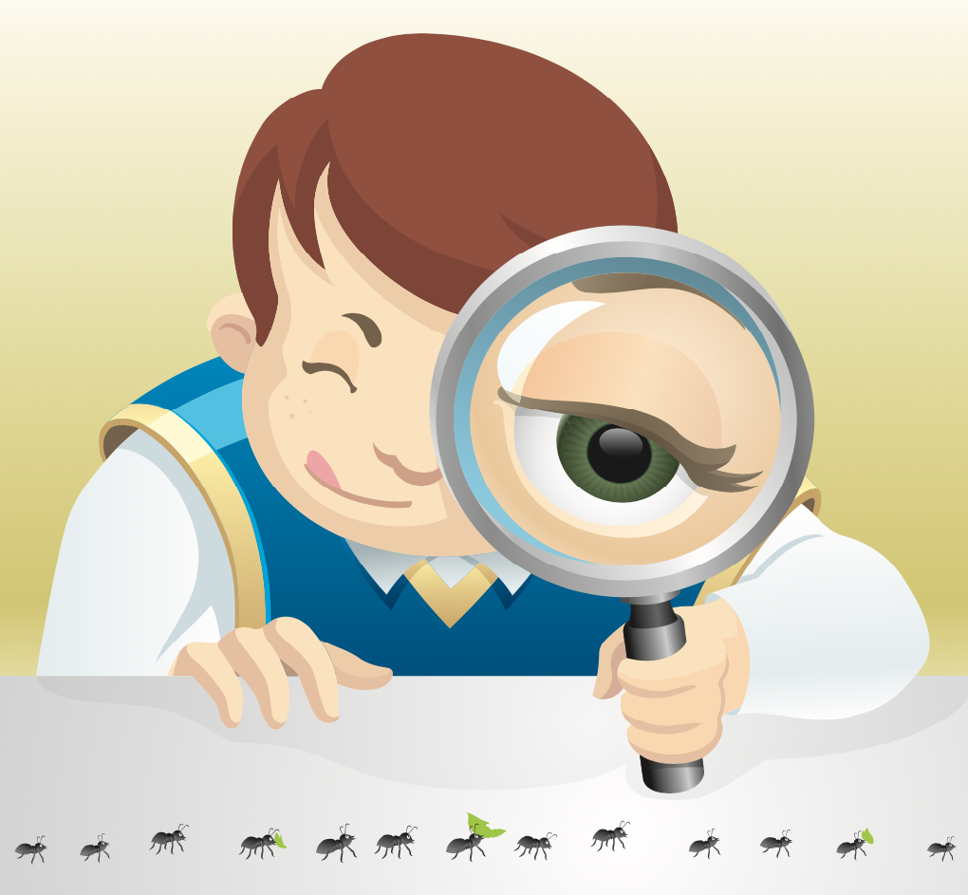 我看见......。
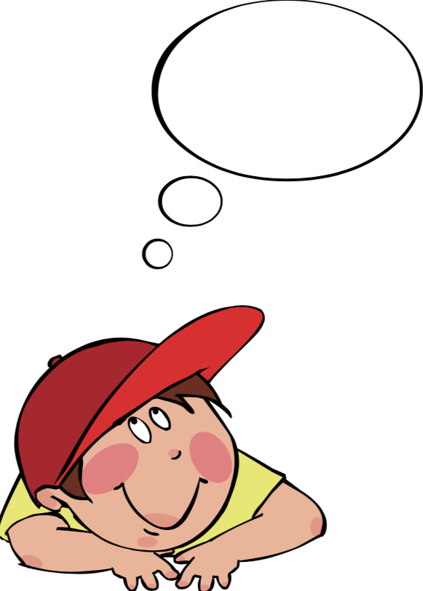 我觉得......。
我想问.......。

2. Questions for Video Clip 1&2

- What is Guiding Reading？小组指导性阅读的定义是什么？

2) Why is Guided Reading so important？ 为什么要进行小组指导性阅读？

Activity 2 : Guided Reading Observation Form for Fiction Read Aloud Lesson
Guided Reading Fiction Read Aloud Lesson 叙述性文体  阅读课 | What Does Teacher Do？  老师做什么？ | What Do Students Do？  学生做什么？ | Questions or Notes  提问和其他记录
Pre-Reading
阅读前

While-Reading
阅读中

Post-Reading
阅读后

