**Season 18  
—  
Debating the 2017-2018 NSDA Policy Resolution**

The “status quo” refers to current policies, essentially what Affirmative teams need to change. Policy debaters must have a solid understanding of the current state of affairs before debating the year’s topic. The purpose of this article is to give competitors the underlying knowledge of the status quo as it relates to the following resolution:

**“The United States federal government should substantially increase its funding and/or regulation of elementary and/or secondary education in the United States.”**

**Table of Contents**

Status Quo of Federal Education Policy 2

Federal vs. States 3

Funding 4

Regulations Against Discrimination 5

Title IX of the Education Amendments Act of 1972 6

Individuals with Disabilities Education Act (IDEA) 6

Title I of the Elementary and Secondary Education Act 6

“Public School Failure” 7

School Choice 9

Worksheet: Status Quo of Federal Education Policy 11

Answers 13

*Content collected and written by Vance Trefethen. Chris Jeub wrote the worksheets at the end of the essay.*

Status Quo of Federal Education Policy



NSDA’s 2017-2018 Policy Resolution:

“The United States federal government should substantially increase its funding and/or regulation of elementary and/or secondary education in the United States.”

In this article, we examine some of the better known and widely debated issues that are currently being discussed in the literature on elementary and secondary education in the United States. Our goal is not to persuade you to any point of view, but rather to summarize what some of the arguments are so that you have a better understanding of the positions you may find yourself debating this year. This may also give you ideas for areas of research on Affirmative cases you could write or Negative briefs you will need to prepare.

Federal vs. States

Historically, whenever education resolutions are used in policy debate, Negatives will often have a prepared counterplan advocating “states do it instead.” Given the historical and constitutional responsibility of the states to manage elementary and secondary education, the fact that the states are funding 92% of it anyway, and the array of experts who argue that local control is better, it is easy to see how this will be a useful position for Negatives to brief and prepare. The classic argument is that, in addition to being more accountable to the voters, states are “laboratories of democracy” where ideas can be tested, with the good ones adopted nationwide and the bad ones only hurting the states that tried them and not the entire population.[1]

Affirmatives should be prepared to show why states perform poorly at the particular function mentioned in their plan, in order to head off “states do it instead” Negative challenges. This could be as simple as the fact that the states just don’t have the money to pay for the programs, or Affirmatives could delve deeper into the motivations, competencies or attitudes of state officials toward the policy under consideration.

Another way for Affirmatives to head off Negative arguments about the states is to work on a subject completely and unquestionably under federal jurisdiction. One area of uniquely federal responsibility is the District of Columbia, which is assigned to Congressional oversight by the Constitution. The DC school system has enough issues to keep school reformers busy for a lifetime,[2] so Affirmatives can always propose changes to DC schools (e.g. expanding school vouchers) without any risk of Negative complaints about the states. Congress also has jurisdiction over territories like Puerto Rico, Guam and the Virgin Islands, if you find issues in those places that could be fixed by an Affirmative plan (see Article IV of the Constitution).

Another rich area of research could be the federal government’s constitutionally assigned jurisdiction over American Indian reservations. There are any number of complaints about lack of funding, failing infrastructure, and other forms of neglect by the federal Bureau of Indian Education (BIE) for Native American children.[3] Affirmatives may also find issues with schools operated by the Defense Department on US military bases, which would obviously have no room for state action.

Funding

As noted in the history article, the amount spent on elementary and secondary education, per student and adjusted for inflation, has approximately tripled since 1970. What do we have to show for it? Has the quality of education tripled since 1970? Since the resolution invites Affirmatives to increase federal spending on education, Negatives will be wise to be prepared to prove that public spending isn’t related to academic success, and they will have ample historical data to support that thesis.

An alternate view of “funding hasn’t worked” is that the funding increases in the last generation haven’t gone to academics, so the notion that funding won’t improve academics hasn’t really been tried yet. A quick look at the programs that have boosted funding shows billions spent on things like school lunches, anti-discrimination efforts, and special education programs for disabled students. Though vastly increasing spending, none of those would be expected to increase average test scores much.

Affirmatives with “increased spending” plans might do well to focus on specific programs or policies where spending can be proven to lead to success. While general programs that just “give more money to schools” might face stronger Negative challenges, Affirmatives could more successfully single out specific programs that are underfunded and have a proven track record of success.

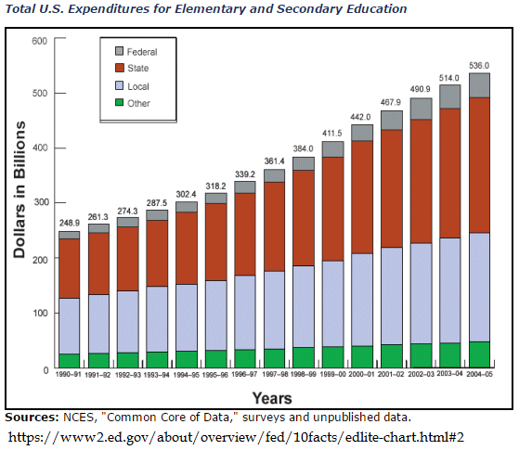

But school funding is not only about quantity, it’s also about equity. Rich regions have more tax money to spend on their schools than poorer ones, so children of the rich presumably get better public schools than children of the poor. As noted in the previous chapter, one of the goals the Dept. of Education sees itself fulfilling is filling in gaps where states create inequities among students of different socio-economic backgrounds. If certain groups are left behind, marginalized, or discriminated against, perhaps there can be some role for the federal government to correct such disparities in funding.

Regulations Against Discrimination

Marginalized groups are not only affected by funding; they can be affected by regulation as well. Much of the federal involvement in the “strings attached” funding it provides to the states, coming from laws passed in the 1960s and ‘70s, is designed to stamp out inequities in the way states treat students from different backgrounds. Some examples include:

Title IX of the Education Amendments Act of 1972

“Title IX is a comprehensive federal law that prohibits discrimination on the basis of sex in any federally funded education program or activity. The principal objective of Title IX is to avoid the use of federal money to support sex discrimination in education programs and to provide individual citizens effective protection against those practices. Title IX applies, with a few specific exceptions, to all aspects of federally funded education programs or activities.”[4]

Areas of concern about gender equality in schools under Title IX take numerous forms. Some current issues in Title IX include funding for boys/girls sports, bathroom/locker facility rules for transgender students, sexual harassment and violence, and gender-based or sexually-based bullying.

Individuals with Disabilities Education Act (IDEA)

“The Individuals with Disabilities Education Act (IDEA) is a law ensuring services to children with disabilities throughout the nation. IDEA governs how states and public agencies provide early intervention, special education and related services to more than 6.5 million eligible infants, toddlers, children and youth with disabilities.”[5]

The essential feature of IDEA is that the federal government gives funding to local schools in order to provide a free appropriate education that meets the needs of students with disabilities, also known as “Special Education,” or Special Ed. Schools are required to do an evaluation and come up with a specific education plan for the student with a disability. Over the years our concept of “disability” has changed and expanded.[6] There is great concern that funding from the federal government is insufficient to meet the needs of Special Ed students today.

Title I of the Elementary and Secondary Education Act

“Title I, Part A (Title I) of the Elementary and Secondary Education Act, as amended (ESEA) provides financial assistance to local educational agencies (LEAs) and schools with high numbers or high percentages of children from low-income families to help ensure that all children meet challenging state academic standards. Federal funds are currently allocated through four statutory formulas that are based primarily on census poverty estimates and the cost of education in each state.

Basic Grants provide funds to LEAs in which the number of children counted in the formula is at least 10 and exceeds 2 percent of an LEA’s school-age population.

Concentration Grants flow to LEAs where the number of formula children exceeds 6,500 or 15 percent of the total school-age population.

Targeted Grants are based on the same data used for Basic and Concentration Grants except that the data are weighted so that LEAs with higher numbers or higher percentages of children from low-income families receive more funds. Targeted Grants flow to LEAs where the number of schoolchildren counted in the formula (without application of the formula weights) is at least 10 and at least 5 percent of the LEA's school-age population.

Education Finance Incentive Grants (EFIG) distribute funds to states based on factors that measure:

* a state's effort to provide financial support for education compared to its relative wealth as measured by its per capita income; and
* the degree to which education expenditures among LEAs within the state are equalized.”[7]

Title I attempts to rectify inequities in funding among poor school districts compared to rich ones in the US. It also tries to deal with special situations of poverty such as migrant workers.

“Public School Failure”

There’s a widespread belief in America is that public schools in general are not succeeding at bringing students to high levels of academic achievement. It’s not hard to find general critiques of public schools, much of it based on the argument that government-operated enterprises are inherently less efficient than competitive private market operations or individual efforts. Not facing shareholders expecting return on investment, nor the risk of going bankrupt if they fail, public schools can operate inefficiently and fail to produce results for many years without facing much in the way of consequences. Teacher unions may be able to block reform and force the retention of poorly performing educators. Schools may even be able to use failure as a reason to justify increased budgets to solve the problems they themselves created. Negatives should be prepared to brief out arguments with evidence to persuade judges that no amount of tinkering or reform of public schools will ultimately succeed, because the underlying problem with public schools is that they’re “public.”

But there’s another perspective that Affirmatives must study and prepare to defend. The meme of “public school failure” should be reconsidered when the definition of success is examined carefully. Compared to the tasks asked of them, one can argue that public schools are actually doing a decent job of meeting them. Often the measurements (e.g. test scores) that compare US students with foreigners fail to account for our universal system of education (where everyone takes the test) contrasted with foreign public schools, where only select groups are tested in specific subjects. Such apples to oranges comparisons make our schools look bad, when in fact we are trying to achieve different goals. Our schools are trying to educate everyone, whereas theirs may be trying to educate only the college-bound, for example.

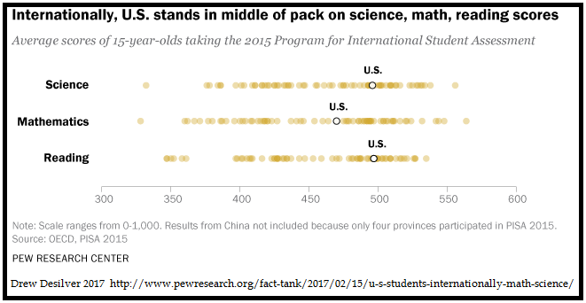

A more nuanced view is that public schools in many areas are doing fine, but urban and poor schools are in trouble, not so much because the schools themselves are bad, but because the social deficits they must overcome are posing too much of an obstacle to success.[8] If that’s the case, Affirmatives may be able to prove that specific changes in funding or regulation at the federal level, targeting the schools that have these obstacles to overcome, could be of some value in improving public education.

School Choice

Expanding opportunities for school choice—that is, the ability of parents to send their students somewhere else besides the school assigned to their school district—has long been a theme in education reform. Giving parents more options and creating some measure of competition among learning institutions to attract students by a track record of success seems like a win-win for everyone. In economics, the default assumption is that monopolies are bad, since having only one supplier of a commodity means that one supplier can take the market for granted, charge above-normal prices, and deliver substandard quality, since he faces no competition. He has no incentive to improve, since his customers cannot go anywhere else. Breaking the public school monopoly has long been a goal of many school reform advocates.

Wealthy Americans have always had school choice. A large percentage of them choose to pay for private schools to improve the quality of their children’s education. If stamping out inequities is a worthy goal, one can make the case that all students should have such choices.

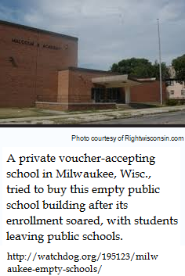One way to get to school choice is a system of vouchers. Education vouchers, first proposed by economist Milton Friedman in 1955, replace school assignment with a voucher representing some quantity of money that can be redeemed at any qualifying institution of learning. Parents can take their government-supplied voucher to any school and use it to pay for their child’s education. If public schools survive, they survive by taking the vouchers and competing with private schools that take them as well. A race to attract students ensues, since each school derives its funding only from the number of students and vouchers they attract.

Voucher systems have been experimented in a few places, with mixed, and highly debatable, results.[9] No state has completely switched over to a public school voucher system, but some cities have tried them on a limited basis. You would do well to brief both sides of this issue (vouchers are good / vouchers are bad) because Affirmatives could argue for more funding to increase them, or for more regulations to tell states to stop doing them. The District of Columbia has a small voucher system serving some of its poor students, but not covering the majority of the students in their system.

Charter schools are another widely used option to expand school choice. They normally receive less funding and support (e.g., no bus service) from their school district and their operation is contracted out to a third-party. In return, they operate with the freedom to set their own rules independently of the rest of the school district.

“Kolderie: The term "charter" really refers to the decision by states to turn public education into a two-sector system. One is a traditional school district, centrally managed. The other, charter schools, are independent, not owned by a central school board. Both are public, but they're organized in radically different ways. …The charter sector [operates on] limited contracts. Their renewal is subject to performance. Charters are authorized by [groups] defined in state law. In New Jersey and Massachusetts, for example, the state is the only authorizer. Some states have created separate boards that authorize charters. Authorizers are usually non-profits and include universities but in most cases, local school boards authorize charter schools.

**Rees:**A local school district does not tell charters when to open or close their doors, what kind of curriculum to use, what company to contract for food or paper. Charters have the freedom to hire teachers without a union contract.”[10]

Affirmatives might propose plans to increase federal funding for charter schools, under the theory that they improve education and should be promoted. They could, alternatively, propose more regulations under the theory that they aren’t working effectively or are committing some sins of discrimination that need to be remedied. Negatives should be prepared to brief out both sides of the “charter schools good/bad” debate.

Worksheet: Status Quo of Federal Education Policy

Name: ____________________________________ Date: ________________________

Answer the following in the spaces provided.

1. How much are states funded by local governments? How does this fact benefit Negatives this year?

2. Do Affirmative teams need to focus on local schools in the 50 states? What other areas are available?

3. What is the “classic argument” for Negative debaters in regards to federal spending for local schools?

4. What are some areas of concern pertaining to *Title IX of the Education Amendments Act of 1972?*

5. What are schools required to do to receive funding under the *Individuals with Disabilities Education Act (IDEA)?*

6. What is the purpose and intent of Title I?

7. What wide-spread belief about public education is commonly held? How should Negative debaters prepare for this belief?

8. Should Affirmatives accept the meme of “public school failure”? How can they argue against this?

9. Has any state completely embraced the public school voucher system? How should Negatives prepare for this?

10. How might Affirmatives plan to address the charter school system?

Answers

1. Given the historical and constitutional responsibility of the states to manage elementary and secondary education, the fact that the states are funding 92% of it anyway, and the array of experts who argue that local control is better, it is easy to see how this will be a useful position for Negatives to brief and prepare.

2. Affirmative teams do not need to focus solely on the 50 states and their local school districts. Other areas that may be reformed are DC schools and the United States protectorates (e.g. Puerto Rico).

3. The classic argument is that, in addition to being more accountable to the voters, states are “laboratories of democracy” where ideas can be tested, with the good ones adopted nationwide and the bad ones only hurting the states that tried them and not the entire population.

4. Areas of concern about gender equality in schools under Title IX take numerous forms. Some current issues in Title IX include funding for boys/girls sports, bathroom/locker facility rules for transgender students, sexual harassment and violence, and gender-based or sexually-based bullying.

5. Schools are required to do an evaluation and come up with a specific education plan for the student with a disability in order to receive federal funding under the *Individuals with Disabilities Education Act.*

6. Title I attempts to rectify inequities in funding among poor school districts compared to rich ones in the US. It also tries to deal with special situations of poverty such as migrant workers.

7. There’s a widespread belief in America is that public schools in general are not succeeding at bringing students to high levels of academic achievement. It’s not hard to find general critiques of public schools, much of it based on the argument that government-operated enterprises are inherently less efficient than competitive private market operations or individual efforts.

8. The meme of “public school failure” should be reconsidered when the definition of success is examined carefully. Compared to the tasks asked of them, one can argue that public schools are actually doing a decent job of meeting them.

9. No state has completely switched over to a public school voucher system, but some cities have tried them on a limited basis. You would do well to brief both sides of this issue (vouchers are good / vouchers are bad) because Affirmatives could argue for more funding to increase them, or for more regulations to tell states to stop doing them.

10. Affirmatives might propose plans to increase federal funding for charter schools, under the theory that they improve education and should be promoted. They could, alternatively, propose more regulations under the theory that they aren’t working effectively or are committing some sins of discrimination that need to be remedied.

1. Justice Louis Brandeis 1932 dissent in the case of *New State Ice Co. v. Liebmann*. “Denial of the right to experiment may be fraught with serious consequences to the nation. It is one of the happy incidents of the federal system that a single courageous state may, if its citizens choose, serve as a laboratory; and try novel social and economic experiments without risk to the rest of the country. 
2. “Study: DC Schools Are LITERALLY The Worst In The Nation” THE DAILY CALLER 2015 <http://dailycaller.com/2015/07/28/study-dc-schools-are-literally-the-worst-in-the-nation/>
3. Indian Schools : A Nation’s Neglect » MINNEAPOLIS STAR-TRIBUNE 2014 <http://www.pulitzer.org/files/2015/editorial-writing/burcum/01burcum2015.pdf>
4. US Dept of Justice <https://www.justice.gov/crt/overview-title-ix-education-amendments-1972-20-usc-1681-et-seq>
5. US Dept of Education <http://idea.ed.gov/>
6. <http://www.encyclopedia.com/history/dictionaries-thesauruses-pictures-and-press-releases/disabled-education>
7. US Dept of Education <https://www2.ed.gov/programs/titleiparta/index.html?exp=0>
8. An example of this view is Prof. William Galston http://www.pbs.org/wgbh/pages/frontline/shows/vouchers/howbad/crisis.html
9. Vouchers Fail: “Dismal Voucher Results Surprise Researchers as DeVos Era Begins” N.Y. TIMES 23 Feb 2017 <https://www.nytimes.com/2017/02/23/upshot/dismal-results-from-vouchers-surprise-researchers-as-devos-era-begins.html>. Vouchers Succeed: Dr. Patrick J. Wolfe 2009 <http://educationnext.org/lost-opportunities/> «statistically significant achievement gains » in Milwaukee and Charlotte when vouchers were used. 
10. Ted Kolderie and Nina Rees quoted by NPR 2017 <http://www.npr.org/sections/ed/2017/03/01/511446388/just-what-is-a-charter-school-anyway> (brackets in original)