ORDINANCE 2023-020

AN ORDINANCE OF THE TOWN OF FORT GIBSON AMENDING TITLE III, ADMINISTRATION, CHAPTER 34, POLICE AND PUBLIC SAFETY, § 34.028 SERVICE OUTSIDE TOWN, SUBSECTION (C) AUTHORITY TO ANSWER CALLS, TO UPDATE FEES CHARGED FOR SERVICES OUTSIDE OF TOWN LIMITS AND DECLARING AN EMERGENCY

NOW, THEREFORE, BE IT ORDAINED BY THE BOARD OF TRUSTEES OF THE TOWN OF FORT GIBSON, OKLAHOMA, THE FOLLOWING AMENDMENT TO THE ABOVE STATED ORDINANCE TITLE AND SECTION.

Section §34.028

C. Authority to answer calls. The Town Fire Department is authorized and directed to make calls outside of the corporate limits covered by fire protection contracts and upon authorized calls of owners of property or their agents, requesting fire protection within the parameters of, West to Muskogee City Limit (East of Arkansas River); East to center of 6 Mile Road-Residence East of 6 Mile road call Woodall Fire Department; North to Canyon Road Park area on Hwy 80 South of the Fort Gibson Dam; South to Arkansas River and East to the bottom of Braggs Mountain on Hwy 10; Three (3) miles Northwest on the road between Fort Gibson and Okay; Two (2) miles North on 4 Mile Road; North on 2,3,5, and 6 Mile Roads (to the end of road, unless, in the opinion of the Fire Chief, it is inexpedient to do so on account of another fire in town or any other physical condition that may exist. They shall pay the Town five hundred dollars ($500.00) per truck, per hour and two hundred fifty dollars ($250.00) per man, per hour. Nothing shall prohibit the Chief of the Fire Department from dispatching fire or other emergency equipment outside the corporate limits of the Town in excess of above stated parameters. (1995 Code title 13 § 2.12)

D. Emergency It being immediately necessary for the preservation of the peace, health, safety and welfare of the Town of Fort Gibson, and the inhabitants thereof that the provisions of this Ordinance be put into full force and effect, an emergency is hereby declared to exist by reason whereof this Ordinance shall take effect and be I n full force from and after its passage as provided by law.
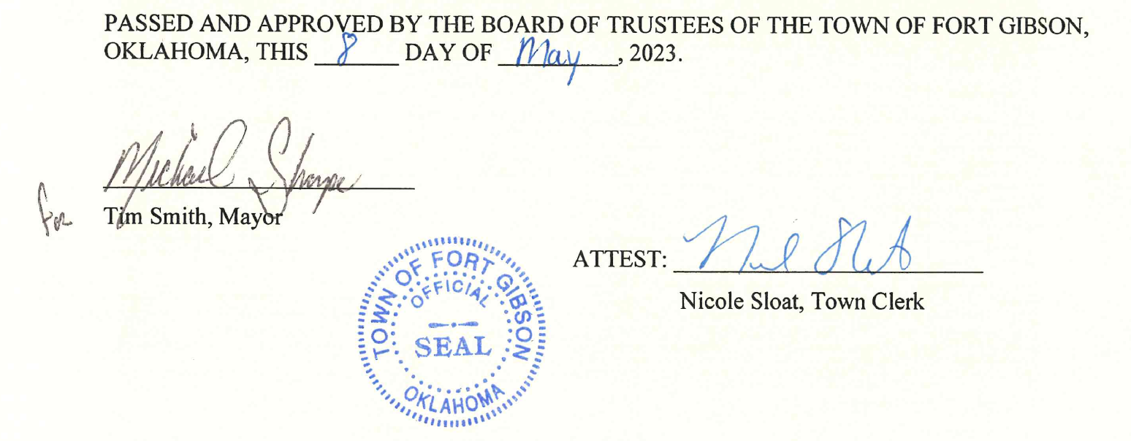
As amended on May 8th, 2023, and effective May 8th, 2023

