Insurance Coordinator – 8 Hour Day
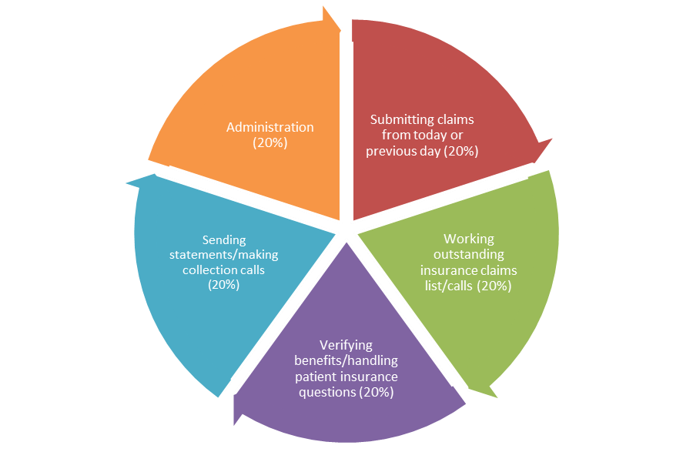
This graph illustrates how to break down an 8 hour day as the insurance coordinator. It breaks out five 1.5 hour portions of your day (20% each) to total 7.5 hours + .5 hour lunch.
As the insurance coordinator your day functions best when it is organized and well planned. You can use this graph to help you organize your day and ensure productivity.
Time Activity
8 AM – 9 AM

9 AM – 10 AM

10 AM – 11 AM

11 AM – 12 PM

12 PM – 1 PM

1 PM – 2 PM

2 PM – 3 PM

3 PM – 4 PM

4 PM – 5 PM

