E-Portfolio Assignment
Your final assignment of the semester is to create a process portfolio based on your research paper. A process portfolio includes not only finished work, but also shows the process you use to create it and reflects on what worked well and what could have been better. To begin, you will create an e-portfolio in Blackboard.
The My Portfolios page is the launching point for viewing, creating, and reviewing portfolios. Access the My Portfolios page from the global navigation menu at the top right of the page. Select Tools and click Portfolios. You can also access it from within any course by going to Communications & Tools and clicking Portfolios Homepage.
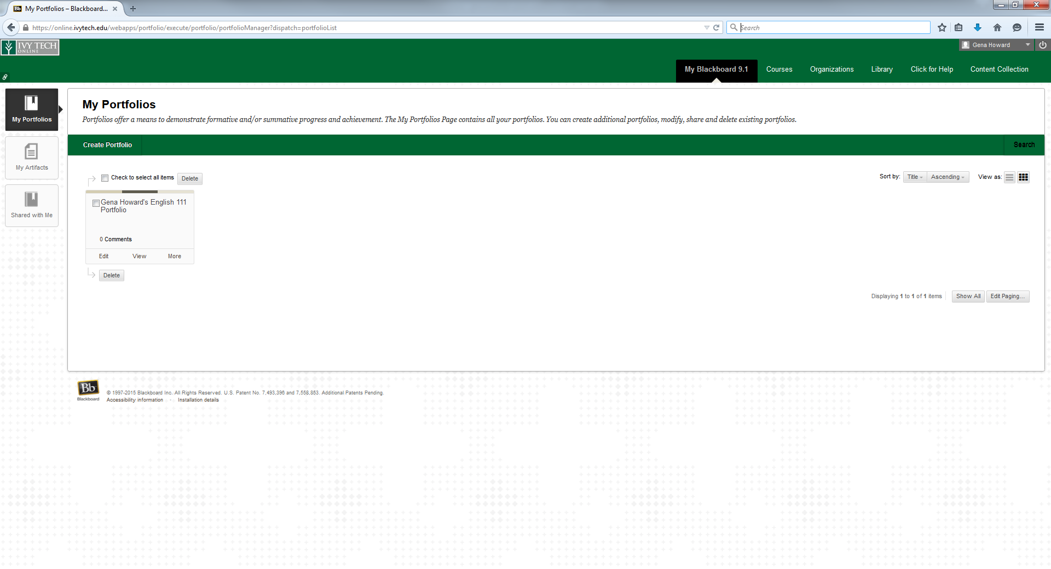
Creating a portfolio includes the following steps:
- Create a portfolio.
- Add pages and artifacts.
- Design the appearance.
- Determine the settings.

To Create your Portfolio:
Click “Create Portfolio” on the green bar.
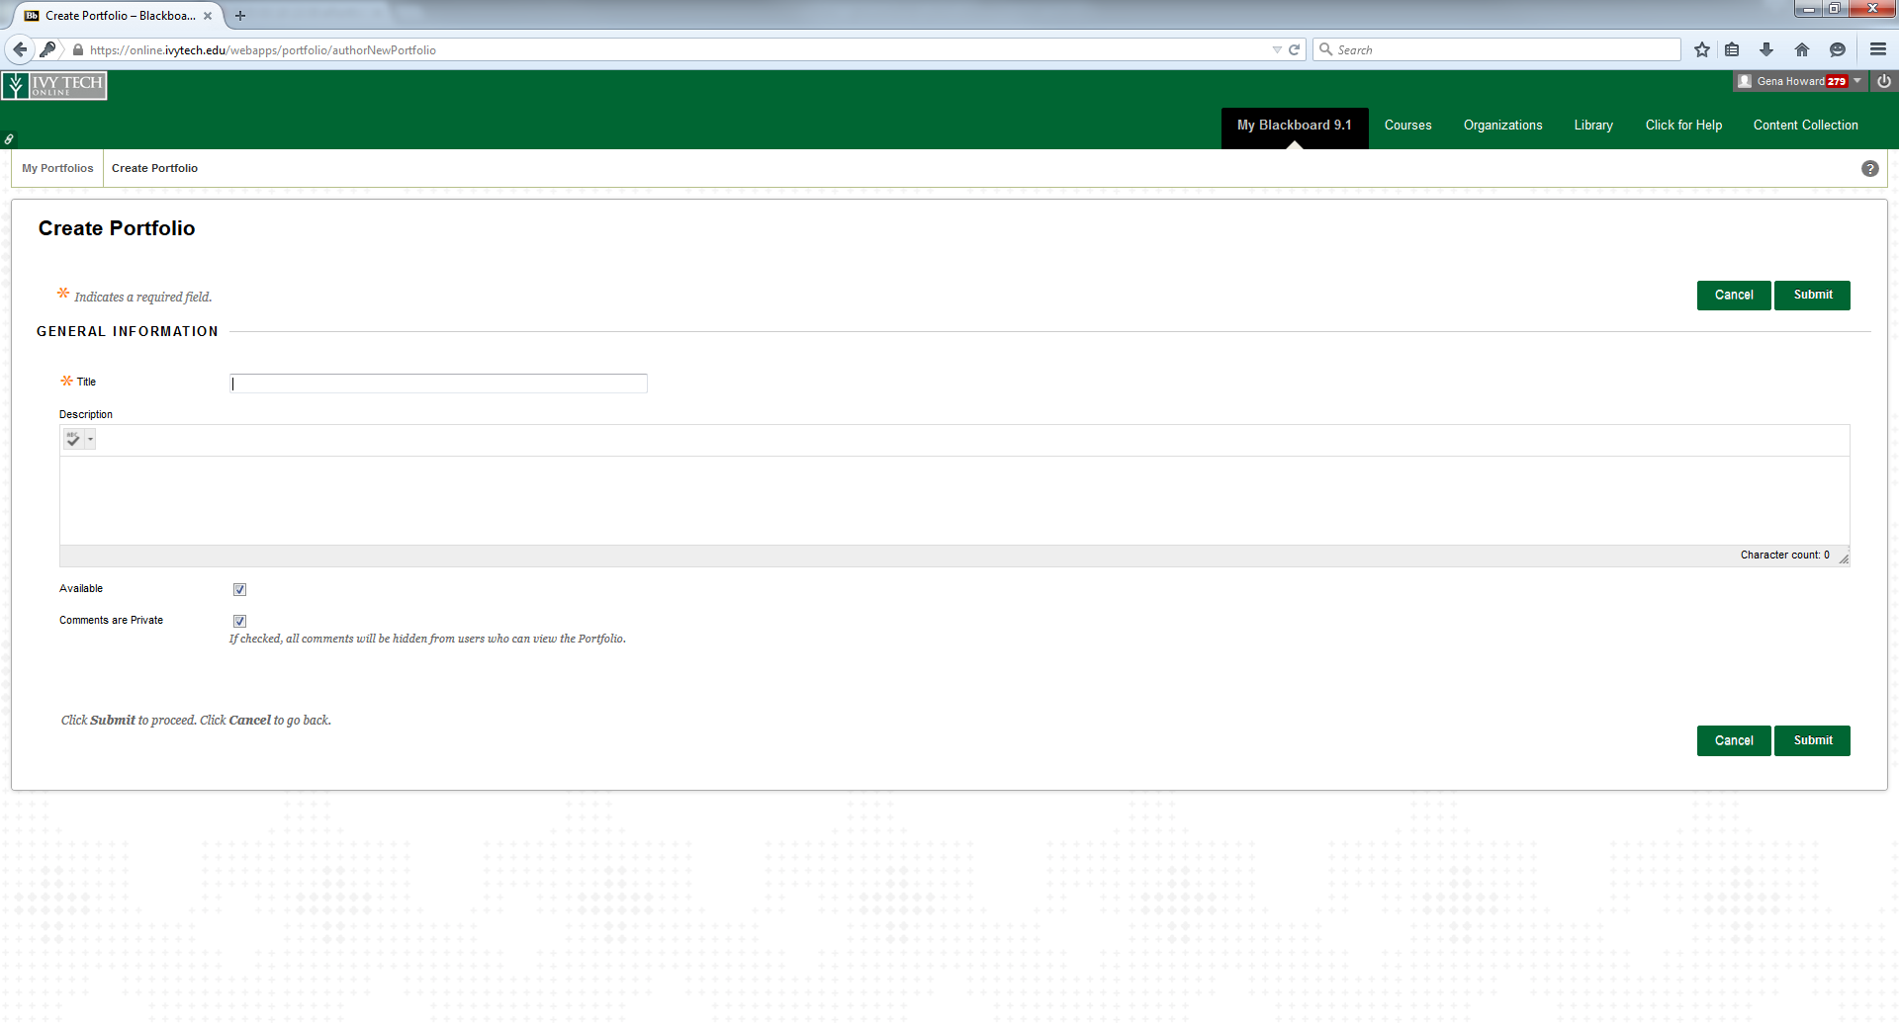
Enter a title for your portfolio. You can also enter a description if you choose but this is not required. Make sure that the availability box is checked then click submit. This will take you to a tour which you can go through or click Explore on My Own. You can always go back to the tour at any time by clicking the tour icon in the upper right corner.
Your design screen will look like this:
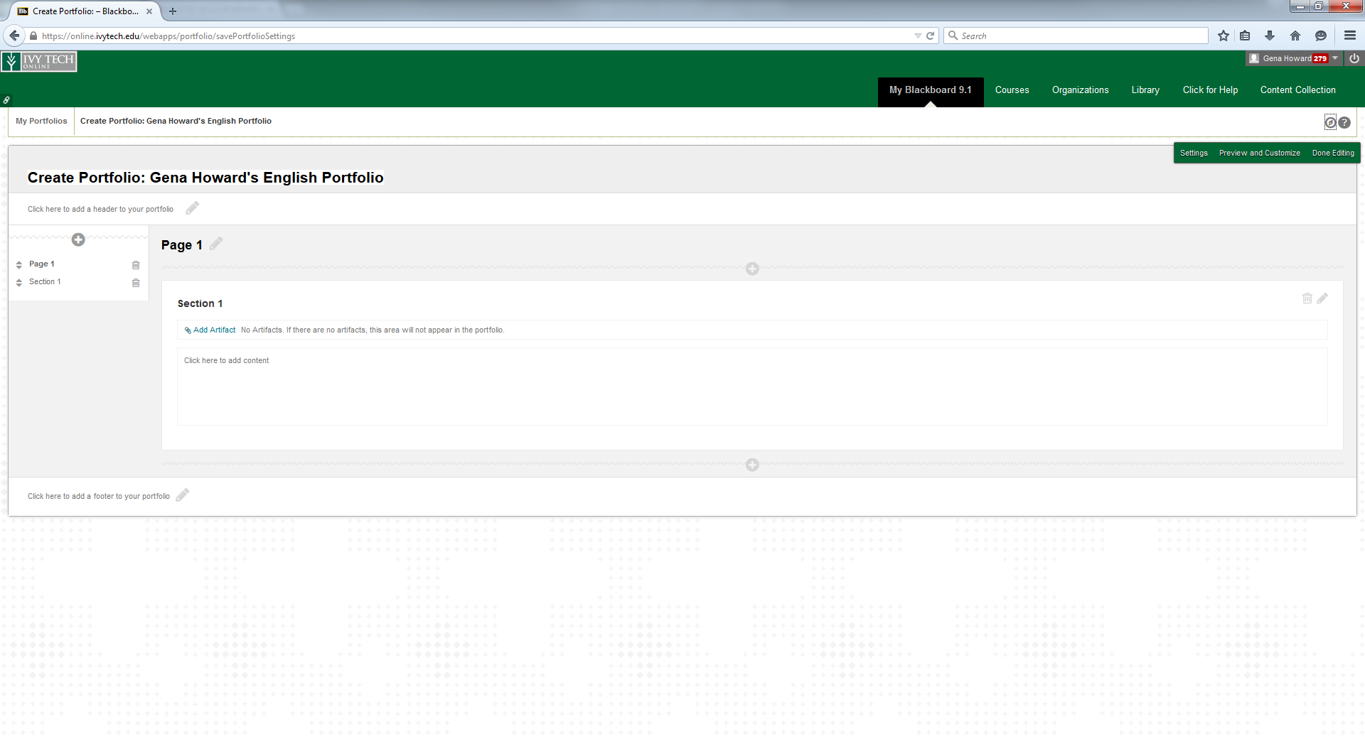
You will see pencil icons and plus icons in places where you can make changes and add material.
At the top and bottom you will see a header and footer that can be customized or left blank. I recommend you leave this blank until you have all of your materials added in and then decide if you want to use them. Anything in the header and footer will appear on every page of your portfolio.
Click on the pencil icon next to “Page 1”. Type the title Writer’s Statement or something similar.
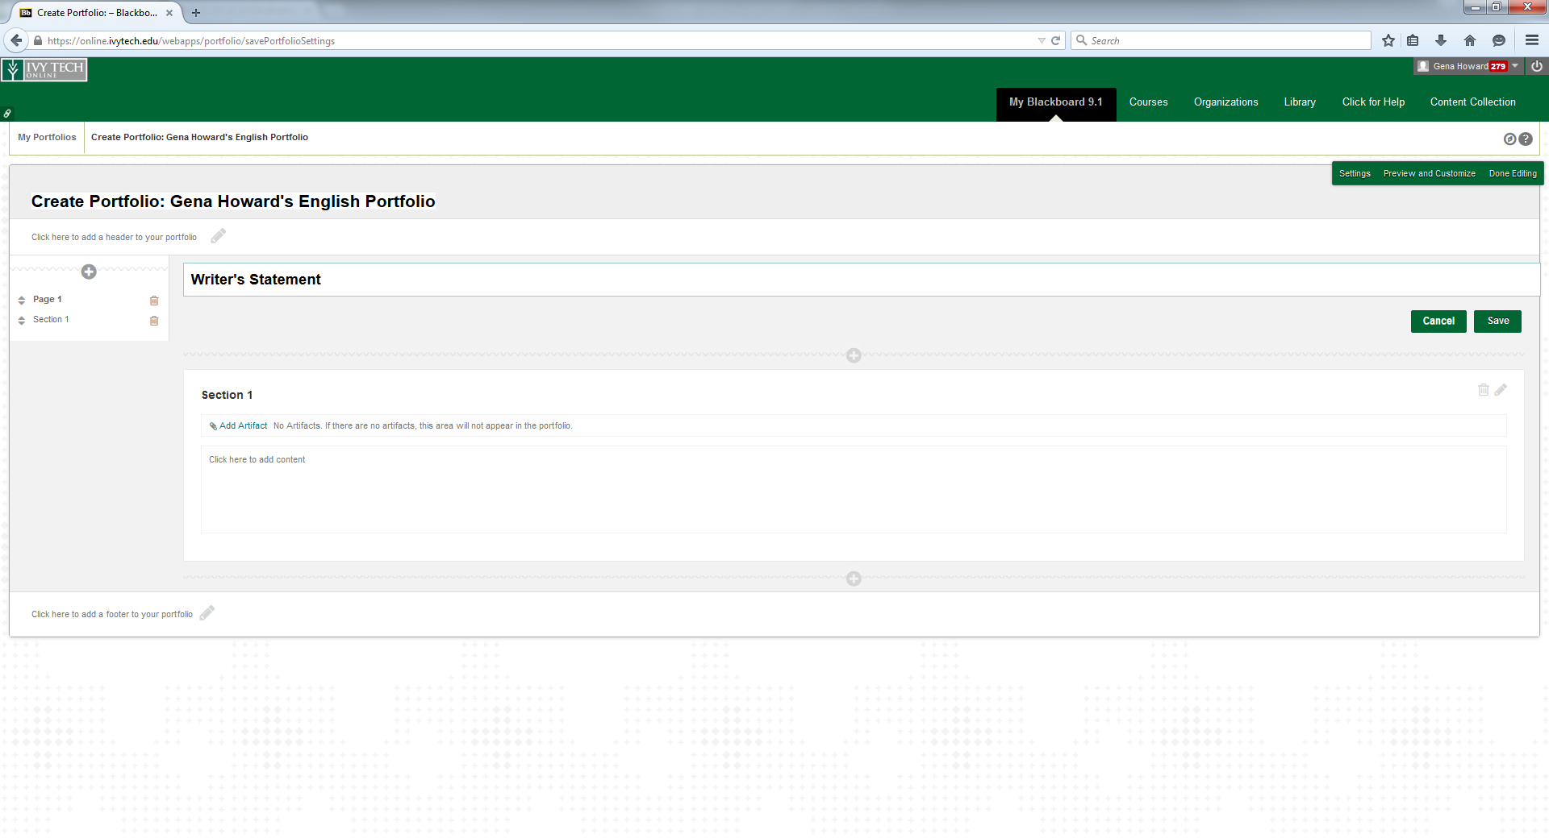
Then click in the section 1 box. This is where you will type or copy and paste your writer’s statement. Change the title from section 1 to something you feel captures your accomplishments in this class. Type or copy and paste your statement into the dialogue box. You can also add an image as long as it is appropriate.
When done, click both save buttons on the page and you will see the finished page. You can go back in and make changes by clicking the pencil icon again.
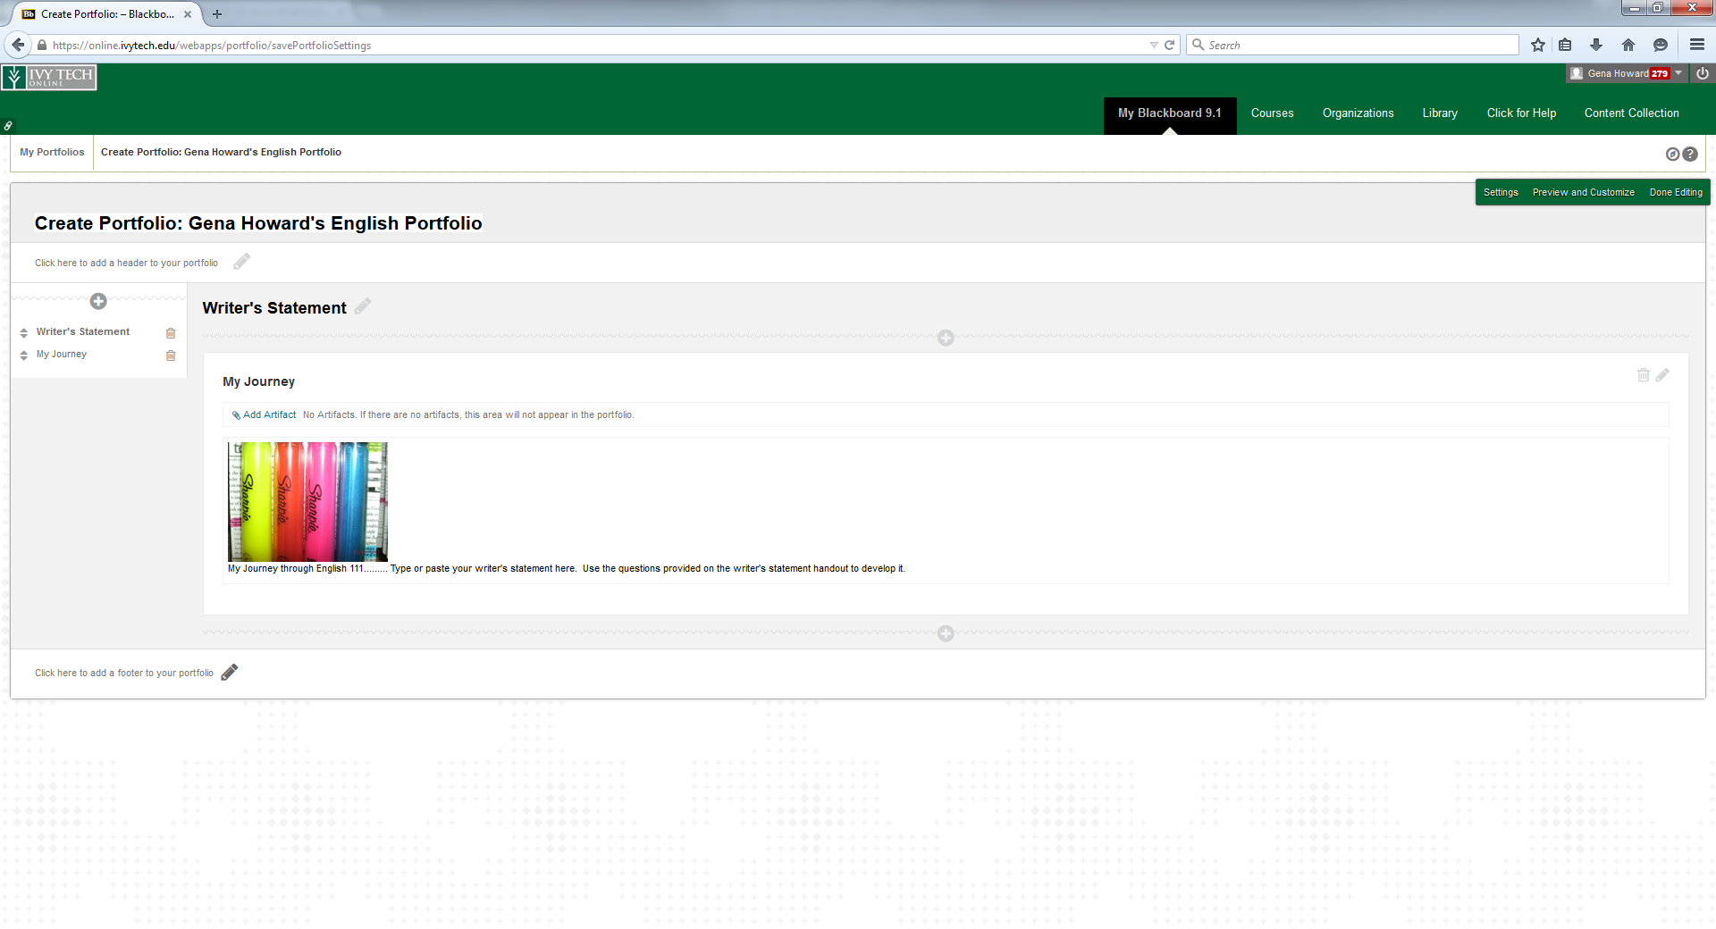

Now in the menu on the left you will see these titles. To add a new page, click the + button at the top of the menu. This creates a new page in your portfolio. You will be creating a page for each piece of the research project you include in the portfolio – Research Proposal, Annotated Bibliography, Zero Draft, Outline, Rough Draft, Final Draft.
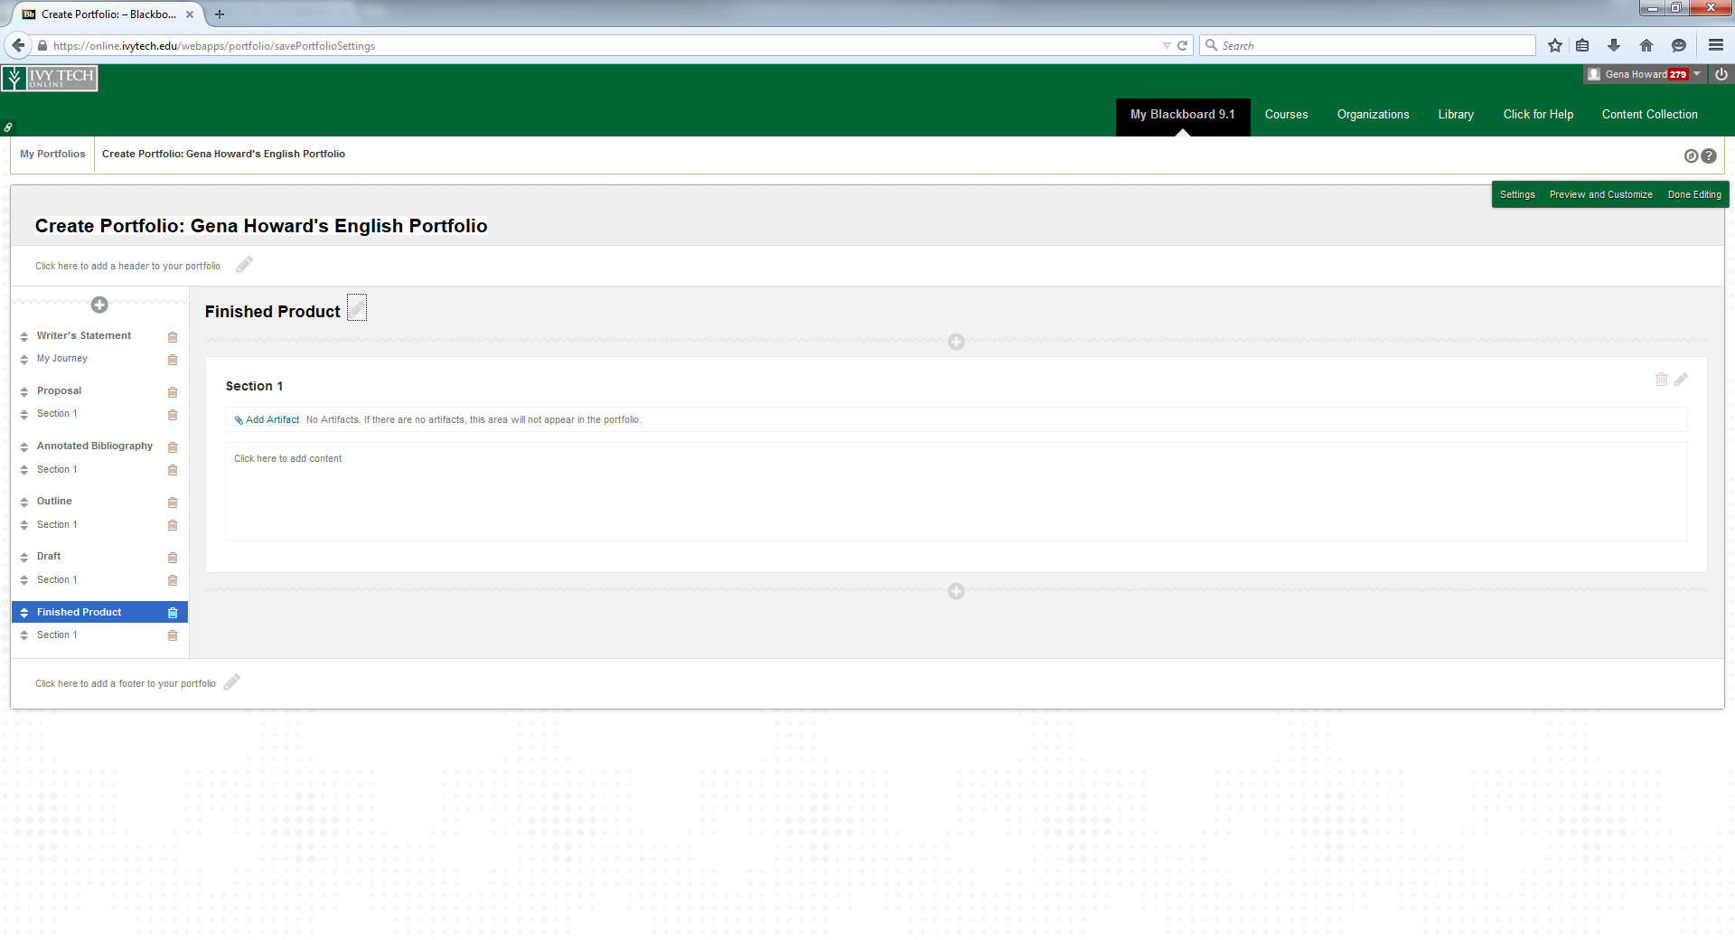
In the dialogue box for each page, you will write a little about how this one piece contributed to the whole project.
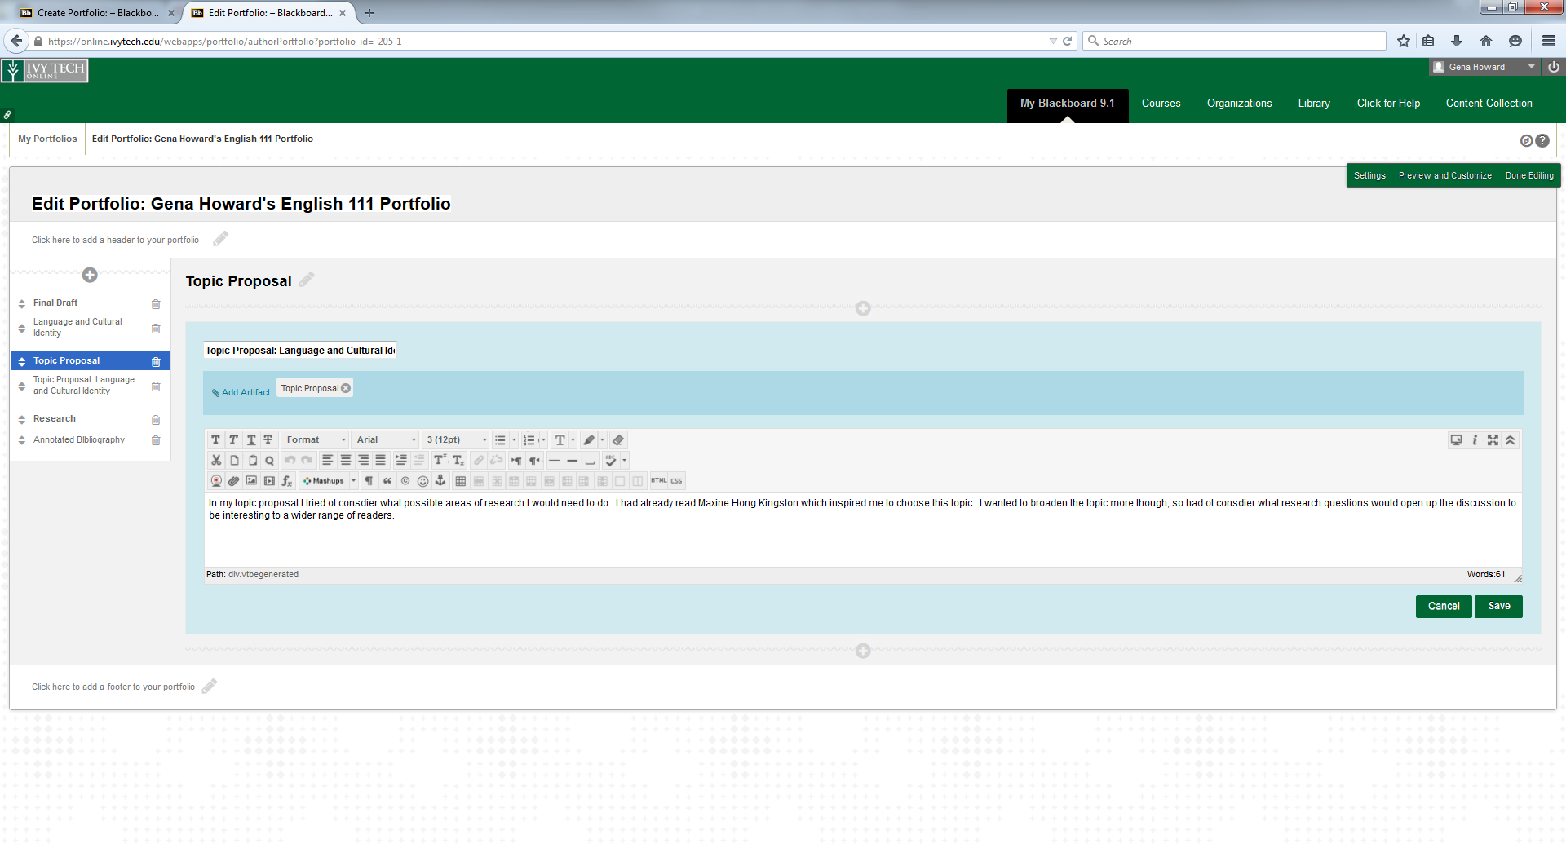
Change the section title and then click “Add Artifact” to attach your document created earlier this semester. You will be able to add something from the course or upload something from your flashdrive or computer.
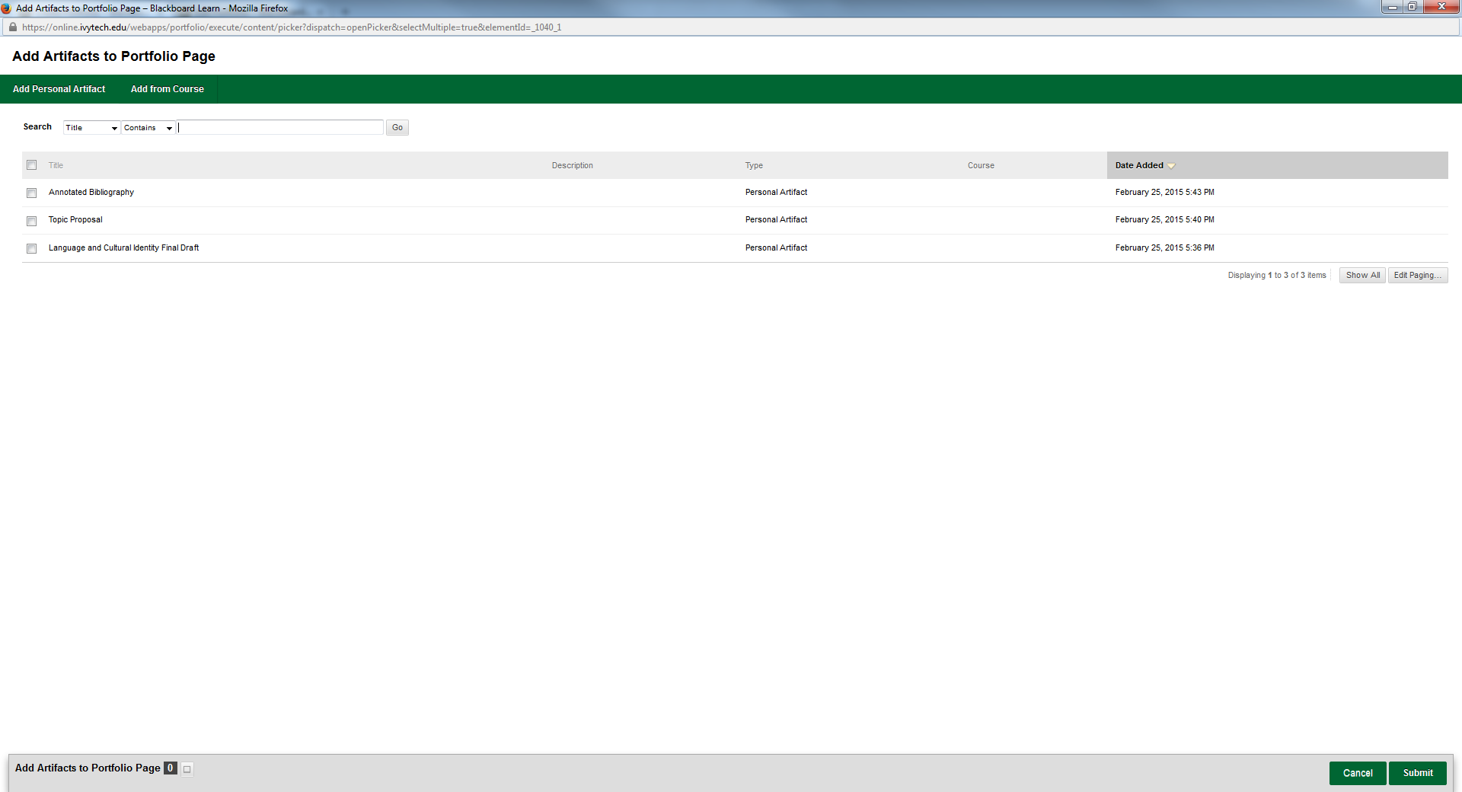
Once you have added something to a portfolio, it is saved in My Artifacts on your My Portfolios screen also and they can be used in any portfolio you create.
Continue to work through each page until you have all of your pages created.
Once you have all your pages completed, click Done Editing in the upper right corner. This will save all of your work and take you back to the My Portfolio page. You can then decide how you want your portfolio to look. Click View and your portfolio will open in the way that others will be able to see it.
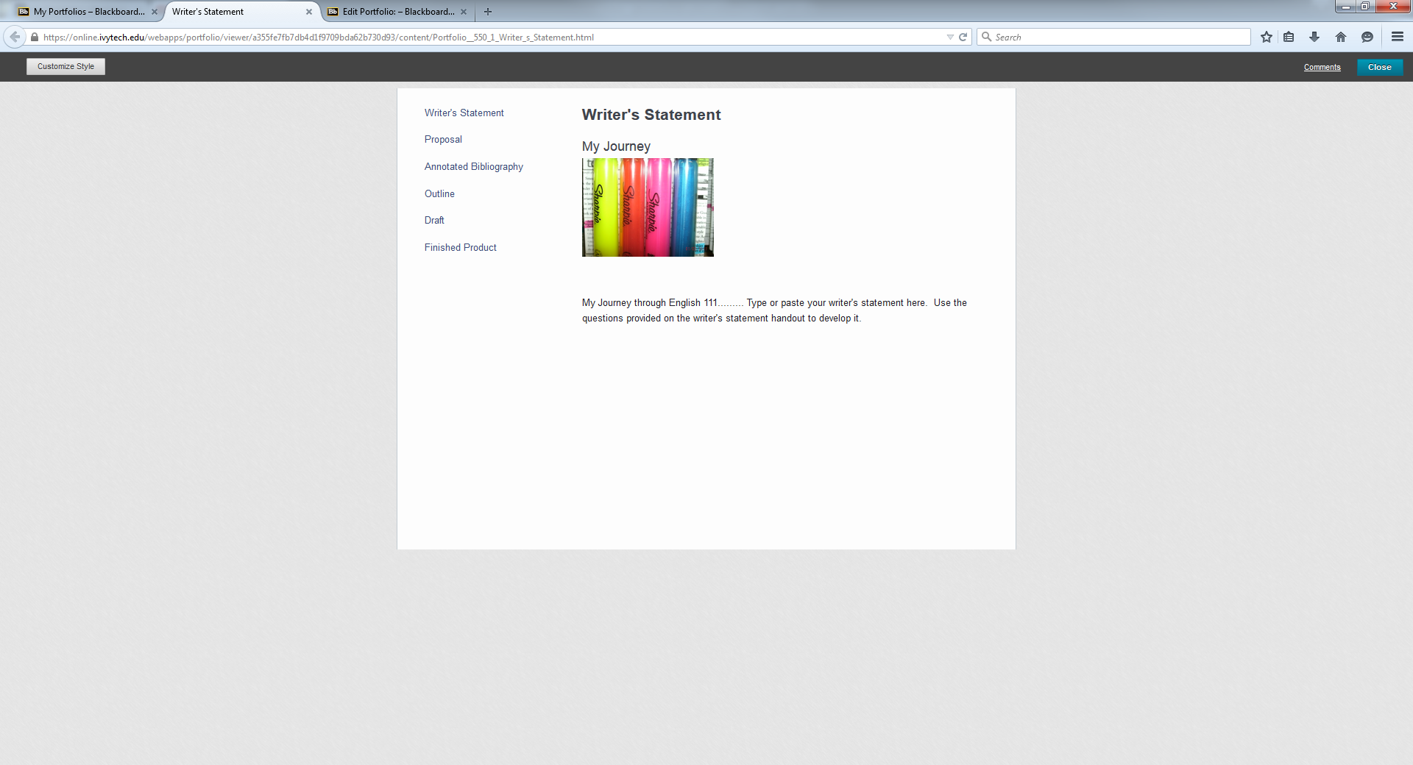
To customize the appearance click the “Customize Style button in the top left corner. You will then be able to try different layouts and backgrounds until you find a combination you like. Once you have them set, click save.
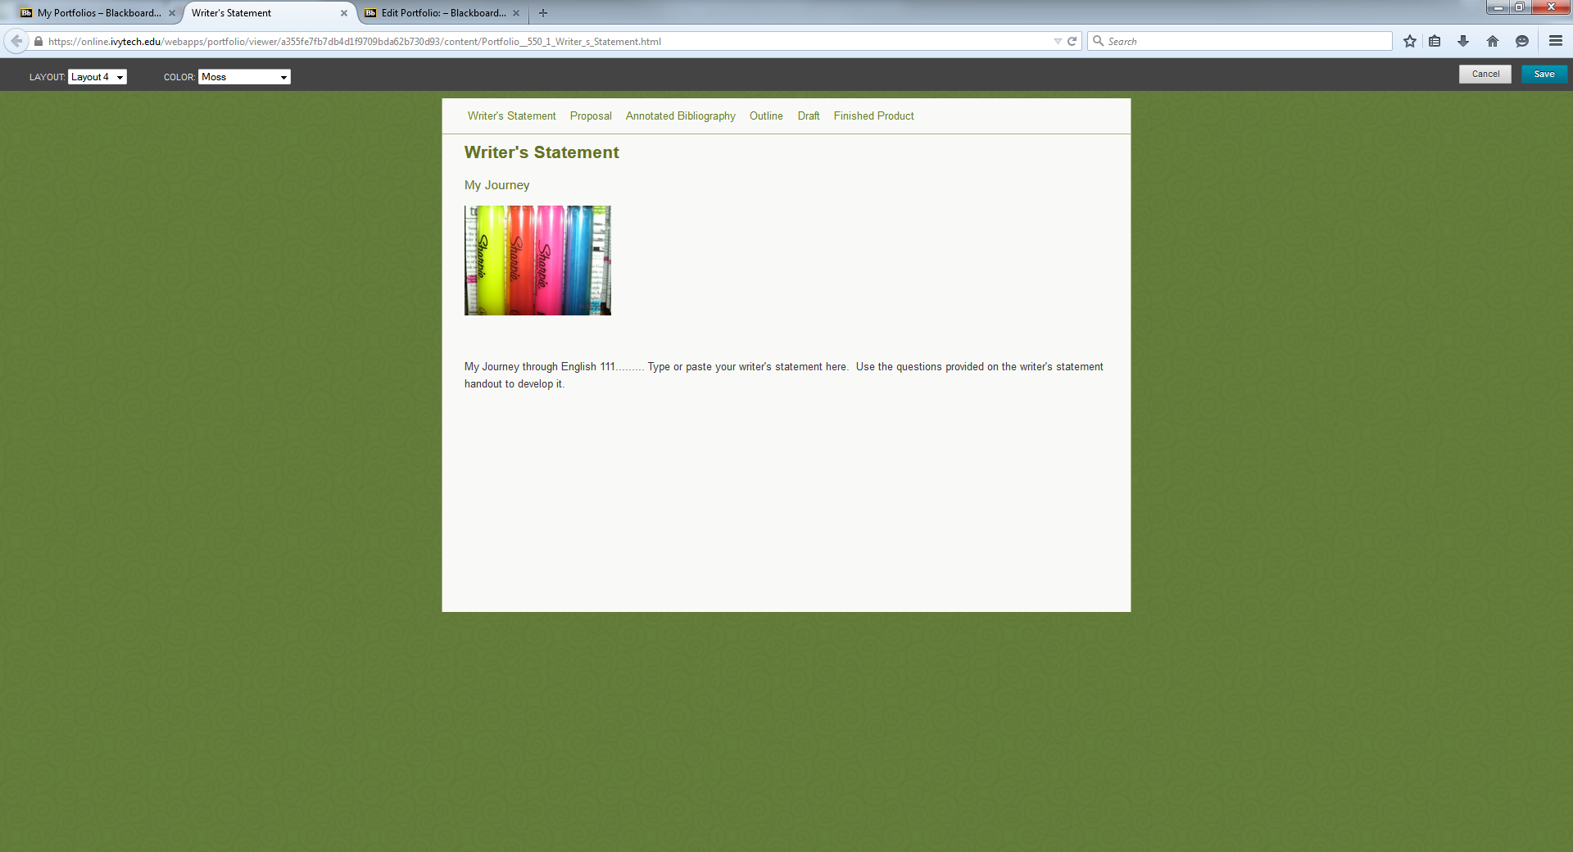
Now is also a good time to decide if you want to include a header and/or footer. You could include a quote for example that you feel sums up your feelings about writing or about your growth as a writer. Here is an example of one with a header.
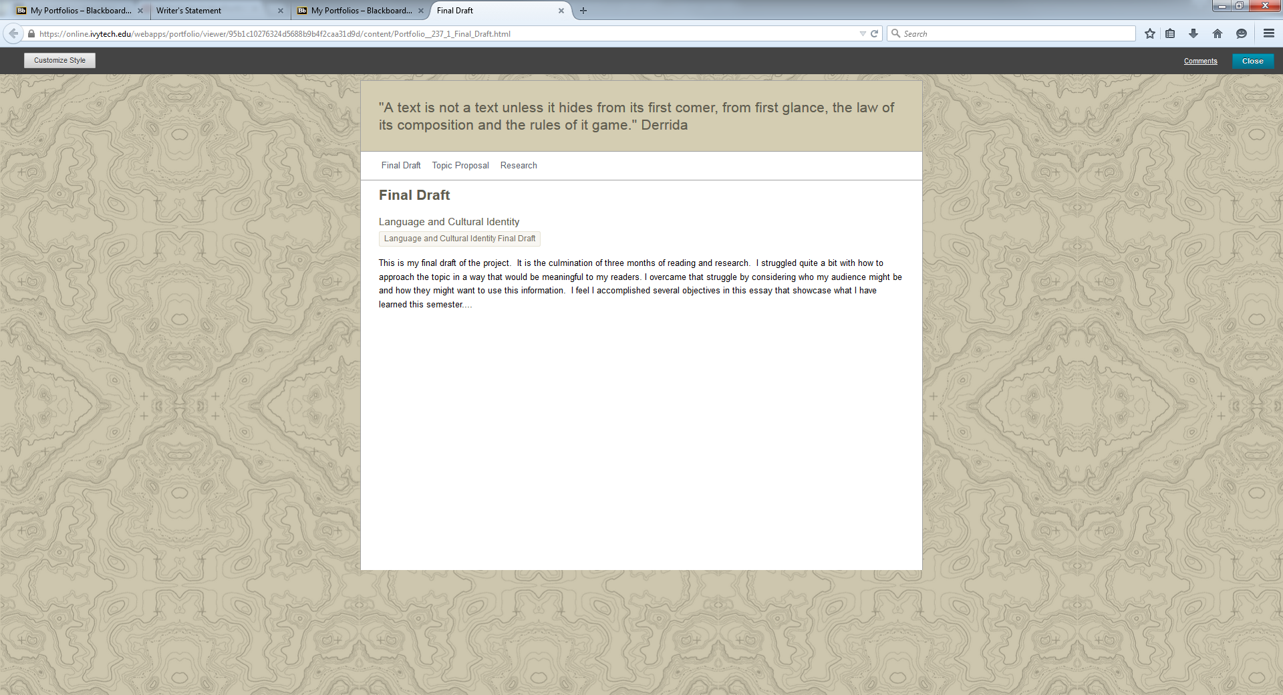
To create the header, click close first and then click the edit button for your portfolio. Click the pencil icon next to header or footer – wherever you want to add. Just remember it will appear on every page of your portfolio.

