Cameron Rehmani Seraji
Dr. Michelle Lum Dr. Demian Willette
Biology Lab 112 Section 14
14 April 2016
PGPR Analysis Bacillus pumilus and Micrococcus luteus
Introduction
The rhizosphere is a highly favorable habitat for the proliferation of microorganisms and exerts a potential impact on plant health and soil fertility (Sorensen, 1997). There are many microorganisms that live within the rhizosphere of plant roots. Microorganisms can be free-living, parasites, or organisms that live on dead or decomposing matter. An important group of these microbial communities that exerts beneficial effects on plant growth upon root colonization were first defined by Joseph Kloepper and Milton Schroth and termed as plant growth-promoting rhizobacteria (PGPR) (Kloepper & Schroth, 1978). PGPR promote plant growth by nitrogen fixation, increasing supply of other nutrients, enhancing beneficial bacteria, and controlling pathogens. Plant growth enhanced by PGPR is quantified as an increase in seedling emergence, vigor, biomass, proliferation of root system and yield in various plant species (Podile, 2006).
For this study, the beneficial effect on plant growth of PGPR by isolating bacteria from the rhizosphere, making biological and molecular characteristics, and determining if they have plant growth promoting activity in the rhizosphere was tested. The hypothesis was that PGPR have plant growth promoting activity and will have a less harmful impact on the environment than chemical fertilizers. PGPR is a bio fertilizer that can be used to promote more sustainable agricultural practices. Cowpea (Vigna unguiculata) seeds will be inoculated with rhizobacteria that was isolated from soil taken around the California Sage Shrub (Artemisia californica) located at Kenneth Hahn Park. To quantify the results, we analyzed PCR samples and our plants to see which had the most growth.
Materials and Methods
Isolating Bacteria from the Rhizosphere
A California Sage Scrub from Kenneth Hahn Park was chosen to isolate bacteria from the rhizosphere. A five cm piece of root was cut from the plant, sterilized, placed in ten ml of saline, and vortexed. Then serial dilutions of 10^{-2,} 10^{-3,} and 10⁻⁴ were made. 100 ul of bacteria from each dilution was pipetted on three TY plates. Plates were incubated for one week at 28°C.
Isolating Bacteria from the Nodule
To isolate bacteria from the nodule, a nodule was cut from the root of California Sage Scrub and sterilized. Then serial dilutions of 10⁻¹, 10⁻², and 10⁻³ were made. 100 ul of bacteria from each dilution was spread onto three TY plates. Plates were incubated for one week at 28°C.
Screening the Bacteria for Plant Growth-Promoting Properties
After one week, 16 isolated colonies were selected from the spread plates to be used for further analysis. Colony shape, margin, surface, and color were documented for all sixteen colonies. A sample from each colony was plated on a different type of plate to test for the different characteristics of PGPR. Bacteria were streaked on a nitrogen free plate, a plate containing calcium phosphate, a TY plate containing 5mM tryptophan, a plate containing Carboxymethylcellulose (CMC), and a M9 minimal media with ACC as the sole nitrogen source. Plates were incubated for one week at 28°C. After another week, choose four isolates to further analyze. Prepare streak plates by touching a sterile loop to the bacteria from the TY plate with 16 streaks. Incubate for one week at 28°C.

Planting Seeds to test for Plant Growth Promotion
The hydroponic setup use three plant boxes. Place one wick and one basket into each of the six holes in each of the black boxes. Fill the baskets 2/3 full with pumice. Make sure the wick reaches the bottom of the box. Seeds are prepared in a glass beaker and covered with 1.5% sodium hypochlorite. After 15 minutes, rinse seeds with sterile dH₂O five times. Use 95% EtOH to sterilize forceps, then transfer two seeds to each basket. Cover the seeds with more pumice and fill each plant box with 1.1L of ¼ strength Hoagland’s –N. Label boxes and place on plant growth rack.
Further Bacterial Screening
Choose two of the four isolates to prepare new TY streak plates for. Incubate for one week at 28°C.
Analysis of Colony Morphology
Prepare gram stains of the isolates to document the cellular morphology. Obtain two clean grease-free microscope slides. Pipette ten ul of sterile water onto each slide. A small amount of bacteria from a single colony was picked up and smeared in water and the slides were air-dried. The smears were heat-fixed by passing it through the Bunsen burner flame. Flood the smears with crystal violet. After one minute gently rinse smear with water. Next, flood the smears with Gram’s Iodine solution for one minute and rinse off with water. Cover smear with 95% ethanol, tilt back and forth, and drain off alcohol. Repeat several times until there is no purple then rinse off with water. Cover smear with safranin solution for one minute then rinse off with water. Dry and examine smears with a light microscope.

Inoculation of Plants
To prepare the bacteria inoculums obtain two tubes of five ml sterile saline. Use a sterile swab to collect bacteria from the TY plate and swirl swab in the saline to remove the bacteria then vortex the bacteria. Measure the absorbance of the bacteria. Obtain one cuvette for each strain. Pipette one ml of bacteria and one ml of saline into the cuvette. Blank the spectrometer, then measure the absorbance at 600 nm and multiply by two as the bacterium was diluted.
Retesting PGPR Properties
Obtain a phosphorous solubilization plate, CMC agar plate, Ty + trp plate, Nitrogen free, ACC deaminase plate, TY plate, and two NYDA plates. Divide each of the plates, except for the NYDA plates, in half. Apply two ul of an isolate to three well-separated spots on each side of the plate. Let the plates dry then incubate agar side up. The procedure will be repeated for NYDA plates, except that they will not be divided in half. One isolate will be plated on each plate.
Testing for Plant Growth Promotion
If two seedlings have germinated in a basket from the plant box, remove one of the seedlings. Pipette 3.5 ml of saline into one of the plant boxes. Label it control. Pipette 3.5 ml of the bacterial solution into each of the appropriately labeled boxes.
Preparation of Lysates
Obtain a microfuge tube with 200 ul of sterile water for each isolate. Obtain bacteria by using a yellow tip to scrape up a visible amount of bacteria and suspend in water then vortex well. Place the microfuge tube on dry ice for 3 minutes then the 95°C heat block for 3 minutes. Vortex and repeat 2 additional times. Vortex a final time at 12,000 rpm for 1 minute and immediately place on ice.

PCR Amplification from Lysates
Pipette 10 ul of the appropriate bacterial lysate into the PCR tube. Pipette to mix. Place samples in rack designated for PCR amplification.
PGPR Properties Analysis
Flood CMC plate with gram’s iodine and look for clearings. Look for clearings on the phosphate solubilization plate. Place the nitrocellulose membrane from the R2A + trp plate onto a dish of salkowski reagent, wait 30 minutes, and look for red halos. Look for growth on nitrogen free and ACC plate. Photograph all plates.
Analysis of Antimicrobial Properties
For the fungal inoculation, take a sterile swab, touch the swab to the fungus on the stock plate and touch it to the center of the NYDA plate. Repeat for 2nd fungus. Parafilm plates and incubate. For the bacterial inoculation, obtain 3 sterile microfuge tubes. Aseptically add 200 ul of saline to each tube. Pick up 1-3 colonies with a sterile pipette tip, suspend the inoculum in the saline, and vortex well. Pipette 2 ul of the S. aureus on either side of the top spots. Repeat for E. coli and P. aeruginosa, but pipette on either side of the middle spots and the bottom spots, respectively.
Permanent Stocks Preparation
Obtain 2 tubes of YMB broth + 15% glycerol and label with isolate. Scrape up 3-4 colonies and suspend in the tube by vortexing. Place in the rack on ice.
Gel Electrophoresis of PCR sample
Pipette 10 ul from the PCR and transfer it to a microfuge tube. Return PCR tube to ice bucket. Add 2 ul of 6X loading dye to the microfuge tube of PCR sample. Load 5 ul of the each sample to the appropriate well. Do not go to the 2nd stop on the pipette. Once all samples have been loaded, cover the unit and plug in the cables to their respective colors. Apply 100 volts and run for 35 minutes. Once finished, examine gel using a transilluminator.
Plant Analysis
Compare the leaf color of the plants to the –N control. For each of the 36 plants that grew, separate the roots from the shoots. Record the length of each shoot and root then wrap separately in tin foil. Measure the mass of the foil before putting the roots and shoots in. After the shoots and roots dry, weigh the mass of them with the foil then subtract the mass of the foil. Determine if there is a statistical difference using ANOVA. Go to the ANOVA website and choose the One-Way ANOVA. Enter the data, click independent samples, click unweighted, and click calculate.
Co-Inoculation of Isolates 5 and 14
Planting Seeds to test for Plant Growth Promotion
The hydroponic setup used four plant boxes and one wick and one basket for each of the six holes in the black boxes. Fill the baskets 2/3 full with pumice. Make sure the wick reaches the bottom of the box. Seeds are prepared in a glass beaker and covered with 1.5% sodium hypochlorite. After 15 minutes, rinse seeds with sterile dH₂O five times. Use 95% EtOH to sterilize forceps, then transfer two seeds to each basket. Cover the seeds with more pumice and fill each plant box with 1.1L of ¼ strength Hoagland’s –N. Label boxes and place on plant growth rack.
Testing for Plant Growth Promotion
If two seedlings have germinated in a basket from the plant box, remove one of the seedlings. Pipette 3.5 ml of saline into one of the plant boxes. Label it control. Pipette 3.5 ml of the bacterial solution into each of the appropriately labeled boxes. Pipette 2.5 ml of each isolate into the fourth box and label it co-inoculation.
Preparation of Lysates
Obtain a microfuge tube with 200 ul of sterile water for each isolate. Obtain bacteria by using a yellow tip to scrape up a visible amount of bacteria and suspend in water then vortex well. Place the microfuge tube on dry ice for 3 minutes then the 95°C heat block for 3 minutes. Vortex and repeat 2 additional times. Vortex a final time at 12,000 rpm for 1 minute and immediately place on ice.
PCR Amplification from Lysates
Pipette 10 ul of the appropriate bacterial lysate into the PCR tube. Pipette to mix. Place samples in rack designated for PCR amplification.
Gel Electrophoresis of PCR sample
Pipette 10 ul from the PCR and transfer it to a microfuge tube. Return PCR tube to ice bucket. Add 2 ul of 6X loading dye to the microfuge tube of PCR sample. Load 5 ul of the each sample to the appropriate well. Do not go to the 2nd stop on the pipette. Once all samples have been loaded, cover the unit and plug in the cables to their respective colors. Apply 100 volts and run for 35 minutes. Once finished, examine gel using a transilluminator.
Plant Analysis
Compare the leaf color of the plants to the –N control. For each of the 24 plants that grew, separate the roots from the shoots. Record the length of each shoot and root then wrap separately in tin foil. Measure the mass of the foil before putting the roots and shoots in. After the shoots and roots dry, weigh the mass of them with the foil then subtract the mass of the foil. Determine if there is a statistical difference using ANOVA. Go to the ANOVA website and choose the One-Way ANOVA. Enter the data, click independent samples, click unweighted, and click calculate.
Results
Isolation of Rhizobacteria
A California Sage Scrub plant was collected from Kenneth Hahn Park. The soil had a pH of 6.40 and a salinity of 129 ppm. Isolate 14CRJM05 is the first isolate that was observed. It had positive results from gram staining (Fig. 1). A round shape, curled margin, wrinkled surface, and white color was observed through a light microscope. From the gram stain, the colonies appear to rod-shaped and occur in clusters and chains (Fig. 2). There are some empty areas, which means that the isolate has spores. The second isolate 14CRJM14. It had a positive result from gram staining. A round shape, curled margin, smooth surface, and yellow color were observed through a light microscope. The colonies appear to be irregular in shaped and occur in clusters and sporadically. There are some empty areas like isolate 14CRJM05, which means it is has spores.
Screening for PGPR Characteristics
Isolate 14CRJM05 was chosen because it was one of three isolates to show signs of phosphate solubilization on the first bacterial analysis. Isolate 14CRJM14 was chosen because it was one of two isolates to show signs of Auxin production on the first bacterial analysis. 14CRJM05 tested positive for phosphate solubilization again, negative for Auxin production, negative for Cellulase activity, negative for Nitrogen fixation, and negative for ACC deaminase activity (Table 2). 14CRJM14 tested positive for phosphate solubilization, negative for Auxin production, negative for Cellulase activity, positive for Nitrogen fixation, and there was no determination for ACC deaminase activity (Table 2). In addition, for phosphate solubilization, isolate 14CRJM14 had larger halos, but isolate 14CRJM05 had halos spread farther in relation to its size. After 2 weeks of growth, the control plant and the plant inoculated with isolate 14CRJM05 have more growth than the plant inoculated with 14CRJM14.
Plant Growth
The control plant did better than the bacteria inoculated plants in measurements of leaf count, root dry weight, root length, and shoot length. There was a statistical difference found between the control and 14CRJM14 inoculated plants in root length (Fig. 5).
Sequence Analysis
Upon analysis and sequencing of 14CRJM05, it was discovered that it is most likely a strain of Bacillus pumilus. Isolate 14CRJM14 was unable to be analyzed and a match was unable to be determined because the original sequence of the isolate was too short to match. The phylogenetic tree shows Bacillus pumilus and it relative to the other strains from the lab.
Co-Inoculation of Isolates 5 and 14
Plant Growth
Isolate 14JMCR14 did better in measurements of root dry weight (Fig. 7). The co-inoculation did in measurements of shoot dry weight and shoot length (Fig. 8 and 10). Bacillus Pumilus did better in measurements of root length (Fig. 9). There was no statistical difference found between any of the samples.
Sequence Analysis
Upon analysis and sequencing of 14CRJM14, it was discovered that it is most likely a strain of Micrococcus luteus. A phylogenetic tree was made with Micrococcus luteus and Methanocaldococcus (Fig. 12).

Discussion
The beneficial effect of bacteria isolated from the rhizosphere on plant growth, observing characteristics of bacteria, and discovering if the rhizosphere has plant growth promoting activity were tested in this experiment. Based on morphological observation and bacterial analysis, two isolates were found and tested to see if they promoted plant growth through the rhizosphere. Table 1 shows that isolate 14CRJM05 and isolate 14CRJM14 had similar results for the gram stain, shape, margin, and occurrence of spores. However, fig.1 and fig. 2 present a difference between the isolates. Fig. 2 shows the gram stain for isolate 14CRJM14 and the arrangement of the bacteria appears different then isolate 14CRJM05. Isolate 14CRJM14 has more irregular shaped colonies and has more large, observable clearings. Colony morphology similar to isolate 14CRJM05 had been reported in another study (Majeed et al., 2015).
The second bacterial analysis came up with some results that were different then the first bacterial analysis. Both of the isolates tested positive for phosphorus solubilization this time. However, there was a contamination on the first phosphorous solubilization plate, which may have interfered with the first data analysis. A previous study has shown that the phosphate solubilization is a major mean of attaining early growth promotion in wheat (Khalid et al., 2004). There was no determination for ACC deaminase activity for isolate 14CRJM14 because the same media is used to test for nitrogen fixation. Therefore it is unknown if the isolate is fixing nitrogen or if ACC deaminase is present.
After the growth of the plants had been stopped, it appeared that neither of the two isolates had PGPR characteristics. The growth of the –N control, Bacillus pumilus, and Micrococcus luteus all appeared to be the same. The measurement of root and shoot weights and heights confirmed that except for there was a statistical difference in the average root length. In addition, the co-inoculation of both isolates did not provide data that it would be a stronger PGPR than the two isolates, individually. To summarize, this study has provided insight into the effects promoting through the rhizosphere has on plant growth. Isolate 14CRJM05 and isolate 14CRJM14 both do not show signs of being PGPRs. Therefore, these isolates do not offer potential to be used as biofertilizers.
References
Khalid, A., Arshad, M., and Zahir, Z. A. (2004). Screening plant growth promoting rhizobacteria for improving growth and yield of wheat. J. Appl. Microbiol. 46, 473–480. doi: 10.1046/j.1365-2672.2003.02161.x
Kloepper, J. W., & Schroth, M. N. (1978). Plant growth promoting rhizobacteria on radishes. In Proceedings of the fourth International Conference on Plant Pathogenic Bacteria (Vol. 2). (pp. 879-892). Argers, France: Station de Pathologie Vegetale et Phytobacteriologyie, INRA.
Majeed, A., Abbasi, M., Rahim, N., Hameed, S., and Imran, A. (2015). Isolation and characterization of plant growth-promoting rhizobacteria from wheat rhizosphere and their effect on plant growth promotion. Frontiers In Microbiology. (2015, Mar); 61-10.
Podile, Appa Rao, and G. Krishna Kishore. “Plant Growth-promoting Rhizobacteria.” Plant-Associated Bacteria: 195-230. Web.
Sorensen, J. (1997). The rhizosphere as a habitat for soil microorganisms. In J. D. van Elsas, J. T. Trevors & E. M. H. Welington (Eds.). Modern Soil Ecology (pp. 21-46). New York: Marcel Dekker, Inc.

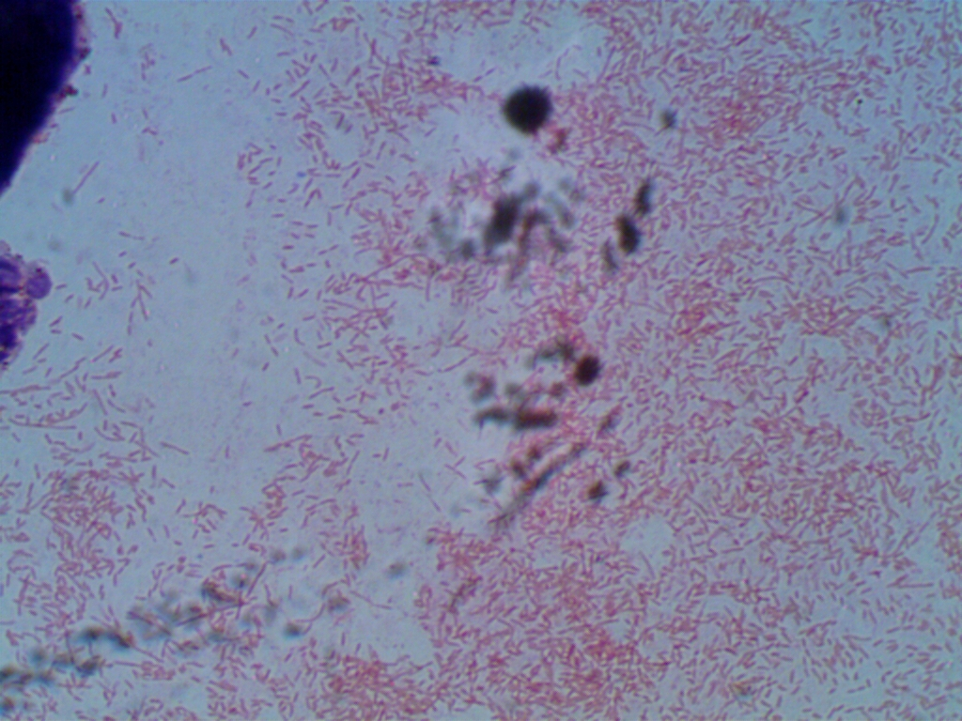
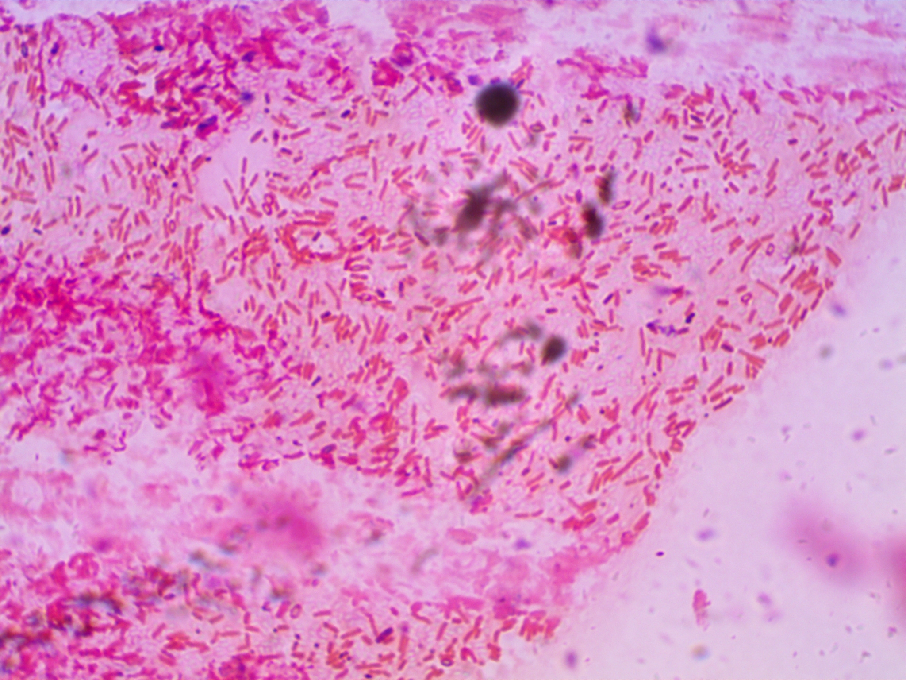
Tables & Figures

Figure 2: Gram Stain of Isolate 14CRJM14.
Figure 1: Gram Stain of Isolate 14CRJM05.

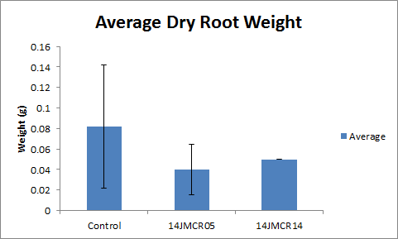
Fig 3: Graph of the averages of the root lengths taken from the 3 different inoculation conditions. As can be seen, the control condition had the most growth, in terms of weight, but there was no deviation for the plants inoculated with 14JMCR14. Upon statistical analysis, there was no significant difference found between the 3 conditions (F=1.35, P=0.295926, no statistical difference).

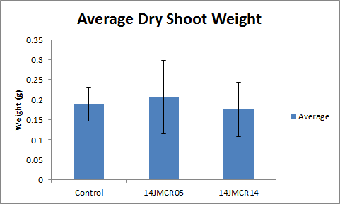
Fig. 4: The averages of the dry shoot weights taken from each of the 3 inoculation conditions. In this case, the plants inoculated with 14JMCR05 had the largest dry shoot weight. Upon statistical analysis, there was no statistically significant difference between the 3 conditions (F=0.25, P=0.782758, no statistical difference)
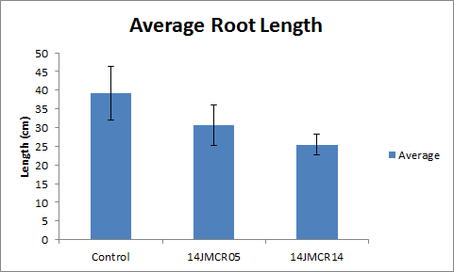

Fig. 5: The average root lengths taken from each of the 3 inoculation conditions. In this case, the plants in the control condition had the largest root growth, averaging approximately 39 centimeters. Upon statistical analysis with ANOVA, a statistically significant difference was found between the control and the plants inoculated with 14JMCR14 (F=7.06, P=0.009403, statistical difference).

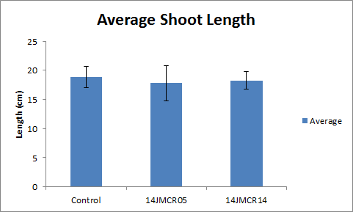
Fig. 6: The average shoot length was taken from each of the 3 conditions. In this case, all of the plants were extremely similar, but control outdid the others with growth averaging approximately 18.8 cm. Upon statistical analysis, there was no statistically significant difference between the 3 conditions (F=0.26, P=0.775285, no statistical difference).

Fig. 7: The averages of the dry root weights taken from each of the 4 inoculation conditions. In this case, the plants inoculated with 14JMCR14 had the largest dry root weight. Upon statistical analysis, there was no statistically significant difference between the 4 conditions (F=0.91, P=0.454, no statistical difference)

Fig. 8: The averages of the dry shoot weights taken from each of the 4 inoculation conditions. In this case, the plants co-inoculated had the largest dry shoot weight. Upon statistical analysis, there was no statistically significant difference between the 4 conditions (F=0.39, P=0.7615, no statistical difference)

Fig. 9: The averages of the root lengths taken from each of the 4 inoculation conditions. In this case, the plants inoculated with 14JMCR05 had the largest root length. Upon statistical analysis, there was no statistically significant difference between the 4 conditions (F=2.92, P=0.059186, no statistical difference)

Fig. 10: The averages of the shoot lengths taken from each of the 4 inoculation conditions. In this case, the plants co-inoculated had the largest root length. Upon statistical analysis, there was no statistically significant difference between the 4 conditions (F=0.89, P=0.463316, no statistical difference)
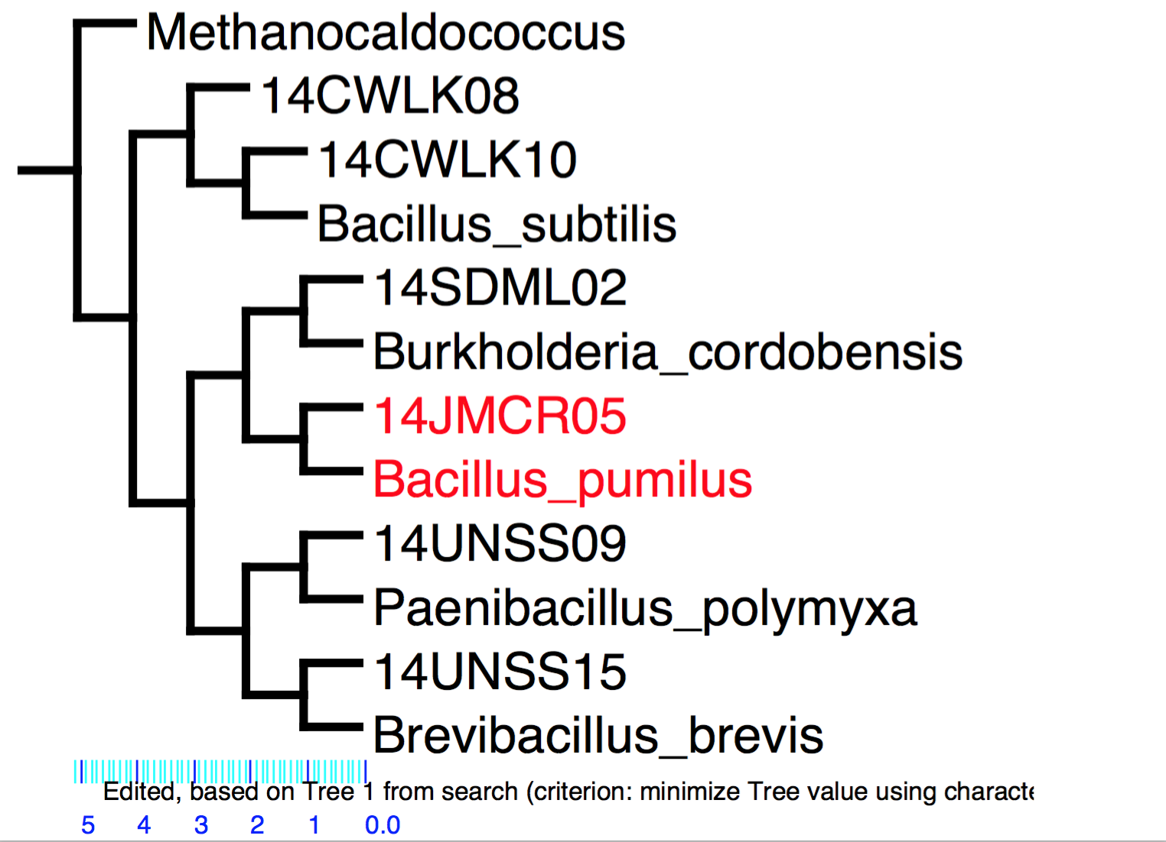
Fig. 11: This tree shows the phylogeny of all the bacteria isolated and DNA tested in the lab.

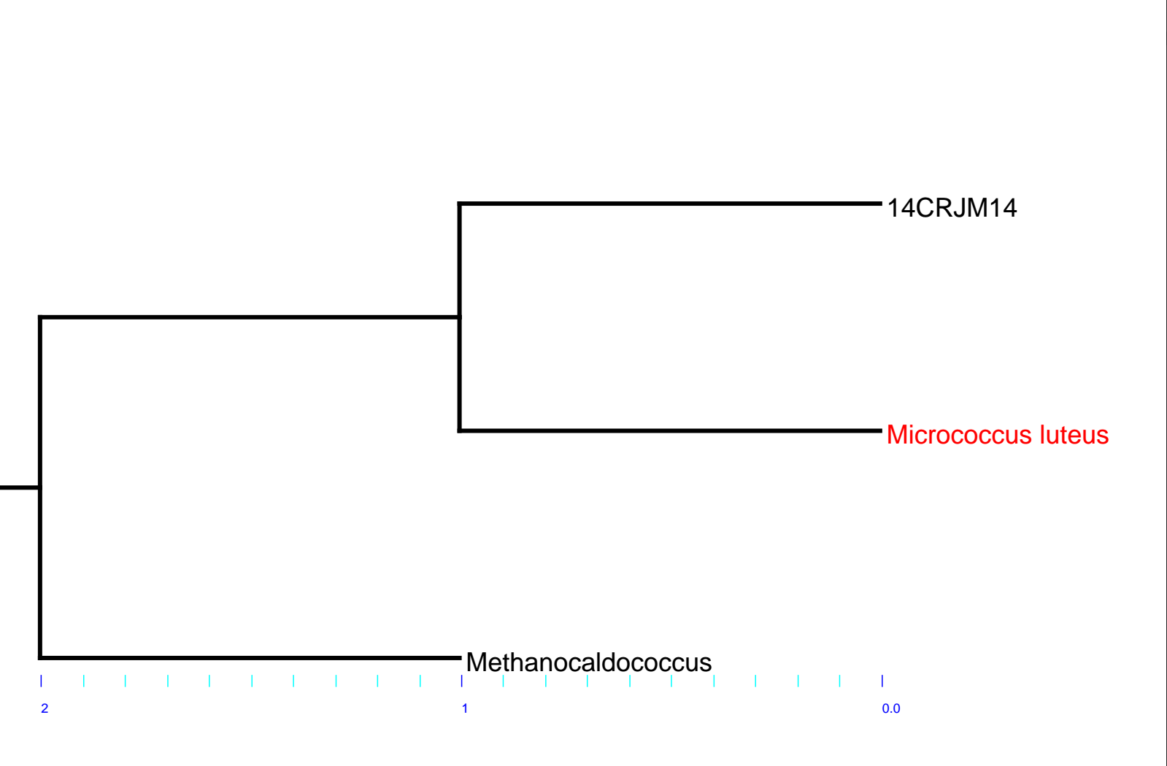
Fig. 12: This tree shows the phylogeny of isolate 14JMCR14.

Strain | ACC | CMC | PO₄ solubilization | N free | TY+Trp
14JMCR05 | - | - | + | - | -
14JMCR14 | ND* | - | + | + | -
Table 1. Colony morphology of the 4 isolates chosen for further study.

Strain | Shape | Margin | Surface | Color
14JMCR05 | round | curled | wrinkled | white
14JMCR06 | round | lobate | wrinkled | white
14JMCR09
14JMCR14 | round | curled | smooth | Golden yellow
Table 2. After retesting, these were the biochemical properties that were exhibited by the 2 final isolates chosen for further study. Since 14JMCR14 tested positive in the N free, the results of the ACC deaminase test was inconclusive.

