Primary Ovarian Cancer Ascites Culture for Drug Screening Experiments

- Receive ascites fluid from patients undergoing paracentesis at UMass Medical School, and use immediately upon receipt.
They will contact you one day ahead or the same day in the morning to ask you if you want samples.
Contact information:
Cristian Fraioli
Cancer Center Tissue and Tumor Bank
Phone number:508-856-4432
- Recover either single cells or ovarian carcinoma ascites spheroids from patient samples.
Note: We usually get two bottles of 250 ml each, use one for single cells the other one for spheroids.

For single cells, use 250 ml of ascites fluid
- Centrifuge 250 ml of ascites fluid at 200 g for 10 min at 4 °C. Note: Cool down centrifuge for 10 min before use.
- Remove supernatant and store at -80 °C. If you want to use supernatant as a culture medium, filter it through a 0.45 μm syringe filter prior to use.
- Remove red blood cells by resuspending the cell pellet in cold red blood cell lysis buffer (0.83% w/v ammonium chloride, 0.1% w/v potassium bicarbonate, and 0.0037% w/v EDT).
- Rock the tube at room temperature for 10 min.
- Spin cells down at 200 g for 10 min at 4 °C.
- Wash cells with PBS pH 7.4 and centrifuge at 200 g for 5 min at 4 °C.
- Resuspend cells in RPMI, 10% FBS, 1%P/S, and count them with trypan blue staining.
- Use single cells for different purposes:
- Freeze a few vials (1 million cells/ml) in 90% FBS/10% DMSO.
- Put some in culture in RPMI, 10% FBS, 1%P/S.
- Seed them on TCPS (96-well plate) (1 x 10^4 cell/well), 2D PEG-PC hydrogels (96 well plate) (1x10^4 cell/well) or encapsulate them in 3D PEG-MAL hydrogels (Range between 5,000 to 40,000 cells per gel) for drug screening experiments.
- Encapsulate them in polyNIPAAM (1 x 10^5 cell/ml) for spheroid formation.

For ovarian carcinoma ascites spheroids, use 250 ml of ascites fluid
- Filter 250 ml of ascites fluid through a 40 μm mesh cell strainer.

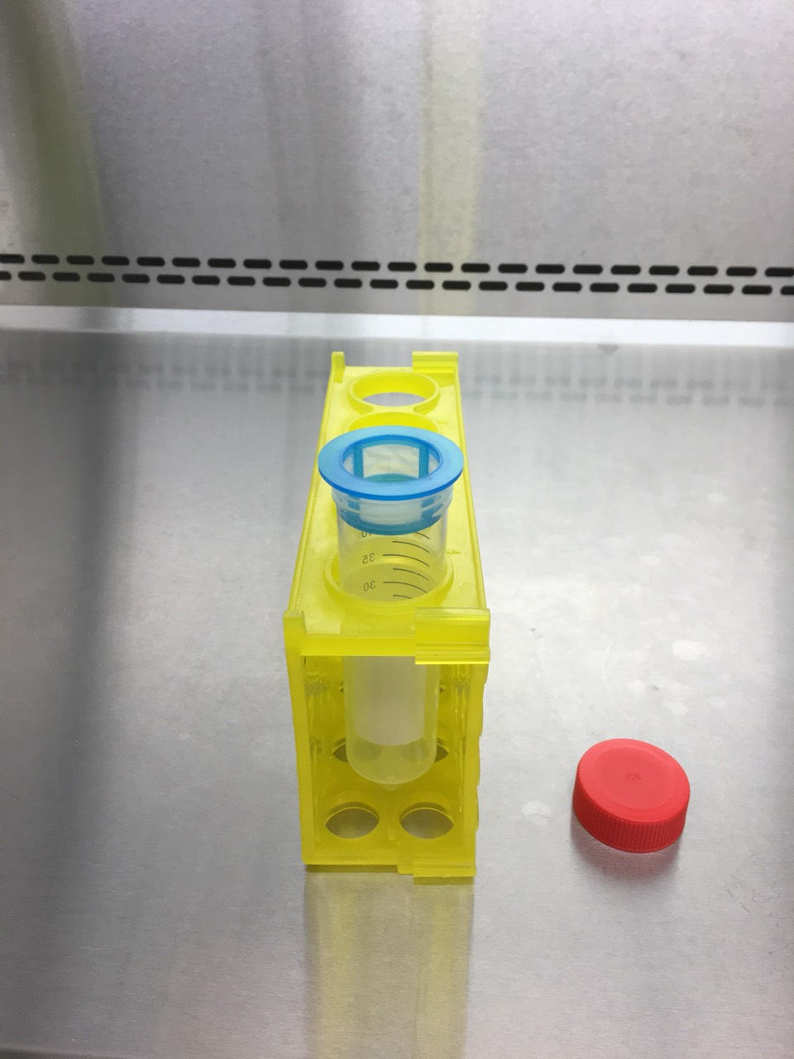
- Store the filtrate liquid at -80 °C.
- Collect the retained spheroids by using a cut pipet tip on the inverted cell strainer and some medium.
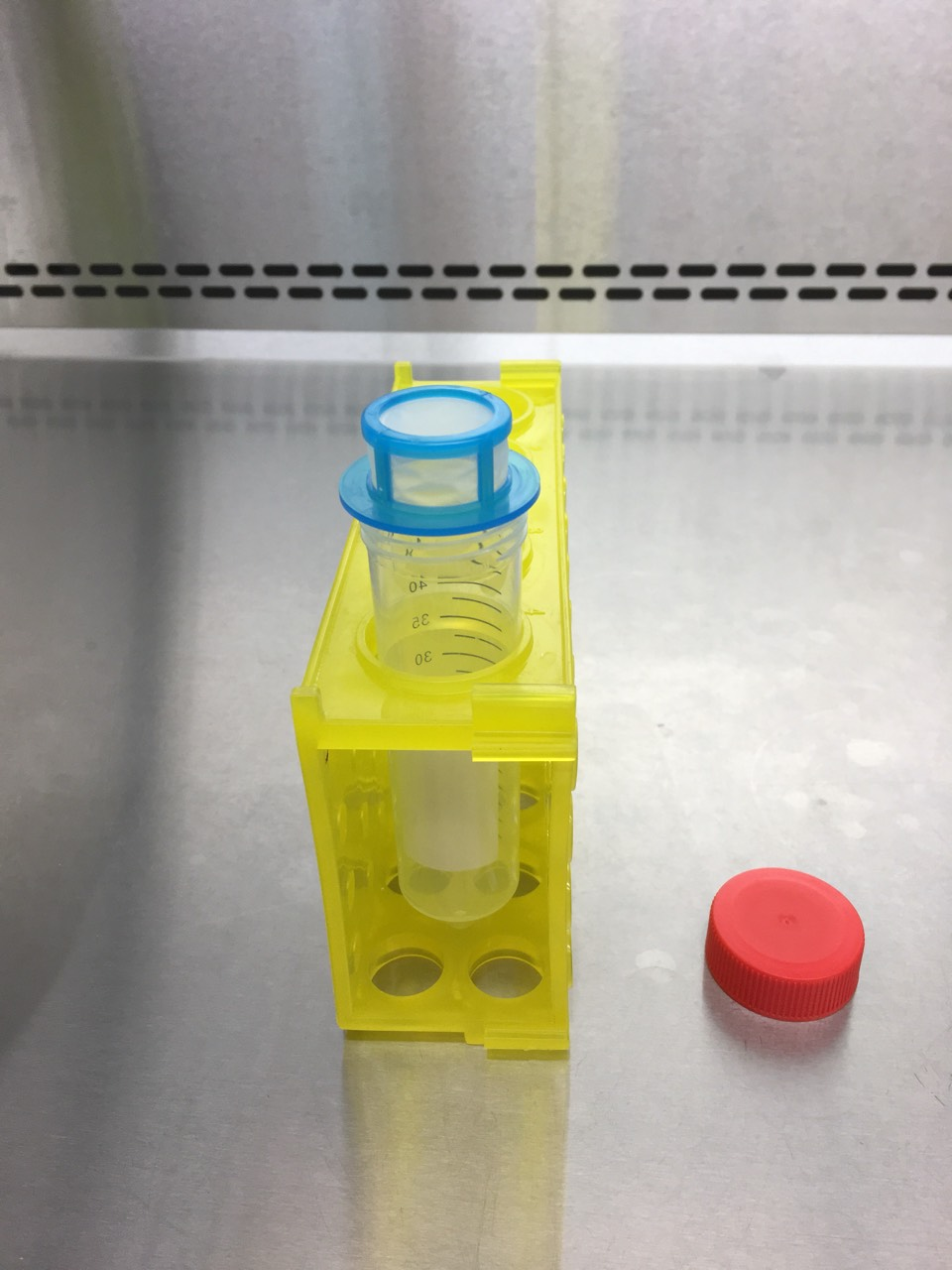

- Centrifuge spheroids solution at 30 g for 5 min.
- Remove medium and use spheroids for different purposes. Handle spheroids with a cut pipet tip to minimize shear stress.
- Encapsulate them in polyNIPAAM for spheroid formation.
- Encapsulate them in 3D PEG-MAL hydrogels for drug screening experiment.

