Lauren Kelly
Dr. Lum
Bio 112-14
29 April 2016
The isolation, testing, and identification of two strains of plant growth-promoting rhizobacteria, Bacillus Subtilis
Introduction
The mutualistic relationship between plant growth-promoting rhizobacteria and plants is extremely beneficial in nature. Bacteria in the rhizosphere, the area of soil influenced by the root, receive metabolites secreted from the plant roots that are used as nutrients (Lugtenberg and Kamilova, 2009). They also play a tremendous role in the success of plant growth. These bacteria not only increase plant growth directly, but they also protect the plant from soil-borne diseases (Lugtenberg and Kamilova, 2009). Nitrogen is a crucial aspect of successful plant growth, but it is not found naturally in a form that plants can readily use. The interaction between legumes, of the family Fabaceae, and (Brady) Rhizobium leads to the formation of root nodules, which fix nitrogen that the plant can use (Ligero et al., 1999). Other types of bacteria possess the enzyme ACC-deaminase and have the ability to turn the ACC in plant tissue into ammonia, which is another form of usable nitrogen (Shaharoona et al., 2006). There are a wide variety of other types of PGPR that promote plant growth in different ways beyond nitrogen fixation.
For this experiment, 16 isolated colonies of bacteria from plant roots and nodules were obtained and tested for plant growth-promoting qualities. The testing was narrowed down to two bacteria inoculums, which were tested on wheat seeds. Wheat is an important crop in the world of food production. A recent study has found that the application of PGPR on horticulture crops increased their yield in laboratory, greenhouse, and field settings (Ruzzi and Aroca, 2015). This study also discussed ways in which the PGPR could be used in dry inoculum, which would be more beneficial in the commercial world than fresh inoculum (Ruzzi and Aroca, 2015). Understanding the effects of PGPR on the growth of wheat could increase yield and profits.
Materials and Methods
Isolating the Bacteria from the Rhizosphere
The cowpea plant “Temescal Tree #5” was chosen for rhizosphere bacteria examination. Bacteria was extracted from a ~5 cm piece of root. Three serial dilutions of 10⁻², 10⁻³, and 10⁻⁴ were made, and 100 µL of each were pipetted onto three TY plates. The plates were incubated at 28°C for one week.
Isolating the Bacteria from the Nodules
A nodule was cut from a “Temescal Tree #5” root, sterilized with bleach, and crushed to extract the bacteria. Three serial dilutions of 10⁻¹, 10⁻², and 10⁻³ were made and 100 µL of each dilution were spread on three TY plates. The plates were incubated at 28°C for one week.
Screening the Bacteria for Plant Growth-Promoting Properties
After one week, the plates were examined for 16 isolated colonies to be used for further analysis. The sixteen colonies were classified according to shape, margin, surface, and color. In order to test for different characteristics of PGPR, small samples of all 16 colonies were grown simultaneously on plates. Five different plates were prepared in order to screen for the ability to fix nitrogen, phosphate solubilization, auxin production, cellulase activity, and ACC deaminase activity. A regular TY plate was also used as a control.
The plates were incubated at 28°C for one week. Afterwards, the plates were observed for evidence of growth under the different conditions. Four isolates (14CWLK01, 14CWLK02, 14CWLK08, and 14CWLK10) were chosen for further analysis and streak plated in order to obtain pure cultures of the bacteria. The streak plates were incubated at 28°C for one week.
Testing the Effects of PGPR on Plants
The streak plates were observed and the two most pure cultures (14CWLK08 and 14CWLK10) were chosen to test further. New streak plates were prepared and incubated at 28°C for one week. Bacteria from the original streak plates were gram stained and inspected under the microscope.
Wheat seeds were planted in black boxes filled with nutrient solution. Once the seeds germinated, one box was randomly assigned as the control, while the other two were inoculated with the bacterial inoculums of 14CWLK08 and 14CWLK10.
The bacterial inoculums were also placed onto new plates, including two NYDA plates, in order to retest the PGPR properties and test the isolates for inhibition of pathogens. These plates were placed in the incubator at 28°C for one week.
The NYDA plates were streaked, one with bacteria that can be human pathogens and the other with fungi that can be plant pathogens. Both plates were placed in a drawer for one week.

Preparation of the Bacterial Lysate and PCR Amplification of the 16s rDNA of the Isolates
Visible amounts of 14CWLK08 and 14CWLK10 were suspended in a microfuge tube containing 200 µL of sterile water. In order to lyse the cells and release template DNA into the solution, the cells were placed alternatively on dry ice and a 95ͦC heat block. The samples were placed on ice to prevent the degradation of nucleases.
Ten microliters of the appropriate bacterial lysate were pipetted into PCR tubes containing the components for the PCR reaction. The samples were taken for amplification in a PCR machine.
The PCR samples were used in gel electrophoresis to analyze the bacterial DNA and confirm the presence and size of the PCR products. Upon confirmation, the DNA was sent to be sequenced.
Sequence Analysis
When the sequences were received, they were put in FASTA format and searched in BLAST (Basic Local Alignment Search Tool) in order to make a preliminary identification for the microorganisms from which the 16S rRNA genes were obtained.
The sequences of each of the isolates, the corresponding matches from the database, and the outgroup sequence were aligned using MUSCLE and trimmed using GBlocks. A phylogenetic tree was generated using MESQUITE.
Testing the Inhibition of 14CWLK08 by 14CWLK10
Throughout the process of this experiment, it was noted that 14CWLK10 seemed to inhibit the growth of 14CWLK08. To test this further, four new hydroponic containers were prepared to grow more samples of wheat seeds. One was kept as the –N control, one was inoculated with 14CWLK08, one was inoculated with 14CWLK10, and one was inoculated with both 14CWLK08 and 14CWLK10. The plants were allowed to grow for two weeks. Afterwards, they were harvested and the lengths and weights of the shoots and roots were measured.
The isolates were also grown in close proximity on TY plates. The TY plates were incubated at 28°C for two weeks.

Testing Bacterial and Fungal Inhibition
The isolates were each grown on NYDA plates and TY plates. The TY plates were inoculated with S. aureus and E. coli and the NYDA plates were inoculated with R. stolonifer and F. oxysporum. The bacterial TY plates were incubated at 28°C and the fungal NYDA plates were kept in a drawer for one week. Afterwards, the plates were observed for inhibition of bacterial and fungal growth.

Results
Isolation of Rhizobacteria
For this experiment, the isolated rhizobacteria were tested on wheat. The soil, taken from Temescal Tree #5, had a salinity of 153 ppm and a pH of 6.40. The root sample had a colony count of about 80,000 CFU/mL.
14CWLK08 and 14CWLK10 had very similar morphological characteristics (Table 1). When the isolates were Gram stained, they both stained Gram positive and looked almost identical. Both stains showed clusters and some chains of purple bacillus (Figure 1). One flaw with Gram staining, however, is that it does not work very well on old bacteria. These bacteria were stained a week after they were incubated and therefore did not hold the purple stain very well. The presence of the bacteria that held the purple stain, however, proved that the bacteria is Gram positive. One big difference between the two samples of bacteria is spore production. 14CWLK10 has evidence of spore production, as shown by the empty areas in vegetative cells on the Gram stain (Figure 1).
Screening for PGPR Characteristics
14CWLK08 and 14CWLK10 were chosen for further testing of various plant growth-promoting qualities. These samples in particular were chosen because they had interesting results after the first round of testing and produced the best streak plates. Both 14CWLK08 and 14CWLK10 exhibited the same results when they were screened for PGPR characteristics (Table 2).
These tests also had unexpected results among some of the isolate samples. All of the bacteria on the phosphate solubilization plates were red and had red halos around them. The halos around 14CWLK08 were about 10.0 ± 2.65 mm and the halos around 14CWLK10 were about 9.0 ± 2.08 mm. The bacteria were thought to have not been solubilizing phosphate after all. This test was declared positive because there were halos, although they were most likely not the halos that would have formed if the bacteria solubilized phosphate as expected. Something in the media caused the bacteria to express a red pigment. There were also beads of liquid on top of the bacteria, which could be an antibiotic. These strange results were found again when the bacteria were screened for phosphate solubilization a second time. Furthermore, the bacterial samples grew in the area they were deposited on in all of the plates except the ACC Deaminase plate. This plate seemed to have induced swarming in 14CWLK08. The NYDA plates, which had not yet been treated with bacteria or fungi, exhibited the inhibition of growth of 14CWLK08 by 14CWLK10. The bacteria had splashed on both sides of the plate, bringing both samples together in close proximity in some areas. There were clearings around 14CWLK10 where 14CWLK08 did not seem to be able to grow.
Plant Growth
The bacteria did not seem to cause a significant difference in shoot length. The shoots were all about the same length, were the same shade of green, all had two to three leaves, and all seemed to turn brown at the same rate.
An ANOVA was used to compare the averages of the shoot lengths. With a P-value of 0.159, the difference in shoot length is not statistically significant. The average root lengths were also compared and had a P-value of 0.0404. This difference is statistically significant (Figure 4).
The weights of the roots and shoots were also averaged but had no significant results.

Isolate Identification
The results of the BLAST search were both interesting and expected. Due to the identical PGPR characteristics and morphologies, it was predicted that the isolates were the same type of bacteria. The isolates were both identified as Bacillus subtilis (Table 3).
These results are further confirmed by the phylogenetic tree that was generated. Both isolates are in the same clade as the Bacillus subtilis sequences that they most closely matched (Figure 5).
Isolate Inhibition
Inoculating the plants with the isolates did not have a statistically significant effect. On average, the wheat inoculated with both isolates 8 and 10 had the greatest shoot and root weight (Figure 6). The wheat inoculated with isolate 8 had the longest shoots and the wheat inoculated with isolate 10 had the longest roots. In all cases, the ANOVA showed P-values that were too high (>0.05). T-tests were run between different groups and it was found that none of the bacterial treatments caused a significant difference in plant growth.
Growing the isolates in close proximity on TY plates brought interesting results. The initial question was whether or not isolate 10 inhibited the growth of isolate 8, but the shapes of the colonies indicate that the isolates are inhibiting each other (Figure ). Both colonies are not symmetrical and seem repelled by each other.
Bacterial and Fungal Inhibition
The fungal inhibition plates were inconclusive. No fungi grew on any of the plates and it was impossible to determine whether or not either isolate inhibited the growth.
The bacterial inhibition plates did not yield significant results either. 14CWLK08 was unable to be tested because the plate had been contaminated. 14CWLK10 did not appear to inhibit the growth of S. aureus and E. coli. The colonies of both bacterial pathogens were symmetrical and did not seem to be effected by 14CWLK10 (Figure )
Discussion
The goal of this experiment was to isolate bacteria from the roots and nodules of plants and identify their PGPR characteristics. Our two isolates, 14CWLK08 and 14CWLK10, both tested positive for nitrogen fixation and phosphate solubilization, which are both very important processes that greatly benefit plant growth. Another study by West et al. found that plants supply more nutrients to nodules that contain nitrogen-fixing bacteria, thus increasing the fitness of rhizobacteria that fix nitrogen (2002). It is a mutualistic relationship that benefits both parties involved. The plants cannot fix nitrogen on their own and thus depend on these rhizobacteria for healthy growth.
Similar to nitrogen, the phosphorus in soils is mostly in a form that plants are unable to access, thus PSRB (phosphate solubilizing rhizobacteria) are needed for the plant to be able to access phosphate and have increased growth and crop yield (Hariprasad and Niranjana, 2008).
While halos did form around the bacteria on the medium containing calcium phosphate, the bacteria and the halos were red and not the clearings that were expected, as shown in Figure 2. This irregular behavior could be a result of a contaminant or a component of the media that caused these rhizobacteria to exhibit a red pigment. Other studies in which the rhizobacteria exhibit similar behavior when grown on this media could not be found. The rhizobacteria also had beads of liquid on top, which could possibly be type of antibiotic.
Another interesting result of this experiment did not arise from the interactions of the bacteria with the different types of growth media, but from the interactions of the bacteria with each other. On one of the NYDA plates, the samples of inoculum had splashed to opposite sides of the plate. 14CWLK10 appears to be inhibiting the growth of 14CWLK08, as shown by the clearings around 14CWLK10 (Figure 3). A study conducted by Bent and Chanway showed a very similar relationship between different strains of PGPR. It was found that competing microorganisms on the inside or outside of the plant tend to inhibit endophytic PGPR (Bent and Chanway, 1998). Bent’s results are very similar to the behavior of the bacteria on the NYDA plates. 14CWLK08, which was taken from a plant nodule, was inhibited by 14CWLK10, which was taken from a root sample. The results appear to support the statement that bacteria on the outside of the plant inhibit bacteria on the inside of the plant.
Bacillus subtilis is a very common type of Gram-positive rhizobacteria and has the ability to produce a wide variety of antibiotics with differing structures. Many different types of genes specify antibiotic biosynthesis, but no strain possesses them all (Stein, 2005). Based on this fact, it is possible that the isolates (14CWLK08 and 14CWLK10) are two different strains of Bacillus subtilis that produce different antibiotics. The antibiotic produced by 14CWLK10 could inhibit the growth of 14CWLK08, or the interaction of the isolates’ antibiotics together could have negative effects. This hypothesis was supported by growing the isolates in close proximity on TY plates. They appeared to inhibit each other, and one of the most logical explanations for this is the production of different antibiotics.
Bacillus subtilis is also known for its antifungal activity against soil-borne phytopathogenic fungi, including F. oxysporum. Cazorla et al. investigated the antifungal effects of various strains of Bacillus subtilis from the avocado rhizoplane and found promising biocontrol activities (2007). Our isolates were tested twice for fungi inhibition with F. oxysporum in the lab, but both sets of results were inconclusive. Based on Cazorla et al.’s study, it is possible that our isolates also possess antifungal activity that has yet to show up in the lab. On the other hand, our isolates could also be strains that do not possess the genes that code for antifungal antibiotics.

References
Bent, E., & Chanway, C. P. (1998). The growth-promoting effects of a bacterial endophyte on
lodgepole pine are partially inhibited by the presence of other rhizobacteria. Can. J. Microbiol. Canadian Journal of Microbiology, 44(10), 980-988. Retrieved February 24, 2016.
Cazorla, F., Romero, D., Pérez-García, A., Lugtenberg, B., Vicente, A. D., & Bloemberg, G.
(2007). Isolation and characterization of antagonistic Bacillus subtilis strains from the avocado rhizoplane displaying biocontrol activity. Journal of Applied Microbiology, 103(5), 1950-1959. Retrieved April 12, 2016.
Hariprasad, P., & Niranjana, S. R. (2008). Isolation and characterization of phosphate
solubilizing rhizobacteria to improve plant health of tomato. Plant Soil Plant and Soil, 316(1-2), 13-24. Retrieved February 24, 2016.
Ligero, F., Poveda, J.L., Gresshoff, P.M. and Caba, J.M. (1999) Nitrate inoculation in enhanced
ethylene biosynthesis in soybean roots as a possible mediator of nodulation control. J Plant Physiol 154, 482–488.
Lugtenberg, B., & Kamilova, F. (2009). Plant-Growth-Promoting Rhizobacteria. Annual Review
of Microbiology Annu. Rev. Microbiol., 63(1), 541-556. Retrieved February 17, 2016.
Ruzzi, M., & Aroca, R. (2015). Plant growth-promoting rhizobacteria act as biostimulants in
horticulture. Scientia Horticulturae, 196, 124-134. Retrieved February 11, 2016.
Shaharoona, B., Arshad, M., & Zahir, Z. (2006). Effect of plant growth promoting rhizobacteria
containing ACC-deaminase on maize (Zea mays L.) growth under axenic conditions and on nodulation in mung bean (Vigna radiata L.). Letters in Applied Microbiology Lett Appl Microbiol, 42(2), 155-159. Retrieved February 11, 2016.
Stein, T. (2005). Bacillus subtilis antibiotics: Structures, syntheses and specific functions.
Molecular Microbiology, 56(4), 845-857. Retrieved April 21, 2016.
West, S. A., Kiers, E. T., Simms, E. L., & Denison, R. F. (2002). Sanctions and mutualism
stability: Why do rhizobia fix nitrogen? Proceedings of the Royal Society B: Biological Sciences, 269(1492), 685-694. Retrieved February 18, 2016.

Tables and Figures
Table 1. This table displays the morphological characteristics of isolates 14CWLK08 and 14CWLK10. The bacteria appear to be very similar, with the exception of spore production.
Isolate | Gram Stain | Colony Morphology | Indiv. Bacteria | Spores
14CWLK08 | Positive | Clusters of bacillus, purple, old bacteria remained pink | Long rods arranged in clusters, others appear to be in chains. Varying rod lengths. | No evidence
14CWLK10 | Positive | Clusters of bacillus, purple, old bacteria remained pink | Long rods arranged in clusters, others appear to be in chains. Varying rod lengths. | Evidence of spores

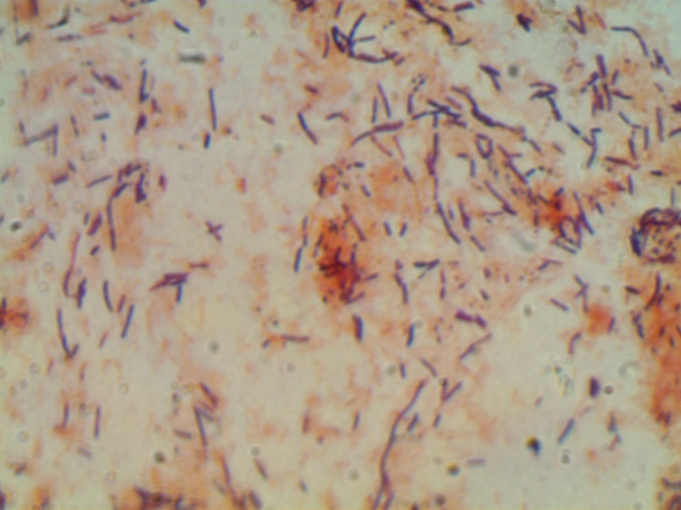
Figure 1. The Gram stains of 14CWLK08 (left) and 14CWLK10 (right) illustrate the similarities between the two isolates. Both are Gram positive bacillus arrange in mostly clusters and some chains. 14CWLK10, however, shows evidence of spores (empty areas in vegetative cells), which are circled in the image.

Table 2. This table displays the results from screening for PGPR characteristics. Both isolates had the same results for each characteristic.
Isolate | Phos. Sol. | Auxin | Cellulase | Nitrogen Fixation | ACC Deaminase
14CWLK08 | + | - | - | + | -
14CWLK10 | + | - | - | + | -

Figure 2. On the phosphate solubilization plate, 14CWLK08 (left) and 14CWLK10 (right) both expressed a red pigment and were surrounded by red halos. This behavior was very unexpected and leads to questions of other unknown characteristics of these rhizobacteria.

Figure 3. 14CWLK08 (left) and 14CWLK10 (right) were grown on an NYDA plate. Splashing of the bacterial inoculum caused the bacteria to be in close proximity to each other. 14CWLK10 (circled) inhibited the growth of 14CWLK08, as shown by the distinct clearings.
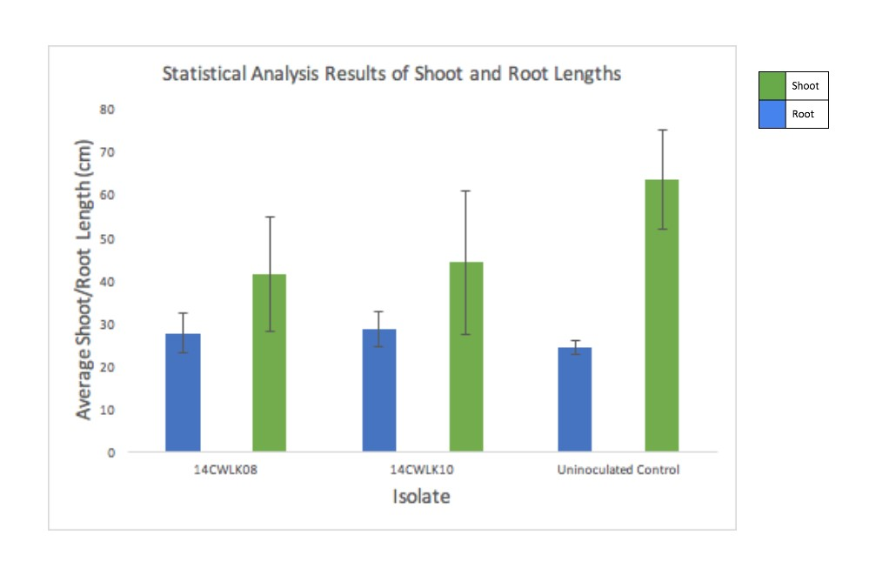
Figure 4. This graph shows the mean shoot and root lengths of the wheat seedlings treated with isolates 14CWLK08 and 14CWLK10 as well as an uninoculated control. The error bars indicate the standard deviations for each sample. The letters above the columns show where there is statistical significance as determined by ANOVA.
A
a
A
b
c
A

Table 3. This table displays the summary of the BLAST results, indicating how well the top match (Bacillus subtilis) corresponds to the isolates. The identity scores of 99% indicate the query and subject sequences are the same species. The gap values of 0% show that there are no differences between the sequences that resulted in gaps caused by missing nucleotides in the sequence. Isolates 14CWLK08 and 14CWLK10 correspond highly to the top match determined in BLAST, Bacillus subtilis.
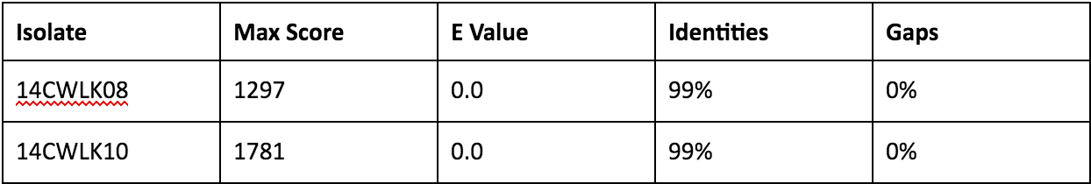

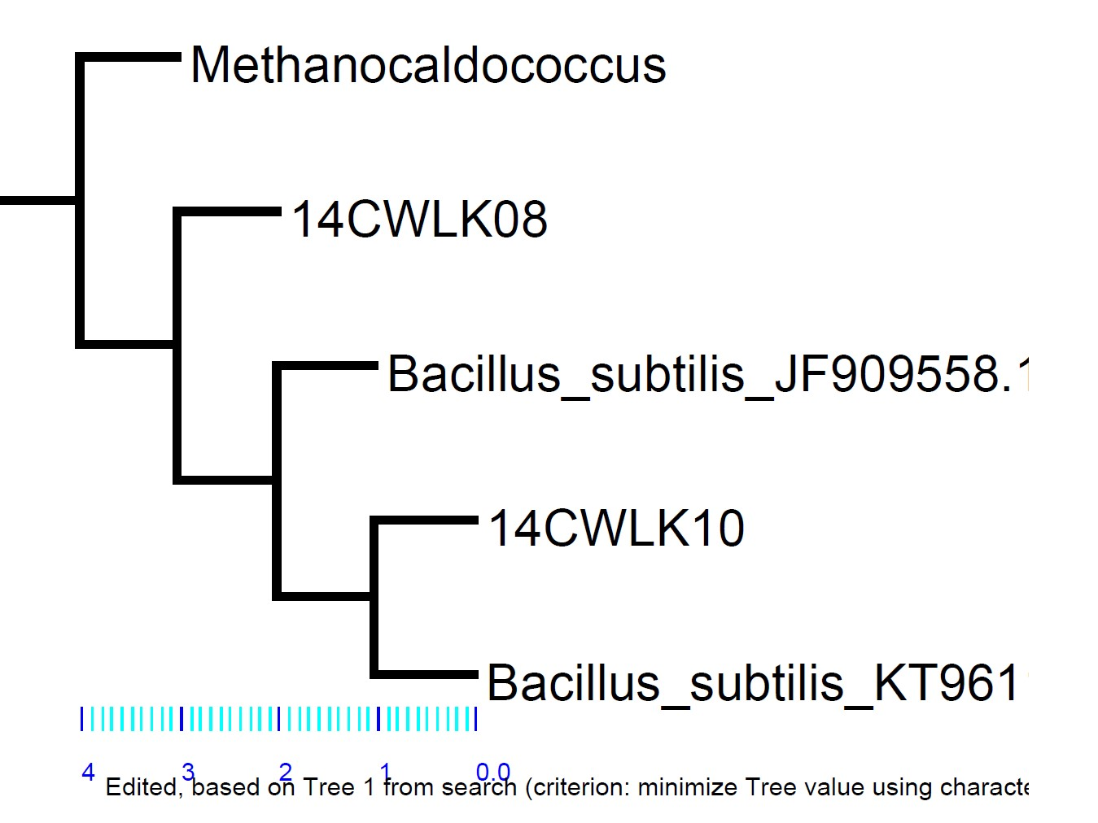
Figure 5. A phylogenetic tree was generated from various sequences. This tree exhibits the close relationship between both of the isolates and Bacillus subtilis. The isolates are in the same clades as Bacillus subtilis.

14CWLK08 and 10
14CWLK08
14CWLK10
Figure 6. This bar graph displays the average weights, in grams, of the roots and shoots of the wheat plants from the four hydroponic containers during the weeks spent testing the isolates for inhibition of each other. The roots had a P-value of 0.459443 and the shoots had a P-value of 0.901058, both of which are far greater than 0.05 and therefore statistically insignificant.

Roots
Shoots
Figure 7. This bar graph displays the average lengths, in cm, of the roots and the shoots from the wheat plants that were grown during the weeks spent testing the inhibition of the isolates. The roots had a P-value of 0.421956 and the shoots had a P-value of 0.686519, both of which are statistically insignificant.
10
8

Figure 8. Isolates 8 (right) and 10 (left) were grown next to each other in close proximity on a TY plate. The irregular shapes of both colonies indicate that the isolates inhibit each other.

Figure 9. Bacterial inhibition test of isolate 14CWLK10. The isolate did not appear to inhibit the growth of S. aureus or E. coli. The bacterial pathogen colonies remain symmetrical, which indicate that they are not affected by isolate 14CWLK10.
E. coli
S. aureus

