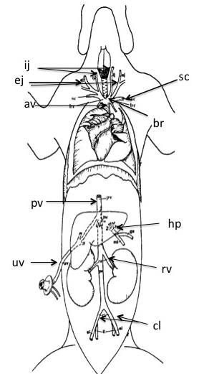 | av = anterior vena cava  ej and ij = jugular  sc = subclavian  br = brachiocephalic  pv = posterior vena cava  hp = hepatic portal  rv = renal vein  cl = common iliac  uv = umbilical vein

Fig. 7.2 Veins of the Fetal Pig.

