Investigation Report:

Effect of ATP concentration on ligation success rate

Abstract

Ligase is an important enzyme involved in joining nicks of DNA strands, especially in forming recombinant DNA. As ATP is required as a co-factor of T4 DNA ligase activity, an experiment was done investigating the effect of ATP concentration on DNA ligation success rate. Two DNA fragments obtained from the BioBrick Parts Registry -BBa_J04450, an mRFP generator, and pSB1AK3, which is a vector with high copy number- were ligated in ligation mixtures with different ATP concentrations. Successful ligations, indicated by the formation of red colonies on gel plate after transformation, which was measured in CFU (Colonies Forming Unit). Due to insufficient sample replicates, the data collected in this experiment is insufficient for suggesting a correlation between the two variables.

Introduction
Ligation is a process in which two fragments of DNA are joined together in the presence of enzyme ligase. T4 DNA ligase is one of the the enzymes commonly used for ligation in laboratories. It requires ATP as a co-factor to form phosphodiester bonds between the two DNA fragments. In the assembly of genes, optimisation of the ligation process is crucial for obtaining maximal successful DNA constructs. Thus, in this experiment, the effect of ATP concentration on ligation success rate was investigated.

2 plasmids were employed, namely BBa_J04450-pSB3K3 and BBa_B0015- pSB1AK3, to extract mRFP generator and backbone respectively. The ATP concentration was varied by adding different concentration of ATP during ligation of the insert and backbone, i.e. 10mM, 15mM, 20mM .
The plasmids were transformed into E.Coli DH10B, which is a commonly used strain to carry, replicate and express plasmids pSB1AK3. The ligation success was measured by counting the number of red colonies formed after overnight incubation of the transformed cells, reported in Colony Forming Units(CFU) and compared.

It was hypothesized that the increase of ATP concentration in the ligation mixture increases the ligation efficiency, as ligase requires ATP to carry out ligation.

Materials and Methods

- Preparation of LB broth
2 bottles of 400mL of LB broth with agar were prepared, each by mixing the below ingredients and made up to 400ml with double distilled water(ddH2O).
- Tryptone 4g
- Yeast 2g
- NaCl 4g
- Agar 6g
The mixtures were brought to autoclave. One bottle was added with chloramphenicol and the other with ampicillin, then poured into plates and left for solidification.

- Transformation:
After thawing the competent cells in ice, 1 µl of BBa_J04450 in pSB3K3 DNA was added to tubes of competent cells for transformation. A plate of cells without any plasmid was made as negative control. 1ml of LB broth was added to the competent cells and left for incubation. The cells were then grown on kanamycin added LB agar plate overnight with the corresponding antibiotics.

- Inoculation
Two colonies of cells were extracted for inoculation in LB broth overnight. Cells with plasmid BBa_J04450-pSB3K3 were obtained from agar plates from the previous day, and cells with plasmid BBa_B0015- pSB1AK3 was obtained from an agar plates of cells with corresponding plasmids.

- Miniprep
Miniprep was carried out following the standard procedure given in the Mini Plus ™ Plasmid Extraction System Miniprep kit. The DNA concentrations of each sample were obtained by NanoDrop machine.

- Digestion
DIgestion mixtures following the below recipes were made and incubated at 37 °C for 1 hour. No enzymes were added to the negative controls.

Table 1- digestion recipe of plasmid J04450-pSB3K3. S1, S2, S3, S4 are referred as experimental setups, while S1-C, S2-C, S3-C, S4-C are controls.
Sample | S1 | S1-C | S2 | S2-C | S3 | S3-C | S4 | S4-C
DNA conc. (ng/µl) | 100.4 | 100.4 | 101.3 | 101.3 | 111.7 | 111.7 | 99.2 | 99.2
DNA amount(ng) | 1000 | 150 | 1000 | 150 | 1000 | 150 | 1000 | 150
DNA amount(µl) | 9.96 | 1.49 | 9.87 | 1.48 | 8.95 | 1.34 | 10.08 | 1.51
Buffer 4(µl) | 5 | 1 | 5 | 1 | 5 | 1 | 5 | 1
EcoRI-HF(units) | 3 | 0 | 3 | 0 | 3 | 0 | 3 | 0
EcoRI-HF(µl) | 0.15 | 0 | 0.15 | 0 | 0.15 | 0 | 0.15 | 0
PstI-HF(units) | 3 | 0 | 3 | 0 | 3 | 0 | 3 | 0
PstI-HF(µl) | 0.15 | 0 | 0.15 | 0 | 0.15 | 0 | 0.15 | 0
ddH2O(µl ) | 34.74 | 6.51 | 34.83 | 6.52 | 35.75 | 6.66 | 34.62 | 6.49
Total | 50 | 9 | 50 | 9 | 50 | 9 | 50 | 9

Table 2- digestion recipe of plasmid B0015-pSB1AK3
 | Sample | Control
DNA conc. (ng/µl) | 185 | 185
DNA amount(ng) | 1500 | 200
DNA amount(µl) | 8.108108108 | 1.081081081
Buffer 4(µl) | 5 | 1
EcoRI-HF(units) | 3 | 0
EcoRI-HF(µl) | 0.15 | 0
PstI-HF(units) | 3 | 0
PstI-HF(µl) | 0.15 | 0
ddH2O(µl) | 36.59189189 | 6.918918919
Total(µl) | 50 | 9

- Gel electrophoresis
Following digestion, gel electrolysis was run to isolate the mRFP generator fragment(1110bp) from the pSB3K3 backbone(2709bp), and the pSB1AK3 backbone(3148bp).
0.8% agarose gel was made and placed in 0.5x TEB buffer. 20µl wells were used.
Samples S1, S2, S3, S4 and PSB1AK3 were each separated into 3 wells to prevent overloading of DNA in wells. Another well containing the NEB 1kb DNA ladder was used for reference.

- Purification
Gel was cut under UV to extract desired DNA fragments. The isolated gel was purified using FavorPrep™ GEL Purification Kit.

- Ligation
Insert BBa_J04450 and backbone pSB1AK3 were ligated using the below ligation recipe. Since sample S1(6.5ng/µl) contained the highest concentration of DNA, it was used for the ligation mixture. The ATP concentration was varied from 10mM to 20mM, by adding corresponding volumes of ATP solution(10mM of ATP) to create 15mM and 20mM mixture.
The solution was left to incubate overnight at 16 °C.

Table 3- ligation recipe
 | ATP Concentration
 | 10mM | 15mM | 20mM | Control
T4 DNA ligase | 0.5 | 0.5 | 0.5 | 0
T4 DNA ligase buffer | 1 | 1 | 1 | 1
Backbone(ng) | 20 | 20 | 20 | 20
Backbone(µl) | 6.45 | 6.45 | 6.45 | 6.45
Insert(ng) | 19 | 19 | 19 | 19
Insert(µl) | 2.92 | 2.92 | 2.92 | 2.92
ddH2O(µl) | 1.12 | 0.62 | 0.12 | 1.62
additional ATP(µl) | 0 | 0.5 | 1 | 0
Total(µl) | 12 | 12 | 12 | 12

- Transformation
The ligation mixtures after overnight incubation were each transformed into 50 µl of competent cells. The cell mixture was left to incubate for 1 hour at 37 °C to allow sufficient time for recovery.

10) Screening
The cells were spread on agar plate with ampicillin resistance and incubated overnight at 37 °C . The number of red colonies formed on each plate were counted the next day.

Results

The following results were obtained after transforming the ligated products and incubating the transformed cells overnight.

Table 4- Number of red colonies (CFU) on plates containing cells with plasmids ligated at varying concentrations of ATP (10mM, 15mM, 20mM)
sample | CFU
10mM ATP | 642
15 mM ATP | 6
20mM ATP | 566
negative control | 0
positive control | 0

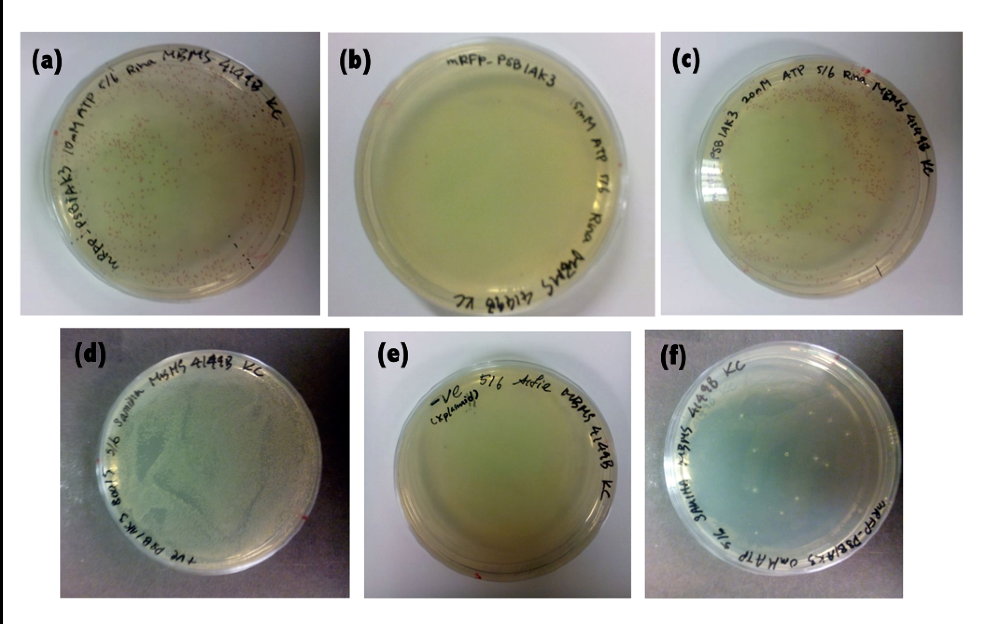
Figure 1: Colonies of cells with plasmid ligation conducted at different ATP concentrations-(a)10mM ATP (b) 15mM ATP (c) 20mM ATP (d)Positive control: cells containing plasmidBBa_ B0015-pSB1C3 (e) Negative control: cells without transformed plasmid (d)negative control: cells transformed with DNA without ligase added during ligation

Conclusion and Discussion
Through data obtained in this experiment, a conclusion for the investigation topic could not be made. This is due to the insufficient sample replicates, which was because of the lack of pSB1AK3 obtained after the purification of gel following gel electrophoresis. In future experiments, more DNA should be used in digestion taking into account that loss of DNA occurs during electrophoresis.

A discrepancy of data was observed for 15mM ATP ligation mixture. A significant decrease was observed compared to the 10mM ATP ligation mixture, from 642 to 6 CFU. This result could possibly be due to the following errors: 1) When the 100ul cells were split into half, proper mixing was missed, leading to a non-homogenous cell mixture. The cell solution that was transformed by 15mM ligation mixture had much lower cell number, leading to the low CFU on the agar plate.
2) Although all the transformations were done by the same person, there might be some discrepancies between these transformations, some mistakes or errors affected the 15mM transformation.

