RESEARCH STRATEGY

Significance

1. Current drug development platforms are not predictive of clinical outcome.
In drug development, potential chemotherapies are screened in multi-well formats, followed by animal model testing and clinical trials: a process costing over one billion dollars and seven years per drug on average. Unfortunately, many drugs, which trigger cell death in vitro, are eventually unsuccessful in vivo. I hypothesize that this lack of clinical success is due to 1) our reliance on inappropriate cell culture platforms, and 2) the failure of rodentia to predict clinical outcome. Recent initiatives by the NIH Common Fund and DARPA demonstrate awareness of this issue, but we are critically hindered by an unrealistic FDA approval route. Testing on multi-well tissue culture polystyrene (TCPS) and in rodents leads to many false positive results, which are eventually unsuccessful in humans. Here, I am proposing to develop a reproducible, and quick drug screening platform, that I envision would be used in between TCPS and animal screens, to 1) rule out potential false positives, and 2) lend insight into why certain drugs have eventually failed.

2. The relationship between drug resistance and physicochemical properties of the tumor microenvironment has largely been ignored.
Resistance is a known, critical problem in drug development. Carcinomas are able to circumvent kinase inhibitor action via multiple pathways [1]. Outside of epigenetic or phenotypic resistance, we hypothesize the extracellular matrix (ECM) may provide physical pathways for resistance. Tumor environments are notoriously stiff, relative to healthy tissue, due to a reorganized, pathological ECM [2-7]. The ability of ECM stiffening to regulate carcinoma cell behavior has most widely been studied in breast cancer, where these physical changes have been qualitatively correlated to metastatic potential [8-11]. The biomaterials and biosciences communities have uncovered these phenomenological relationships between the ECM and cell phenotype, and we now need to translate this information to tangible treatment solutions. The approach taken here, that the reorganized tumor ECM contributes to reduced drug efficacy, is important. TCPS platforms, upon which drugs are developed by industry world-wide, fail to represent the complex cell-ECM interactions that exist in in a living tumor, and the omission of these cues from an in vitro testing environment is at least partially responsible for an inefficient drug development pipeline. With improved drug testing platforms, which include physical and chemical features of the tumor microenvironment, and human cells, we can avoid false positive results, which result in wasted time and money in the development pipeline.

3. Carcinoma cell apoptosis in response to sorafenib is dampened in tumorigenic microenvironments, suggesting that the ECM provides chemo-resistance.
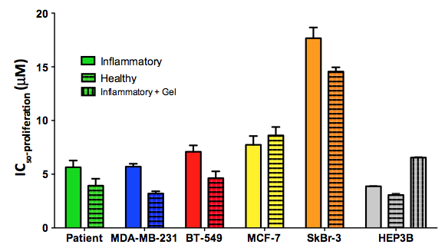
Tumor microenvironments are inflammatory, and are associated with extensive matrix reorganization [2, 3, 12-14]. Receptor tyrosine kinase (RTK) inhibitors, such as, sorafenib, target the RAF/MEK/ERK-pathway [15], which is simultaneously activated by physical and chemical cues from the ECM. This is one likely reason for observed drug resistance, and a minor 3-month increase in patient survival with sorafenib. In preliminary studies, we have observed that breast cancer cell proliferation in response to sorafenib is regulated by the identity of the matrix proteins on the substrate and the stiffness of the substrate (Figure 1). Interestingly, the more aggressive subtypes of breast cancer (Claudin-low and ER/PR-,HER2+) show chemo-resistance on inflammatory protein environments, whereas the non-metastatic MCF-7 luminal cells do not. Secondly, resistance is highest on SkBR3 (ER/PR-,HER2+) cells, which are notoriously difficult to treat. The fact that resistance is subtype specific begs the need for better systems to test drug response, and eventual personalized therapeutics in breast cancer.
Figure 1: Carcinoma proliferation regulated by adhesive proteins and stiffness. We quantified the dose of sorafenib (μM) required to inhibit proliferation in 50% (IC50) of cells across four breast cancer cell lines (colors), and liver cancer cells (gray). On “inflammatory protein cocktails (Collagen I, III, and FN, solid), the MDA-MB-231s, BT549s, SkBr3s, and cells directly from patients (green) require more sorafenib to achieve the same anti-proliferative effect as on a “healthy” protein cocktail (laminin, Collagen IV, stripes). Interestingly, the non-metastatic cell line (MCF-7s, yellow), have the opposite response, in that they exhibit more resistance to sorafenib on the “healthy” protein cocktail. Motivating our biomaterial design, liver carcinoma cells express the most drug resistance (100% increase compared to “healthy” proteins on TCPS) when seeded on inflammatory proteins coupled to compliant hydrogels.
Innovation

1. Reproducible systems to quantify drug efficacy in cancer will explain the biology of matrix-conferred drug resistance.
Our goal is to use a biomaterial platform to gain novel insight into observed drug failures in the clinic. By measuring cancer cell chemo-resistance in a carefully controlled microenvironment, we will eventually build disease-specific risk factors for resistance, based on the disease clinical subtype, and known pre-existing conditions. Quantifying responses across the range of disease subtypes may lead to patient-specific therapy, including development of improved therapeutic regimes tailored to integrin-mediated signaling and force transduction. Importantly, all of the materials systems outlined in this proposal can be adapted to study a wide variety of carcinomas, and expanded to include other clinically reported disease factors.

2. High-throughput biomaterials systems will reduce drug development costs.
Successful deployment of a tunable, high-throughput system that can serve as a quick screen between standard TCPS plates and FDA-required animal testing will help rule out potential false positives (and potentially lead to new, true positives), which will save time and money in the drug development pipeline. This approach could, therefore, have an immediate impact on drug development in cancer. Others in the field have recognized the importance of these types of systems, such as high-throughput collagen gels [16], synthetic gels to test drug responses [4, 17, 18], and organotypic microfluidics [19]. The approach taken here is novel in it combines the advantages and reproducibility of a synthetic hydrogel system, and can assay real-time drug responses across a range of cancer subtypes simultaneously. Although this small proposal is fundamentally basic research, we expect that our findings will impact future cancer research, be a useful platform to test mechanisms of drug efficacy, and, in the longer term, impact the clinical pipeline of drug development. It costs our lab less than $1 per well of these complex microenvironment tests. Though certainly more expensive than running these experiments on a traditional TCPS plate (~10¢ per well), this is a small cost to rule out a drug that would exhibit resistance in an expensive animal, and costs could be further reduced in commercial optimization outside of our lab’s expertise. We expect that this small research proposal will lead to an R01 proposal, which will include validation in animal models.
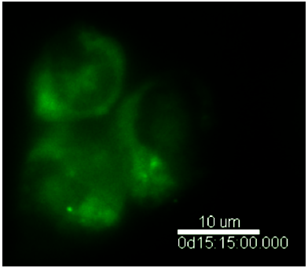
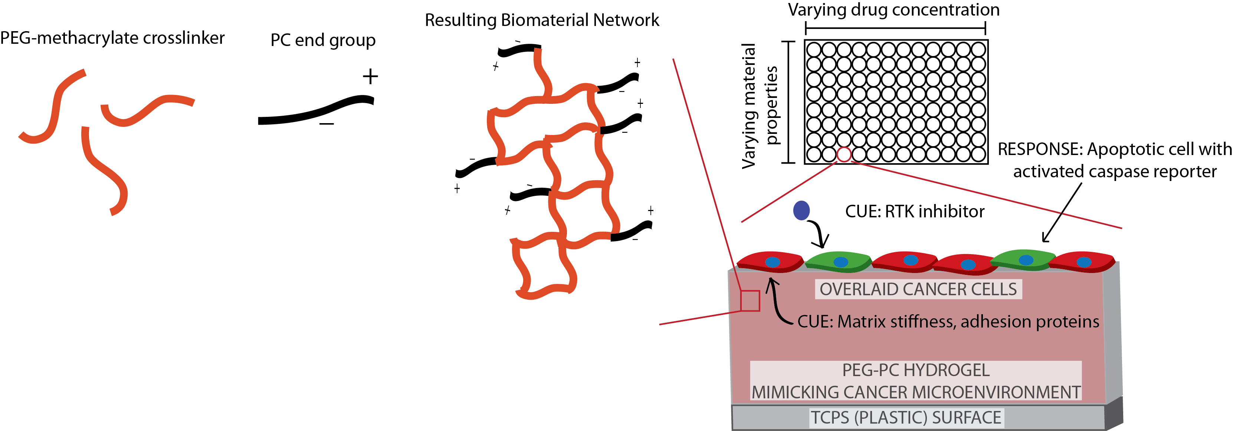
Figure 2: High-throughput hydrogel system. Biomaterials made from PEG and PC groups (left) will form tunable materials in a 96-well plate, for simultaneous, real-time cancer cell responses to material cues and RTK inhibitors (bottom right).

3. Real time tracking of caspase activity across a broad subset of breast cancer cells in a tunable microenvironment will integrate physical and chemical effects with a quantitative analysis.
With our high-throughput, optically clear, tunable biomaterial system, we will be able to track apoptosis in real-time. We will tune biomaterials to match the stiffness and chemical properties of cancer tissue during tumorigenic progression, and then quantify drug resistance with a real- time caspase reporter (see inset of a liver cancer cell activating caspase-7 15 hours after dosing with sorafenib in Figure 2). In this sense, we have a high-throughput, mechanically tunable system, with real-time reporters of chemo-resistance.

Approach

In Aim 1, we will use our high-throughput biomaterial system to quantify apoptosis in response to combinations of sorafenib and matrix stiffness across the breast cancer subset of the NCI/NIH DTP (developmental therapeutics program) cell lines. In Aim 2, we will translate this pilot study toward the clinic in two ways. First, we will use our system to test whether mechanosensing has contributed to failed drug development using recently characterized drugs in the pipeline. Second, we will test for chemo-resistance in cells from metastatic breast cancer patients taken from ascites fluid at the UMass Medical School tissue bank. This will give us an expansive read-out of cell-type specificity of matrix-conferred drug resistance.

Aim 1: Quantify cancer cell resistance to an RTK inhibitor in a tunable tissue environment.

Hypothesis: Mechanical cues from a physiologically relevant ECM help protect breast cancer cells from RTK inhibitor-mediated apoptosis. To test this hypothesis, we will:
- Adapt a biomaterial system that we have in the lab, which has tunable mechanical and chemical properties relevant to several cancer microenvironments, in a high-throughput format.
- Vary the physicochemical properties (namely modulus and profiles of adhesive ECM proteins coupled to the surface) across a range relevant to cancer microenvironments, and quantify how these matrix properties regulate cancer cell resistance to a RTK inhibitor.

We envision several tangible outcomes from this endeavor. Most significantly, we will generate a connection between cancer cell mechanosensing and drug resistance across a panel of breast cancer cell lines representative of different subtypes of the disease. Second, we will generate a set of high-throughput engineered microenvironments that are highly tunable, and adaptable to all types of cancer research.

1.A Biomaterial microenvironment with independently tunable mechanical and chemical features
In order to achieve the objectives listed above, we require a system that meets the following design criteria:

- Independent, orthogonal control of physicochemical cues, to isolate stiffness and adhesive protein effects.
- Biomechanical and biochemical properties over the range of in vivo cancer tissue.
- Optical clarity, for real-time analysis of a live caspase reporter.
- Adaptable to high-throughput formats (96-well dishes).

In order to meet these design criteria, we are adapting a PEG-based biomaterial system, which contains orthogonally tunable mechanics, chemistry, and hydrophilicity, and which we have developed in the lab in collaboration with Dr. Todd Emrick (publication in preparation). We will exploit the orthogonal tunability of these PEG systems to create engineered tissues that mimic the physicochemical properties of tissue prominent at primary tumor environments (Table 1, [5, 10]). From a careful literature analysis of the in vivo microenvironment of breast cancer, we have identified a subset of critical biomechanical and biochemical design criteria for an in vivo tissue mimic. We have narrowed the adhesive matrix proteins based on prominence in breast tissue, both healthy and tumorigenic.

We have previously employed PEG biomaterials to manipulate the behavior of many cell types [20-24]. PEG-based systems allow for long-term cell culture, and can be tuned to target specific integrin-ECM interactions [21], independently of mechanical properties [21], and permit cell-mediated degradation sites [25], for 3D gels investigated outside the scope of this project. As a further improvement to current PEG-based systems, we are including a zwitterion end-group (a phosphorylcholine, PC) to increase hydrophilicity and decrease non-specific protein adsorption [26, 27] to most effectively isolate protein-signaling effects from mechanical effects (Figure 2).

In our forthcoming publication, we have demonstrated this PEG-based (PEG-PC) gel will support cancer cell adhesion, and is mechanically tunable (Figures 3 and 4). The mechanical properties of the gels are tunable over the desired range of tissue via PEG crosslinkers (Figure 3, [5, 10]). We will continue to fully characterize the mechanical properties of the material with rheometry, using facilities available from the UMass MRSEC (See Facilities). To facilitate cell adhesion we use succinimydil ester chemistry (sulfo-SANPAH, Pierce), and subsequently react a full-length protein(s). In sum, the chemistry of the PEG-PC system includes:

- non-degradable PEG chains to control modulus through PEG crosslinking
- heterobifunctional molecules to control adhesivity through peptide presentation
- zwitterion-containing polymers to tune hydrophilicity and block non-specific protein adsorption.

In this fashion, we will have independent control over the PEG-PC adhesive and mechanical properties relevant to cancer. We have enlisted the support of Dr. Todd Emrick in Polymer Science and Engineering at UMass-Amherst, who has extensive experience with zwitterion chemistries (See Attached Letter) to ensure the success of this aim.
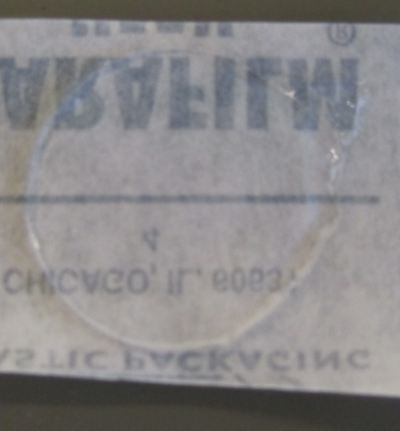
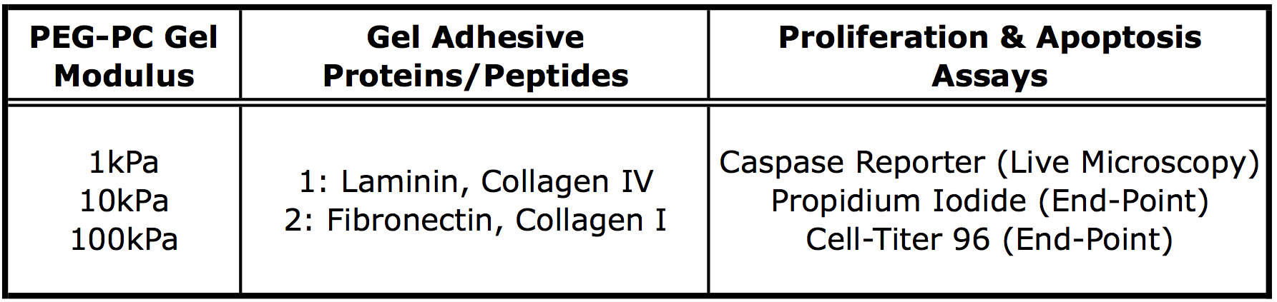
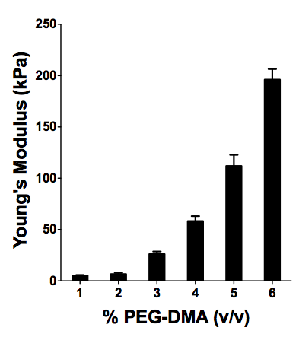
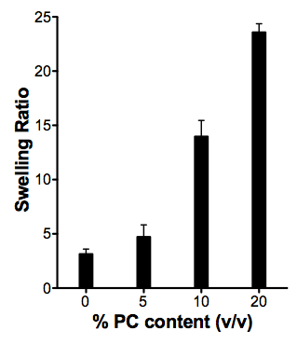
Figure 3: Properties of system and measurements. Left: PEG-PC gels with 20% PC groups, held constant, and varying PEG content (x-axis). With inclusion of PC group, we can achieve very low modulus PEGs, unachievable with PEG only gels. This is because gel formation occurs at very low PEG volume %’s and high swelling ratios (second from left). Center: resulting gels are optically clear. Right: Conditions of gels (stiffness, adhesive proteins) varied while real-time and end-point assays measure cell responses planned in Aim 1.
1.B Cancer cell line selection
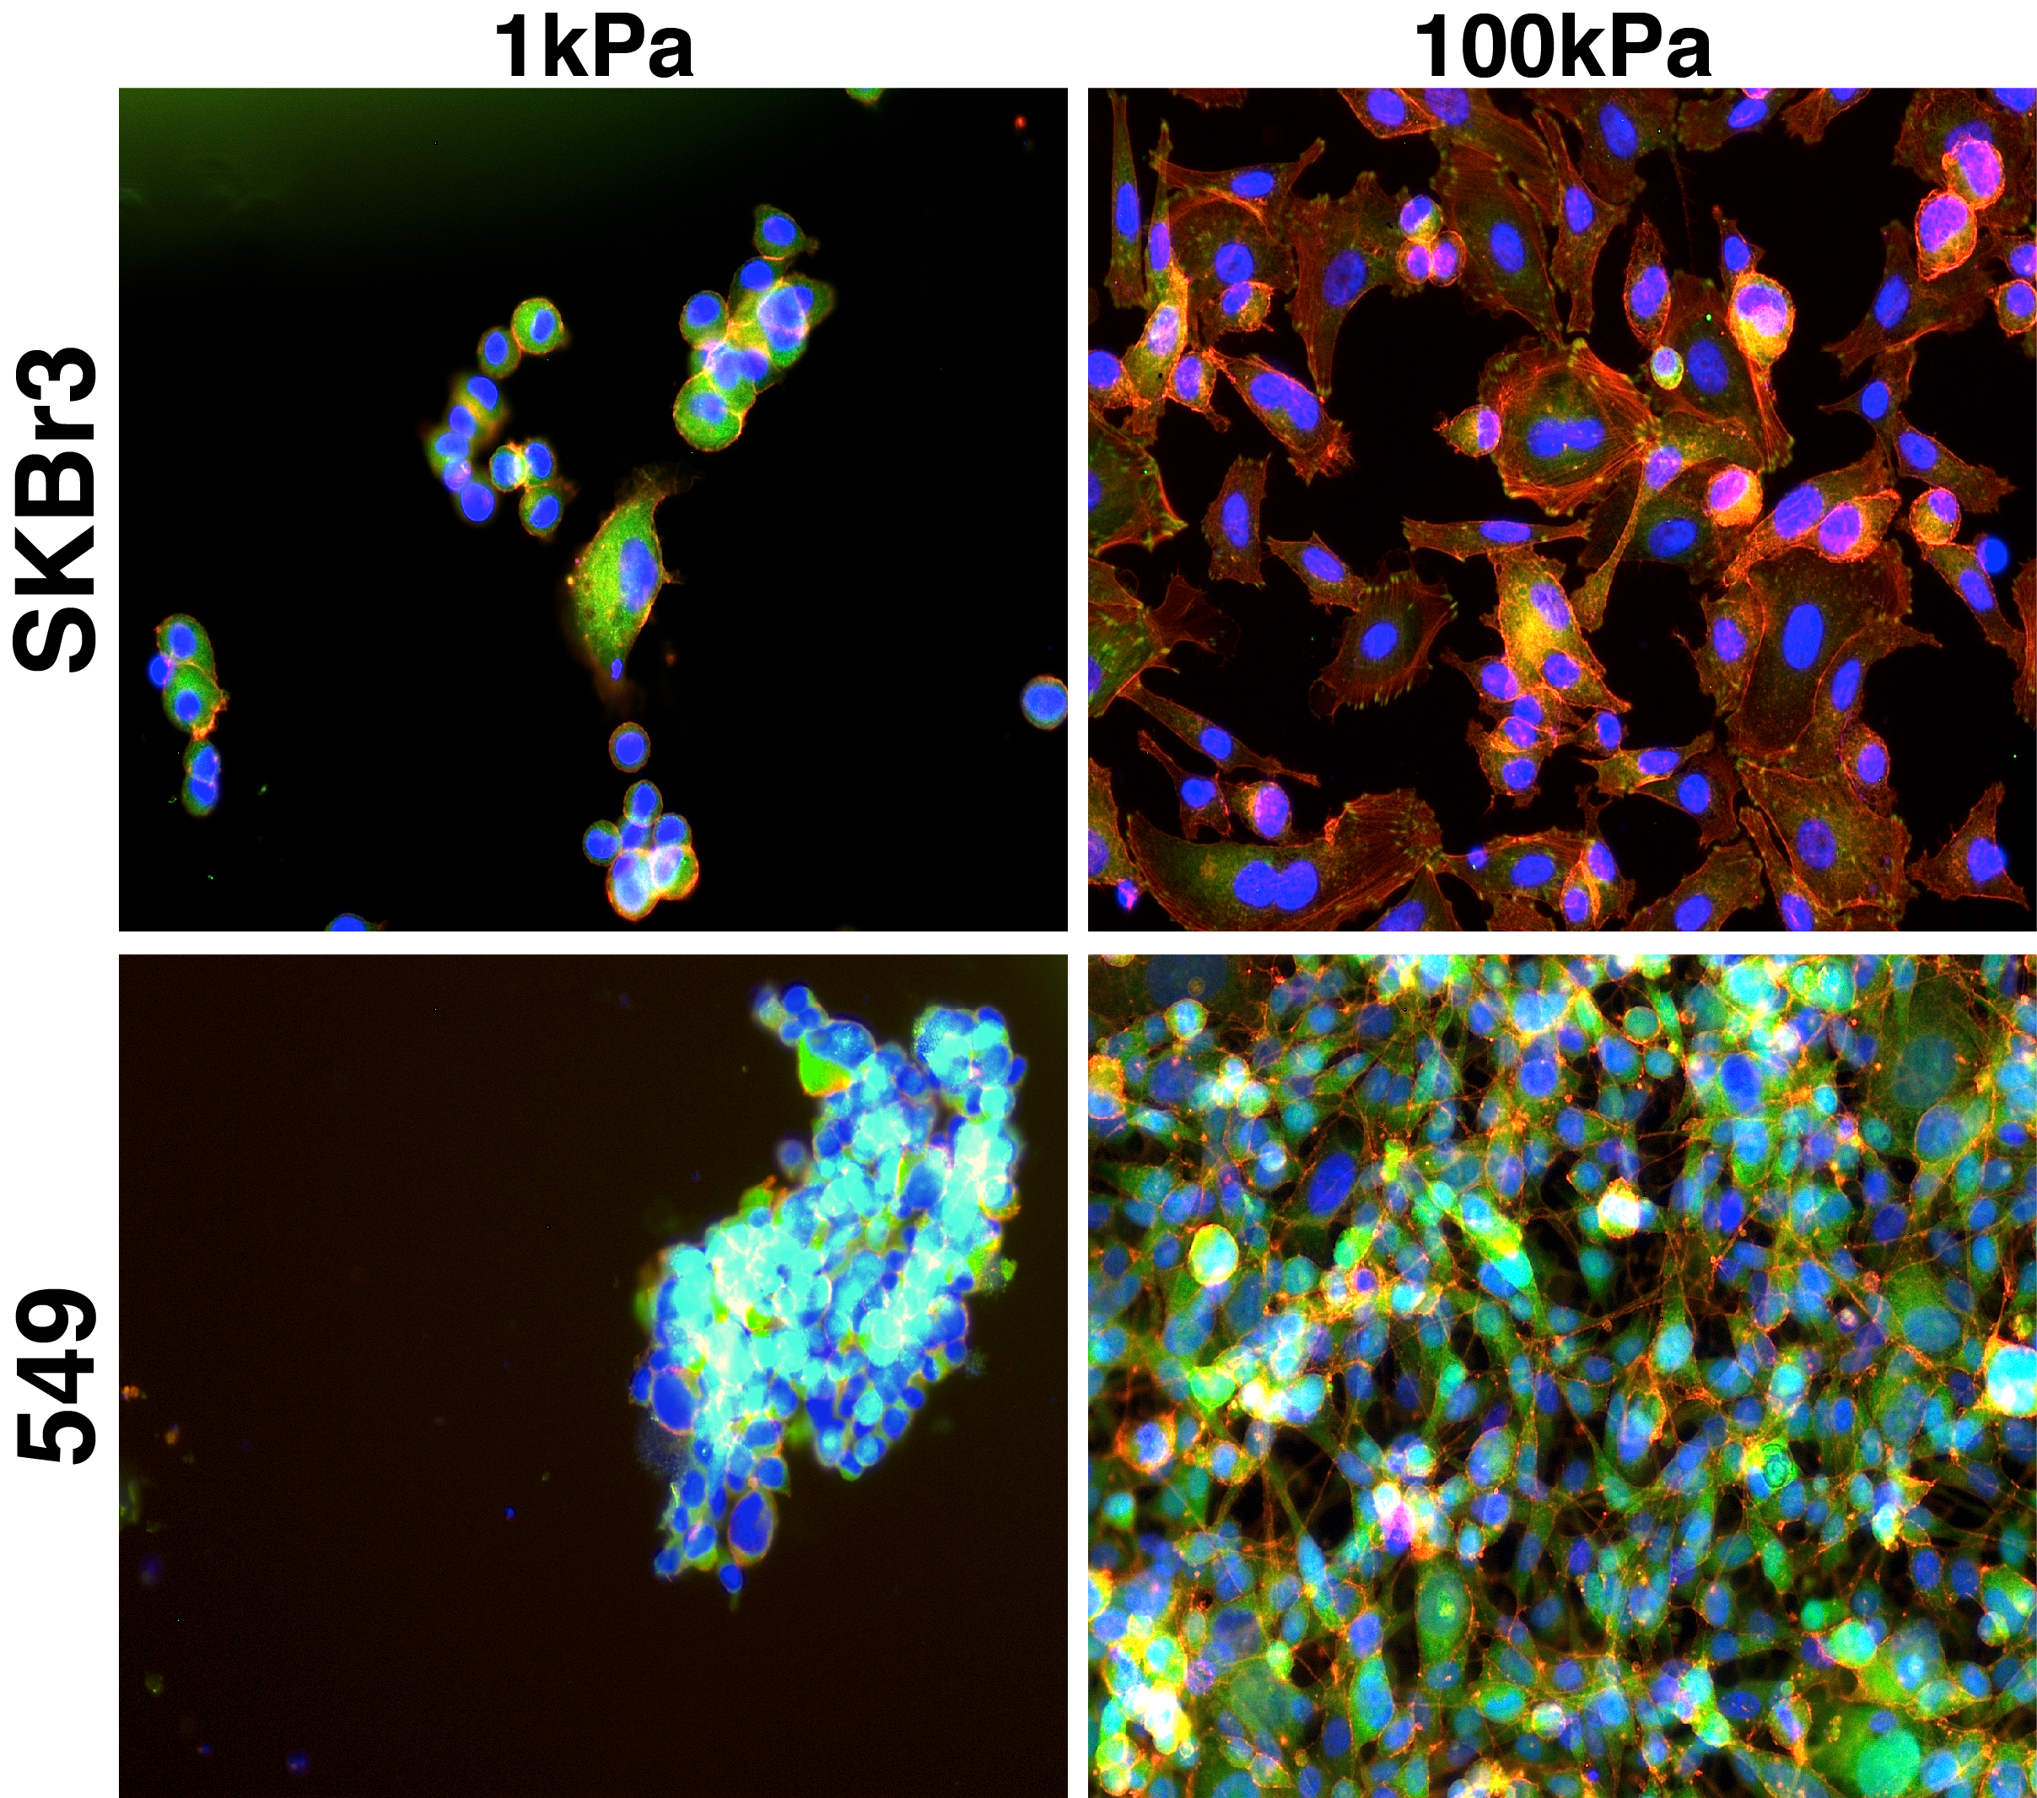
Careful consideration of the cell lines employed in this study is required not only to accurately represent clinically relevant disease states, but also to obtain insight into specific mechanisms underlying chemo-resistance across the spectrum of breast cancer. With this in mind, we will pursue a subset of the 60 cell lines described and approved by NCI as physiologically relevant cell lines representative of aggressive cancers (DTP: Developmental Therapeutics Program, dtp.nci.nih.gov). The cell lines we have chosen from this panel are limited to breast cancer, some of which are already being actively cultured in our own laboratory (Figure 1). We will be testing chemo-resistance in MCF-7s (non-metastatic, luminal), MDA-MB-231 (aggressive, Claudin-Low), BT-549 (Claudin-Low), MDA-MB-468 (basal, ER-), HS578T (ER-, aggressive), and T-47D (luminal, ER+), each of which are included on the DTP-NCI list, and many of which can be classified as Triple Negative, an incredibly difficult to treat subtype [28]. These six cell lines are experimentally narrowed within Aim 1, but also capture the heterogeneity of breast cancer.

1.C Quantification of drug resistance
Post hydrogel polymerization and protein functionalization to match the tissue properties given in Figure 3, cells will be seeded at 3K cells/cm², on the surface of hydrogels. Here in Aim 1, we will use one common clinical RTK inhibitor as a model of drug efficacy, sorafenib (marketed as Nexevar). Sorafenib is an FDA approved multi-kinase inhibitor therapeutic for a subset of epithelial cancers, showing success in non-small cell lung, renal, and primary liver cancer. We have chosen it as the base treatment in Aim 1 because of its success across many different epithelial cancers, and due to our preliminary data in breast cancer (Figure 1). After 24 hours of cell culture on the hydrogel surfaces in a defined growth medium (containing no serum with 20ng/mL of EGF and PDGF), we will add sorafenib to the culture at a serial dilution of concentrations ranging from 0 to 20μM in defined media.
Figure 4: Shown are two breast cancer cell lines cultured on compliant (1kPa, laminin and Collagen 4) and stiff (100kPa, fibronectin, collagen 1) gels. Red: F-actin, Green: vinculin, Blue: nuclei.

To assess whether the matrix properties of an inflammatory matrix environment control cell growth in a differential fashion in the presence of the kinase inhibitor sorafenib, cell proliferation will be quantified as a function of drug concentration (sorafenib 0-20M), on the tissue mimics detailed in Figure 3. Cells will be tested for proliferation at regular intervals (48, 72, and 96 hours) with CellTiter 96 One Cell Proliferation Assay (Figure 1, Promega) and for apoptosis with propidium iodide. Because of the high-throughput nature of our gel set up (Figure 2), we can test an N=3 technical replicates, over a wide dosing range of sorafenib, with 2 matrix conditions in a single plate. Parallel plates will be used to compare proliferation to propidium iodide results. As a control to compare to other reported literature, we will include a thin coating of Matrigel, Type I Collagen (both at 2mg/ml), and blank TCPS. As a consultant on these apoptosis responses, we have enlisted the support of Dr. Sallie Smith Schneider, an expert in apoptosis pathways in cancer, and director of the Center of Excellence in Apoptosis Research (See Attached Letter). In parallel, cell morphology is regulated by the disease state of our engineered substrates (Figure 4).

1.D Real-time caspase reporting
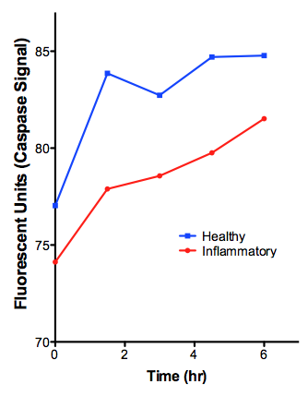
True innovation comes from our ability to use these optically clear hydrogels with live, time-lapse microscopy, to measure the real-time apoptosis of cells in these microenvironments when dosed with an RTK inhibitor. We have adapted a real-time caspase reporter, to report the live caspase activation under sorafenib treatment on the biomaterial system. Caspase-3/7 activation is indicative of internally motivated programmed cell death (i.e. not induced by immune cells), distinct from autophagy and necrosis. CA-GFP (caspase activatable-GFP) is a real-time reporter for execution caspase-7, and has been generously gifted to us from the Hardy lab [29]. CA-GFP contains a quenching peptide, which is used to suppress the activity of the GFP. When caspase-7 is activated, the enzyme will cleave the caspase-7 recognition site (DEVDFQGP), which releases active GFP. We transfect CA-GFP-encoding plasmids into HEP3Bs with Lipofectamine PLUS™ reagent (Invitrogen). After 4 hours of transfection, HEP3Bs are allowed to recover in antibiotic-free serum media for 24 hours, and then plated onto the cancer mimicking matrix environments, described in 2.2. We quantify caspase activation with both live microscopy and an incubated fluorescent plate reader (Figure 5). We quantify the rate of fluorescent increase, and the maximum fluorescence as indicators of apoptosis upon sorafenib dosing.
Figure 5: Real-time caspase reading. HEP3Bs reporting caspase in response to sorafenib on protein cocktails. Caspase activation is slower on “inflammatory” proteins, agreeing with results in Figure 1.

Aim 2: Quantify drug resistance in patient cells with clinically relevant therapeutics.

Hypothesis: Stiffness-mediated chemo-resistance may account for failed clinical trials of numerous chemotherapeutics. To test this hypothesis, we will:
- Quantify ECM-mediated drug resistance to known, failed chemotherapeutics.
- Expand system to quantify drug resistance in cells from breast cancer patients.

These experiments will A) determine if the chemo-resistance we discover in Aim 1 applies to multiple drugs, including those that are not RTK inhibitors, B) help explain why some drugs have failed in clinical trials, and C) determine if resistance occurs in our system with patient-derived cells, instead of just the more commonly used, but potentially less clinically relevant, cancer cell lines used in Aim 1.

2.A Drug resistance across multiple therapeutics
To validate the usefulness of this high-throughput platform, we will expand our testing of therapeutics outside of sorafenib alone. Specifically, we will focus on a set of therapeutics that successful in early development, but have since been abandoned in clinical trials. We hypothesize that resistance donated by the matrix may be one reason for failed advanced clinical trials. We have plan to test cell responses to 1) BSI-201 (iniparib), a PARP inhibitor developed for triple negative breast cancer that was halted in Phase III clinical trials [30], 2) brivanib, a VEGFR2 inhibitor that was designed for patients demonstrating intolerance to sorafenib, which has shown either mild or no ability to halt tumor growth in clinical trials [31], and 3) vemurafenib, a Raf/MEK/ERK inhibitor targeted toward melanoma in current clinical trials [32]. Importantly, this expanded set of testing includes one RTK inhibitor (vemurafenib), but also two drugs that are not classic RTK inhibitors – one PARP inhibitor and a growth factor receptor inhibitor. Although this grant may not be able to understand the mechanism by which these pathways would be affected by matrix stiffness, if we are able to show matrix stiffness mediated drug resistance in these other pathways, it will lead to a world of necessary research to understand these mechanisms and avenues for more successful combinatorial treatments.

We will dose the six cell lines chosen for Aim 1, with a range of single drugs (from 0-20μM). As described in Aim 1, we will quantify apoptosis with two end-point assays (CellTiter 96 and Propidium Iodide) as well as the kinetic rate of apoptosis with our CA-GFP liver reporter. As a control, we will randomize the conditions within our 96-well plates in 5% of our assays to ensure that plate placement does not affect results.

2.B ECM-mediated resistance in patient cells
We have begun to receive carcinoma cells from breast cancer patients from ascites fluids from the UMass Medical School in Worcester, MA (shown in Figure 1). Accompanying the freshly isolated cells is a pathology report and anonymous patient history, which includes a detailed description of chemotherapy received by the patient over the course of the disease (UMass Medical directs the necessary IRB). We have preliminary data showing that one set of patient cells shows resistance when plated on TCPS plates coated with inflammatory proteins. This particular patient has metastatic breast cancer, ER/PR-, HER2+ subtype, which has a particularly high recurrence rate. This patient has received several rounds of treatment over the last 19 years, including visblastine, doxorubicin, thiotepa, docetaxel, and many others. Through the course of this grant, if we find that resistance to these drugs and others is matrix stiffness related, we expect to spark a flood of provocative research into novel drug therapy regimes that account for matrix adhesion and stiffness. We cannot predict the availability of patient cells, but we estimate to be able to test a minimum of four independent patient cells during this grant.

Expected Outcomes: We are currently generating a high-throughput system based on biomaterials that capture physical and chemical properties of the ECM in breast tumors. In this grant, we will use this system to determine whether or not matrix stiffening during tumorigenesis contributes to drug resistance in a subset of carcinoma-targeted drugs that have failed or have not met expectations in clinical trials. The translational component of this small project will determine if cells from patients with known resistance to a variety of drugs are chemo-resistant due to matrix stiffening. This initial project will provide seed funding for a small number of drugs and cell lines, and future work will use our high-throughput system to test large numbers drugs, drug combinations, a more expansive set of cancer cells not investigated here, and animal validation.

Potential Pitfalls and Solutions:
- In vivo, epithelial cells are in a highly polarized 2-D epithelial cell sheet, making a 2D substrate a biologically relevant starting point. The evolution of the tumor environment becomes 3D in vivo, which will be examined outside the scope of this proposal.
- The inclusion of PC zwitterions results in hydrogels with a larger range of mechanical properties over PEG-only gels due to increased hydrophilicity. However, if unexpected complications occur with this gel system, each of our following objectives can be performed on PEG-only gels with minor modifications.

Statistical Analysis: If necessary, principal component analysis (PCA) can be used to define relationships between these varying parameters to aid in understanding the results from this large data set [33]. We perform statistical analysis with Prism 5.0a for Microsoft.

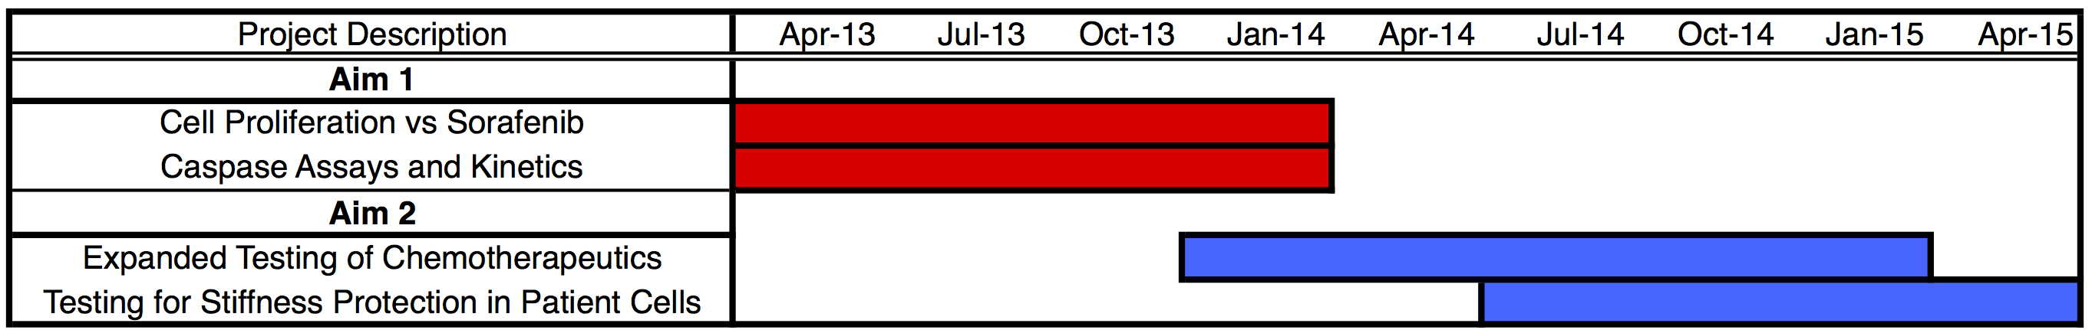

Summary of Goals and Innovation
We will generate a high-throughput system based on biomaterials that match the physicochemical properties of cancer tissue, relevant to disease progression. Preliminary data shows that our PEG-PC biomaterial is optically clear and mechanically tunable. Further, stiffness cues and the combination of integrin-binding proteins in 96-well plates confer sorafenib resistance to carcinoma cells. We will determine the applicability of the biomaterial platform to primary cells as well as to wide-ranging testing of other chemotherapeutics with known clinical results. Finally, we will translate this system to patient cells, with known drug resistance and responses in vivo. In sum, we will generate a novel PEG-PC biomaterial system, and the first known evidence of matrix stiffening as a contributor to chemotherapy response.
REFERENCES

1. Duncan, J.S., M.C. Whittle, K. Nakamura, A.N. Abell, A.A. Midland, J.S. Zawistowski, N.L. Johnson, D.A. Granger, N.V. Jordan, D.B. Darr, J. Usary, P.F. Kuan, D.M. Smalley, B. Major, X. He, K.A. Hoadley, B. Zhou, N.E. Sharpless, C.M. Perou, W.Y. Kim, S.M. Gomez, X. Chen, J. Jin, S.V. Frye, H.S. Earp, L.M. Graves, and G.L. Johnson, Dynamic Reprogramming of the Kinome in Response to Targeted MEK Inhibition in Triple-Negative Breast Cancer. Cell, 2012. 149(2): p. 307-21.
2. Huwart, L., N. Salameh, L. ter Beek, E. Vicaut, F. Peeters, R. Sinkus, and B.E. Van Beers, MR elastography of liver fibrosis: preliminary results comparing spin-echo and echo-planar imaging. Eur Radiol, 2008. 18(11): p. 2535-41.
3. Huwart, L., F. Peeters, R. Sinkus, L. Annet, N. Salameh, L.C. ter Beek, Y. Horsmans, and B.E. Van Beers, Liver fibrosis: non-invasive assessment with MR elastography. NMR Biomed, 2006. 19(2): p. 173-9.
4. Tilghman, R.W., C.R. Cowan, J.D. Mih, Y. Koryakina, D. Gioeli, J.K. Slack-Davis, B.R. Blackman, D.J. Tschumperlin, and J.T. Parsons, Matrix rigidity regulates cancer cell growth and cellular phenotype. PLoS One, 2010. 5(9): p. e12905.
5. Paszek, M.J., N. Zahir, K.R. Johnson, J.N. Lakins, G.I. Rozenberg, A. Gefen, C.A. Reinhart-King, S.S. Margulies, M. Dembo, D. Boettiger, D.A. Hammer, and V.M. Weaver, Tensional homeostasis and the malignant phenotype. Cancer Cell, 2005. 8(3): p. 241-54.
6. Paszek, M.J. and V.M. Weaver, The tension mounts: mechanics meets morphogenesis and malignancy. J Mammary Gland Biol Neoplasia, 2004. 9(4): p. 325-42.
7. Levental, K.R., H. Yu, L. Kass, J.N. Lakins, M. Egeblad, J.T. Erler, S.F. Fong, K. Csiszar, A. Giaccia, W. Weninger, M. Yamauchi, D.L. Gasser, and V.M. Weaver, Matrix crosslinking forces tumor progression by enhancing integrin signaling. Cell, 2009. 139(5): p. 891-906.
8. Bretscher, M.S., On the shape of migrating cells--a 'front-to-back' model. J Cell Sci, 2008. 121(Pt 16): p. 2625-2628.
9. Iwanicki, M.P., R.A. Davidowitz, M.R. NG, A. Besser, T. Muranen, M. Merritt, G. Danuser, T. Ince, and J. Brugge, Ovarian cancer spheroids use myosin-generated force to clear the mesothelium. Cancer discovery, 2011. 1: p. 144-157.
10. Provenzano, P.P., K.W. Eliceiri, J.M. Campbell, D.R. Inman, J.G. White, and P.J. Keely, Collagen reorganization at the tumor-stromal interface facilitates local invasion. BMC medicine, 2006. 4(1): p. 38.
11. Kostic, A., C.D. Lynch, and M.P. Sheetz, Differential matrix rigidity response in breast cancer cell lines correlates with the tissue tropism. PLoS One, 2009. 4(7): p. e6361.
12. Matsuzaki, K., Modulation of TGF-beta signaling during progression of chronic liver diseases. Front Biosci, 2009. 14: p. 2923-34.
13. Wynn, T.A., Cellular and molecular mechanisms of fibrosis. J Pathol, 2008. 214(2): p. 199-210.
14. Saile, B. and G. Ramadori, Inflammation, damage repair and liver fibrosis--role of cytokines and different cell types. Z Gastroenterol, 2007. 45(1): p. 77-86.
15. Liu, L., Y. Cao, C. Chen, X. Zhang, A. McNabola, D. Wilkie, S. Wilhelm, M. Lynch, and C. Carter, Sorafenib blocks the RAF/MEK/ERK pathway, inhibits tumor angiogenesis, and induces tumor cell apoptosis in hepatocellular carcinoma model PLC/PRF/5. Cancer Res, 2006. 66(24): p. 11851-8.
16. Truong, H.H., J. de Sonneville, V.P. Ghotra, J. Xiong, L. Price, P.C. Hogendoorn, H.H. Spaink, B. van de Water, and E.H. Danen, Automated microinjection of cell-polymer suspensions in 3D ECM scaffolds for high-throughput quantitative cancer invasion screens. Biomaterials, 2012. 33(1): p. 181-8.
17. Lamb, B.M., N.P. Westcott, and M.N. Yousaf, Microfluidic lithography to create dynamic gradient SAM surfaces for spatio-temporal control of directed cell migration. Chembiochem: A European Journal of Chemical Biology, 2008. 9(16): p. 2628-2632.
18. Loessner, D., K.S. Stok, M.P. Lutolf, D.W. Hutmacher, J.A. Clements, and S.C. Rizzi, Bioengineered 3D platform to explore cell-ECM interactions and drug resistance of epithelial ovarian cancer cells. Biomaterials, 2010. 31(32): p. 8494-506.
19. Huh, D., B.D. Matthews, A. Mammoto, M. Montoya-Zavala, H.Y. Hsin, and D.E. Ingber, Reconstituting organ-level lung functions on a chip. Science, 2010. 328(5986): p. 1662-8.
20. Peyton, S.R., P.D. Kim, C.M. Ghajar, D. Seliktar, and A.J. Putnam, The effects of matrix stiffness and RhoA on the phenotypic plasticity of smooth muscle cells in a 3-D biosynthetic hydrogel system. Biomaterials, 2008. 29(17): p. 2597-607.
21. Peyton, S.R., C.B. Raub, V.P. Keschrumrus, and A.J. Putnam, The use of poly(ethylene glycol) hydrogels to investigate the impact of ECM chemistry and mechanics on smooth muscle cells. Biomaterials, 2006. 27(28): p. 4881-93.
22. Khatiwala, C.B., P.D. Kim, S.R. Peyton, and A.J. Putnam, ECM compliance regulates osteogenesis by influencing MAPK signaling downstream of RhoA and ROCK. J Bone Miner Res, 2009. 24(5): p. 886-98.
23. Khatiwala, C.B., S.R. Peyton, M. Metzke, and A.J. Putnam, The regulation of osteogenesis by ECM rigidity in MC3T3-E1 cells requires MAPK activation. J Cell Physiol, 2007. 211(3): p. 661-72.
24. Peyton, S.R., Z.I. Kalcioglu, J.C. Cohen, A.P. Runkle, K.J. Van Vliet, D.A. Lauffenburger, and L.G. Griffith, Marrow-Derived stem cell motility in 3D synthetic scaffold is governed by geometry along with adhesivity and stiffness. Biotechnol Bioeng, 2011.
25. Raeber, G.P., M.P. Lutolf, and J.A. Hubbell, Molecularly engineered PEG hydrogels: a novel model system for proteolytically mediated cell migration. Biophys J, 2005. 89(2): p. 1374-88.
26. Ishihara, K., H. Nomura, T. Mihara, K. Kurita, Y. Iwasaki, and N. Nakabayashi, Why do phospholipid polymers reduce protein adsorption? Journal of Biomedical Materials Research, 1998. 39(2): p. 323-330.
27. Samanta, D., S. Mcrae, B. Cooper, Y.X. Hu, and T. Emrick, End-Functionalized Phosphorylcholine Methacrylates and their Use in Protein Conjugation. Biomacromolecules, 2008. 9(10): p. 2891-2897.
28. Lehmann, B.D., J.A. Bauer, X. Chen, M.E. Sanders, A.B. Chakravarthy, Y. Shyr, and J.A. Pietenpol, Identification of human triple-negative breast cancer subtypes and preclinical models for selection of targeted therapies. The Journal of clinical investigation, 2011. 121(7): p. 2750-67.
29. Nicholls, S.B., J. Chu, G. Abbruzzese, K.D. Tremblay, and J.A. Hardy, Mechanism of a genetically encoded dark-to-bright reporter for caspase activity. The Journal of Biological Chemistry, 2011. 286(28): p. 24977-86.
30. Patel, A. and S.H. Kaufmann, Development of PARP inhibitors: an unfinished story. Oncology, 2010. 24(1): p. 66, 68.
31. Finn, R.S., Y.K. Kang, M. Mulcahy, B.N. Polite, H.Y. Lim, I. Walters, C. Baudelet, D. Manekas, and J.W. Park, Phase II, open-label study of brivanib as second-line therapy in patients with advanced hepatocellular carcinoma. Clinical cancer research : an official journal of the American Association for Cancer Research, 2012. 18(7): p. 2090-8.
32. Bollag, G., P. Hirth, J. Tsai, J. Zhang, P.N. Ibrahim, H. Cho, W. Spevak, C. Zhang, Y. Zhang, G. Habets, E.A. Burton, B. Wong, G. Tsang, B.L. West, B. Powell, R. Shellooe, A. Marimuthu, H. Nguyen, K.Y. Zhang, D.R. Artis, J. Schlessinger, F. Su, B. Higgins, R. Iyer, K. D'Andrea, A. Koehler, M. Stumm, P.S. Lin, R.J. Lee, J. Grippo, I. Puzanov, K.B. Kim, A. Ribas, G.A. McArthur, J.A. Sosman, P.B. Chapman, K.T. Flaherty, X. Xu, K.L. Nathanson, and K. Nolop, Clinical efficacy of a RAF inhibitor needs broad target blockade in BRAF-mutant melanoma. Nature, 2010. 467(7315): p. 596-9.
33. Pritchard, J.R., B.D. Cosgrove, M.T. Hemann, L.G. Griffith, J.R. Wands, and D.A. Lauffenburger, Three-kinase inhibitor combination recreates multipathway effects of a geldanamycin analogue on hepatocellular carcinoma cell death. Mol Cancer Ther, 2009. 8(8): p. 2183-92.

