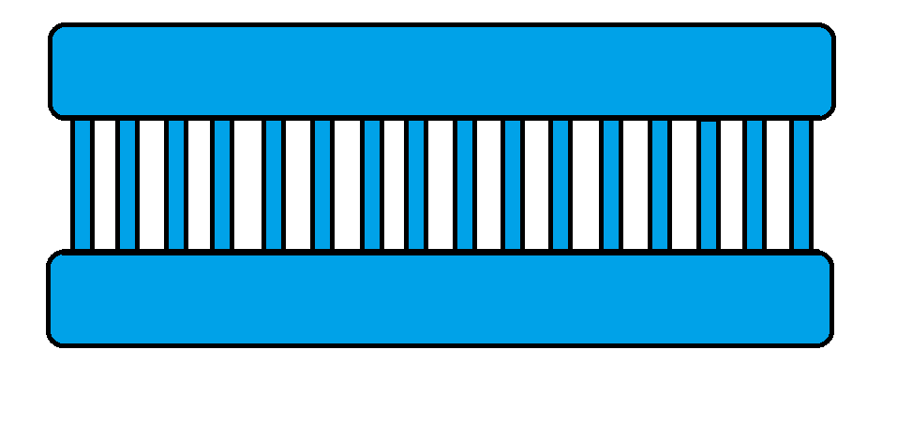

Cancer DNA Template

Original DNA Strand



Primer

Taq DNA polymerase



Taq DNA polymerase

Primer



Original DNA Strand



Original DNA Strand

New Strand

New Strand

Original DNA Strand