Melissa Novy, Dhea Patel, Keyun Wang

September 27, 2012

CHEM-571

Horseradish Peroxidase Assays

HRP-AAP Assay

Horseradish peroxidase catalyzes the oxidation of 4-aminoantipyrine, enhanced by the addition of 4-Iodophenol, by H2O2. The reaction was monitored in UV-visible spectrophotometer. A graph of absorbance vs. time of the solution color change was used to determine the activity rates of HRP.

The protocol for HRP assay with 4-aminoantipyrine was found on Dropbox [2]. Deviations from the protocol are as follows:

* 4-Iodophenol was also found to be immiscible in water, so it was dissolved in 700μM DMSO instead. Note that the amount of DMSO in the reaction solution was dilute enough that it did not affect the reaction and absorbance peak.

The UV-vis was set to detect the absorbance at 510nm at 25°C over the course of 300 seconds. The interior of the spectrophotometer was set to a constant temperature of 25°C ± 0.1°C. These settings were not changed for the duration of the experiment. It was also determined that the optimal solution volume for absorbance measurements was slightly more than 1.5mL in a 3mL cuvette [Table A]. These volumes were not varied, unless indicated.

Table A: Volumes of Components of the Reaction Solution

|  |  |
| --- | --- |
| Solution | Volume [μL] |
| 4-Iodophenol | 10 |
| AAP | 700 |
| H2O2 | 750 |
| HRP | 50 |

The concentrations of the 4-Iodophenol and HRP remained consistent throughout the trials (18mM and 2.3uM, respectively). The concentrations of AAP and H2O2 varied [Table B]. Note that the HRP was added to each cuvette at the last moment.

Table B: Concentrations of Reactants in Solution

|  |  |  |  |  |
| --- | --- | --- | --- | --- |
| Trial | [Phenol] | [AAP] | [H2O2] | [HRP] |
| 1 | 18mM | 2.5mM | 1.7mM | 2.3uM |
| 2 | 18mM | 2.5mM | 850uM | 2.3uM |
| 3 | 18mM | 2.5mM | 425uM | 2.3uM |
| 4 | 18mM | 2.5mM | 212.5uM | 2.3uM |
| 5 | 18mM | 2.5mM | 106.25uM | 2.3uM |
| 6 | 18mM | 2.5mM | 1.7mM | 2.3uM |
| 7 | 18mM | 1.25mM | 1.7mM | 2.3uM |
| 8 | 18mM | 635uM | 1.7mM | 2.3uM |
| 9 | 18mM | 312.5uM | 1.7mM | 2.3uM |
| 10 | 18mM | 156.25uM | 1.7mM | 2.3uM |

The final concentrations in the total volume of 1.5mL for H2O2, AAP, and phenol were 0.000017M, 0.001167M, and 0.00012 M, respectively.

Two graphs were made: one showing the results of fixed [AAP] and varied [H2O2] [Figure A] and one showing the results of fixed [H2O2] and varied [AAP] [Figure B]. Note that the absorbance of only the buffer was included in both graphs to demonstrate that it does not absorb at 510nm and did not affect the absorbance of the other components of the analyzed solutions.

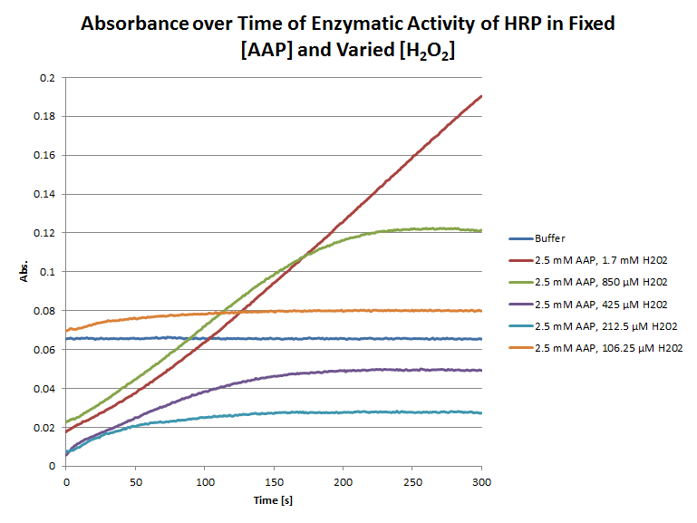

Figure A. Absorbance over time of enzymatic activity of HRP in fixed [AAP] and varied [H2O2] at 510nm. The concentration of HRP in all solutions was 2.3 μM and the signals of all solutions were amplified by adding 10 μL of 18 mM 4-iodophenol in DMSO. The concentration of AAP was fixed at 2.5 mM, while the concentration of H2O2 was varied between 1.7 mM to 106.25 μM. For every 0.75 mL of H2O2 solution, 0.7 mL of AAP solution was added, for a total volume, including that of the 4-iodophenol solution, of about 1.46 mL in the cuvette.

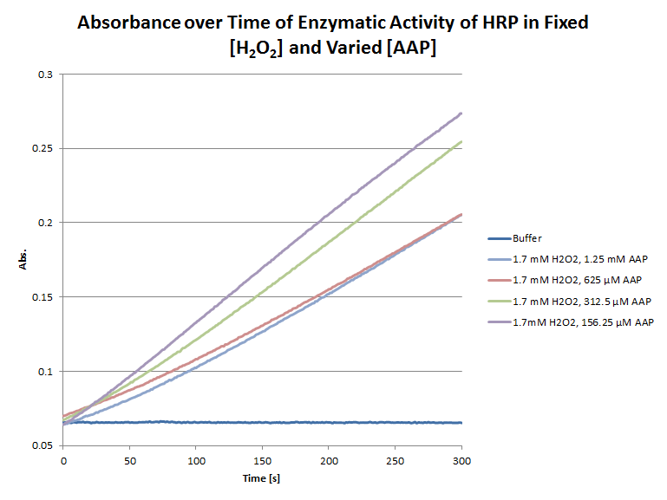

Figure B. Absorbance over time of enzymatic activity of HRP in fixed [H2O2] and varied [AAP] at 510nm. The concentration of HRP in all solutions was 2.3 μM and the signals of all solutions were amplified by adding 10 μL of 18 mM 4-iodophenol in DMSO. The concentration of H2O2 was fixed at 1.7 mM, while the concentration of AAP was varied between 1.25 mM to 156.25 μM. For every 0.75 mL of H2O2 solution, 0.7 mL of AAP solution was added, for a total volume, including that of the 4-iodophenol solution, of about 1.46 mL in the cuvette.

HRP-Luminol Assay

Horseradish peroxidase catalyzes the oxidation of luminol by H2O2. The resultant luminescence, enhanced by adding 4-iodophenol to the solution, is monitored with a fluorimeter. A graph of intensity over time of the luminescence produced by the reaction can be used to determine the activity rates of HRP.

Initial experiments with the HRP-luminol assay were based on the luminescence procedure found on Dropbox [1]. Deviations from the protocol are as follows:

* Luminol was found to be immiscible in water, so sodium carbonate was added to the solution to dissolve it completely. Then sodium bicarbonate was added to adjust the pH to 7.
* 4-Iodophenol was also found to be immiscible in water, so it was dissolved in DMSO instead. Note that the amount of DMSO in the reaction solution was dilute enough that it did not affect the reaction and luminescence.

The fluorimeter was set to take a TimeDrive spectrum. The excitation wavelength was 350 nm and the emission wavelength was 430 nm. The excitation slit width was 15 nm and the emission slit width was 20 nm. These settings were not changed for the duration of the experiment. It was also determined that the optimal solution volume for fluorescence measurements was slightly less than 2 mL. This total volume determined the amounts of solutions added to the 3 mL cuvette (Table 1). These volumes were not varied, unless indicated.

Table 1: Volumes of Components of the Reaction Solution

|  |  |
| --- | --- |
| Solution | Volume [μL] |
| 4-Iodophenol | 13.2 |
| Luminol | 920 |
| H2O2 | 990 |
| HRP | 66 |

The original concentrations of the solutions of luminol, H2O2, and HRP were found to give meaningless results, so they were diluted and then recombined in various reaction solutions.

Another study of the HRP-luminol assay indicated that the optimal pH for the reaction is 8.5 and that the optimal mole ratio of H2O2 to luminol is 2.2 [2].

References

1. Kricka, L.J. Chemiluminescent and bioluminescent techniques. *Clin. Chem.* **1991**, 37, 1472-1481.
2. GoldBio.com. Horseradish Peroxidase Assay.

Catalyzes the oxidation of luminol by h2o2

What we did

* Followed procedure on Dropbox
  + Made 2.5 mM luminol stock solution (note that it is immiscible in water, so sodium carbonate was added to dissolve it completely. Then, sodium bicarbonate was added to adjust the pH to 7. Literature indicates that the optimal pH for luminol-HRP assay is 8.5 -> refer to article posted on CHEM-571 Literature Survey page).
  + Made 2.3 μM HRP stock solution -> refer to protocol on 2012/09/18. Further testing indicated that the HRP concentration was too high, so it was diluted to concentrations of 1.15 μM, and 0.23 μM. Concentrations of 9.2 μM and 4.6 μM were also made.
  + Made 1.7 mM H2O2 stock solution from 30% H2O2 in water and 0.2 M sodium phosphate buffer.
  + Made 18 mM 4-iodophenol solution in DMSO, as 4-iodophenol is immiscible in water. Note that DMSO in the final solution has negligible effects on the reaction and chemiluminescence.
* Although various combinations of dilutions of H2O2 and luminol were tested, it was determined that the optimal concentration of H2O2 was 1.7 mM and that of luminol was around 0.625-1.25 mM. (Note that literature indicates that the optimal mole ratio of H2O2 to luminol is 2.2.). It was also observed that at higher concentrations of HRP, the reaction proceeded too quickly and the chemiluminescence was too transient to be monitored within a time period of 300 s.