Nicole Miller's Video Portrait:
Capturing a live interview

Pick a friend, classmate, or acquaintance you are interested in filming. Using the following questions as examples, decide what you would like to ask your subject, depending on what you know and what you don’t know about that person.

Media:
Video, sound, people
Materials:
+ Video camera (any quality)
+ Paper
+ Computer
Optional:
+ Tripod
+ Sound recorder
+ Lighting

If your chosen subject is a friend, ask them a question about something you know about them, something they are interested in, or something they have a history with.
For example: “Explain to me what your first game of soccer was like.” Or: “What was it like when you traveled to Europe?”
If your subject is an acquaintance, ask them a question that will further your understanding of who they are. The question should encourage them to tell a full and long story.
For example: “How has your family been a part of shaping your personality?” Or: “Tell me a story about your favorite place in the world.”
If your subject is a classmate that you don’t know well, ask an open question that anyone could answer.
For example: “Tell me about a special talent you have and how you discovered this about yourself.”

Write your questions down on a piece of paper so you don’t forget. Be as creative as possible with your questions.

Filming Preparation
Camera Selection
You don’t need expensive video equipment for this project—you can use any type of video camera, a smartphone, or anything that can record video and sound. If you don’t have anything to shoot with, borrow a smartphone from a friend or parent.
Tripod
Try to film on a tripod so that the image is not shaky. If a tripod is not available, make a makeshift one out of books or place the camera on a table. If you must hold the camera in your hand, make yourself steady and solid like a rock, and pay attention to your body movements so that the camera does not shake.
Sound
Make sure that you do a sound test using your chosen device. Some equipment records sound better than others. Try changing the position of the camera to ensure that you can record proper audio. Be aware of any background noise that might make it hard to hear your subject, such as an airplane flying by, kids shouting, or cars honking.
Filming
Don’t discuss your question with your subject until you are actually filming them. Once you ask your question, stay silent so that it is only your subject’s voice in the video. Don’t fill silences with your voice—let that be part of the work. The image can be of the subject silently standing there figuring out what to say; it can simply show them thinking. Once you are done recording, thank your subject for their time. This is your finished video portrait.
Screening Your Video
A video is different from a drawing or a painting. It’s not as easy to hang it on a wall to exhibit it for your friends to see. Uploading videos to the Internet can make them accessible for others to view. Creating a Vimeo, YouTube, or Instagram account can be a great way to show all of your new work in one place. The more video portraits you make, the larger your series of works will be. Gather your friends together and watch your new works on a computer.

Artist Biography:
Nicole Miller
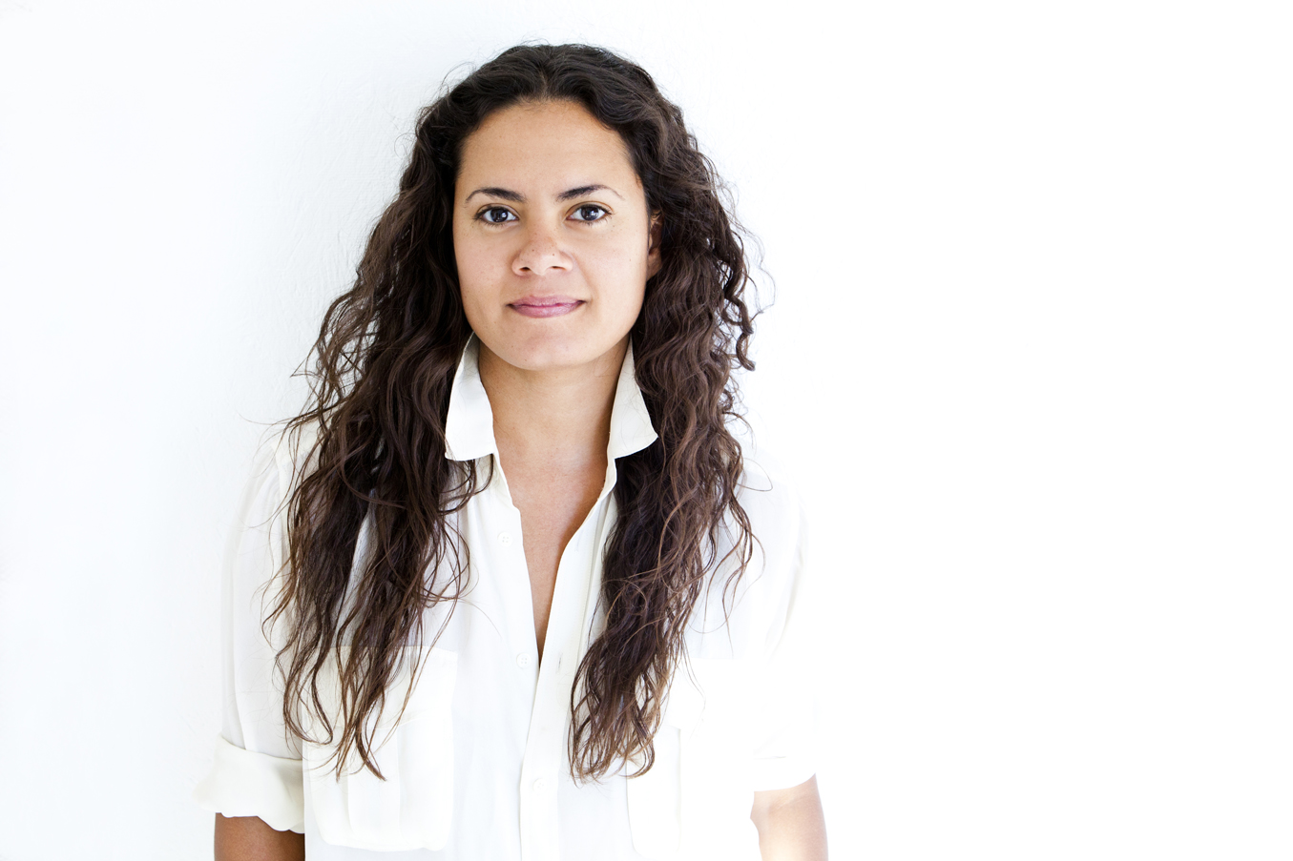Nicole Miller

Born in 1982 in Tucson, Arizona
Currently lives in Los Angeles, California
Nicole Miller moved to Los Angeles in 2001 to attend CalArts and continued with a graduate degree from USC Roski School of Fine Arts; she still lives and works in Los Angeles. Recently, Miller has had solo exhibitions at Ballroom Marfa, Centre d’Art Contemporain Geneva, the High Line in New York, and Kunst Werke in Berlin. She has also shown at LAXART in Los Angeles, and her work has been featured in major museum exhibitions such as Made in LA at the Hammer Museum, Fore at the Studio Museum in Harlem, and Dallas Biennale at Dallas Contemporary. Last year she completed an eighteen-month project with the Los Angeles County Museum of Art. Her work is included in the collections of LACMA, the Hammer Museum, and SFMOMA.

