MATADOR MADNESS
Tournament Week (4/29 - 5/3)

Compete against fellow MV sports teams for fun and team pride!

Day 1 (4/29) (16 teams) Sweet 16 Relay Day 1

Day 2 (4/30) (16 teams) Sweet 16 Relay Day 2

Day 3 (5/1) (8 teams) Elite 8 Ultimate Frisbee

Day 4 (5/2) (4 teams) Final 4 Dodgeball

Day 5 (5/3) (2 teams) Finals Capture the Flag

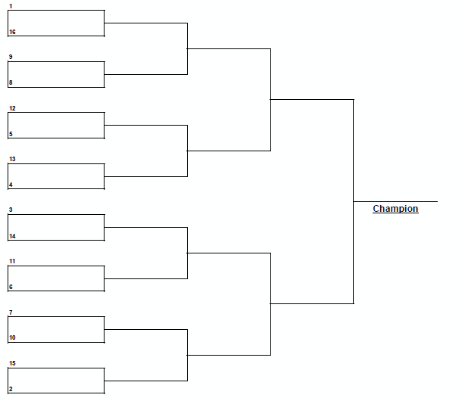

Rosters due to Google form by April 23rd
https://forms.gle/e3gY2Q5FtpREiBqU8

Available Rosters for combined sports:
- Football/Field Hockey
- B & G Water Polo
- Cross Country
- Track
- B & G Golf, Dance
- B & G Tennis
- B & G Soccer
- B & G Basketball
- B & G Volleyball
- Spirit & Wrestling
- Badminton
- Swim/Dive
- Baseball & Softball
- Student Team
- Plus 2 additional teams

