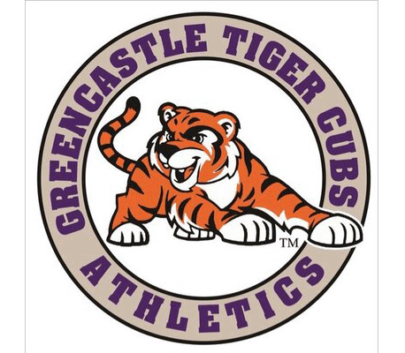

Car Wash Fundraiser
Hosted by Greencastle Girls Basketball Program
Saturday, September 19th, 2020 3-7pm
@ O’Reilly’s Auto Parts
2 Putnam Plaza Greencastle, IN 46135

Donations are greatly
appreciated and will
go towards our team
shoes and practice
packs!

Questions? Contact Kellie Kirkhoff
kkirkhoff@greencastle.k12.in.us

