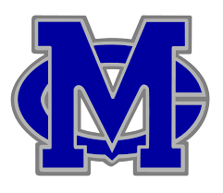
STUDENT APPRECIATION NIGHT!!
BOYS BASKETBALL v LAKE CENTRAL
FRIDAY, FEBRUARY 12, 7pm

HALF PRICE TICKETS FOR STUDENTS!!
ONLY $3!!
SENIORS ARE FREE!!
Prizes! Giveaways! Contests!
Come support your squad!!
Game sponsored by:

