2018/2019
Edgewood High School
Athletic Sports Physicals
June 12th 2018 1:30-3:00pm $15 Pride Corner
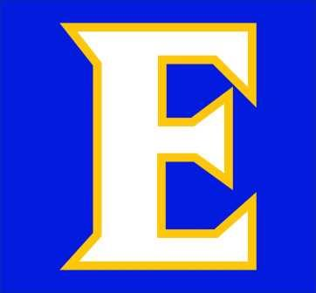
Online Athletic Clearance on Athleticclearance.com
Chromebooks will also be available for online clearances on June 12th in Pride Café 1:30pm-3:00pm
You will need to complete your online athletic clearance for the 2018/2019 school year along with turning in a copy of your physical exam document to your Coach or Mr. Soto the Athletic Director in the athletic office prior to first practice/tryout.
If you have any questions, feel free to contact Mr. Soto at asoto@wcusd.org

