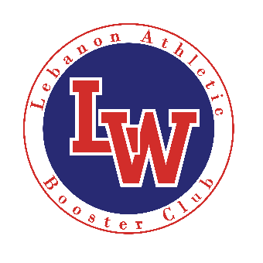
LEBANON ATHLETIC BOOSTER CLUB

Lebanon Athletic Booster Club is a group of parents, staff and community members whose mission is to:

- Increase community awareness of current athletic activities and programs while continuing to build a positive athletic image for the community of Lebanon.
- Promote the positive aspect of student development through athletics.
- Work alongside high school coaches and administration in raising funds and in-kind services to improve athletic programs and facilities.
- Support high school athletic events and activities through coordination of local volunteers and organizations.

The Booster Club is pursuing our mission with the following objectives:
- Increasing athletic participation
- Speed, Agility, and Strength Programs
- Mentorship programs
- Capital improvement programs

Cost – $75 per Individual/Family

Member’s Receive
- Sticker for Car or Home.
- 10% off Warrior gear through on-line store.
- Invitation to Booster Club Functions
- Opportunity to participate in Booster Club Committees to provide funds and service to programs and kids.

Members Name(s)_________________________Contact # __________________ E-Mail ____________________________________
Members Name(s)_________________________Contact # __________________ E-Mail ____________________________________
Street Address __________________________________________________City_________________________ Zip _________________
Size Quantity Amount

$75 -Yearly Membership Dues _____ _____ $_______
$25 – Warrior Flex Fit Ball Cap _____ _____ $_______
$25 – Men’s Booster Polo _____ _____ $_______
$25 – Women’s Booster Polo _____ _____ $_______
Total Amount Paid $_______

Please make checks payable to: Lebanon Athletic Booster Club

Payment and form can be mailed to: P.O. Box 2631 Lebanon, Or 97355

Email Doug Phillips with Question’s – Doug.Phillips@edwardjones.com

