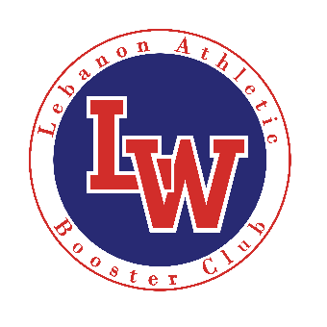
Lebanon Athletic Booster Club
Sign Sponsorship Order Form
To support the Lebanon Athletic Booster Club and help us pursue our mission, please choose from one of the following sponsorship opportunities:
Name: ________________________________ Date: ____________
Billing Address:_________________________________________________________________
City: ________________________ State: ____________________ Zip: ___________________
Phone: __________________ Email:_______________________________________________
Signature: ______________________________ Printed Name: ___________________________
****Please submit logo for sponsorship signs to: jake.haley@weyerhaeuser.com****
Venue: For single venue – initial cost $300 for first year to cover banner cost, $250 thereafter:
LHS Gymnasium ____Sign(s) x $300/250 = ________
Heath Stadium (Football Field & Track) ____Sign(s) x $300/250 = ________
Croco Field (Baseball Field) ____Sign(s) x $300/250 = ________
Tennis / Soccer (Tennis & Soccer signs will be placed on Tennis Courts) ____Sign(s) x $300/250 = ________
Ron Fuller Field (Softball Field) ____Sign(s) x $300/250 = ________
Corporate Sponsor: All Locations $1000 = ________
Please designate if wishing to contribute to a specific Sport: ______________________$_________________
Please make checks payable to Lebanon Booster Club (credit card billing is available upon request)
Payment and form can be mailed to P.O. Box 2631 Lebanon, Or 97355
Please bill me: (CHECK ONE)
- Annually: ________ FULL PAYMENT DUE NOW, BILLED ANNUALLY IN SEPTEMBER THERAFTER
- Bi-Annually: ______ ½ PAYMENT DUE NOW, REMAINING BALANCE DUE IN MARCH
- Quarterly: ________ ¼ PAYMENT DUE NOW, THEN ¼ PAYMENT DUE IN DECEMBER, MARCH AND JUNE

Billing Cycle will be September 1st through August 31st. Sign packages/sponsorships made after January 1st will be billed at 75% and those sponsors made after April 1st will be billed at 50%. Sign packages/sponsorships purchased in July and August will not be billed until September as part of next yearly billing cycle. Sponsorship’s will be renewed each September.
Additional Corporate Sponsorship packages are available. Please contact Athletic Office at (541) 451-8555 ext. 1065 for more information.

