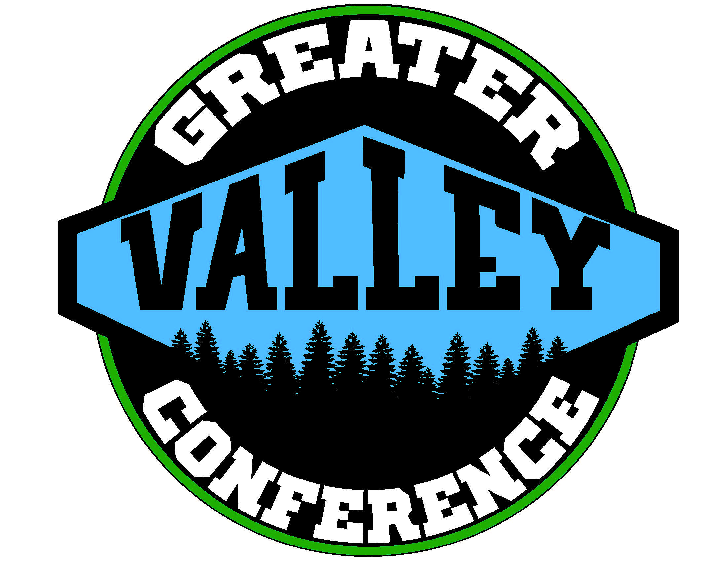
2017-2018 Swimming Schedule
Greater Valley Conference

Thursday, November 30, 2017
West Salem – Bye
22 Sprague @ McMinnville 128
98 Forest Grove @ McNary 71
36 McKay @ South Salem 120

Friday, December 1, 2017
31 North Salem @ West Albany 136

Thursday, December 7, 2017
North Salem – Bye
120 South Salem @ Sprague 35
75 McMinnville @ West Salem 95
101 McNary @ McKay 54
89 West Albany @ Forest Grove 81

Thursday, December 14, 2017
McMinnville – Bye
Sprague @ McNary (2:00)
Forest Grove @ North Salem (4:30)
West Salem @ South Salem (7:00)

Friday, December 15, 2017
McKay @ West Albany

Tuesday, January 2, 2018
Forest Grove – Bye
South Salem @ McMinnville
McNary @ West Salem (2:00)
West Albany @ Sprague (4:30)
North Salem @ McKay (7:00)

Thursday, January 4, 2018
South Salem – Bye
Sprague @ North Salem (3:30)
McMinnville @McNary (6:00)
McKay @ Forest Grove

Friday, January 5, 2018
West Salem @ West Albany

Thursday, January 11, 2018
McKay – Bye
North Salem @ West Salem (2:00)
Forest Grove @ Sprague (4:30)
McNary @ South Salem (7:00)
West Albany @ McMinnville

Thursday, January 18, 2018
McNary – Bye
West Salem @Forest Grove
McMinnville @ North Salem (3:30)
Sprague @ McKay (6:00)

Friday, January 19, 2018
South Salem @ West Albany

Thursday, January 25, 2018
Sprague – Bye
Forest Grove @ McMinnville
McKay @ West Salem (2:00)
West Albany @ McNary (4:30)
North Salem @ South Salem (7:00)

Tuesday, January 30, 2018
West Albany – Bye
South Salem @ Forest Grove
McNary @ North Salem (2:00)
McMinnville @ McKay (4:30)
West Salem @ Sprague (7:00)

District Championship – February 9-10, 2018
(McMinnville Aquatic Center)
State Championship – February 16-17, 2018
(Mt Hood Community College)
2017-2018
GVC Girls Swimming Standings
After Round Two

1) South Salem 2-0
1) West Albany 2-0
3) West Salem 1-0
4) Forest Grove 1-1
4) McMinnville 1-1
4) McNary 1-1
6) North Salem 0-1
8) McKay 0-2
8) Sprague 0-2

