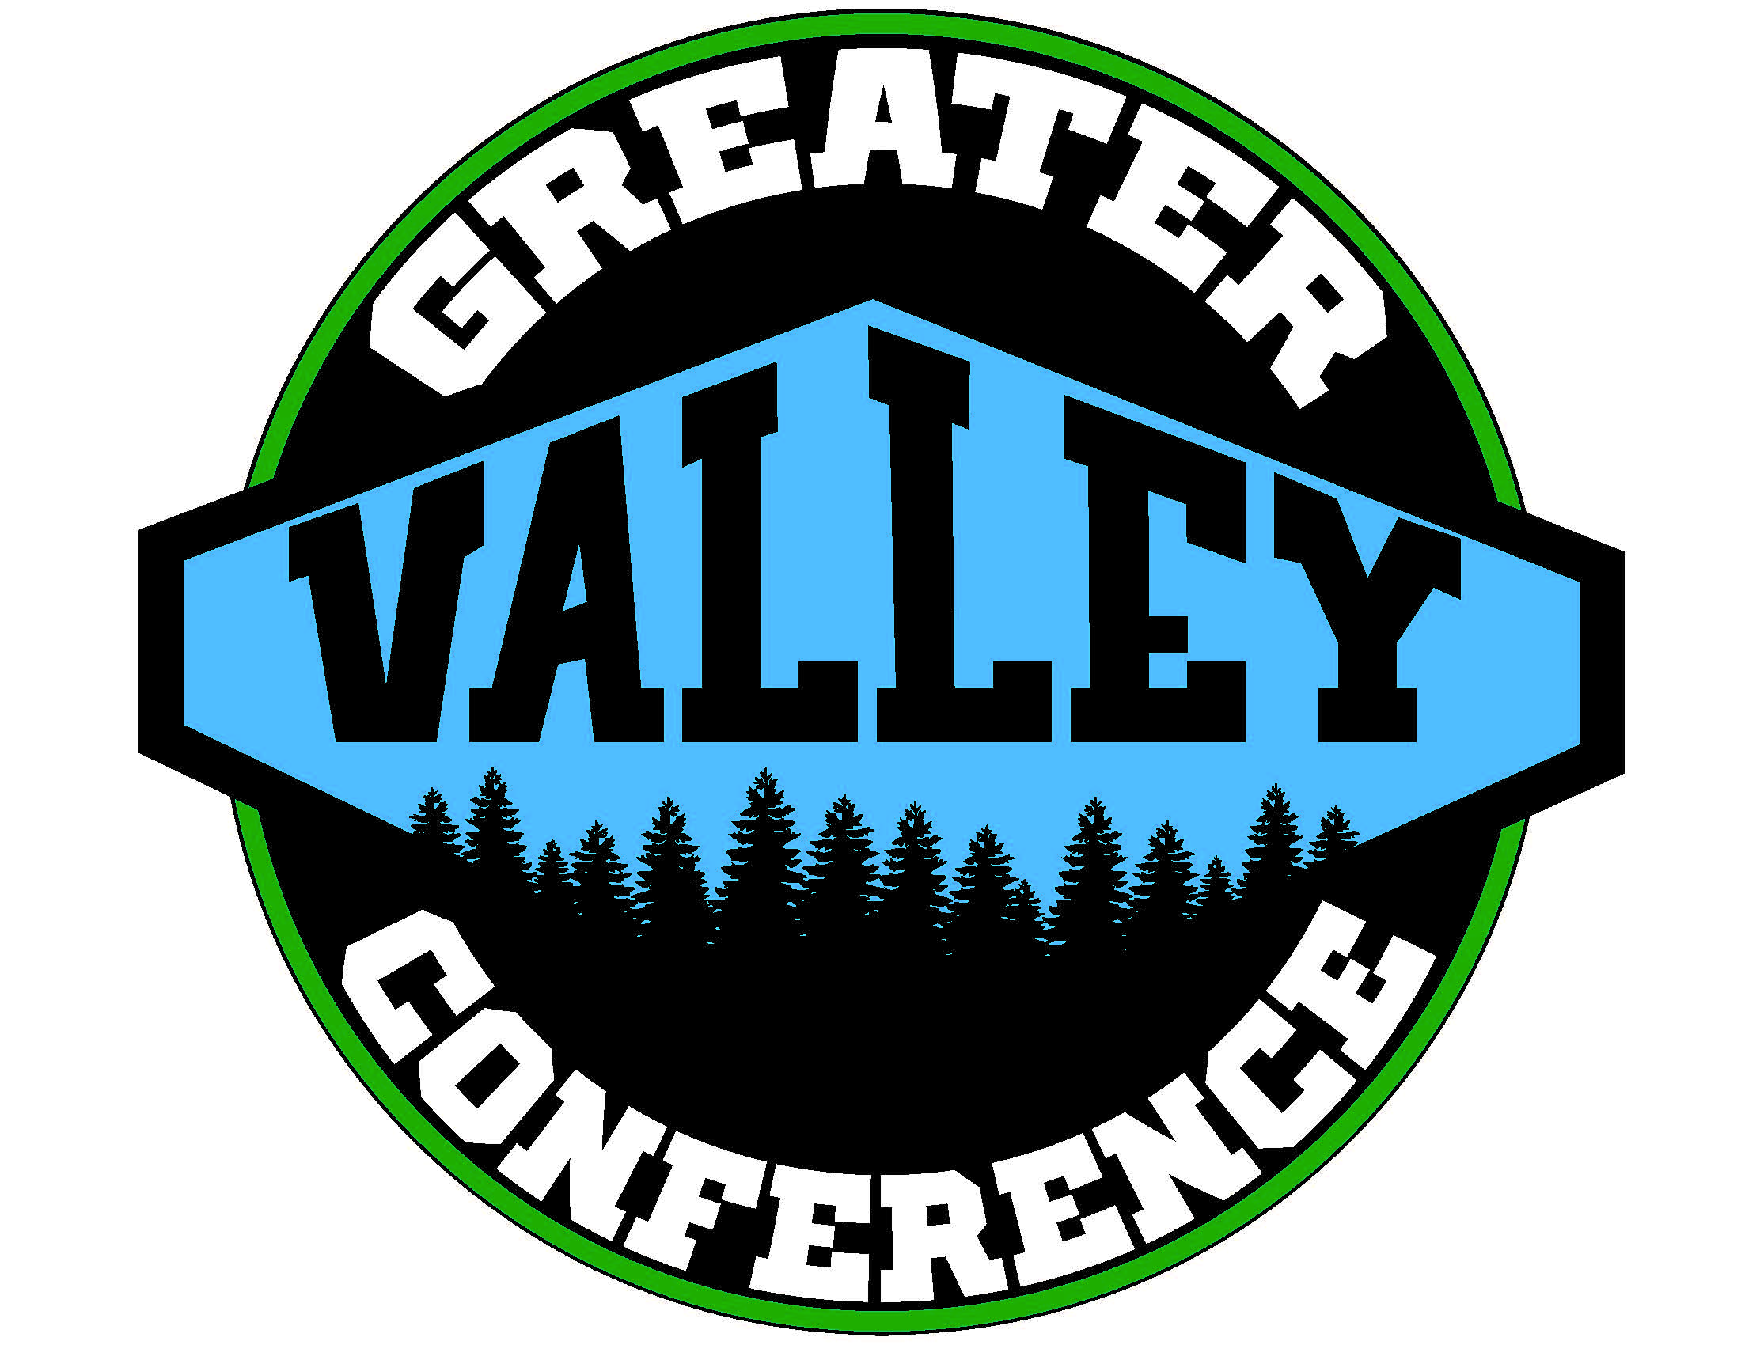
2017-2018 Swimming Schedule
Greater Valley Conference

Thursday, November 30, 2017
West Salem – Bye
50 Sprague @ McMinnville 111
101.5 Forest Grove @ McNary 58.5
28 McKay @ South Salem 133

Friday, December 1, 2017
24 North Salem @ West Albany 126

Thursday, December 7, 2017
North Salem – Bye
122 South Salem @ Sprague 37
119 McMinnville @ West Salem 50
123 McNary @ McKay 33
85 West Albany @ Forest Grove 80

Thursday, December 14, 2017
McMinnville – Bye
92 Sprague @ McNary 71
106 Forest Grove @ North Salem 26
57 West Salem @ South Salem 113

Friday, December 15, 2017
36 McKay @ West Albany 134

Tuesday, January 2, 2018
Forest Grove – Bye
82 South Salem @ McMinnville 88
87 McNary @ West Salem 83
73 West Albany @ Sprague 94
62 North Salem @ McKay 88

Thursday, January 4, 2018
South Salem – Bye
113 Sprague @ North Salem 24
119 McMinnville @McNary 51
40 McKay @ Forest Grove 122

Friday, January 5, 2018
72 West Salem @ West Albany 98

Thursday, January 11, 2018
McKay – Bye
North Salem @ West Salem (2:00)
Forest Grove @ Sprague (4:30)
McNary @ South Salem (7:00)
West Albany @ McMinnville

Thursday, January 18, 2018
McNary – Bye
West Salem @Forest Grove
McMinnville @ North Salem (3:30)
Sprague @ McKay (6:00)

Friday, January 19, 2018
South Salem @ West Albany

Thursday, January 25, 2018
Sprague – Bye
Forest Grove @ McMinnville
McKay @ West Salem (2:00)
West Albany @ McNary (4:30)
North Salem @ South Salem (7:00)

Tuesday, January 30, 2018
West Albany – Bye
South Salem @ Forest Grove
McNary @ North Salem (2:00)
McMinnville @ McKay (4:30)
West Salem @ Sprague (7:00)

District Championship – February 9-10, 2018
(McMinnville Aquatic Center)
State Championship – February 16-17, 2018
(Mt Hood Community College)
2017-2018
GVC Boys Swimming Standings
After Round Five

1) McMinnville 4-0
2) West Albany 4-1
3) South Salem 3-1
3) Forest Grove 3-1
5) Sprague 3-2
6) McNary 2-3
7) McKay 1-4
8) West Salem 0-4
8) North Salem 0-4

