Dear Parents,

The Fairview High School Cross Country team is hosting a summer running camp for athletes in grades 3-8 (incoming). The two-week camp will be held Monday, June 18th through June 29th. The camp will meet at the Fairview High School track both weeks on Monday, Wednesday, and Friday from 10:30am to 12:00pm. During the two week camp, athletes will learn how to properly warm-up, improve their running form and technique, train with current Fairview High School cross country runners and former Fairview cross country runners who are now running at the collegiate level, and have the chance to show off their talents at our cross country 2 mile race at Bain Park on the last day of camp.

The cost of the camp is $40.00 per athlete, and $20.00 for each additional family member. You may also register your child for one week for $30.00. You will need to fill out the Parent Permission/Waiver Form, and Emergency Medical Form. All forms are attached to this letter. All registration forms and checks will be due by Friday, June 15th if you would like a t-shirt. Deadline to register is Monday June 18th. All forms and checks (made out to Fairview CC Boosters) can be mailed to Jennifer Dahler at 4648 West 220 Street, Fairview Park, Ohio 44126.

Athletes should start running on their own prior to the start of running camp. We would like athletes to have a good running base so we can focus more on running endurance and specific running skills. Please make sure athletes have proper running shoes and clothes for running in the summer heat. If you are going to purchase new running shoes, I recommend going to Second Sole in Rocky River. It is recommended that athletes bring water daily. Athletes will receive a running camp t-shirt, daily goodies, and awards for the cross country race on the last day of camp. Parents are encouraged to attend the Cross Country style race starting at Bain pavilion at 10:30am on June 29th.

Our goal is to make this a positive experience for all runners. Please help us get the word out to all athletes and parents. If you have any questions, please contact Coach Dahler at 440-478-3062 or e-mail at jennifer.dahler@gmail.com

To receive messages about running camp via text, text @runcamp18 to 81010.

Thank you,

Jen Dahler
Running Camp Director
Fairview HS Boys/Girls CC Coach

JOIN Running Camp 2018 on REMIND for text updates and information on the camp:
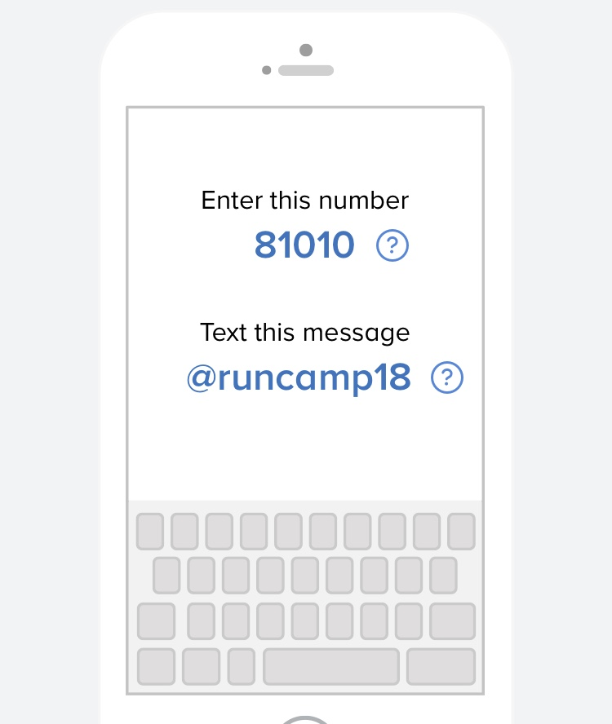

Fairview Running Camp
Permission/Waiver Form

______________________ has my permission to compete in the
Name of son/daughter Summer Running Camp from June
18th-June 29th.

_____________________ ________________________
Print name Sign name

- T-shirt size- ______________ (youth sizes available). All registration forms and checks will be due by Friday, June 15th if you would like a t-shirt.

- Age of athlete on June 29th- ____________________

- As parent/legal guardian of the child named herein, I hereby represent that the child has been examined by a pediatrician and is physically fit to participate in the Summer Running Camp. I understand there are inherent risks to participating in this athletic program. I hereby accept responsibility for and agree to pay any and all costs of medical treatment resulting from any injury suffered by my child as a result of his/her participation at the Summer Running Camp. I further agree to indemnify and hold harmless all coaches and cross country athletes from any and all liability, damage, or expense arising out of my child’s participation in the Summer Running Camp. In the event that I cannot be reached in an emergency, I hereby give permission for a qualified Summer Running Camp coach, an emergency medical technician, a physician or staff member at a hospital, or any other qualified individual to administer care and provide any medical treatment deemed necessary for my child.

I understand and agree to the statements above. ________________________
Parent signature

Summer Running Camp Emergency Medical Form

Student’s Name: ______________________________ Date of Birth: _______________

Address: ______________________________________ City: ____________________

Zip:______________________ Phone #: _______________________

Parent/Guardian name: ____________________________

Place of Employment:_____________________________________

Work Phone: __________________ Cell Phone:___________________

Mother’s Name: ____________________________

Parent/Guardian name:_____________________________________

Work Phone: __________________ Cell Phone:___________________

Allergies (including those to medication/s) or other important medical information:

_______________________________________________________________________

_______________________________________________________________________

_______________________________________________________________________

If unable to reach parents in an emergency, contact:

Name: _________________________ Relationship: _____________________

Phone: _______________________

List any medical conditions that we need to know about prior to the camp, especially any that may prohibit your son daughter from any physical activities they may be participating in during the camp. If there are major medical concerns, please contact Jen Dahler at 440-478-3062.

_______________________________________________________________________

_____________________________________________________________________________________________________________________________________________

